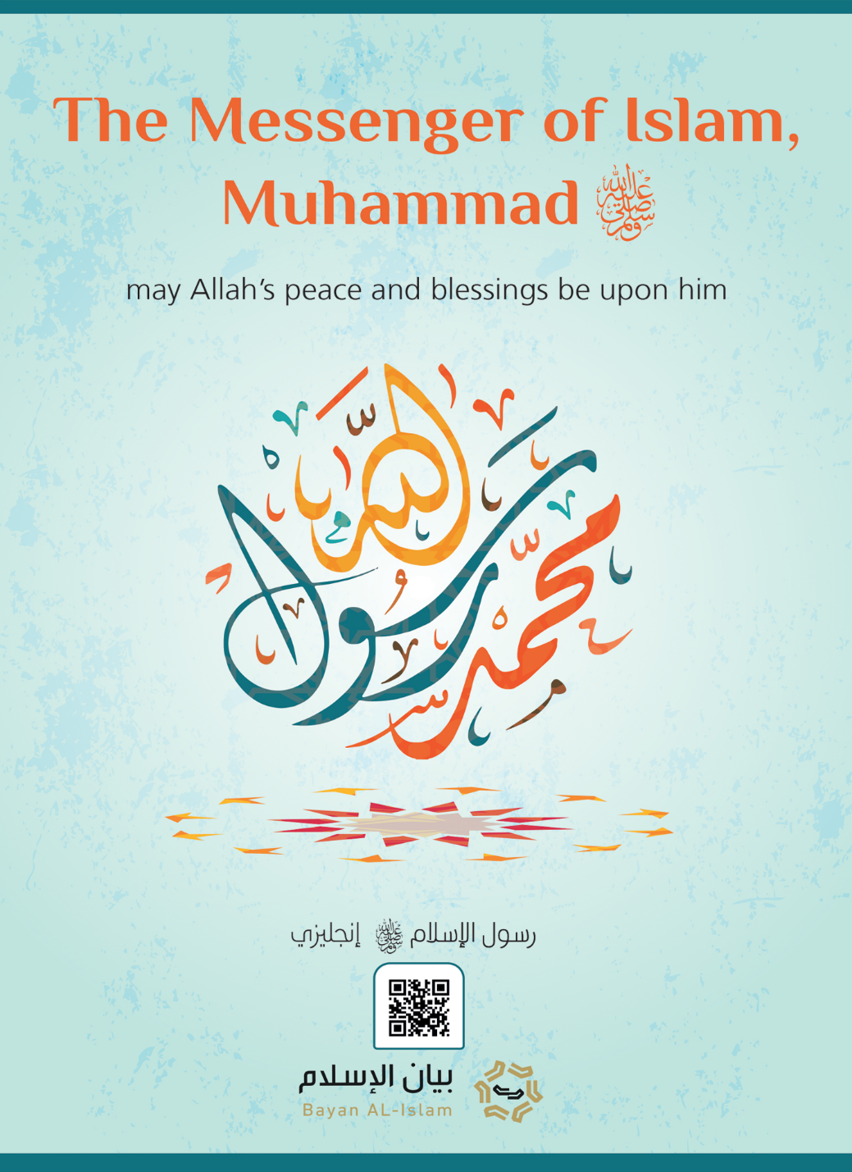
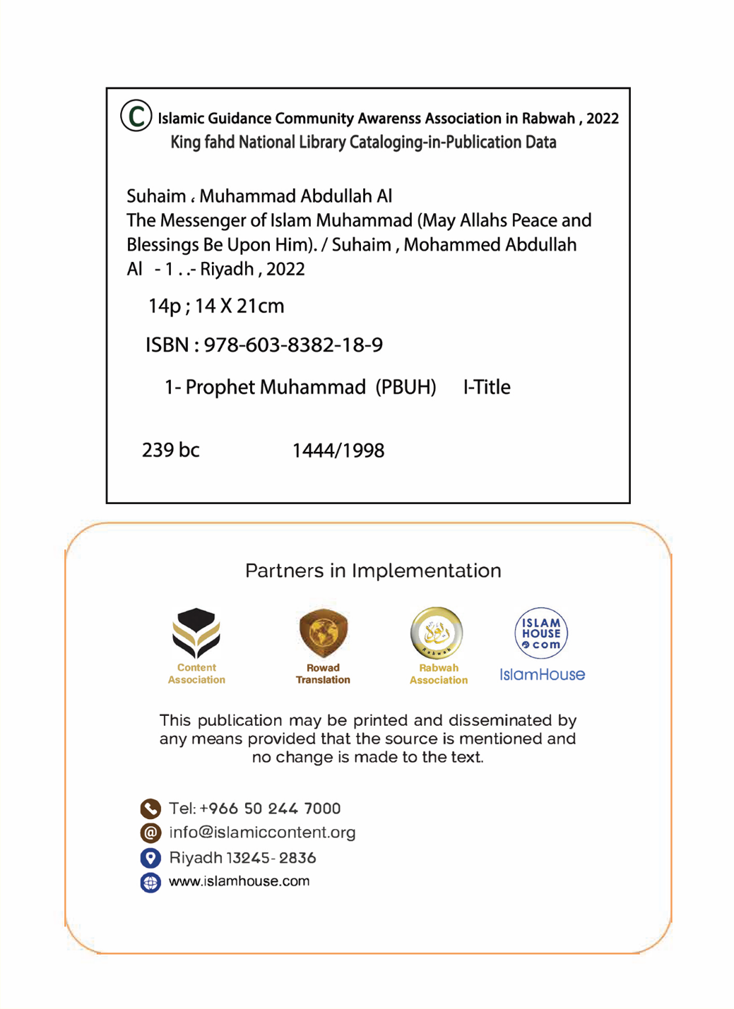



In the Name of Allah, the Most Compassionate, the Most Merciful

The Messenger of Islam, Muhammad (may Allah’s peace and blessings be upon him)

In the Name of Allah, the Most Compassionate, the Most Merciful
A brief introduction of the Messenger of Islam Muhammad (may Allah’s peace and blessings be upon him) . It explores his name, lineage, home country, marriages, and mission. It also covers the signs of his prophethood, his Shariah, and his enemies’ stance towards him.

1- Name, lineage, and birthplace:
The Messenger of Islam is Muhammad ibn ‘Abdullah ibn ‘Abd al-Muttalib ibn Hashim. His line of ancestors extends back to Ismail (Ishmael), son of Ibrahim (Abraham) (peace be upon them). Prophet Abraham (peace be upon him) traveled from the Levant to Makkah in the company of his wife, Hajar, and his son, Ishmael when he was a baby. By Almighty Allah’s command, he settled them in Makkah. Years later after the boy had grown into a young man, Abraham (peace be upon him) returned to Makkah and began building the Kabbah (i.e., the Sacred House) with the help of his son Ishmael (peace be upon him). It attracted throngs of people who traveled to Makkah, the destination of Allah’s worshippers, seeking to perform Hajj. Centuries passed and people worshiped Allah in accordance with Abraham’s religion. Unfortunately, deviation ensued across the Arabian Peninsula, leaving it no less idolatrous than its surrounding territories. The worship of idols, burial of baby girls alive, oppression of women, perjury, consumption of alcohol, perpetual immorality, devouring the wealth of orphans, and consumption of usury were all manifestations of idolatry. In such environment, the Messenger of Islam, Muhammad ibn ‘Abdullah, the descendant of Ismail ibn Ibrahim (peace be upon them) was born in 571 AD. His father died before his birth and his mother passed away when he was six. His uncle, Abu Talib, looked after him. Muhammad was a poor orphan and he lived off his own manual labor.

2- Blessed marriage to a blessed woman:
At the age of twenty-five, Muhammad (may Allah’s peace and blessings be upon him) married a prestigious Makkan lady. Her name was Khadījah bint Khuwaylid (may Allah be pleased with her). She gave birth to four girls and two boys, but the boys died in their childhood. He treated his wife and family with utmost gentleness and love. It is no wonder that Khadījah loved him immensely. He loved her back so much that she was etched on his memory even after years of her death. He used to slaughter a sheep and give out its meat to her friends as an honor for them and out of loyalty to Khadījah.

3- The outset of revelation
Prophet Muhammad (may Allah’s peace and blessings be upon him) enjoyed an upright moral character since his birth. His people used to call him “the honest” and “the trustworthy”. He participated with them in dignified pursuits but shunned their idolatrous conduct and never took part in it.
At the age of forty, Allah chose him to be a Messenger when he was in Makkah. Jibril (Gabriel) (peace be upon him) descended upon him with the first few verses of the first Surah revealed from the Qur’an. Those verses are:
﴿ٱقۡرَأۡ بِٱسۡمِ رَبِّكَ ٱلَّذِي خَلَقَ١ خَلَقَ ٱلۡإِنسَٰنَ مِنۡ عَلَقٍ٢ ٱقۡرَأۡ وَرَبُّكَ ٱلۡأَكۡرَمُ٣ ٱلَّذِي عَلَّمَ بِٱلۡقَلَمِ٤ عَلَّمَ ٱلۡإِنسَٰنَ مَا لَمۡ يَعۡلَمۡ٥﴾ [العلق: 1-5]
{Read in the name of your Lord Who created, created man from a clinging clot. Read, and your Lord is the Most Generous, Who taught by the pen, taught man what he did not know.} [Surat al-‘Alaq: 1-5]
He rushed back to his wife Khadijah (may Allah be pleased with her) and his body was trembling. He told her about his experience, but she comforted him and took him to her cousin, Warqah ibn Nawfal. He was a devoted Christian and had knowledge of both the Torah and the Gospel. Khadijah requested her cousin to listen to the story. He asked the Messenger of Allah (may Allah’s peace and blessings be upon him) who told him what he had seen. After attentive listening, Waraqah said, "This is the same angel (Gabriel) whom Allah had sent down to Musa (Moses). I wish I could be young and live up to the time when your people would drive you out.” The Messenger of Allah (may Allah’s peace and blessings be upon him) exclaimed: “Will they drive me out?” Waraqah replied in the affirmative and said, “No man came with something similar to what you have come with except that he was opposed; and if I remain alive till that day of yours, I will support you strongly.”
In Makkah, the Qur’an was consistently revealed through Gabriel, who would also convey to him the details of the mission from Allah, Lord of the worlds.
The Messenger of Allah (may Allah’s peace and blessings be upon him) invited his people to Islam despite their denial and resistance. They even offered him wealth and leadership in return for giving up his mission, but he rejected it all and endured their name-calling, just like other prophets did. His people called him a sorcerer, liar, and a fabricator. They tightened up his life conditions, assaulted his honorable body, and persecuted his followers. The Messenger of Allah (may Allah’s peace and blessings be upon him) continued his mission in Makkah calling people to Allah during the pilgrimage season as well as the Arab seasonal markets. He would meet people and explain Islam to them. His means of attraction featured neither worldly gains nor leadership, nor did he practice any sort of forced conversion because he had no sovereignty. At the beginning of his mission, he challenged his people to produce something like the Qur’an. He continued challenging his opponents, so some of his honorable Companions believed in him (may Allah be pleased with them). In Makkah, Allah honored him with the grand event of the night journey to Jerusalem followed by his ascension to the heaven (Al-Isra’ and Al-Me’raj). It is known that Allah raised both prophets Ilyas (Elias) and ‘Isa (Jesus) to the heaven, as documented in Islam and Christianity. The Prophet (may Allah’s peace and blessings be upon him) received the obligation of prayer in heaven. It is the very prayer that Muslims perform five times a day. During his stay in Makkah, another grand sign took place, namely the splitting of the moon so visibly that the polytheists saw it clearly.
The disbelievers of Quraysh pursued every possible means to hurdle the progress of the Prophet’s mission such that they plotted against him, warned people of approaching him, made rigid requests of signs, and sought help of the Jews to step up their rebuttal arguments and effectively prevent people from listening to him.
In response to the increasing persecution that Muslims suffered at the hands of the disbelievers of Quraysh, the Prophet (may Allah’s peace and blessings be upon him) gave them permission to migrate to Abyssinia saying, “ There is a just king who allows no oppression.” He was a Christian king. Two groups of the believers migrated to Abyssinia. After their arrival, they explained the religion brought by the Prophet Muhammad (may Allah’s peace and blessings be upon him) to Negus. He accepted Islam and said, “By Allah, it comes from the same source from which the religion of Moses (peace be upon him) came from.” Whereas in Makkah, persecution of the Prophet and his Companions continued.
But in a glimmer of hope, a group of people from Madinah, who attended the pilgrimage season, believed in him. They pledged allegiance to embrace Islam and support his cause when he traveled to their city, which was then called Yathrib. Then, he gave permission to those believers who remained in Makkah to migrate to Madinah. So, they migrated and spread Islam therein so much that Islam has reached every single house.
The Prophet (may Allah’s peace and blessings be upon him) spent thirteen years calling to Allah in Makkah. Afterwards, Allah gave him permission to migrate to Madinah. He (may Allah’s peace and blessings be upon him) migrated and continued preaching Islam. There, the legislations of Islam were revealed gradually. He began to dispatch messengers with letters asking the heads of tribes and kings to accept Islam. Examples of those kings are the Roman king, the Persian king, and the king of Egypt.
In Madinah, an incident of the solar eclipse took place and frightened people. It coincided with the death of Ibrahim, the Prophet’s son. People, thus, said that it was Ibrahim's death that caused the sun to eclipse. However, the Prophet (may Allah’s peace and blessings be upon him) said, "The sun and the moon do not eclipse on the death or birth of anyone. But both are among the signs of Allah with which Allah frightens His servants.” Had the Prophet (may Allah’s peace and blessings be upon him) been a lying imposter, he would have seized this opportunity to warn people who would deny his message and claim that it was my son’s death that caused the solar to eclipse; so, what would happen to those who deny my message?
Allah adorned His Messenger (may Allah’s peace and blessings be upon him) with perfect morals. Allah described him saying,
﴿وَإنَّكَ لَعلَي خُلُقٍ عَظِيم﴾ [القلم: 4]
{Indeed, you are of a great moral character.}[4] [Surat al-Qalam: 4]
He was characterized by all good morals such as truthfulness, sincerity, bravery, fairness, generosity, and faithfulness even with enemies. He loved to give charity to the poor, the needy, and the widows. He was very keen on guiding them, showing them mercy, and treating them humbly so much that he would not be recognizable for a stranger who would ask his Companions about him whilst he was in their midst.
His life crystalizes perfection and honor when dealing with everyone: friends and enemies, relatives and distant individuals, old and young, men and women, animals and birds.
After Allah completed His religion and the Prophet (may Allah’s peace and blessings be upon him) conveyed it perfectly, he died at the age of sixty-three, forty years of which before his prophethood, and twenty-three as a Prophet and Messenger. He (may Allah’s peace and blessings be upon him) was buried in Madinah, leaving no wealth or inheritance except for his white mule that he used to ride and a piece of land that he gave out in charity for the wayfarer.
The number of believers and followers was enormous. More than a hundred thousand of his Companions attended the Farewell Hajj with him, approximately three months before his death. This is perhaps one of the reasons his religion was preserved and spread. He raised his Companions on the values and principles of Islam. They were, thus, among the best of his companions, fair, ascetic, religious, loyal, and striving for the cause of this great religion.
With respect to faith, knowledge, good deeds, sincerity, conviction, generosity, and bravery, the best of the Companions (may Allah be pleased with them) were Abu Bakr al-Siddīq, ‘Umar ibn al-Khattab, ‘Uthman ibn ‘Affān, and ‘Ali ibn Abi Talib. They were among the earliest Companions to embrace Islam and believe in it. They held the office of Caliphate and advocated the cause of Islam after the Prophet’s death. They had nothing of the privileges of prophethood nor did the Prophet (may Allah’s peace and blessings be upon him) privileged them with anything to the exclusion of the other Companions (may Allah be pleased with them).
Allah preserved the Book the Prophet was sent with and his Sunnah, his biography, statements, and practices in his mother language. Remarkably, his biography has unprecedentedly lasted throughout history to the extent that minor details such as his sleeping, eating, drinking, and smiling habits, how he dealt with his family, and all other aspects of his life were kept intact in his biography. He has no properties of Lordship nor is he able to bring harm or benefit even to himself.

4- His message
Allah sent Muhammad (may Allah’s peace and blessings be upon him) at a time when polytheism, disbelief, and ignorance prevailed in the world so much there was none worshiped Allah alone without associating others with Him except for a handful of individuals from the People of the Book. To reform this situation, Allah commissioned His Messenger Muhammad (may Allah’s peace and blessings be upon him) as the seal of the prophets and messengers. Allah sent him with guidance and the religion of truth for the entire world to make it prevail over all other religions and save people from the darkness of idolatry and disbelief to the light of monotheism and faith. His message complements the messages of the previous prophets (peace be upon them).
He preached the same teachings preached by Nūh (Noah), Abraham, Moses, Suleyman (Solomon), Dawud (David), and Jesus. This includes believing that the true Lord is Allah, the Creator, the Provider of sustenance, the Giver of life and death, the Absolute Owner, the Disposer of affairs, the Compassionate, and the Merciful. The Prophet (may Allah’s peace and blessings be upon him) also preached that Allah is the Creator of everything in the universe, the seen and the unseen. So, everything apart from Allah is His creation.
Furthermore, he invited people to the worship of Allah alone, and abandon the worship of any other deity. He declared in perfect elucidation that Allah is One without any associates in His worship, sovereignty, creation, and managing affairs. He also announced that Allah Almighty has not begotten nor was He begotten, there is none like unto Him, and He does not manifest in any of His creation, nor does anything embody Him.
In addition, the Prophet (may Allah’s peace and blessings be upon him) called people to believe in the Divine scriptures such as the Scriptures of Abraham and Moses (peace be upon them), the Torah, the Psalms, and the Gospel. He extended his call to believe in all messengers, thereby considering the denial of one prophet a denial of all prophets.
He gave people glad tidings of the mercy of Allah Who provides them with sufficiency in this world. He informed them that Allah is the Most Merciful Lord and He alone will judge people on the Day of Reckoning when He resurrects them from their graves. Allah is the One Who rewards the believers tenfold for their good deeds while sin is only counted as one. Moreover, He Almighty will admit them to eternal bliss in the Hereafter, whereas disbelievers and sinners will meet the consequences of their deeds in this world and the Hereafter.
In his message, the Messenger of Allah (may Allah’s peace and blessings be upon him) did not elevate his tribe, country, or his honorable self. Interestingly, his name is outnumbered by names of other prophets like Noah, Abraham, Moses, and Jesus (peace be upon them). Neither his mother’s name nor those of his wives are mentioned in the Qur’an, while the name of Moses’ mother is mentioned more than once and Maryam’s name (peace be upon her) is mentioned thirty-five times.
The Prophet Muhammad (may Allah’s peace and blessings be upon him) is infallible and protected from anything that goes against Shariah, reason, sound human nature, or sound morals because all prophets (peace be upon them) are protected from erring in the message that Allah sent them with. They are also charged with conveying the commands of Allah to His servants. However, the prophets share no features of Lordship or Divinity because they are humans whom Allah Almighty entrusted with His messages.
One of the most convincing proofs that the message of Muhammad (may Allah’s peace and blessings be upon him) is a true revelation from Allah is that it has persisted throughout time until now, in the same manner as it was during his life. More than a billion Muslims follow that message and practice its commands - such as prayer, Zakah, fasting, and Hajj among others - without any change or distortion.

5- Signs and evidence of his Prophethood
Allah supports the prophets with proofs, arguments, and evidence to establish the truth of their prophethood. Each prophet is given enough evidence to convince his people to believe him. The greatest signs ever given to a prophet are those endowed on our Prophet Muhammad (may Allah’s peace and blessings be upon him). Allah gave him the Noble Qur’an, the only lasting sign until the Day of Judgment. Allah supported him with other miraculous signs as well including:
Al-Isra’ and Al-Miraj (the Night Journey and Ascension), the moon splitting, the rainfall several times after supplicating His Lord to provide people with water in times of drought, increasing little food and drink to feed throngs of people, and reporting the unseen past whose details are unknown to anyone, after Allah informed him of the stories of the past prophets with their respective nations, and the story of the People of the Cave.
Other signs include his prophesizing about the unseen future events that took place as described by him, as he was informed by Allah. For example: the erupting of fire in the land of Hijaz and will be sighted by the inhabitants of the Levant; and people competing one another in constructing lofty buildings.
Allah granted him sufficiency and protection against people.
The promises he made to his Companions were fulfilled such as his saying: "You will conquer Persia and Rome and you will spend their treasures for the sake of Allah.”
Allah supported him with angels.
The prophets (peace be upon them) gave their nations glad tidings of the prophethood of the Messenger Muhammad (may Allah’s peace and blessings be upon him) such as Moses, David, Solomon, and Jesus (peace be upon them) among other prophets sent to the Children of Israel.
Allah supported him with logical evidence and examples that command the submission of sound minds.
The above evidence, signs, and logical examples are spread across the Qur’an and Sunnah beyond count. If anyone wishes to learn about them, let him ponder on the Qur’an, the Sunnah collections, and the Prophetic biography, for they have definite information about them.
If such grand signs had never occurred, his enemies from the disbelievers of Quraysh, Jews, and Christians residing in the Arabian Peninsula would have seized the opportunity to belie him and warn people against him.
As for the Noble Qur’an, it is the Book that Allah sent down upon Prophet Muhammad (may Allah’s peace and blessings be upon him). It is the speech of the Lord of the worlds. Allah challenged the men and Jinn to produce a similar version of it or even a single Surah. The challenge is still effective until today. This Qur’an answers a great deal of critical questions millions of people have on their minds. It is preserved in the Arabic language, the original language in which it was revealed without dropping a single letter. It is printed and published. Moreover, the Qur’an is an inimitable and the greatest Book ever revealed to mankind. It is worth reading or the translation of its meanings. Missing the opportunity to read and believe in it leads to losing of all goodness. Likewise, the Sunnah of the Prophet Muhammad (may Allah’s peace and blessings be upon him), his guidance, and biography are preserved and transmitted by a series of trustworthy narrators. It is printed in the very Arabic language the Messenger of Allah (may Allah’s peace and blessings be upon him) spoke as if he is living among us. It is also translated into many languages. Together with the Qur’an, they are the only source of the Islamic rulings and legislation.

6- The Shariah of Prophet Muhammad (may Allah’s peace and blessings be upon him)
The Shariah delivered by Prophet Muhammad (may Allah’s peace and blessings be upon him) is the Shariah of Islam. It is the seal of divine legislation and messages. In essence, it is identical with the principal legislation of the previous prophets even though they differ in their applications.
This Shariah is the embodiment of perfection, suitable for every place and time. It comprises the reformation of people’s worldly and religious affairs, as it contains all acts of worship the servants must devote to Allah, the Lord of the worlds, such as prayer and Zakah. It explains the permissible and forbidden aspects of conducting business transactions and operating the economic, social, political, environmental, and military affairs, not to mention all other things required for this life and the Hereafter.
Moreover, this Shariah protects people’s religions, lives, honor, wealth, reason, and offspring. Just as it is inclusive of every commendable conduct and virtue, it also warns against every immoral and evil act. It champions the preservation of human dignity, moderation, justice, sincerity, cleanliness, perfection, and love of goodness for others. Not only does Shariah ban bloodshed and advocate peace among nations, but it also prohibits frightening and scaring people unjustly. The Messenger of Allah (may Allah’s peace and blessings be upon him) waged war against tyranny and corruption in all its forms, and denounced superstition, isolation, and monasticism.
Prophet Muhammad (may Allah’s peace and blessings be upon him) made it clear that Allah honored the human being, males and females, and guaranteed all their rights. He also assigned man the responsibility for all his choices, actions, and practices. Man is held accountable for any action that incurs harm upon himself or others. Men and women are equal as far as their faith, responsibilities, reward, and punishment. This Shariah dedicated special care for the woman as a mother, a wife, a daughter, and a sister.
The Shariah brought by Prophet Muhammad (may Allah’s peace and blessings be upon him) preserves reason and prohibits anything that affects it negatively such as the consumption of intoxicants. Islam regards religion as a torch of light showing reason the way so that the individual worships his Lord with knowledge and insight. Shariah elevated the status of reason considering it the backbone of legal competence, and it freed it from the shackles of superstition and idolatry.
The Islamic Shariah appreciates sound knowledge, encourages objective scientific research, and invites people to ponder and reflect on their own selves, the universe, and the sound scientific conclusions that conform with what the Messenger of Allah (may Allah’s peace and blessings be upon him) preached.
Shariah does not privilege any gender or ethnic group over others because everyone is equal with respect to its rulings since people are essentially equal. No ethnic group outclasses another except by virtue of piety. The Messenger of Allah (may Allah’s peace and blessings be upon him) established that each newborn is born with a sound innate disposition to worship none but Allah alone, and none is born a sinner or inheriting another one’s sin.
In the Islamic Shariah, Allah legislated repentance by returning to one’s Lord and abandoning the sin. Embracing Islam erases any sin committed beforehand and, in the same manner, repentance erases previous sins, so there is no need to confess one’s guilt before any other human. In Islam, the relationship between an individual and Allah is directly without the need for an intermediary, because Islam bans holding humans as deities or associates with Allah in His Lordship or Divinity.
The Shariah brought by Muhammad (may Allah’s peace and blessings be upon him) abrogates all previous laws because it is the seal of the laws until the Day of Judgment. It is for all mankind. Therefore, it abrogates all the previous legislations, as each subsequent divine legislation abrogates its preceding one. Allah Almighty accepts no other Shariah but that of Islam, nor does He accept any religion but that of Islam. Anyone who embraces a different religion will not be accepted. And if one wishes to learn about the rulings of this Shariah in detail, one should seek it from the reliable sources and books that introduce and explain Islam.
Just like any divine message, the goal of the Islamic Shariah is to elevate the human being with the true religion such that one becomes a devoted servant of Allah, the Lord of the worlds. It also frees the human from slavery to materialism or superstitions.
The Islamic Shariah is universally suitable for every time and place. It has no conflict with the sound human interests, because it is a revelation from Allah Who perfectly knows what people need, which is an internally coherent set of life-governing laws aiming to reform humanity. It cannot be man-made but rather received from Allah Who guides people to the path of good and guidance. If they resort to Him to settle their disputes, their worldly affairs will be set straight, and they will be safe from oppressing one another.

7- The testimonies and stance of his enemies
Undoubtedly, each prophet had his enemies who antagonized him and hindered his progress by turning people away from him. Prophet Muhammad (may Allah’s peace and blessings be upon him) had many enemies during his life and after his death, but Allah granted him victory over all of them. Many of those enemies, old and new, have testified to his prophethood and that he was sent with the same message brought by the previous prophets (peace be upon them). They were certain of his veracity, but many refused to believe for various reasons such as the desire for leadership, fear of society, or losing the wealth they earn from their position.
All praise is due to Allah, the Lord of the worlds.
Written by: Prof. Dr. Muhammad ibn ‘Abdullah al-Suhaym
Former professor of Creed in the Islamic Studies Department
College of Education, King Saud University
Riyadh, Kingdom of Saudi Arabia

Contents
In the Name of Allah, the Most Compassionate, the Most Merciful 3
In the Name of Allah, the Most Compassionate, the Most Merciful. 4
1- Name, lineage, and birthplace: 4
2- Blessed marriage to a blessed woman: 6
3- The outset of revelation 7
4- His message 16
5- Signs and evidence of his Prophethood 20
6- The Shariah of Prophet Muhammad (may Allah’s peace and blessings be upon him) 24
7- The testimonies and stance of his enemies 29
Contents 30

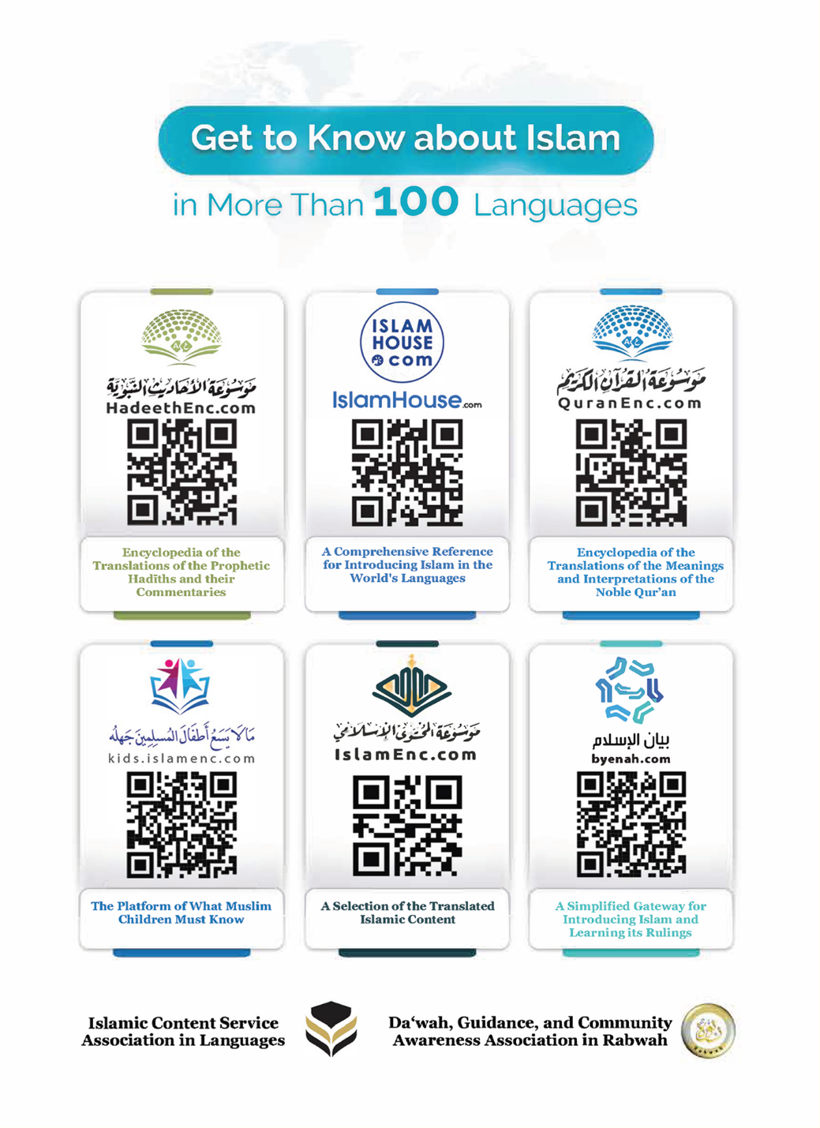
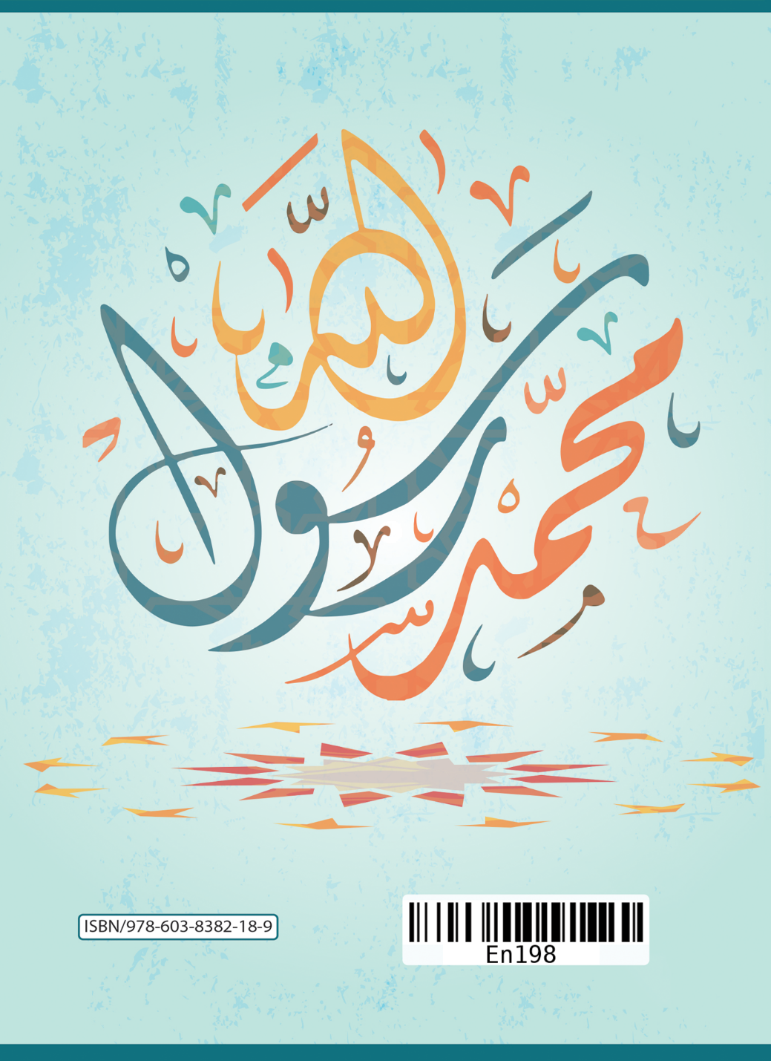

For purposes of translation, I carefully juxtaposed the word ‘Messenger’ with ‘Muhammad.’
Agreed upon on the authority of ‘Ā’ishah (may Allah be pleased with her). Sahīh al-Bukhāri (2) (1/7); Sahīh Muslim (152) (1/139).
Sahīh Muslim (901).
Sahīh al-Bukhāri (4461) (6/15).
For example, Allah Almighty says, {O people, a similitude is set forth, so listen to it: those whom you invoke besides Allah can never create even a fly, even if they all come together for that. And if a fly snatches something away from them, they cannot retrieve it. How feeble is the invoker as well as the invoked!} [Surat al-Hajj:73]

