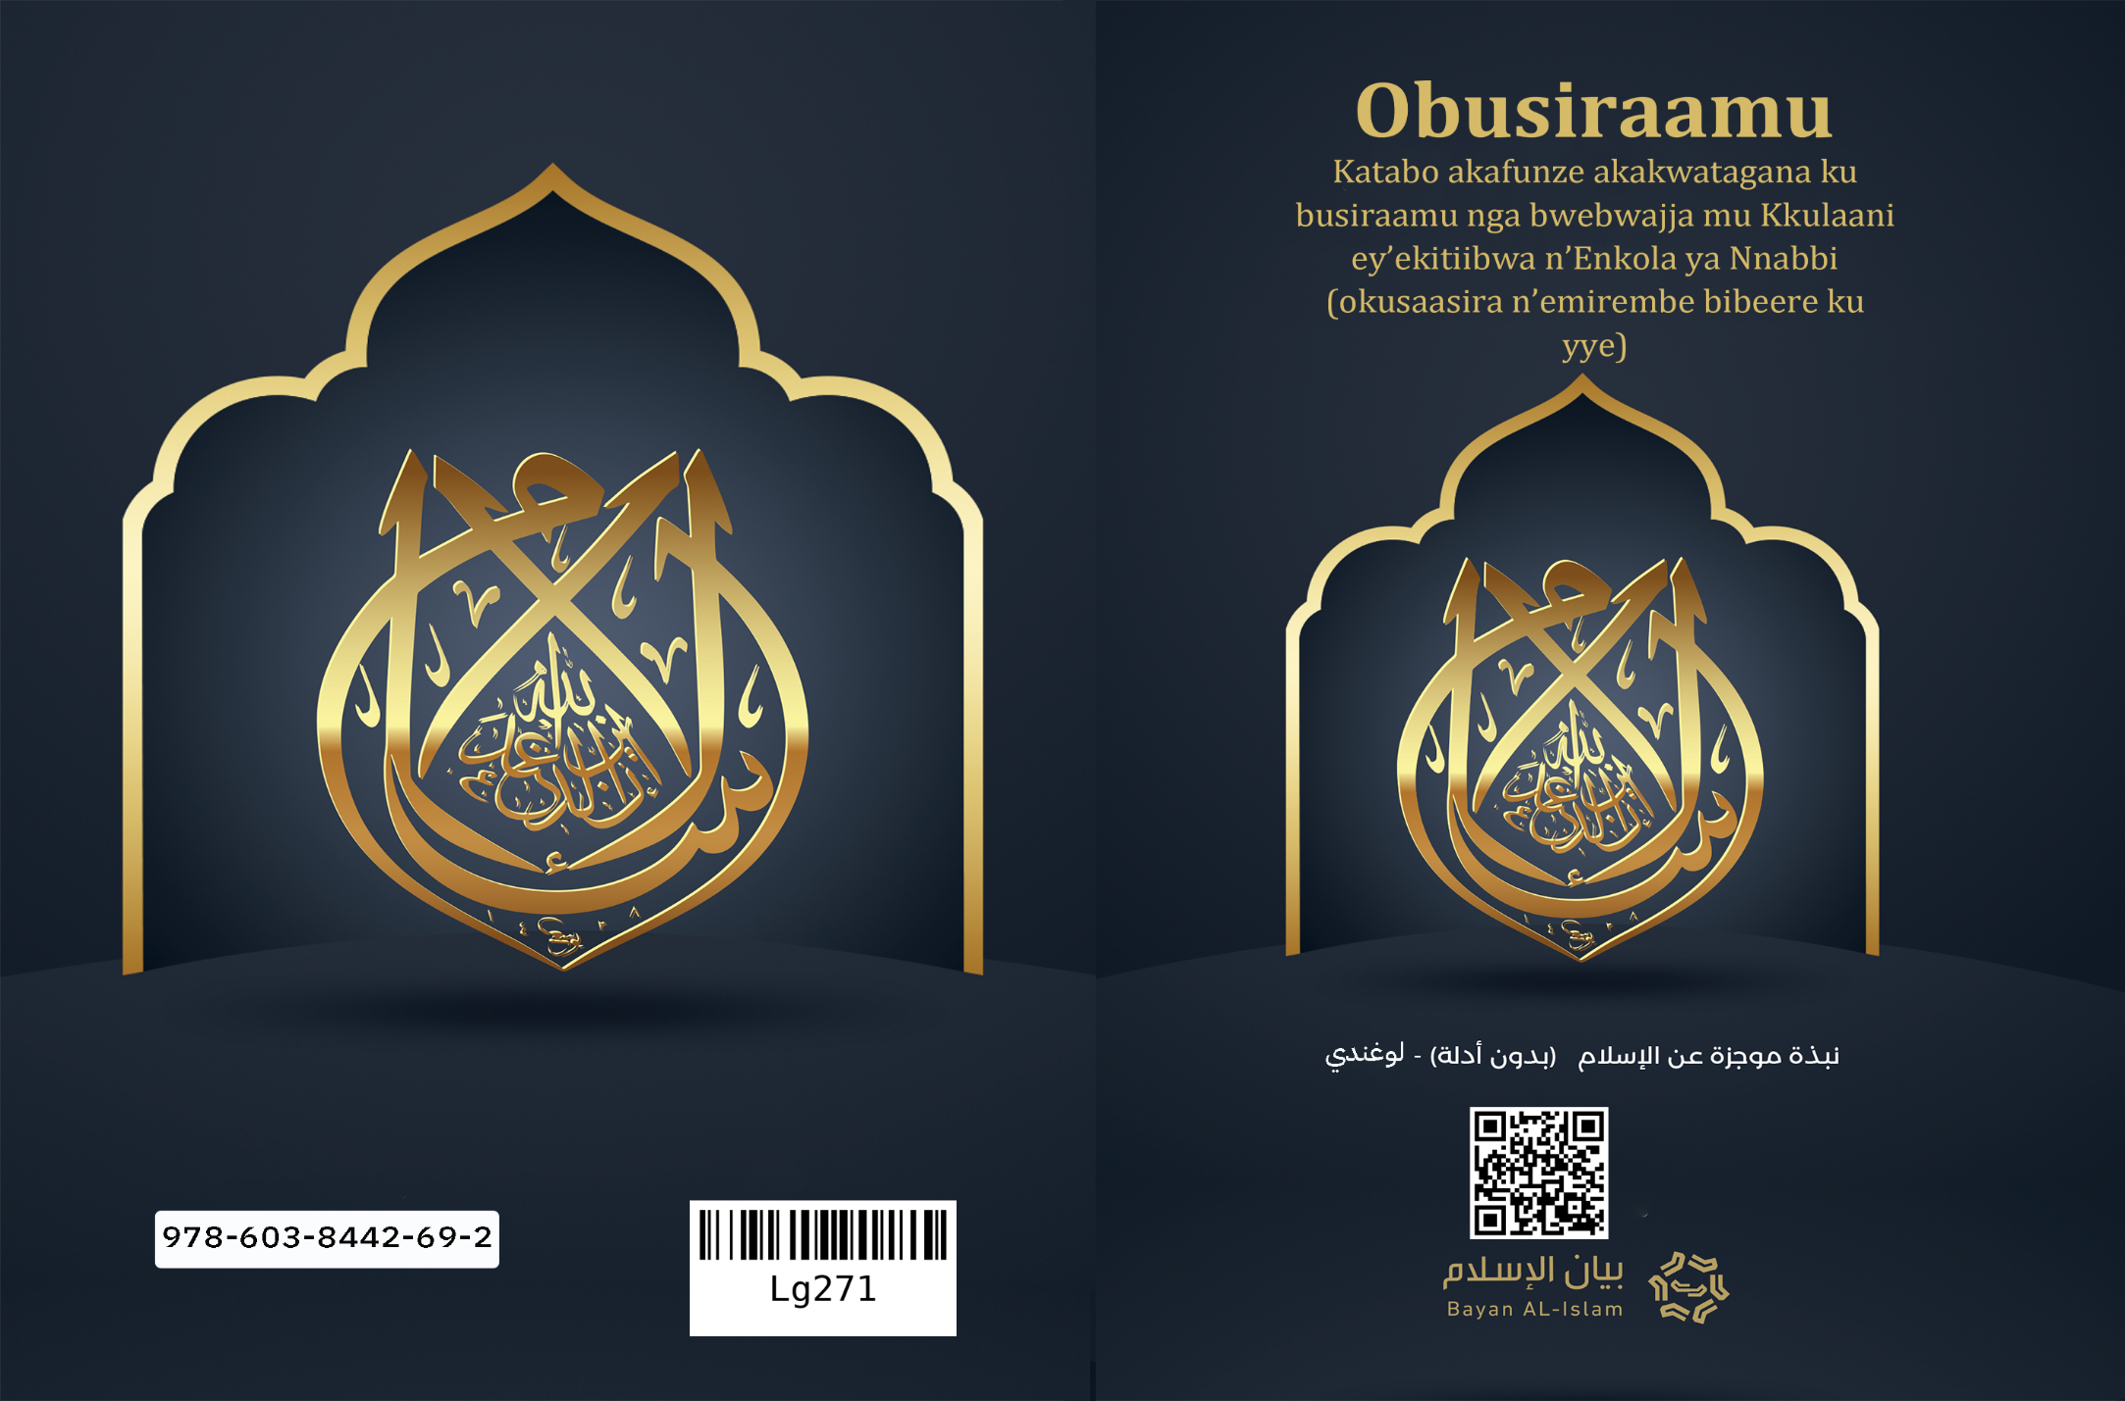
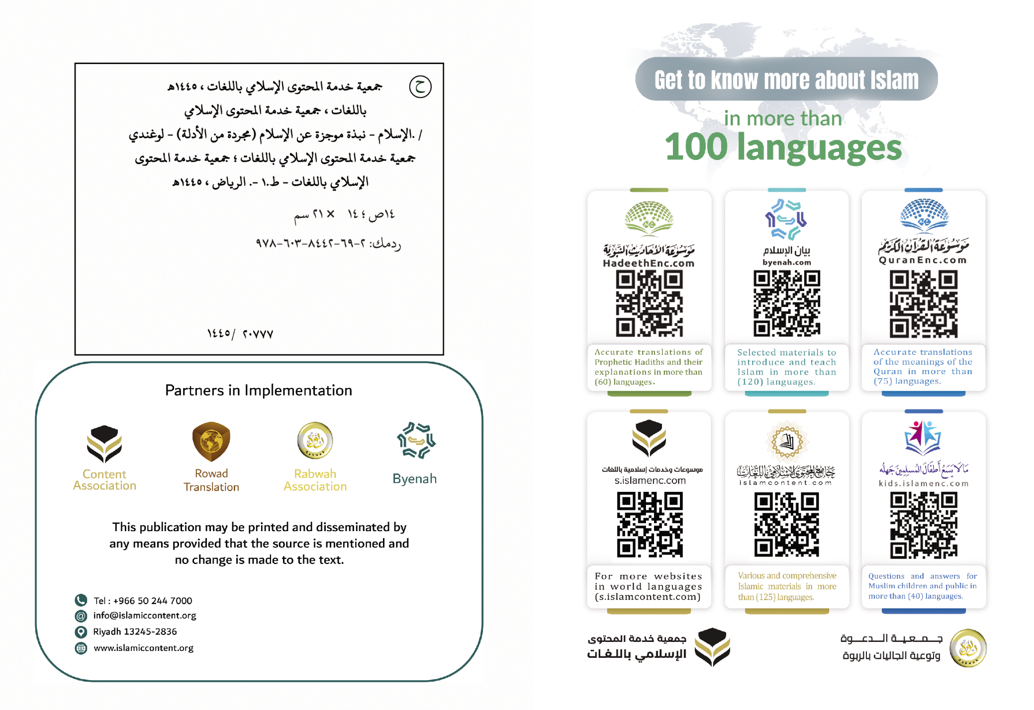

Obusiraamu

Katabo akafunze akakwatagana ku busiraamu nga bwebwajja mu Kkulaani ey’ekitiibwa n’Enkola ya Nnabbi (okusaasira n’emirembe bibeere ku yye)
(Kkopi nga temuli bujulizi)
Katabo kakulu kalimu okunnyonyola okufunze ku busiraamu, kalaga ebikolo byabwo ebikulu n’ensomesa zabwo n’ebirungi byabwo, nga bijjibwa mu nsibuko zabwo ez’ekikolo, era nga nazo ye Kkulaani ey’ekitiibwa n’Enkola ya Nnabbi, era akatabo kano k'abantu bonna abakulu mu basiraamu n’abatali basiraamu mu nnimi zaabwe mu kiseera kyonna era mu buli kifo kyonna mu buli ngeri n’embeera ez’enjawulo.

Kulw'erinnya lya Allah Omusaasizi ennyo ow'ekisa ekingi
1. Obusraamu bwebubaka bwa Allah eri abantu bonna, era bwebubaka bw'obwa-Katonda obw'olubeerera.
2. Era Obusiramu ssi ddiini eyeyawulidde ekikula oba akabinja, wabula yyo ddiini ya Allah ey’abantu bonna.
3. Obusiraamu bwebubaka obw'obwa-Katonda obwajja okujjuuliriza obubaka bwa bannabbi n’ababaka abaasooka okusaasira n’emirembe bibeere ku bbo, eri ebibinja by’abantu baabwe.
4. Ba nnabbi emirembe gibeere ku bbo, eddiini yaabwe eri emu wabula Ssemateeka waabwe wanjawulo.
5. Obusiraamu bukoowoola – nga ba nnabbi bonna bwebaakoowoola: Nuuhu ne Ibrahim ne Musa ne Sulayimani ne Dawuda ne Isa emirembe gibeere ku bbo-, eri okukkiriza nti omulezi ye Allah omutonzi, omugabirizi, awa obulamu, ajjako obulamu, nnyini bwakabaka, era yye y'atambuza ensonga, era yye y'owekisa omusaasizi.
6. Allah eyayawukana era owa waggulu yemutonzi era y’agwaana okusinzibwa yekka, era nga tasinzibwa nakirala kyonna.
7. Allah ye mutonzi wa buli kiriwo mu nsi mu byetulaba ne byetutalaba, era buli ekitali yye kitonde mu bitonde bye, era Allah yatonda amagulu n’ensi mu nnaku mukaaga.
8. Era Allah eyayawukana era owa waggulu talina kimwegattako mu bufuzi bwe oba okutonda kwe oba okutambuza kwe ensonga oba okusinzibwa kwe.
9. Era Allah eyayawukana teyazaala era teyazaalibwa era talina kimwenkana yadde ekimufaanana.
10. Era Allah eyayawukana era owa waggulu teyeeyolekera mu kintu kyonna, era tayambala mubiri gwa kintu kyonna mu bitonde bye.
11. Allah eyayawukana era owa waggulu wa kisa musaasizi eri abaddu be; y’ensonga lwaki yatuma ababaka n’assa n’ebitabo.
12. Allah ye mulezi omusaasizi, yye yekka yajja okubala ebitonde ku lunaku lw’enkomerero mukiseera w'anaabazuukiza bonna okuva mu ntaana zaabwe, era asasule buli muntu bye yakola mu birungi oba ebibi. Olwo yenna eyakola ebirungi era nga mukkiriza waakufuna ebyengera eby’olubeerera, na buli yenna eyawakanya n’akola ebibi waakufuna ebibonerezo ebyamaanyi ku nkomerero.
13. Allah eyayawukana era owa waggulu yatonda Adam okuva mu ttaka, era naayinjiwaza abaana be oluvannyuma lwe, nabwekityo abantu bonna mu nsibuko yaabwe benkana, era tewali kikula kikira ku kirala, yadde ekibinja ekikira ku kirala okujjako na kutya Allah.
14. Era buli muzaale(mwana) azaalibwa ali ku bubumbwa.
15. Era tewali muntu n'omu azaalibwa nga mwonoonyi oba nga asikidde ekyonoono ky’omulala.
16. Era ekigendererwa mu kutonda abantu kusinza Allah yekka.
17. Obusiraamu bwagulumiza omuntu –abasajja n’abakyala- ne bumukuumira byonna byalina okufuna, era ne bumufuula nga avunaanyizibwa ku kusalawo kwe, n’emirimu gye, n’ebikolwa bye. Era nebumutikka okuvunaanibwa ku mulimu gwonna ogukosa omwoyo gwe, oba ogukosa abalala.
18. Era ne bufuula omusajja n’omukyala nga beenkana mu bikwatagana n’obuvunaanyizibwa n’okusasulwa n’empeera.
19. Obusiraamu bwagulumiza omukyala, era ne butwala abakyala nti bali nga abasajja, era ne bukakasa ku musajja okumulabirira bwaba asobola, nabwekityo taata akakatibwako okulabirira muwala we, n’omwana omulenzi akakatibwako okulabirira maama we bwaba nga mukulu era nga alina obusobozi, era omwami akakatibwako okulabirira mukyala we.
20. Era okufa ssi kwekuggwawo okw'olubeerera, wabula kkwo kujjulukuka okuva mu nyumba y'okukola okudda mu nyumba y'okusasulwa, era okufa kutuuka ku mubiri n'omwoyo, era okufa kw'omwoyo kwekwawukana kwagwo ku mubiri, oluvannyuma [omwoyo] gudde mu mubiri oluvannyuma lw'okuzuukizibwa ku lunaku lw’enkomerero, era omwoyo tegugenda mu mubiri mulala oluvannyuma lw'okufa, era tegwambala mubiri mulala.
21. Obusiraamu bukoowoola okudda eri okukkiririza mu bikolo by’obukkiriza ebinene, era nga nabyo: kwe kukkiririza mu Allah ne malayika ze, n’okukkiririza mu bitabo byobwa-Katonda nga Tawraati ne Injil ne Zabbuur -nga tebinnakyusibwa- ne Kkulaani, n’okukkiririza mu ba nnabbi bonna n’ababaka, emirembe jibeere ku bbo, n'okukkiririza mu yasembayo era nga ye Muhammad omubaka wa Allah, nabbi era omubaka eyasembayo, n’okukkiririza mu lunaku lw’enkomerero, era tukimanyi nti obulamu bw’ensi ssinga ye yali enkomerero; obulamu n’obuwangaazi gwandibadde muzannyo gwennyini, era n’okukkiririza mu kusalawo n’okugera [kwa Allah].
22. Era ba nnabbi emirembe gibeere ku bbo, bakuumibwa mwebyo byebatuusa okuva eri Allah, era bakuumibwa okuva eri buli ekyawukana n’amagezi oba nga obutonde obulamu bukigaana. Era ba nnabbi bebavunaanyizibwa ku kutuusa ebiragiro bya Allah eri abaddu be, era ba nnabbi tebalina kintu kyonna mu byeyawulidde ku bulezi oba okusinzibwa; wabula bbo bantu nga abantu abalala, Allah abassaako obubaka bwe.
23. Era Obusiramu bukoowoola okudda eri okusinza Allah yekka n’ebikolo by’ensinza ebikulu, era nga nazo ze: Esswala, era nga nayo kwe ku yimirira n’okukutama n’okuvunnama n’okujjukira Allah n’okumusuuta n’okusaba, omuntu agisaala emirundi etaano buli lunaku, era muyyo ebyawula byonna bivaawo, kuba omugagga n’omwavu, n’omufuzi n’afugibwa baba mu lunyiriri lumu mu sswala. Ne Zzaka, era nga nayo kigero kitono okuva mu by’obugagga -okusinziira ku bukwakkulizo n’ebigero Allah byeyagera- , ekakata mu mmaali y’abagagga, eweebwa abaavu n’abalala, omulundi gumu mu mwaka. N’okusiiba, era nga nakwo: kweziyizaako bisiibulula emisana mu mwezi gwa lamanzaani, kuteeka mu mwoyo okwagala n’obugumiikiriza. N’okulamaga (Hijja): era nga nakwo: kwe kwolekera ennyumba ya Allah mu Makka ey’ekitiibwa omulundi gumu mu buwangaazi ku yenna asobola, era mu kulamaga kuno abantu bonna baba kyenkanyi mu kwolekeza obwenyi bwabwe eri Omutonzi eyayawukana, era ebyawula bivaawo n’ensibuko.
24. Era mu bikulu ebyawula ensinza mu busiramu, kwekuba nti engeri yaazo, n’ebiseera byazo, n’obukwakkulizo bwazo, Allah eyayawukana era owa waggulu y'eyabiteekawo, n’abissa eri omubaka we okusaasira n’emirembe bibeere ku yye, era abantu tebeenyigira mu nsinza ezo mu ngeri y’okwongeramu oba okukendeezaamu ppaka Olwaleero, era ensinza zino zonna enkulu ba nnabbi bonna emirembe gibeere ku bbo baakoowoola okudda gyeziri.
25. Omubaka w’obusiraamu ye Muhammad mutabani wa Abdallah okuva mu lunyiriri lwa Ismail mutabani wa Ibrahim emirembe gibeere ku bbo, yazaalibwa mu Makka omwaka 571, era yatumwa muyyo (makka), n’asenguka okudda e Madina, era teyeetaba na bantu be mu bintu bya busamize, naye yali yeetaba nabo mu mirimu egy’ekitiibwa, era yali wa mpisa nnungi nnyo nga tannaba kutumibwa, era abantu be baamuyita nga omwesigwa, era Allah yamutuma bweyaweza emyaka amakumi ana, era Allah n’amuwagira n’obubonero(Eby’amegero) obw’amaanyi, era nga n’akasinga obukulu ye Kkulaani ey'ekitiibwa, era kekabonero akasinga obubonero bwa bannabbi, era kekabonero ak’olubeerera mu bubonero bwa bannabbi okutuusa Olwaleero, era Allah bweyamujjuliza eddiini, n’omubaka okusaasira n’emirembe bibeere ku yye n’ajituusa mu bwennyini bw’okujituusa, yafa nga wa myaka nkaaga mw’esatu, era n’aziikibwa mu Madina okusaasira n’emirembe bibeere ku yye, era omubaka Muhammad okusaasira n’emirembe bibeere ku yye, ye ow'enkomerero mu ba nnabbi n’ababaka, Allah y'amutuma n’obuluŋŋamu n’eddiini eya mazima, aggye abantu mu bizikiza by’obusamize n'obuwakanyi [obukaafiiri] n’obutamanya, [abazze] eri ekitangaala ky’okwawula Allah n’obukkiriza, era Allah yamujulirako nti mazima yye yamutuma nga amuwadde olukusa okuba omukoowooze okudda gyali.
26. Era Ssemateeka w’obusiraamu omubaka Muhammad okusaasira n’emirembe bibeere ku yye gwe yajja naye yeyakomekkereza obubaka bw'obwa-Katonda ne zi Ssemateeka ez’obwa-Katonda, era ye Ssemateeka ow’obujjuvu, era mu yye mwe muli okulongooka kwe diini y’abantu n’ensi yaabwe, era eri ku ddaala erisooka mu kukuuma: eddiini z’abantu n’emisaayi gyabwe n’emmaali yaabwe n’amagezi gaabwe n’ezzadde lyabwe, era y’asangulawo zi Ssemateeka ezaasooka, nga era zi Ssemateeka ezasooka bwezajja zisangulaganawo.
27. Era Allah eyayawukana era owa waggulu takkiriza ddiini etali busiraamu obw'omubaka Muhammad okusaasira n’emirembe bibeere ku yye bwe yajja nabwo, era yenna anaayingira eddiini etali busiraamu tajja kufuna kukkirizibwa ku yyo.
28. Kkulaani ey’ekitiibwa ky'ekitabo Allah kyeyassa ku mubaka Muhammad okusaasira n'emirembe bibeere ku yye, era nga bigambo bya Mulezi w'ebitonde, Allah yasoomoza abantu n'amajinni okuleetayo ekikifaanana oba essuula efaanana emu ku ssuula zaakyo, era okusoomooza kukyaliwo okutuusa Olwaleero. Era Kkulaani ey'ekitiibwa eddamu ebibuuzo bingi ebikulu ebitawaanya obukadde n'obukadde bwa'abantu, era Kkulaani ey'ekitiibwa nkuume okutuusa olwaleero mu lulimi oluwalabu mweyakkira, era temwetoolangamu yadde ennukuta, era yakubibwa n'esasaanyizibwa, era kitabo ky'amaanyi eky'amagero ekisaanye okusomebwa oba okusoma okuvvunula kw'amakulu gaakyo, ng'era n'Enkola z'omubaka Muhammad okusaasira n'emirembe bibeere ku yye, n'ensomesa ze, n'ebyafaayo bye bwebiri ebikuume era binyumizibwa nga biyita mu lujegere lw'aboogezi abeesigika, era nabyo byakubibwa mu lulimi oluwalabu omubaka okusaasira n'emirembe bibeere ku yye lweyayogera nga, era byavvuunulwa mu nnimi nyinji. Era Kkulaani ey’ekitiibwa n’Enkola y'omubaka okusaasira n'emirembe bibeere ku yye, byombi y'ensibuko yokka ey'ennamula z'obusiraamu n'amateeka gaabwo. Nabwekityo Obusiraamu tebuggyibwa ku bikolwa bya bassekinnoomu ababulimu; wabula buggyibwa mu bubaka bwa Allah: Kkulaani ey'amaanyi n'Enkola ey'obwannabbi.
29. Era Obusiraamu bulagira okulongoosa eri abazadde, nebwebaba nga ssi basiraamu, n'okulaamira abaana.
30. Obusiraamu bulagira obwenkanya mu bigambo n'ebikolwa, yadde eri abalabe.
31. Era Obusiraamu bulagira okulongoosa eri ebitonde byonna, era bukoowoola okudda eri empisa ennungi n'emirimu emirungi.
32. Era Obusiraamu bulagira empisa ez'ettendo nga amazima, n'okutuukiriza obwesigwa, n'ensa, n' ensonyi, n'obuvumu, n'okuwa, n'okugaba, n'okuyamba omwetaavu, n'okudduukirira awankawanka, n'okuliisa omuyala, n'okulongoosa omuliraano, n'okuyunga eŋŋanda, n'obukwatampola eri ebisolo.
33. Obusiraamu bwakkiriza ebirungi mu byokulya n'ebyokunywa, era ne bulagira okulongosa omutima n'omubiri n'ewaka, era kyekyo lwaki bwakkiriza obufumbo, nga bwebwabulagira ba nnabbi emirembe gibeere ku bbo, era [kuba] bbo balagirwa buli kirungi.
34. Era Obusiraamu bwaziyiza ebikolo by'ebitakkiribwa nga okugatta ku Allah, n'obukaafiri, n'okusinza amasanamu, n'okwogera ku Allah awatali kumanya, n'okutta abaana, n'okutta omwoyo ogugulumizibwa, n'okwonoona mu nsi, n'eddogo, n'ebyobukaba ebyeyolefu n'ebyekwese n'obwenzi n'ebisiyaga, era nebuziyiza enfissi (riba), era nebuziyiza okulya ebifudde, n'ebyo ebisalirwa amasanamu n'ebibumbe, era nebuziyiza ennyama y'embizzi, na byonna ebikyafu n'ebyenyinyalwa, era nebuziyiza okulya emmaali ya baamulekwa, n'okukendeeza ebipimo n'emirengo, era nebuziyiza okukutula eŋŋanda. Era ba nnabbi bonna emirembe gibeere ku bbo, begattira kukuziyizibwa kw'ebyagaanibwa ebyo.
35. Obusiraamu buziyiza emize ejivumirirwa ng'obulimba, n'okubuzaabuza, n'obutali bwesimbu, n'obukumpanya, n'obulyake, n'ensaalwa, n'enkwe embi, n'obubbi, n'obulumbaganyi, n'obulyazaamanya, era buziyiza buli mpisa mbi.
36. Obusiraamu buziyiza enkolagana z'ebyensimbi ezirimu enfissi (riba) oba okukosa, oba obutali bulambulukufu, oba obulyazaamanya, oba okubuzaabuza, oba kyonna ekireeta ebizibu n'obulabe obubuna ebitundu n'abantu neba ssekinnoomu.
37. Obusiraamu bwajja n’okukuuma amagezi era n’okuziyiza kyonna ekigoonoona nga okunywa omwenge, era Obusiraamu bwagulumiza ensonga y’amagezi era ne bugafuula nga gegasinziirwako okuweebwa obuvunaanyizibwa, era ne bugawa eddembe okuva mu njegere z’obulimba n’obusamize. Era mu busiraamu temuli byama oba nnamula zeeyawulidde ddaala ly'abantu awatali ddala, era buli nnamula zaabwo n’amateeka gaabwo gakwatagana n’amagezi amatuufu, era gali mu buufu bwa bwenkanya na butegeevu.
38. Era eddiini enfu, abazigoberera bwebaba tebategedde kukontana kuzirimu n’ebintu amagezi gebitakkiriza, bannaddiini bawabya abagoberezi nti mazima eddiini eri waggulu wamagezi, era nti mazima amagezi tegalina ngeri gyegasobola kutegeera ddiini nakugifumiitirizaako. Sso nga bwo Obusiraamu bwatwala eddiini nga kitangala ekimulisiza amagezi ekkubo lyago; nabwekityo bannyini madiini amafu baagala omuntu alekewo amagezi ge abagoberere, ate Obusiraamu bwagala omuntu azuukuse amagezi ge; amanye obutuufu bw’ensonga nga bweziri.
39. Obusiraamu bugulumiza okumanya okutuufu, era bukubiriza okunoonyereza ku kumanya okutaliimu kwagala kwa mwoyo. Era bukoowoola okudda eri okutunula n’okufumiitiriza ku ffe ffenyini ne kubitwetolodde mu bitonde, era ebituufu ebiva mu kunoonyereza kw’okumanya tebikontana na busiraamu.
40. Era Allah takkiriza mulimu, yadde okuguweerako empeera ku nkomerero, okuggyako okuva mu muntu eyakkiriza Allah era n’amugondera era n’akakasa [obw’amazima bw’] ababaka be okusaasira n’emirembe bibeere ku bbo. Era Allah takkiriza nsinza okujjako ezo zeyalagira, kati butya omuntu bwawakanya Allah ate naasubira okumusasula ? Era Allah takkiriza kukkiririza kwa muntu yenna, okujjako nga akkiririzza mu ba nnabbi emirembe gibeere ku bbo bonna, era n’akkiriza obubaka bwa Muhammad okusaasira n’emirembe bibeere ku yye.
41. Mazima ekigendererwa ky’obubaka bwonna obw'obwa-Katonda kyekyokuba nti: eddiini entuufu esuumuusa omuntu abeere muddu omwesimbu eri Allah omulezi w’ebitonde, era bumuwe eddembe okuva mu buddu bw’omuntu oba ekintu oba obulimba, nabwekityo Obusiraamu – nga bwolaba- tebusuusuuta bantu nakubasitula kusukka ddaala lyabwe, era tebubafuula balezi, yadde Ebisinzibwa.
42. Allah yateekawo okwenenya mu busiraamu, era nga nakwo: kudda kwa muntu eri omulezi we n’okuva ku kyonoono, era okusiramuka kuggyawo ebyonoono ebiba byasooka, era okwenenya kuggyawo ebyonoono ebyakulembera, nabwekityo tewali bwetaavu bwa kweyabiza mu maaso ga muntu ku byonoono bya muntu byaba akoze.
43. Era nabwekityo mu busiraamu, enkolagana wakati w’omuntu ne Allah eba ya butereevu, era teweetaaga muntu yenna kubeera kayungirizi wakati wo ne Allah, era Obusiraamu buziyiza, ffe okufuula abantu abasinzibwa oba abagattibwa ku Allah mu bulezi bwe oba okusinzibwa kwe.
44. Ku nkomerero y’akatabo kano tujjukira nti mazima abantu mu kwawukana kw’emirembe gyabwe, n’amawanga gaabwe n’ensi zaabwe, ssinakindi buli kkuŋŋaaniro ly'abantu lyonna, lyawukana mu ndowooza zalyo n’ebigendererwa byalyo, lyanjawulo weriwaangalira n’emirimu gyalyo, nabwekityo lyetaavu nnyo eri omuluŋŋamya okulirambika, n’enteekateeka erikuŋŋaanya, n’omulamuzi alikuuma, era ababaka ab’ebitiibwa –okusaasira n’emirembe bibeere ku bbo- beebakola kw’ekyo nga bafunye obubaka okuva eri Allah -eyayawukana-, baluŋŋamya abantu eri ekkubo ly’obulungi n’obutegeevu, era nebabakuŋŋaanyiza ku Ssemateeka wa Allah, era nebalamula wakati waabwe n’amazima, era ensonga zaabwe nezitereera okusinziira ku nyanukula yabwe eri ababaka abo, n’okusinziira ku kusembera kw’omulembe gwabwe eri obubaka obw'obwa-Katonda, era Allah yafundikira obubaka bwonna n’obubaka bw’omubaka Muhammad okusaasira n’emirembe bibeere ku yye, era n’abuwandiikako okusigalawo, era n’abufuula nga buluŋŋamu eri abantu, era nga kisa, era nga kitangala, era nga kiragirira eri ekkubo erituusa gyali eyayawukana.
45. N’olwensonga eyo nkukoowoola owange gwe omuntu oyimirire oluyimirira olw’amazima ku lwa Allah, olutaliimu bugoberezi [obw’obuzibe] yadde ennono, era omanye nti oluvannyuma lw’okufa kwo oli wa kudda eri omulezi wo, era weetunulemu gwe kennyini ne mu mpuuyi z’ensi n'ebikwetolodde, nabwekityo siramuka weesiime ku nsi yo ne kunkomerero yo, era bwoba oyagadde okuyingira mu busiraamu, tewali kikwetaagisa okujjako ggwe okukakasa nti tewali kisinzibwa [mumazima] okujjako Allah, era mazima Muhammad mubaka wa Allah, era weesambe buli kyonna ekisinzibwa ekitali Allah, era okkirize nti Allah waakuzuukiza ebiri mu ntaana, era mazima okubalwa n’empeera by'amazima, era bwoba okakasizza okukakasa okwo obeera ofuuse omusiraamu. Ekikukakatako oluvannyuma lw’ekyo kubeera nga osinza Allah n’ebyo byeyalagira, nga okusaala n’okutoola ezzaka n’okusiiba n’okulamaga [ku kaaba e Makka] bwoba nga okifunyeko obusobozi.

kkopi ya nga: 19-11-1441 [ez'obusiraamu]
Kyawandiikibwa Prof. Dr. Muhammad bin Abdallah Assuhaim
Eyali Omusomesa w'Enzikiriza mu kitongole ky'emisomo gy'obusiraamu (gyebuvuddeko)
Essomesezo lya Tarbiya, SSettendekero wa king saud
Riyadh, Saudi Arabia

