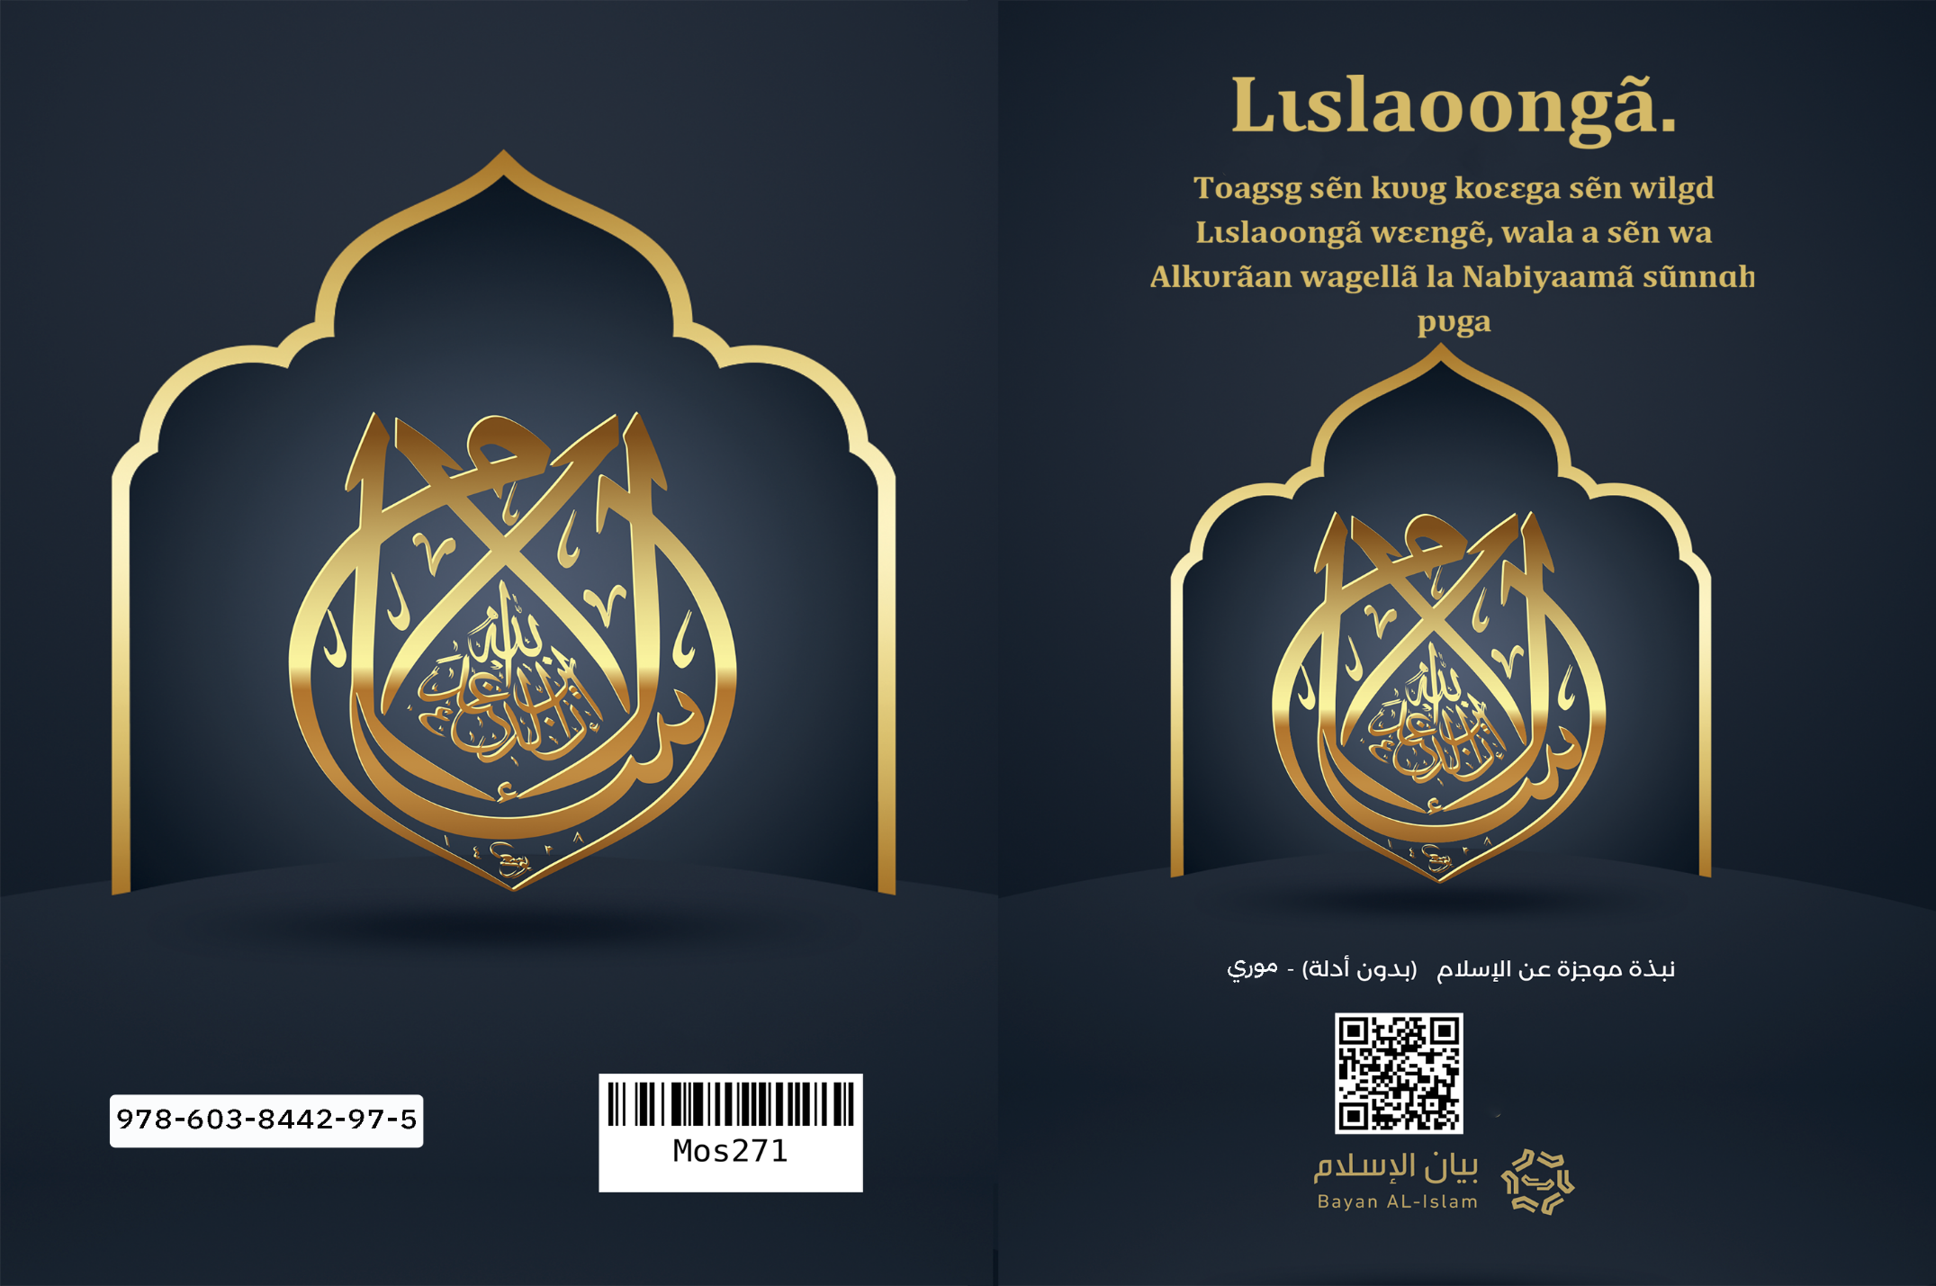
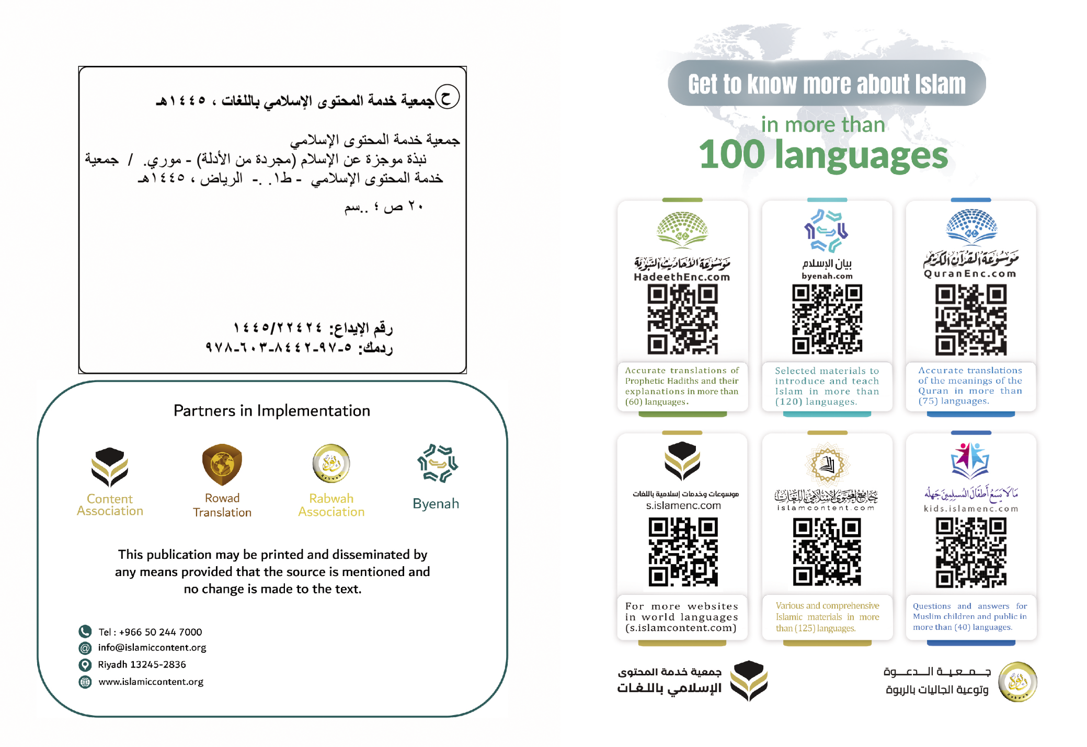

Lɩslaoongã.
Toagsg sẽn kʋʋg koεεga sẽn wilgd Lɩslaoongã wεεngẽ, wala a sẽn wa Alkʋrãan wagellã la Nabiyaamã sũnnɑh pʋga
(Wãnde yɑɑ yiisgu, (Kopɩ) b sẽn n yãk daliil-rãmbã n bɑse) [1]
Yaa gaf sẽn be sʋka, a gũbgɑ wĩnig-rãmbɑ sẽn kʋʋg kεoogɑ n wĩngd Lɩslɑoongã sẽn yɑɑ ɑ soɑba, n vẽnegd a yẽg nins sẽn tʋg n pak n yɩɩda, la a sɑglsã, lɑ ɑ sõmblemã, n yõnged n yit a tigsg nins sẽn yaa yẽgã, yẽndɑ me la Alkʋrãan wagellã la Nabiyaamã Sũnnah, la gafã a togendɑ Šari tʋʋma sẽn zao b rãmb fãa gilli (Bɑɑligsã) sẽn yaa b lɩslaamba la sẽn ka b lɩslaamba, ne bãmb buudã goam, b sẽn be zĩig ning fãa la zãmaan ning fãa, b yεlã lɑ b ɑlhɑɑlã sẽn tʋg n yõs taab fãa gilli.
Ne Wẽnd Yʋʋrã Albarka, sẽn yɑɑ Dũni yols zãng naabã, n leb yɑɑ Sɩd-kõatbã welg n yols naabã
1- Lɩslaoongã yaa Wẽnd tẽn-tʋmde n tʋg nebɑ fãa gill nengẽ, rẽnd yẽnda la Wẽnd tẽn-tʋmd ning sẽn duumdã.
2-La lɩslaoongã ka dĩin sẽn welge n kõ buud toore maa neb toor ye, ad a yaa Wẽnd dĩin n kõ nebɑ fãa gill kεp.
3- Lɩslaoongã la Wẽnd tẽn-tʋmd ningɑ sẽn wa n pids nabiyaam-rãmbã la tẽn-tʋʋmbã sẽn reng taoore tẽn-tʋmã, tɩ tʋg b nebẽ wã pʋʋsg la tɩlgr be b yĩnga.
4-Nabiyaam-rãmbã, -tɩlgr be b yĩnga- b dĩinã yaa a yembr tãa, la b tũudmã soya yõsa taaba.
5-Lɩslaoongã boondame n tʋgdẽ wala nabiyaam-rãmbã fãa sẽn boolã, a Nuuh la a ɭbraahɩɩm la a Muusa la a Sʋlaymaan
la a Daawʋʋd la a ɭɩsa -tɩlgr be b zugu- n tʋgd sɩd-kũuni (lɩɩmaoongo) tɩ ad Soabã, Yẽndã la Wẽnde, sẽn yaɑ Naandã, n yaɑ Rɩlgdã, sẽn vɩɩmsdɑ la A kʋʋdã, sẽn yaɑ Naamã Soaadã, Yẽndã me n rɑbsd yεlã, Yẽ me yaɑ nimbãan-Zoata, n yaa Yolsda.
6- Wẽnde, A Naam yɩlgame, Yẽnda la Naandã, Yẽ n sõmb ne tũudmã Yẽ a yembr tãa, la b ra tʋg n tũ n lagem-A zẽng sẽn ka Yẽ ye.
7- Wẽnd la Naanda bũmb ningɑ sẽn be dũni wã fãɑ pʋgẽ, tõnd sẽn ne la d sẽn pa ne wã, la zẽng sẽn ka Yẽ fãɑ yaa bõn-naandga sẽn be A bõn-naandsã pʋgẽ, lɑ Wẽnd nɑɑnɑ saasã la tẽngã rasem a yoob pʋgẽ.
8- La Wẽnde, A Naam yɩlgame n zẽke, A ka tar lagem-n-taaga A Naamẽ wã maa A naanegẽ wã ye, maa A rabsdgẽ wã maa A tũudmẽ wã.
9- La Wẽnde, A Naam yɩlgame, A ka roge, b ka rog-A, A ka tar mams-n-taaga, A ka tar bils-n-taaga.
10- La Wẽnde, A Naam yɩlgame n zẽke, A ka sigd bũmb pʋgẽ ye, A ka lebd bũmb me n rɩk ɑ yĩng ye, sẽn yɑɑ bũmb ning fãɑ sẽn be A bõn-nɑɑndsẽ wã:
11- Wẽnde, A Naam yɩlgame n zẽke, A yaa nimbãan-Zoεta n yaa Yolsda ne A yembsã, rẽ n kɩt t'A tʋm tẽn-tʋʋmbã, la A sik Gaf-rãmbã.
12- Wẽnd la Soabã sẽn yaa Yolsdã, Yẽnd A Yembr tãa n na n geel yembsã Dũni wã yikr raarã, wakat ning A sẽn na n yik-b fãa b yaadẽ wã, n rol ned fãa a sẽn tʋmã, sõma la wẽnga. Rẽnd ned ning sẽn tʋma tʋʋm sõmɑ t'ɑ yaa sɩd-kõta rẽnd yẽ soab tara neema sẽn duumdã, la ned ning sẽn kɩfla la a tʋm wẽnga, yẽ tara nɑng sẽn yaa bedre, yaoolem raarã.
13- Wẽnde, A Naam yɩlgame n zẽke, A naana a Adama ne tom, n maan ɑ koambã tɩ b fɩɩgdẽ rẽ loogr poorẽ, rẽnd nebã fãa gilli, b yẽgrã yaa yembre, yɩɩdlem ka be ne buudu, buud a to zug ye, ka be ne neb me, neb a taab zugu, sã n ka ne Wẽn-zoεεg bala.
14- La biig fãa rogda Fɩtrã wã (dĩinã) zugu.
15- La ned ka be ninsaalbã pʋgẽ n rogdẽ t'a yaa tudgda, maa a rɩk a to tudgr faad ye.
16- La nebã naanegã võor yaa: Wẽnd tũudum yĩngɑ Yẽ A Yembre:
17- Lɩslaoongã waooga ninsaala- b raopa la pagba- la a leb n kõ-a a hakε-rãmb gilli, la a maan-a tɩ b na n sok-a a sẽn tũus yεl ninsã fãa gilli, la a tʋʋmã fãa gilli, la a mɑnesmã fãɑ, lɑ ɑ rogend-a tʋʋm ning fãɑ sẽn namsd a mengã ne-ɑ, maa sẽn namsd neb a taabã.
18- La Lɩslaoongã maana raoa la pagɑ tɩ b yaa yembre, sã n yaa ne tʋʋmã wεεngẽ, la rolbã la yel-sõmdã wεεngẽ
19- Lɩslaoongã waooga paga, la a maan tɩ pagbã b yaa raopa boɑgɑ, la a rogl raoã t'a rɩlg-ɑ t'a sã n yaa tõoda, rẽnd bi-pugl rɩlgre yɑɑ tɩlɑe n zao a ba wã, tɩ ma wã rɩlgr zao a biigã t'a sã n yaa kãsma n tar tõogo, tɩ pag rɩlgr zao a sɩdã.
20- La kũumã ka yẽnda la sεεb ning sẽn duumdɑ ye, ɑyo, ad a yaa tedgre, n na n yi tʋʋm zakẽ n kẽng rolb zakẽ, la kũumã a rɩkda yĩngã la yõorã fãa, la yõorã kũum yaa a sẽn na wa welg n bas yĩngã, rẽ poorẽ t'ɑ lebg n wa ɑ yĩngẽ wã, b sẽn wat n yik nebã poore, dũni yikr raarã, lɑ yõorã pɑ toeemd kũumɑ poore n long yĩng ɑ to ye, ɑ leb n pɑ kẽed yĩng ɑ to ye.
21-Lɩslaoongã boondame n tʋg tɩ b kõ sɩda ne lɩɩmaoongã (kõ-sɩdã) yẽga sẽn yaa bεd-bεdã, bãmb me la kõ-sɩd ne Wẽnde, la malεgsã, la Wẽnd Gaf-rãmbã, wala Tawraatã, la Lingiilã, la Zabʋʋrã - taoor tɩ b na n ka toeem-ba - la Alkʋrãanã, la kõ sɩda ne Nabiyaam-rãmbã fãa la Tẽn-tʋʋmbã, tɩlgr be b yĩnga, la ɑ leb n kõ sɩda ne b Pidsdã, yẽ me lɑ a Mʋhammad sẽn yaa Wẽnd Tẽn-tʋʋmã, sẽn yaa Nabiyaam-rãmbã la tẽn-tʋʋmbã Pidsdã. La ɑ kõ sɩd ne Yaoolem raarã. La d bãng tɩ ad dũni vɩɩmã, sã n da yaa yẽ la tεka; mikdame tɩ vɩɩmã la belmã yaa bũmb sẽn yaa reem bala. La d leb n kõ sɩda ne Bʋʋdã la Pʋlengã.
22- La nabiyaam-rãmbã -tɩlgr be b yĩnga- b gũ-b lame n yi tudgri bũmb ning fãa b sẽn taasdã pʋgẽ tɩ yi Wẽnd nengẽ wã, b leb n gũ-b lame n yi tudgri sẽn kẽed ne bũmb fãa sẽn
yõsgd yam maa zʋg-sõngo, la nabiyaam-rãmbã, b rogl-b lame tɩ b taas Wẽnd saglsã A yembsẽ wã. La nabiyaam-rãmbã b ka tar baa fʋɩ sẽn yaa wala Rʋbʋʋbɩya ( Wẽndlem) maa Ʋlʋʋhɩya ( Sobendem). Ka woto ye, bãmb pʋs n yaa yĩng rãmb bala, n wõnd nebã fãa gilli, tɩ Wẽnd tʋmsd tɩ kẽngd b nengẽ A tẽn-tʋmã.
23-La lɩslaoongã boondame n tʋgd Wẽnd tũudum, A Yembre, ne tũud-rãmbɑ yẽg sẽn yaa b bεdã, bãmb me: la Pʋʋsgã, sẽn yaa yasgo, la surbu (Rukuu), la suguudu la Wẽnd Yʋʋr tẽegre, la A pẽgbo la kosgo, ninsaal pʋʋsd-a-la raar fãa noor a nu, tɩ yɩɩd-taabã fãa sε a pʋgẽ, rẽnd rakãagre la talga la naaba la sẽn ka naaba, fãa bee rulg a yembr zugu Pʋʋsgã pʋgẽ. La Zaka, yẽ me yaa sõor sẽn yaa bilfu sẽn yi arzεkẽ wã, n zems ne sart-rãmba, la sõor ningã Wẽnd sẽn yãke, tɩ yaa tɩlae n be
rakãagbã arzεgsẽ, tɩ b yiisd n kõt talse la zẽng sẽn ka bãmbɑ. Yaa vugr tãa yʋʋm pʋgẽ. La No-loeerã, yẽ me la yõk-m-menga n yi bõn-kaoodɩ Ramadaanã kiuug wĩntoogã pʋgẽ, tɩ yaa bũmb sẽn wubd yõorã ne raabo la sugri. La Hagiimdã, yẽ me la Wẽnd Roogã toglgo, sẽn be Mak tẽn-wagellã pʋgẽ, vugri yõorã woglem pʋgẽ, tɩ rog sẽn yaa tõogda, n tõe n kẽnge, la hagiimdã pʋgẽ, nebã fãa zemsda taaba togle n tʋg Naandã nengẽ wã -A Naam yɩlgame- tɩ yɩɩdlemã sẽn welgd nebɑ ne tɑɑbɑ la yẽgã fãa menemda beenẽ n lebg bũmb a yembre.
24-La bũmb sẽn yaa zɩsg n yɩɩd sẽn kõt tũud-rãmbã yɩɩldlem lɩslaoongã pʋgẽ t'ɑ yɩɩd ɑ tɑɑbã, yaa t'a yalẽ wã, la a wakat-rãmbã, la ɑ sart-rãmbã, yɑɑ Wẽnd n maan-ba -A Naam yɩlgame n zẽke- la A sẽn taas A Tẽn-tʋʋmã -
Wẽnd pʋʋsg la A tɩlgr be a yĩnga- tɩ ninsaalbã ka kẽes b toaag a pʋgẽ, zem tɩ yaa paasgo maa boogre, n wa tãag rũnda, la tũud-kãensã fãa gill sẽn yaa bεd-bεda, tẽn-tʋʋmbã fãa boolame n tʋg-a, tɩlgr be b yĩnga.
25-Lɩslaoongã Tẽn-tʋʋmã, yẽ la a Mʋhammad sẽn yaa a Abdʋllaah biiga, n yi a Ismaa'ʿɩɩl sẽn yaa a ɭbraahɩɩm biigã pendẽ, pʋʋsg la tɩlgr be b yĩnga, a roga Maka, yʋʋm 571, nabi ɭɩsa rogmã poorẽ, b tʋms-a lame t'a be Maka, t'a yik rẽ poorẽ n kẽng Madiina, la a ka lagem a nebã rʋbsã tũub yelẽ ye, la a rag n yɩɩme n lagemd-ba tʋʋm sõmbs a taaba sẽn yaa waglã pʋgẽ, a rag n yɩɩme n be zʋgd sẽn yaa zɩsd pʋgẽ, taoor tɩ b na n ka tʋms-a ye. La a nebã rag n yɩɩme n da boond-a t'a amiin (bas-m-yam soaba). Wẽnd tʋms-a lame a sẽn wa n ta yʋʋm pis-naase (40). La Wẽnd kenga
a boollã ne tagmas-rãmba (yεl soalem-rãmba) sẽn yaa zɩsdo, la b sẽn tʋg n yɩɩda yaa Alkʋrãan wagellã, yẽ me la nabiyaam-rãmba tagmas-rãmb zɩslem sẽn tʋg n yɩɩda, yẽ me la tagmas ning sẽn pa, nabiyaam-rãmbã tagmas-rãmbẽ wã, n na n tʋg n tãag rũnda. La Wẽnd sẽn wa n tʋg n pids dĩinã n kõ-a wã, tɩ Nɑbiyɑɑmã tɑɑs-ɑ tɑɑsg tεkã, ɑ mɑɑnɑ kɑɑlem t'ɑ yʋʋmɑ yɑɑ pis-yoob lɑ ɑ tãɑbo, lɑ b mum-ɑ-lɑ Mɑdiin sẽn yɑɑ Nɑbiyɑɑmã tẽngã, lɑ Tẽn-tʋʋmɑ ɑ Mʋhɑmmɑd pʋʋsg lɑ tɩlgr be ɑ yĩngɑ yẽ lɑ nɑbiyɑɑm-dãmbɑ lɑ tẽn-tʋʋmbã Pidsdɑ, Wẽnd tʋms-ɑ lɑ ne kãndgre lɑ sɩd dĩinã bʋl yĩng t'ɑ yiis nebã rʋbsã lɑ kɩflmã lɑ zɩɩlmã ligsã, n tʋg Wẽnd-yembgã lɑ sɩd-kũunɑ vẽenem, lɑ Wẽnd mɑɑnɑ kɑset tɩ ɑd A tʋms-ɑ lɑme t'ɑ yɑɑ boondɑ n tʋg A nengẽ ne Yẽ tõogo.
26-La lɩslaoongã Šari wã Tẽn-tʋʋm a Mʋhammad -Wẽnd pʋʋsg la A tɩlgr be a yĩnga- sẽn wɑ ne-ɑ wã, yaa yẽnd n pidsd Wẽnd tẽn-tʋmã lɑ A Šari-rãmba, yẽ me lɑ Šari sẽn pidi, nebã dĩinɑ la b dũni wã me manegr be a pʋgẽ, yẽ me gũusda: nebã b dĩin-rãmba la b zɩ-rãmba la b arzεgsã la b yamã la b koambã, yẽ me n yẽes Šari fãa sẽn reng taoore, wala Šari-rãmb nins me sẽn da reng taoorã sẽn yẽes taabã.
27- La Wẽnde, A Naam yɩlgame n zẽke, a ka reegd dĩin sã n ka lɩslaoongã dĩin ye, ning Tẽn-tʋʋmɑ a Mʋhammad -Wẽnd pʋʋsg la A tɩlgr be a yĩnga- sẽn wa ne wã. La ned ning sẽn wa n tʋg n kẽ zẽng sẽn ka lɩslaoongã, A ka na n tol n reeg a yĩng ye.
28- Alkʋrãan wagellã, yẽnda la gaf ning Wẽnd sẽn tʋms-a n tʋg Tẽn-tʋʋmã ɑ
Mʋhɑmmɑd nengẽ wã pʋʋsg lɑ tɩlgr be ɑ yĩngɑ, yẽnda me yaa bon-naands Naaba goama, Wẽnd geesa ninsaalbã la zĩn-dãmba tɩ b wa ne a buudu, maa Sʋʋra sẽn wõnd a sʋʋrɑ-rãmbɑ buud bala, la geesgã ka bak n ket n be n tãag rũnda, la b ka tõog n wa ne-a ye. La Alkʋrãan wagellã, a leogsda sogsg wʋsgo, sẽn yirb neb tus-kẽems wʋsgo. La Alkʋrãan wagellã, yẽnda yaa Wẽnd sẽn gũ n yi toeeng buudu, n tʋg n wa tãag rũnda, ne Laarabiimd ningã a sẽn sig ne wã. Baa gom-bil a yembr ka boog beenẽ ye, yaa bũmb me sẽn wẽ n yiisi t'ɑ sãeege, yaa gaf sẽn yaa bedre n ka tar to, tɩ sõmb tɩ b karem-a, mɑɑ b kɑrem ɑ maanɑ wã sẽn lebg ne buud ɑ tɑɑbɑ goamã, wala Tẽn-tʋʋmã a Mʋhammade -Wẽnd pʋʋsg la A tɩlgr be a yĩnga- Sunnɑ me, la a sẽn wilg yεl ninsã la a vɩɩmã yellã, yẽ me yaa bũmb b
sẽn gũusi n tall-a n tɑɑs sẽn tũ ne Rʋwaat (toagsdb) n yaa b sẽn maan-b rãmb bas-m-yam, halɩ tɩ wa tʋg n ta tõndo, yẽ me yaa bũmb b sẽn wẽ n yiis ne Laarabiimd ning Tẽn-tʋʋmã -Wẽnd pʋʋsg la A tɩlgr be ɑ yĩngɑ- sẽn goam ɑ soɑbã, yaa bũmb b sẽn lebg ne buud goam wʋsgo. La Alkʋrãan wagellã ne Tẽn-tʋʋmã Sunnã -Wẽnd pʋʋsg la A tɩlgr be a yĩnga- yaa bãmbã b yiibã la yẽgr a yembr tãa b sẽn yãkd lɩslaoongã Bʋʋdã la a Šari-rãmbã b pʋgẽ, rẽnd lɩslaoongã, b ka reegd-ɑ neb nins sẽn yet tɩ b yaa lɩslaambã manesmã pʋgẽ ye; la ad b reegd-ɑ lɑme n yi Wẽnd wahɩẽ wã: Alkʋrãan wagellẽ wã la Nabiyaamã Sunnẽ wã.
29- La lɩslaoongã sagenda ne manegre n tʋg roagdb a yiibã, baa tɩ b sã n yɩɩme n ka moeemba, a leb n sagendame tɩ b rɩk na-kẽng sõngo ne koambã.
30- Lɩslaoongã sagenda ne tẽeg-tɩrga goam la tʋʋm pʋgẽ, hal n tʋg n tãag ne bεεbã.
31-La lɩslaoongã sagenda ne manegre n tʋg bõn-naandsã gilli, n leb n boondẽ n tʋgd zʋg wagla la tʋʋm sõmbse
32-La lɩslaamdã sagenda ne zʋg sõmbse, wala sɩda la bas-m-yam la boabl lebsgo la yõk-m-menga la yãn-zoεεga la raoodo la kũuni la kõ-yalengo, la tʋlsem-rãmbã sõngre la pakr sẽn pak-b rãmb fãagre, la kom soab rɩlgre, la yak-n-taar manegre, lɑ rogem tõkre, la maan bʋg-bʋg ne rũmsã.
33-Lɩslaoongã kõo sor tɩ b rɩ rɩ-yɩlmã fãa, sẽn yaa rɩɩbo la bõn-yũudɩ, la a sagle tɩ b yɩlg sũyã la yĩnga, la zaka, rẽ n kɩte t'a kõ sor ne fur loεεga, wala nabiyaam-rãmbã me sẽn sagl ne rẽnda, tɩlgr be b yĩnga, bala b sagenda ne bũmb fãa sẽn yaa yɩlenga
34- La lɩslaoongã gɩdga haraam-dãmbɑ yẽgã, wɑla lagem-n-taar ne Wẽnde, la kɩfẽndo, la rʋbsã tũubu, la yeel Wẽnd zugu tɩ ka tũ ne bãngr ye, la koam kʋʋbo, la kʋ yõor ninga Šari wã sẽn ka kõ sore tɩ b kʋ, la sãoong tẽngã pʋga, la tɩɩm sɑoobo, la yel-beedo sẽn vẽneg la sẽn solge, la yoobo, la raop kẽed-n-taar ne taaba, lɑ ɑ gɩdg Rɩbɑ'a, la ɑ gɩdg gɩf wãbre, la bũmb ning b sẽn kodge rʋbsã yĩnga, la a gɩdg kukur nemd wãbre, la rẽgd-rãmbã fãa gilli, la a gɩdg kɩɩb arzεk rɩɩbo, la boogre vugbẽ wã la magbẽ wã, la a gɩdg rogem wãagre. Lɑ Nabiyaam-rãmbã fãa gill zemsa taaba ne haraam-kãensã gɩdgre.
35- Lɩslaoongã gɩdgda zʋg-wẽnse, wala zĩri-beedo la zãmbo, la pʋ-lika la belgre la sũ-kiiri la rab-wẽnse la wagdem la maan-n-zʋʋkɑ la wẽgdo, la a gɩdgda zʋg-wẽng buudã fãa gilli.
36- Lɩslaoongã gɩdgda ligda tʋm-n-taar ning rɩbaag sẽn be a pʋgẽ, maa namsgo, maa belgre, maa wẽgdo, maa zãmbo, maa a yɩta sabab n wa ne sãanga la namsgo n gũbgd ne zãmã wã la nebã yembr-yembre.
37-Lɩslaoongã waame n gũus yamã, la a gɩdg bũmb fãa sẽn sãamd-ɑ wala rãam yũubu, la Lɩslɑoongã zẽkɑ yamã yelle, n maan tɩ yaa yẽnda la tʋʋmã roglg zĩiga, n yidg-a n yi rog-m-mikã la kɩfẽndã bãense, la ka be lɩslaamdã pʋga, sẽn yɑɑ yel-soaandɩ maa yaa bʋʋdo n welg ne neb ɑ tɑɑbɑ tɩ pɑ tũ ne ɑ tɑɑbɑ, ad a Bʋʋd-rãmbã fãa la a Šari-rãmbã fãa yaa sẽn zems ne yam sõmbsã, yẽ me yɑɑ bũmb sẽn zems ne tẽeg tɩrgã la yam-bedrã.
38- La dĩin yoodã, b pʋgdbã sã n ka bãng bũmb ning sẽn be a pʋgẽ sẽn kɩɩsd taabã, la yεl nins sẽn ka kẽed yamã: la dĩinã taoor-
rãmb sẽn liibd pʋgdbã n yetẽ: tɩ ad dĩinã a yɩɩda yam tagsgo, lɑ yam ka tar zĩigɑ dĩinã fasẽng pʋgẽ ye. La sã n yɑɑ lɩslaoongã, a rɩka dĩinã tɩ yaa vẽenem n wõond yamã t'a rɩkd a sorã, rẽnd dĩin yoodã rãmba, b ratame tɩ ninsaal bas a yamã la a pʋg bãmba, la lɩslaoongã, a ratame tɩ ninsaal nek a yamã sẽn na yɩl n bãng yεlã meng hakɩɩkã wala b sẽn sɩd yaa to-to wã.
39- Lɩslaoongã zɩsgda bãng sõngo, la a leb n pirsd bãngr pẽesgo, pẽesg ning sẽn lak n yi yõor yɑmleoogã, la a boondẽ n tʋgd tags-n-gesga la tagsgo tõnd mengã pʋgẽ, la bõn-naandsã sẽn be tõnd kɩrengã, la bãng sõng ning sẽn zemsd ne lɩslaoongã.
40- La ad Wẽnd ka reegd tʋʋmde, A leb n ka kõt yel-sõmd a pʋgẽ yaoolem raarã sã n ka mikame tɩ yaa ned sẽn kõ sɩd ne Wẽnde la a
tũ-A la a kõ sɩd ne A tẽn-tʋʋmbã -pʋʋsg la tɩlgr be b yĩnga- A leb n ka reegd tũud-rãmbã sã n ka bũmb ninga A sẽn tuk n kõ-ba ye. Rẽnd na n yɩɩ wãn-wãnɑ tɩ ninsaala kɩfl ne Wẽnde la a tẽed t'A na n kõ-a la keoore? La Wẽnd ka reegd ned baa a yembr sɩd-kũuni sã n ka mikame t'a kõo sɩd ne nabiyaam-rãmbã fãa gill ye, -pʋʋsg la tɩlgr be b yĩnga- la a kõ sɩd ne a Mʋhammad tẽn-tʋmdã, Wẽnd pʋʋsg la A tɩlgr be a yĩnga.
41-Ad Wẽnd tẽn-tʋmã fãa gilli, b raabã yaa: tɩ dĩin sɩdã zẽk ninsaala t'a yɩ yamba sẽn welg toore ne Wẽnd A Yembre sẽn yaa bõn-naands Naabã, la b yidg-a n yi ninsaalbɑ yembdo, maa arzεka maa rog-n-mik yembdo, rẽnd lɩslaoongã yaa wala fo sẽn ne wã, a ka yɩlgd neb n zẽk-ba n yɩɩg b zĩigẽ wã ye, a ka maand-ba tɩ b yaa wẽnd-rãmbɑ la soab-rãmb ye.
42-Wẽnd tuka tuubgã sore lɩslaoongã pʋgẽ, yẽnda me la ninsaal sẽn na n lebs a menga a Soabã nengẽ la a bas zunuuba maanego, la lɩslaoongã a wurda bũmb ning sẽn renga taoorã fãa sẽn yaa zunuub-rãmba, la tuubgã sũkda bũmb sẽn rag n reng a taoorã, sẽn yaa zunuub-rãmbã, rẽnd ninsaal ka tar tʋlsem n na n reeg a zugẽ ne yẽ tʋʋm tuutɩ wã ninsaalb taoor ye.
43- Rẽnd yaa lɩslaoongã pʋga la tõk-n-taarã yɩtɑ ninsaal ne a Soabã sʋka tɩrga, tɩ ka tar tʋlsem tɩ ned baa a yembr zĩnd yẽ ne a Soabã sʋk ye, rẽnd lɩslaoongã gɩdgdame tɩ b wa tʋg n rɩk nisaalba tɩ b yaa soab-rãmba, maa b yaa lagem-n-taase ne Wẽnde, A naanegã pʋgẽ maa A Soabendã maa A wẽndlemã pʋgẽ.
44- Seb-kãngã baasgẽ wã, d tẽegdame tɩ ad nebã b zãmaan-rãmbã sẽn yõs-taabɑ la b
tẽmsã yõs-taabã la b buud-rãmbã halɩ n tʋg n tãag ninsaalbã mensã fãa gilli, b yɑɑ sẽn yõs taaba, b tagsã wεεngẽ, la b tʋlsemã, n leb n yõs taaba b zĩ-zĩidsẽ wã la b tʋʋmẽ wã. Rẽnd sã n yaa woto, a tara tʋlsem wʋsgo, n tʋgd pεεgda sẽn na n togl bãmba, la na-kẽndre sẽn na n tigim bãmba, la bʋʋda sẽn na n gũ-ba, lɑ tẽn-tʋʋmbã sẽn yaa waglã -pʋʋsg la tɩlgr be b yĩngɑ- bãmb n yãs ne yel-kãngɑ, tɩ yaa tẽn-tʋmd sẽn yi Naab A Wẽnd nengẽ - A Naam yɩlgame- n peegd nebã n tʋgd sõma sore la kãndagre, la b tigimd-ba Wẽnd Šari wã zugu, la b bʋʋd b sʋka ne sɩda, tɩ b yεlã yaa sẽn tẽegd tɩrga wɑlɑ bãmb me sak-n-tũ tẽn-tʋʋmbã tεka, la b wakatã me pẽnegr ne Wẽnd tẽn-tʋmɑ, lɑ Wẽnd pidsɑ Tẽn-tʋmã ne Tẽn-tʋʋmɑ ɑ Mʋhɑmmɑd -Wẽnd pʋʋsg lɑ A tɩlgr be ɑ yĩngɑ- Tẽn-tʋmdã, lɑ A bʋ t'ɑ kelle n pɑ,
lɑ A mɑɑn-ɑ t'ɑ yɑɑ kãndagre ne nebã, lɑ yolsgo, lɑ vẽenem, lɑ peegre n tʋg sor ning sẽn tɑɑsd Wẽnd nengẽ wã, A Nɑɑm yɩlgame.
45- Rẽ yĩng n kɩte, tɩ mɑm boond foom a ninsaala, tɩ f yik n yals ne Wẽnde, yalsg sɩd-sɩda, n foog f meng n bas togs-n-taare la rog-m-miki, la f bãng tɩ ad fo kũumã poorẽ, f na n leba f Soabã nengẽ, la f ges fo mengẽ wã la ween-n-vɩɩgã sẽn be fo kɩremsã, bɩ f sak n tũ, tɩ ad f paamda zu-noogo f dũni wã pʋgẽ la f Laahrã pʋgẽ, la fo sã n tʋll n rat n na n kẽ lɩslaoongã ad ka be ne foom sã n pɑ f (maan kaseto tɩ soab sẽn na tũ n tɩlg ka be, rẽnda Wẽnde, la a Mʋhammad me yaa Wẽnd Tẽn-tʋʋma) la f zãag f menga n yi bũmb fãa b sẽn tũudi zẽng tɩ ka Wẽnde, la f kõ sɩda tɩ ad Wẽnde A na n yika neb nins sẽn be yaadẽ wã, la f bãnge, tɩ ad Geelgã la Rolbã yaa bũmb sẽn
yaa sɩda, rẽnd fo sã n maan kaset-kãngã, fo lebga lɩslaama, rẽnd bee ne foo rẽ poorẽ tɩ f tũ Wẽnd ne A sẽn mɑɑn Šari ningã, sẽn yaa Pʋʋsgo, la Zak yãkre, la no-loeere, la hagiimdu tɩ f sã n paam sor n na n tʋg beenẽ.

*****

Yãwã yaa sebrã buk sẽn yiisi, wɑkɑt: 19-11-1441
Yaa karen-saam bedrã a doktoor Mʋhammad ɭbn Abdʋllaah Assʋhaim n gʋls-a
Yɑɑ loεεgã (Wẽnd yembgã) bãngr karen-saamb (kʋdre) lɩslaoongɑ karengã buk zĩigẽ.
Wʋbrã Karen-doogẽ, (Fakilte) naab a Sʋ'ʿʋʋd karen-do zakã (Inɩversɩte).
Rɩyaade, Arabɩ Saoodɩt tẽngẽ wã
