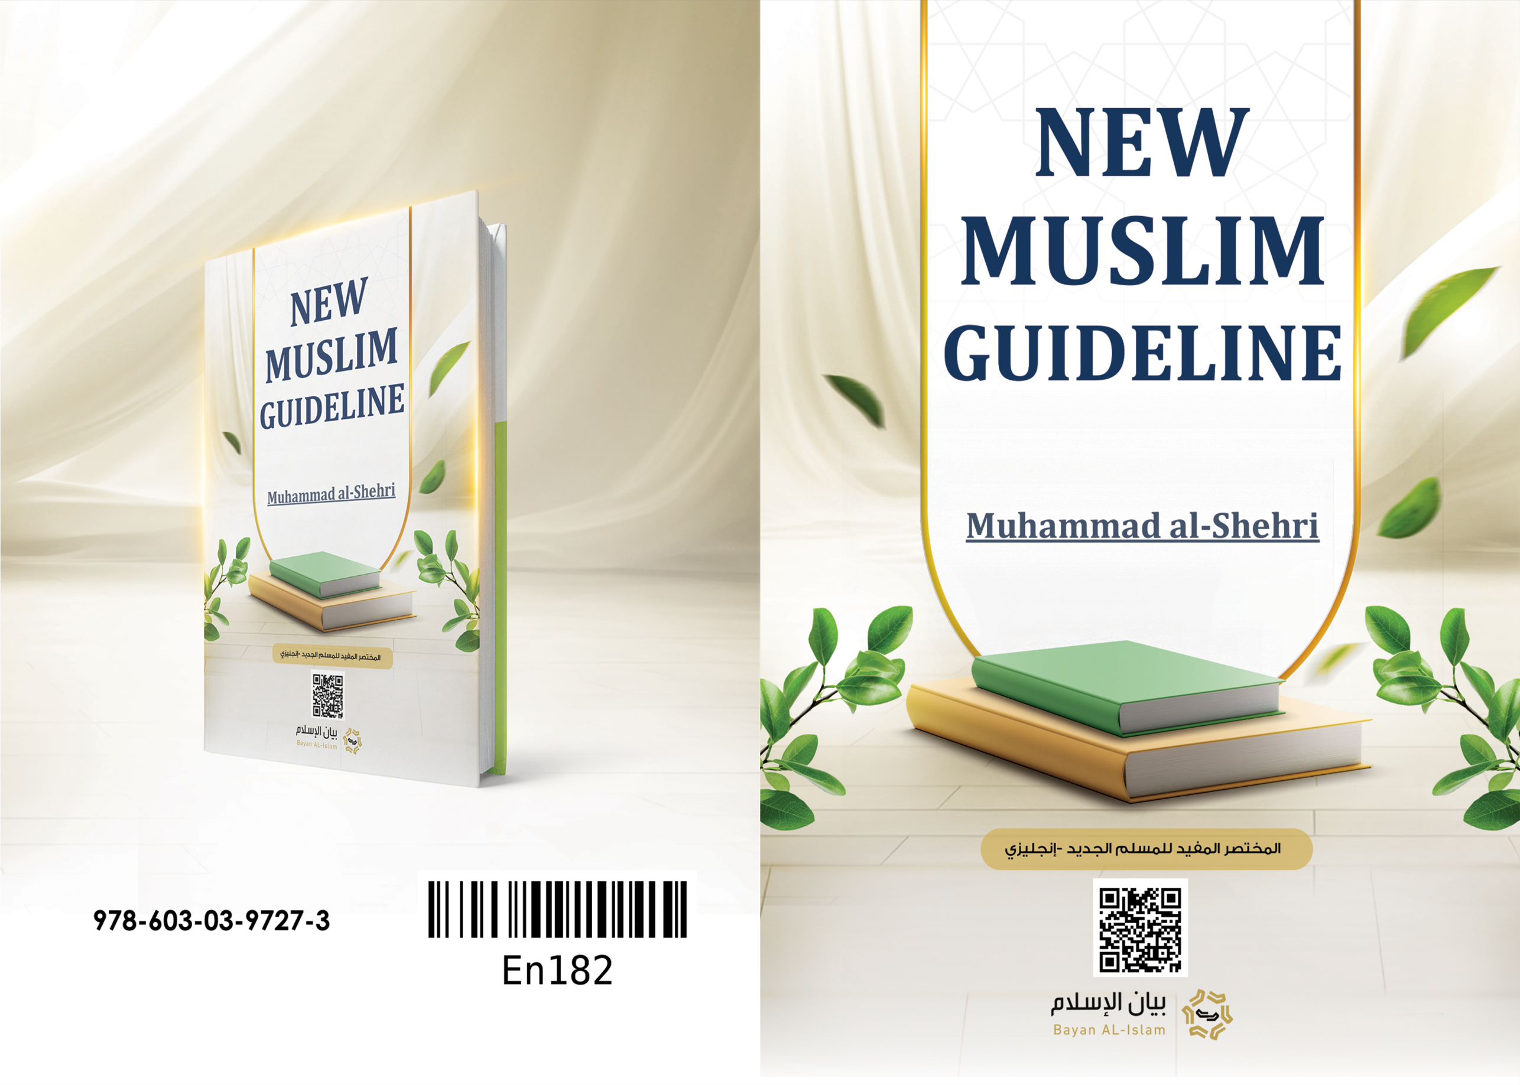
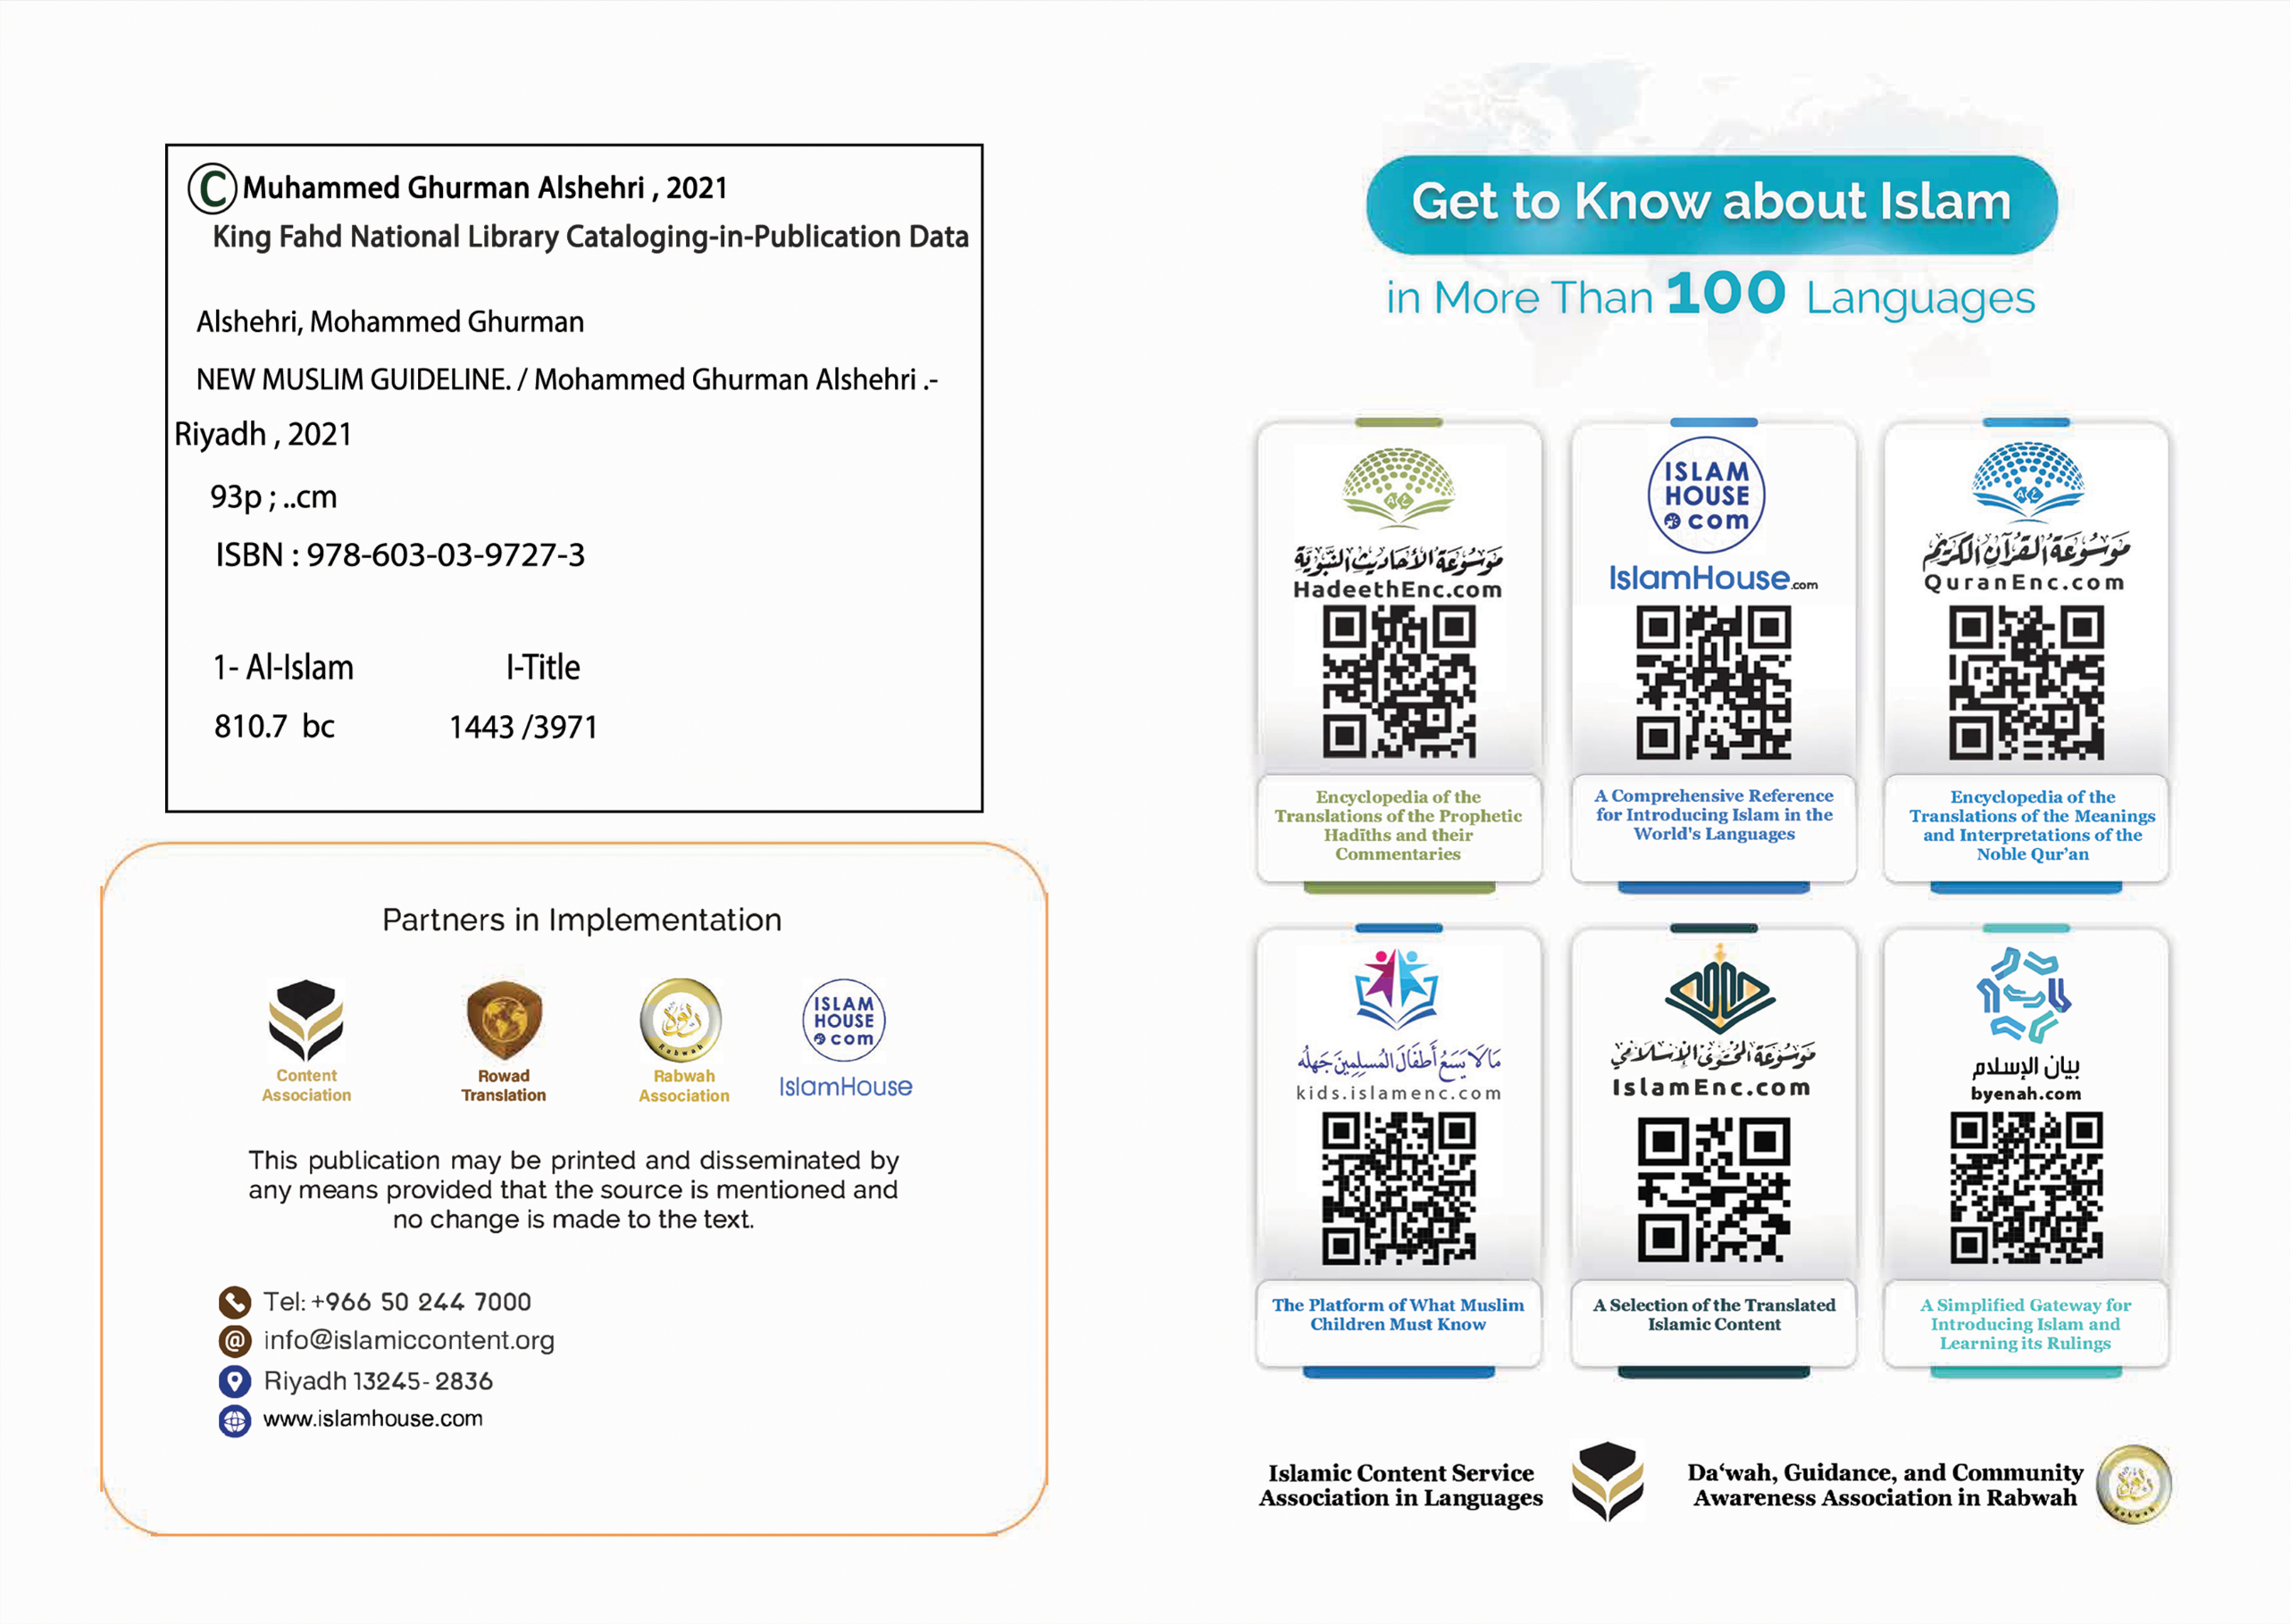

NEW MUSLIM GUIDELINE

By
Muhammad al-Shehri
1441 H / 2020 AD
In the name of Allah, the Most Compassionate, the Most Merciful

Introduction
Praise be to Allah Whom we praise and ask for help and forgiveness. We seek refuge in Allah from the evils of ourselves and our bad deeds. He whom Allah guides no one can lead him astray, and he whom Allah leads astray no one can guide. I bear witness that there is none worthy of worship except Allah, and I bear witness that Muhammad is His slave and messenger.
To proceed,
Allah, the Exalted, has honored the children of Adam and favored them over most of His creation, as He says: {And We have certainly honored the children of Adam} [Ch. 17, Verse 70] He honored this Ummah (the Muslim Community) even more by sending them the best of His Prophets, Muhammad (pbuh), and revealing to them the best of His Books, the Holy Qur’an. Allah, (SWT) says: {You are the best nation produced for mankind. You enjoin what is right and forbid what is wrong and believe in Allah. If only the People of the Book had believed, it would have been better for them. Among them are believers, but most of them are defiantly disobedient.} [Ch. 3, Verse 110] It is Allah’s great favor upon a person to guide him to Islam and to remain firm upon it, and act upon its rulings and laws. Through this book, which is small in size yet rich in content, the new Muslim learns the fundamentals of Islam in a brief manner that clarifies to him the features of this great religion. Once he understands them and acts upon them, he would proceed to seek more knowledge about his God (SWT), his Prophet Muhammad (pbuh), and his religion, Islam, so that he worships Allah based upon knowledge and insight. His heart would thus be reassured, and his faith would increase by drawing close to Allah through worship and through following the Sunnah of His Prophet Muhammad (pbuh).
I ask Allah to bless every word in this book, benefit Islam and Muslims with it, make it sincere for His sake alone, and bestow its reward upon all Muslims, the living thereof and the deceased.
May Allah’s peace and blessings be upon our Prophet Muhammad, his household, and Companions.
Muhammad ibn al-Shībah al-Shahri
2 Dhul-Qi’dah, 1441 H.

My Lord is Allah:
Allah also says: {O mankind, worship your Lord, who created you and those before you, so that you may become righteous} [Ch. 2, Verse 21]
Allah also says: {He is Allah, other than whom there is no deity} [Ch. 59, Verse 22]
Allah also says: {There is nothing like unto Him, and He is the All-Hearing, the All-Seeing.} [Ch. 42, Verse 11]
• Allah is my Lord and the Lord of all things, the Master, the Creator, the Provider, the Disposer of everything.
• He alone is worthy of being worshiped. There is no lord or god but Him.
• To Him belong the excellent names and sublime attributes He has affirmed for Himself or the Prophet (pbuh) affirmed for Him. They are at the peak of perfection and excellence. There is none like unto Him, and He is the All-Hearing, the All-Seeing.
Some of His Names are:
Ar-Razzāq: The Provider, Ar-Rahmān: The Most Merciful, Al-Qadeer: The All-Powerful, Al-Malik: The King, As-Samee’: The All-Hearing, As-Salām: The Most Perfect, Al-Baseer: The All-Seeing, Al-Wakeel: The Trustee, The Disposer of Affairs, Al-‘Azeez: The All-Mighty, Al-Lateef: The All-Subtle, Al-Kāfi: The Sufficient, Al-Ghafoor: The Forgiving.
Ar-Razzāq: The Provider Who provides His creation with the sustenance necessary for their souls and bodies.
Ar-Rahmān: The Most Merciful Whose mercy encompasses everything.
Al-Qadeer: The All-Powerful Who experiences neither inability nor languish.
Al-Malik: The King and Sovereign Who is described with all the attributes of greatness and dominance, and Who owns and directs everything.
As-Samee’: The All-Hearing Who hears every heard thing, the secret thereof and the revealed.
As-Salām: The Perfect Who is free of every deficiency and defect.
Al-Baseer: The All-Seeing Whose sight encompasses everything, regardless of how minute it is. He has thorough knowledge of everything, the visible and the hidden thereof.
Al-Wakeel: The Trustee Who guarantees provision to His creation and manages their affairs in their best interests; the Ally of the believers, facilitating matters for them and protecting them.
Al-Khāliq: The Creator Who creates things and brings them into existence in an unprecedented way.
Al-Lateef: The Subtle and Kind Who honors His servants, shows mercy to them, and responds to their supplications.
Al-Kāfi: The Sufficient Who provides His servants with all their needs, and with Whose assistance there is no need for any help or anyone other than Him.
Al-Ghafoor: The All-Forgiving Who protects His servants from the evil of their sins and spares them the punishment.
The Muslim ponders the wonderful creation of Allah Almighty and the ease He has put on earth. A sign of this is the keenness of all creatures to take care of their young and feed them until they grow up and be self-reliant. Glory be to the One Who creates them and shows them kindness, an aspect of which is providing them with what supports them and fulfills their needs while they are in their weakest state.

My Prophet is Muhammad (pbuh):
Allah also says: {There has certainly come to you a Messenger from among yourselves. Grievous to him is what you suffer; [he is] concerned over you and is kind and merciful towards the believers.} [Ch. 9, Verse 128]
Allah also says: {And We have not sent you, [O Muhammad], except as a mercy to the worlds.} [Ch. 21, Verse 107]
Muhammad (pbuh), the gifted mercy
He is Muhammad ibn Abdullah, the final Prophet and Messenger. Allah, the Exalted, sent him with the religion of Islam to all mankind, to guide them to all that is good, and the greatest of good is Tawhid (monotheism; belief in the Oneness of Allah), and to warn them against all that is evil, and the worst of evil is Shirk (polytheism; associating partners with Allah).
It is an obligation to obey his orders, believe what he said, avoid what he forbade or warned against, and worship Allah only in the manner that he prescribed.
His message and the message of all the prophets before him was to call for the worship of Allah alone without a partner.
Some of his traits (pbuh):
Honesty, mercy, forbearance, patience, bravery, generosity, good manners, fairness, modesty, and forgiveness.

The Noble Qur’an is the Word of my Lord
Allah also says: {O mankind, there has come to you conclusive evidence from your Lord, and We have sent down to you a clear light.} [Ch. 4, Verse 174]
The noble Qur’an is the word of Allah Almighty which He revealed to His Prophet Muhammad (pbuh) to bring people out of depths of darkness into the light and guide them to the straight path.
Reciting it brings a great reward and acting upon its guidance leads to the right path.

I get to know the pillars of Islam:
The Prophet (pbuh) said: “Islam is built on five (pillars): the testimony that there is no god except Allah and that Muhammad is the Messenger of Allah, establishing prayer, giving Zakat, fasting the month of Ramadan, and pilgrimage to the (Sacred) House.”
The pillars of Islam are the outward acts of worship that every Muslim must observe and believe in their obligation, otherwise, his belief is not valid, as Islam is built on them, and that is why they are called the pillars of Islam.
These pillars are as follows:
First Pillar: Shahādah (To bear witness that there is no god except Allah and that Muhammad is the Messenger of Allah).
Allah also says:
فَٱعۡلَمۡ أَنَّهُۥ لَآ إِلَٰهَ إِلَّا ٱللَّهُ... [محمد: 19]
{So, know [O Muhammad], that there is no deity except Allah} [Ch. 47, Verse 19]
He also says: {There has certainly come to you a Messenger from among yourselves. Grievous to him is what you suffer; [he is] concerned over you and is kind and merciful towards the believers.} [Ch. 9, Verse 128]
The Shahādah that “There is no god except Allah” means that there is no deity worthy of worship but Allah.
The Shahādah that “Muhammad is the Messenger of Allah” means that it is obligatory to obey his orders, believe what he related, avoid what he forbade and warned against, and worship Allah only in the manner he instructed.

Second Pillar: Establishing Prayer (Salāh)
Allah also says: {And establish prayer} [Ch. 2, Verse 110]
Establishing prayer means performing prayer in the way prescribed by Allah and taught to us by His Messenger Muhammad (pbuh).

Third Pillar: Almsgiving (Zakat).
Allah also says:
﴿ .... وَءَاتُواْ ٱلزَّكَوٰةَۚ...﴾ [البقرة: 110]
{… and give Zakah …} [Ch. 2, Verse 110]
Allah (SWT) made the Zakah obligatory to test the Muslim’s faith, a way to express gratitude to his Lord for the wealth He has given him, and a means to help the poor and needy.
The obligation of Zakah is fulfilled by giving it to the categories of people who are eligible to receive it.
Giving Zakah is obligatory if the money reaches a certain amount. Its eligible recipients are eight categories of people that are mentioned in the Noble Qur’an, including the poor and needy.
Giving Zakah is an act of mercy and compassion; it purifies the Muslim’s character and wealth, consoles the poor and needy, and strengthens the bonds of love and brotherhood in the Muslim community. Therefore, a good Muslim gives out Zakah wholeheartedly given the happiness he brings to other people by it.
The amount of Zakah is 2.5% of the saved wealth, whether it is gold, silver, cash money, or trade goods allocated for buying and selling for profit. Zakah is given only when the value of the saved wealth reaches the threshold amount and one full lunar year passed while it is in the person’s possession.
Zakah is also obligatory on a certain amount of livestock such as camels, sheep, and goats, if these animals graze naturally most of the year without their owner providing them with fodder.
Zakah is also obligatory on what the land produces of grains, fruits, minerals, and treasure if the certain amount is reached.

Fourth Pillar: Fasting the month of Ramadan
Allah also says:
﴿يَٰٓأَيُّهَا ٱلَّذِينَ ءَامَنُواْ كُتِبَ عَلَيۡكُمُ ٱلصِّيَامُ كَمَا كُتِبَ عَلَى ٱلَّذِينَ مِن قَبۡلِكُمۡ لَعَلَّكُمۡ تَتَّقُونَ﴾ [البقرة: 183]
{O you who believe, fasting is prescribed upon you as it was prescribed upon those who were before you, so that you may become righteous.} [Ch. 2, Verse 183]
Ramadan is the ninth month of the Hijri calendar. Muslims venerate and hold it in a special status, distinct from all the other months. Fasting this whole month is one of the five pillars of Islam.
Fasting Ramadan means worshiping Allah by abstaining from eating, drinking, and sexual intercourse from dawn to sunset during all days of the blessed month of Ramadan.

Fifth Pillar: Pilgrimage to the Sacred House of Allah (Hajj)
Allah also says:
﴿. ..وَلِلَّهِ عَلَى ٱلنَّاسِ حِجُّ ٱلۡبَيۡتِ مَنِ ٱسۡتَطَاعَ إِلَيۡهِ سَبِيلٗاۚ ...﴾ [آل عمران: 97]
{Pilgrimage to the House is a duty owed to Allah upon all people who are able to make their way to it} [Ch. 3, Verse 97]
Hajj is due upon those who are able to make their way to it, once in a lifetime. Hajj is to head to the Sacred House and the Sacred Precincts in Makkah to perform certain acts of worship in a specific time frame. The Prophet (pbuh) performed Hajj, and so did the prophets before him. Allah Almighty commanded Ibrāhīm (Abraham, peace be upon him) to proclaim Hajj to people, as revealed in the verse that says:
﴿ وَأَذِّن فِي ٱلنَّاسِ بِٱلۡحَجِّ يَأۡتُوكَ رِجَالٗا وَعَلَىٰ كُلِّ ضَامِرٖ يَأۡتِينَ مِن كُلِّ فَجٍّ عَمِيق﴾ [الحج: 27]
{And proclaim the pilgrimage to all people; they will come to you on foot and on every lean camel from every distant pathway.} [Ch. 22, Verse 27]

I get to know the pillars of faith:
The Prophet (pbuh) was asked about imān (faith) so he replied: “To believe in Allah and His angels, His books, His messengers, and the Last Day, and to believe in destiny, along with its pleasant and unpleasant aspects.”
The pillars of imān are acts of worship done by the heart and due upon every Muslim. The Islam of anyone can only be valid if he has these beliefs. Hence, they are called the pillars of imān. The difference between the pillars of imān and those of Islam is that the pillars of Islam are outward acts to be done by a person’s body parts, like uttering the testimony of faith, performing prayer, and paying Zakah, whereas the pillars of faith are acts done by the heart, such as the belief in Allah and His books and messengers.
The concept and meaning of imān: It is the heart’s firm belief in Allah and His angels, His books, His messengers, the Last Day, and destiny; its pleasant and unpleasant aspects thereof, and following and applying all what the Prophet (pbuh) brought, whether verbally, like saying “there is no god but Allah”, reciting the Qur’an and Dhikr, and praising Allah Almighty;
or as outward physical acts, like prayer, Hajj, and fasting, as well as inward acts within the heart, such as love for Allah, fear of Him, reliance upon Him, and sincerity to Him.
Experts define it briefly as: belief by the heart, speech by the tongue, and actions by the body parts, and it increases by good deeds and decreases by sins.

First Pillar: Belief in Allah
Allah Almighty says: {The true believers are those who believe in Allah} [Ch. 24, Verse 62]
The belief in Allah requires the belief in His Oneness of Lordship, His Oneness of Worship, and the uniqueness of His Names and Attributes. This includes the following:
• The belief in the existence of Allah (SWT)
• The belief that Allah is the only Lord, and that He is the Owner, Creator, and Sustainer of everything, Who manages the affairs of everything.
• The belief that Allah is the only God, and that He alone deserves to be worshiped. Acts of worship must be dedicated to Him alone without any partners, such as prayer, supplication, making vows, sacrificial animals, imploring for help and protection, and all other acts of worship.
• The belief in His Names and Attributes that He affirmed for Himself or that His Prophet Muhammad (pbuh) affirmed for Him, and negating what He negated about Himself of Names and Attributes or what His Prophet negated about Him. This includes the belief that His Names and Attributes are the most superior in terms of perfection and beauty, and that {there is nothing like unto Him and He is the All-Hearing and the All-Seeing}.

Second Pillar: Belief in the Angels
Allah Almighty says: {All praise be to Allah, the Originator of the heavens and earth, Who made the angels messengers with two, three, or four wings. He increases in creation whatever He wills. Indeed, Allah is Most Capable of all things.} [Ch. 35, Verse 1]
We believe that the angels are part of the unseen realm and that they are servants of Allah that He created from light and made them obedient and submissive to Him.
They are a great creation whose numbers and abilities are known to Allah alone. Each of them has names, traits, and duties that Allah assigned to them. One of them is Jibreel (Archangel Gabriel) who is assigned with delivering the revelation from Allah, the Exalted, to His messengers.

Third Pillar: Belief in Divine Scriptures (Books)
Allah Almighty says: {Say [O believers], “We believe in Allah and what has been sent down to us; and what was sent down to Abraham, Ishmael, Isaac, Jacob, and the descendants [of Jacob]; and what was given to Moses and Jesus; and what was given to the prophets from their Lord. We make no distinction between any of them, and to Him we have submitted.”} [Ch. 2, Verse 136]
It is the firm belief that all the divine Scriptures are the word of Allah, that they were revealed from Allah to His messengers bearing the clear truth, and that Allah Almighty, by sending His Prophet Muhammad (pbuh) to all mankind, has abrogated with this law all the previous laws and legislations and rendered the Qur’an dominant over all the previous scriptures, superseding them. Allah Almighty has pledged to preserve the noble Qur’an against any alteration or distortion, saying: {Indeed, it is We who sent down the Qur’an and it is We Who will be its guardian.} [Ch. 15, Verse 9] This is because the Qur’an is the last revelation to mankind, Muhammad (pbuh) is the last messenger, and Islam is the religion that Allah has approved for mankind until the coming of the Hour. Allah says: {Indeed, the religion in the sight of Allah is Islam} [Ch. 3, Verse 19]
The Divine Scriptures that Allah mentioned in the Qur’an are:
The Noble Qur’an: which Allah revealed to His Prophet Muhammad (pbuh).
The Torah: which Allah revealed to His Prophet Moses (pbuh).
The Gospel: which Allah revealed to His Prophet Jesus (pbuh).
The Psalms: which Allah revealed to His Prophet David (pbuh).
The Scrolls of Abraham: which Allah revealed to His Prophet Abraham (pbuh).

Fourth Pillar: Belief in the Messengers
Allah Almighty says: {Indeed, We sent to every community a messenger, [saying], “Worship Allah and shun false gods.”} [Ch. 16, Verse 36]
It is the firm belief that Allah Almighty sent a messenger to every nation calling them to worship Allah, alone with no partner, and to disbelieve in anything worshiped apart from Him.
It is the belief that all of them were humans, men, and servants of Allah, they were truthful, trustworthy, and honest, and came with guidance for people, that Allah supported them with miracles proving their truthfulness, that they conveyed all the message entrusted to them, and that they were all upon the truth and clear guidance.
The call of all of them was the same with regard to the core of the religion, which is to worship Allah Almighty alone and not associate anything with Him.

Fifth Pillar: Belief in the Day of Judgment.
Allah also says:
﴿ٱللَّهُ لَآ إِلَٰهَ إِلَّا هُوَۚ لَيَجۡمَعَنَّكُمۡ إِلَىٰ يَوۡمِ ٱلۡقِيَٰمَةِ لَا رَيۡبَ فِيهِۗ وَمَنۡ أَصۡدَقُ مِنَ ٱللَّهِ حَدِيثٗا﴾ [النساء: 87]
{Allah - there is no deity except Him. He will surely gather you all for [account on] the Day of Resurrection, about which there is no doubt. Who is more truthful than Allah in speech?} [Ch. 4, Verse 87]
It is the firm belief in all that is associated with the Day of Judgment, which Allah Almighty revealed in His Book or the Prophet (pbuh) informed about, such as death, resurrection, intercession, the Scale, the reckoning, Paradise, Hellfire, etc.

Sixth Pillar: Belief in Destiny; its pleasant and unpleasant aspects thereof
Allah Almighty says:
﴿إِنَّا كُلَّ شَيۡءٍ خَلَقۡنَٰهُ بِقَدَرٖ﴾ [القمر: 49]
{Indeed, We created everything with predestination.} [Ch. 54, Verse 49]
We believe that every worldly event or situation experienced by any creature occurs by the knowledge and predestination of Allah alone without any partner, and that those predestinations were written before the creation of mankind. We also believe that man has free will and is the real doer of his actions, but all of that is not beyond the knowledge and will of Allah.
Belief in Preordainment is of four levels:
First: Belief in Allah’s Knowledge that encompasses everything.
Second: Belief that Allah wrote all that will exist until the Day of Judgment.
Third: Belief in Allah’s executive Will and His Omnipotence. Whatever He wills occurs, and whatever He does not will never occur.
Fourth: Belief that Allah is the Creator of everything and that He has no partner in His creation.

I learn Wudu’ (Minor Ablution):
Allah also says: {Indeed, Allah loves those who are constantly repentant and loves those who purify themselves.} [Ch. 2, Verse 222]
The Prophet (pbuh) said: “Perform ablution like this ablution of mine.”
Given the significance of the prayer, Allah ordained purification before it and rendered this a requirement for its validity and a prelude to its performance. Consciousness of the great merit of purification makes the heart yearn to perform prayer. The Prophet (pbuh) said: “Purification is half of faith... and prayer is light.”
He (pbuh) also said: “If a person performs ablution perfectly, his sins exit his body.”
So, the servant turns to his Lord with physical purification by ablution and moral purification by the performance of this worship, being sincere to Him, and following the example of His Prophet (pbuh).
When ablution is due:
1. Prayer, be it obligatory or supererogatory.
2. Tawāf around the Ka’bah.
3. Touching the Mus'haf (a copy of the Qur’an).
I perform ablution (wudu’) and ritual bath (ghusl) with purifying water.
Purifying water is any water that falls from the sky or springs from the earth and remains in its original state without a change to any of its three characteristics: color, taste, and smell; by one of them the state of purity of water is interrupted.
I learn wudu’ (Minor Ablution)
Step 1: Making niyyah (intention) in the heart. niyyah refers to the resolve in the heart to perform the worship in order to get close to Allah.
Step 2: Washing the two hands up to the wrists.
Step 3: Rinsing the mouth (madmadah)
Rinsing the mouth means to let water into the mouth and swirl it inside then spit it out.
Step 4: Sniffing water into the nostrils (istinshāq)
Istinshāq is to sniff water deep inside the nose.
Then istinthār, which is to blow out what is in the nose of mucus and otherwise.
Step 5: Washing the face:

Face boundaries:
The face: the part of the body with which "facing" is achieved.
Facial boundary widthwise: from one ear to the other ear.
Facial boundary lengthwise: from the usual hairline on the forehead down to the end of the chin.
Washing the face includes all the light hair on it, including the bayād and ‘edhār.
Bayād is the area between the ‘edhār and the earlobe.
‘Edhār is the hair on the tragus (cartilaginous flap) that partially covers the ear opening.
Washing the face also includes the outward thick hair of the beard and the part hanging downward.
Step 6: Washing the hands, from the fingertips to the elbows.
Washing the elbows is included in the obligatory washing of the hands.
Step 7: Passing the wet hands over the head and the ears once.
One starts at the hairline and moves his hands back to the nape and then all the way back.
He then inserts his index fingers inside his ears.
while passing his thumbs over the back of his ears, thus wiping the front and back of the ear.
Step 8: Washing the feet from the toes up to the ankles, given that washing the ankles is included in the obligatory washing of the feet.
The heels are the two protruding bones at the lower part of the leg.
Ablution gets invalidated by the following:
1. What comes out of the two passages, like urine, excrement, wind, semen, and pre-seminal fluid.
2. The absence of mind through deep sleep, fainting, intoxication, or insanity.
3. All that entails ritual bath, like sexual impurity, menstruation, and postpartum bleeding.
When a person answers the call of nature, he is required to remove the impurity either by pure water, which is better, or by something else that can be used for this purpose, like stones, papers, cloth, or similar things, provided that this is done by wiping three times or more and using something pure and lawful.

Wiping over socks and leather socks
A person wearing socks or leather socks may merely wipe over them without needing to wash the feet, with the following conditions:
1. He has worn them while in a state of complete purification from the major and minor hadath, and he had washed his feet in that purification.
2. The socks or leather socks are free from impurity.
3. The wiping takes place within the prescribed time frame.
4. The socks or leather socks are lawfully gained, not stolen, or usurped.
leather socks: the footwear made of light leather or the like, as well as the shoes that cover the feet.
--
Wisdom behind permissibility of wiping over leather socks:
Wiping over the leather socks aims at ease and facilitation for Muslims who find it hard to take off the socks or leather socks to wash their feet, especially in the severe cold weather and during travel.
The time limit for wiping:
A resident: One day and night (24 hours).
A traveler: Three days and nights (72 hours).
The duration for wiping begins from the first time one wipes over the socks or leather socks after breaking his ablution.
How to wipe over the socks or leather socks:
1. Wet your hands.
2. Pass your hand over the top of your foot (from the toes to the lower end of the shank).
3. Use the right hand for the right foot and the left hand for the left foot.
Wiping gets invalidated by:
1. What entails a ritual bath.
2. The expiration of the permissible time duration.

Ghusl (ritual bath)
If a man or a woman engages in sexual intercourse, or he or she discharges semen with lust while being awake or asleep, ghusl becomes due, so that they can perform prayer or whatever requires being in a state of purification. Moreover, when a woman’s menstrual period or postpartum bleeding is over, she is required to take a ritual bath before being able to perform prayer or whatever requires being in a state of purification.
Ghusl is to be done as follows:
Pour water all over your body in whatever manner, rinse your mouth, and inhale water into your nose. When water reaches the whole body, the major hadath is removed and purification is completed.
A person in a state of sexual impurity is banned from the following until he or she makes Ghusl:
1. Prayer.
2. Tawāf around the Ka’bah.
3. Staying in the mosque; only passing through it is allowed, without staying.
4. Touching the Mus'haf.
5. Reciting the Qur’an.

Tayammum (dry ablution)
If a Muslim cannot find water to purify himself therewith or water is available but he cannot use it due to illness or the like, and he fears the time for prayer might end, he may perform tayammum with soil.
In tayammum, the Muslim strikes his hands in dust once and then passes them over his face, wiping only his face and palms. The dust must be free from impurity.
Tayammum gets invalidated by the following:
1. Tayammum gets invalidated by anything that invalidates ablution.
2. If water becomes available before one starts to perform the worship for which tayammum was made.

I learn how to pray:
Allah Almighty ordained upon Muslims five prayers in a day and night, and these are: Fajr, Zuhr, ‘Asr, Maghrib, and ‘Ishā’.
I get ready for prayer.
When the time of prayer comes, the Muslim purifies himself from the minor hadath and the major hadath, if any.
The major hadath is what entails ghusl.
The minor hadath is what entails ablution.
The Muslim should perform prayer in pure clothing at a place free from impurities, while concealing his ‘Awrah (the parts of the body that must be covered).
The Muslim wears proper clothing which covers his body in prayer. The man is not allowed to pray with the area between his navel and knees uncovered.
A woman must cover her entire body for prayer, except for the face and hands.
While performing Salah, the Muslim only says the words relevant to Salah, he listens to the Imam (the person leading the congregational prayer), and he does not turn left or right in Salah. If he is unable to memorize the words of Salah, he should mention Allah and glorify Him (by saying, 'Subhān Allah') until the prayer ends. He is required to hasten to learn Salah and its words.
I learn how to pray:
Step 1: I make the intention in my heart for the prayer I intend to perform.
After I perform ablution, I stand in the direction of the qiblah (direction of the prayer towards Makkah) and I pray while standing if I am able to.
Step 2: I raise my hands to the level of my shoulders and say “Allahu Akbar” (Allah is the Most Great) with the intention of beginning the prayer.
Step 3: I say an opening du‘ā’ (supplication) as reported by the Prophet (pbuh). One of the opening supplications is the following: “Subhānak Allahumma wa bihamdika wa tabārak-asmuka wa ta‘āla jadduka, wa la ilaha ghayrak.” (Glory and praise be to You O Allah. Blessed is Your Name and Exalted is Your Majesty, and there is none worthy of worship but You).
Step 4: I seek refuge in Allah from the accursed Satan, saying: "A‘ūdhu billāhi min ash-shaytān ar-rajīm." (I seek refuge in Allah from the accursed Satan).
Step 5: I read Surat al-Fātihah (Ch. 1 of the Qur’an) in every rak‘ah (unit of the prayer): {Bismillah ar-Rahmān ar-Rahīm [In the name of Allah, the Most Compassionate, the Most Merciful] (1) Al-hamdulillahi rabbil-‘ālameen [Praise is due to Allah, Lord of the worlds] (2) Ar-Rahmān Ar-Raheem [The Most Compassionate, the Most Merciful] (3) Māliki yawm ad-deen [Sovereign of the Day of Recompense] (4) Iyyaka na‘budu wa iyyaka nasta‘een [It is You Who we worship, and it is You Who we ask for help] (5) Ihdina as-sirāt al-mustaqeem [Guide us to the straight path] (6) Sirāt-al-ladheena an‘amta ‘alayhim ghayril-maghdubi ‘alayhim wala ad-dālleen [The path of those upon whom You have blessed, not of those who have evoked [Your] anger or of those who are astray] (7)}
After al-Fātihah, I recite verses from the Qur’an (other than al-Fātihah) only in the first and second rak’a. This recitation is not obligatory but doing it yields a great reward.
Step 6: I say “Allahu Akbar” then I make ruku’ by bowing until my back is level, and my hands are on my knees with the fingers spread out, then I say while in ruku’ “Subhana rabbiy-al-azeem” (Glory is to my Lord, the Great).
Step 7: I rise from ruku’ while saying: “Sami‘ Allahu liman hamidah” (Allah hears the one who praises him) and raising my hands to the level of my shoulders. When I stand straight, I say: “Rabbanā wa lak al-hamd” (Our Lord, and to You is all praise).
Step 8: I say “Allahu Akbar” and prostrate on my hands, knees, feet, forehead, and nose, then I say while prostrating: “Subhāna rabbiy-al-a‘la” (Glory is to my Lord, the Most High).
Step 9: I say "Allahu Akbar" (Allah is the Most Great) and rise from prostration until I sit upright, resting on my left foot and keeping the right foot erect, saying: "Rabbi ighfir li" (My Lord, forgive me).
Step 10: I say "Allahu Akbar" and make a second prostration like the first one.
Step 11: I rise from prostration saying "Allāhu Akbar" until I stand upright. Then I do in the remaining rak’a as I did in the first one.
After the second rak’a in the Zuhr, ‘Asr, Maghrib, and ‘Ishā’ prayers, I sit to recite the first Tashahhud, which is as follows: “At-tahiyyātu lillāh was-salawātu wat-tayyibāt, as-salāmu ‘alayka ayyuha an-nabyy wa rahmatullāhi wa barakātuh; as-salāmu ‘alayna wa ‘ala ‘ibādillāh as-sālihīn; ashhadu an lā ilāha illa Allah, wa ashhadu anna muhammadan ‘abduhu wa rasūluh.” (All greetings, prayers, and good things are due to Allah. May the peace, blessings, and mercy of Allah be upon you, O Prophet. Peace be upon us and upon the pious servants of Allah. I bear witness that there is no god but Allah, and I bear witness that Muhammad is His servant and Messenger.) Then I rise for the third rak’a.
After the last rak’a in every prayer, I sit to recite the last Tashahhud, which is as follows: “At-tahiyyātu lillāhi was-salawātu wat-tayyibātu, as-salāmu ‘alayka ayyuha an-nabyy wa rahmatullāhi wa barakātuh; as-salāmu ‘alayna wa ‘ala ‘ibādillāh as-sālihīn; ashhadu an lā ilāha illa Allah, wa ashhadu anna muhammadan ‘abduhu wa rasūluh. Allahumma salli ‘ala Muhammad wa ‘ala āli muhammad kama sallayta ‘ala Ibrāhīm wa ‘ala āli Ibrāhīm, innaka hamīdun majīd; Allahumma bārik ‘ala Muhammad wa ‘ala āli Muhammad kama bārakta ‘alā Ibrāhīm wa ‘ala āli Ibrāhīm, innaka hamīdun majīd.” (All greetings, prayers, and good things are due to Allah. May the peace, blessings, and mercy of Allah be upon you, O Prophet. Peace be upon us and upon the pious servants of Allah. I bear witness that there is no god but Allah, and I bear witness that Muhammad is His servant and Messenger. O Allah, send Your peace upon Muhammad and upon the family of Muhammad as You have sent Your peace upon Ibrāhīm and upon the family of Ibrāhīm; indeed, You are Praiseworthy, Glorious. O Allah, bless Muhammad and the family of Muhammad as You have blessed Ibrāhīm and the family of Ibrāhīm; indeed, You are Praiseworthy, Glorious).
Step 12: After that, I make taslīm to the right saying "As-salāmu ‘alaykum wa rahmatullāh" and then to the left saying the same and intending to finish the prayer. Thus, I have performed the prayer.

The Muslim Woman’s Hijāb
Allah Almighty says: {O Prophet, tell your wives and your daughters, and the believing women to draw their outer garments over themselves; that is more likely that they will be known [as chaste women] and will not be harassed. And Allah is All-Forgiving, Most Merciful.} [Ch. 33, Verse 59]
Allah Almighty enjoined the Muslim woman to wear hijāb and conceal her ‘awrah (body parts that must be covered) and her entire body from unrelated men by wearing common clothing in her country. She may only take off the hijāb in the presence of her husband or mahram men, who are permanently non-marriageable for her; they are: the father and his ascendants, the son and his descendants, the paternal and maternal uncles, the brother, the nephew, the step-father, the father-in-law and his ascendants, the stepson and his descendants, the milk brother, and the wet nurse’s husband; suckling establishes prohibition in marriage in the same way as blood ties do.
The Muslim woman should observe the following with regard to her clothing:
First: It should cover the entire body.
Second: It should not be one of the dresses worn by women as an ornament.
Third: It should not be see-through, revealing her body.
Fourth: It should be loose-fitting, not sticking to any part of her body and showing its contours.
Fifth: It should not be perfumed.
Sixth: It should not resemble men's clothing.
Seventh: It should not resemble the clothing worn by non-Muslim women in their worship or festivals.
Traits of the Believer:
Allah Almighty says: {The true believers are those whose hearts are filled with awe when Allah is mentioned, and their faith increases when His verses are recited to them, and they put their trust only in their Lord.} [Ch. 8, Verse 2]
- He is honest and does not lie.
- He honors his vows and promises.
- He does not use foul language in disputes.
- He renders trusts to whom they are due.
- He loves for his fellow Muslim what he loves for himself.
- He is generous.
- He is kind to people.
- He maintains kinship ties.
- He is content with Allah’s decree and predestination, grateful at good times, and patient at hard times.
- He is modest.
- He shows mercy to all creation.
- His heart is free from spite and his body parts are free from oppressing others.
- He pardons people.
- He does not consume or deal in usury.
- He does not commit adultery.
- He does not drink alcohol.
- He treats his neighbors well.
- He does not oppress or betray.
- He does not steal or act fraudulently.
- He is dutiful to his parents, even if they are not Muslims, and obeys them in what is good.
- He brings up his children, teaches them virtues and good characters, commands them to do their religious duties, and forbids them from vice and all prohibitions.
- He does not imitate non-Muslims in what is peculiar to their religions or the habits that have become distinctive signs of them.

My happiness lies in my religion, Islam
Allah Almighty says: {Whoever does righteousness, whether male or female, while he is a believer - We will surely cause him to live a good life, and We will surely give them their reward [in the Hereafter] according to the best of what they used to do.} [Ch. 16, Verse 97]
One of the most important things that brings joy and comfort to the Muslim’s heart is his direct connection to his Lord without a mediator from the living, the dead, or the idols. Allah Almighty says in the Qur’an that He is always near to us to hear and answer our duā (supplication): {And when My servants ask you [O Muhammad] concerning Me - indeed I am near. I respond to the invocation of the supplicant when he calls upon Me. So let them respond to Me, and believe in Me so that they may be rightly guided.] [Ch. 2, Verse 186] Allah commands us to call upon Him, and He made supplication one of the great acts of worship whereby a Muslim draws close to Him. Allah says: {And your Lord says: “Call upon Me; I will respond to you.”} [Ch. 40, Verse 60] A true Muslim is permanently in need of his Lord and always seeks to supplicate Him and get close to Him through good deeds.
Allah Almighty created us in this universe for great wisdom and not in vain; He created us to worship Him alone without any partner unto Him. He set for us a comprehensive divine religion that organizes all the affairs of our lives, public and private, thereby preserving the five necessities of life: our religion, life, honor, mind, and property. Whoever follows the Sharia commandments and avoids its prohibitions, without doubt, will preserve these necessities and enjoy a happy peaceful life.
The bond between the Muslim and his Lord is profound, bringing reassurance, spiritual comfort, tranquility, safety, and delight. It makes him feel that Allah is "with" him, taking care of Him and protecting Him. Allah says: {Allah is the ally of those who believe. He brings them out from darknesses into the light} [Ch. 2, Verse 257]
This great relationship is a spiritual state that makes the Muslim feel bliss in worshiping Allah, the Most-Merciful, and yearn to meet Him. It makes the heart filled with happiness when it savors the sweetness of faith.
It is a sweetness whose delight cannot be described except by one who tasted it by obeying His Lord and shunning what He forbade. The Prophet (pbuh) said: “He finds the taste of faith who is pleased with Allah as a Lord, with Islam as a religion, and with Muhammad as a Messenger."
Verily, if a person is mindful that he is ever in the presence of His Creator, knows His Creator by knowing His Beautiful Names and Attributes, and He worships Him as if he sees Him, dedicating his worship sincerely to Allah and seeking by it none other than Him, he would live a happy and blissful life in this world and enjoy the best outcome in the Hereafter.
Even the calamities that befall a believer in the life of this world, their intensity is alleviated by the comfort of certitude and perfect contentment with Allah’s predestination and praising Him for all that He decrees.
Among the deeds that the Muslim should maintain in order to add to his happiness and reassurance is to remember Allah often and to read the Noble Qur’an. Allah says: {Those who believe and whose hearts are assured by the remembrance of Allah. Unquestionably, by the remembrance of Allah, hearts are assured.} [Ch. 13, Verse 28] The more the Muslim remembers Allah and reads the Qur’an, the stronger his bond with Allah becomes; his heart becomes purified and his faith becomes stronger.
The Muslim should also be keen on learning his religion from the correct reliable sources in order to worship Allah based on sure knowledge; “Seeking knowledge is a duty upon every Muslim.” The Muslim should be submissive and yielding to the commands of Allah who created him, whether he knows the wisdom behind them or not; Allah (SWT) says: {It is not for a believing man or a believing woman, when Allah and His Messenger have decided a matter, that they should [thereafter] have any choice about their affair; whoever disobeys Allah and His Messenger is clearly misguided.} [Ch. 33, Verse 36]
May Allah’s peace and blessings be upon our Prophet Muhammad, his household, and Companions.

Summary

Introduction 4
My Lord is Allah: 6
My Prophet is Muhammad (pbuh): 8
The Noble Qur’an is the Word of my Lord 8
I get to know the pillars of Islam: 9
Second Pillar: Establishing Prayer (Salāh) 10
Third Pillar: Almsgiving (Zakat). 10
Fourth Pillar: Fasting the month of Ramadan 11
Fifth Pillar: Pilgrimage to the Sacred House of Allah (Hajj) 11
I get to know the pillars of faith: 12
First Pillar: Belief in Allah 13
Second Pillar: Belief in the Angels 14
Third Pillar: Belief in Divine Scriptures (Books) 14
Fourth Pillar: Belief in the Messengers 15
Fifth Pillar: Belief in the Day of Judgment. 16
Sixth Pillar: Belief in Destiny; its pleasant and unpleasant aspects thereof 16
I learn Wudu’ (Minor Ablution): 17
Face boundaries: 18
Wiping over socks and leather socks 19
Ghusl (ritual bath) 20
Tayammum (dry ablution) 21
I learn how to pray: 21
The Muslim Woman’s Hijāb 25
My happiness lies in my religion, Islam 27
Summary 30

