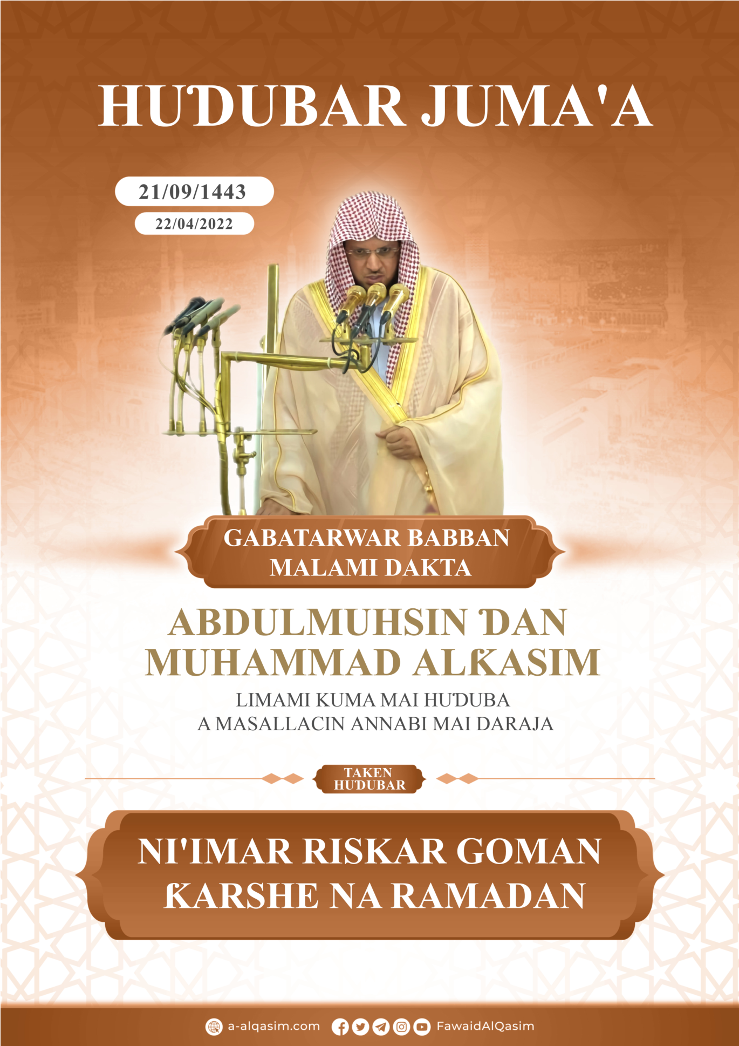
Ni'imar Riskar Goman Ƙarshe Na Ramadan⁽⁾
Dukkan godiya sun tabbata ga Allah, muna gode maSa, kuma muna neman taimakonSa, kuma muna neman gafararSa, kuma muna neman tsarin Allah daga sharrukan kawunanmu, da munanan laifukanmu, wanda Allah Ya shiryar dashi, to babu mai ɓatar dashi, kuma wanda Ya ɓatar to babu mai shiryar dashi, kuma ina shaidawa babu Abin bautawa da gaskiya sai Allah, Shi kaɗai baShi da abokin tãrayya, kuma ina shaidãwa Annabi Muhammad bãwanSa ne kuma ManzonSa ne.
Bayan haka; kuji tsoran Allah -ya ku bayin Allah- haƙiƙanin jin tsoro, kuma ku kiyaye shi cikin ɓoye da kuma ganawa.
Yã Ku Musulmai!
Riskar lokutan alkhairai yana daga ni'imomin Allah masu girma, kuma kaiwa ga lokutan da ake ruɓunya ladan aiki na gari yana daga kyautar Allah da alkairi ga bawanSa, kuma duk yadda shekarun bawa ya tsawaita to gajere ne, kuma a cikin lokutan alkairi akwai ruɓunyar lãdaddaki, da kuma yawaitar lada abinda zai yi dai-dai da ƙaruwar shekaru, da jinkirin ajali.
Kuma lokutan bauta da Allah Ya zabe su ga bayinSa matsayinsu yana banbanta, kuma darajojinsu suna ɗara juna, kuma abin kallo a cikinsu shine kyautatuwar ƙarshe ba tawayar farko ba, kuma ayyuka da ƙarshensu ne ake auna su.
Kuma wanda ya riski Ramadana kuma Allah Ya bashi damar azumtarsa da tsayuwarsa, to haƙiƙa an bashi dama, da ta kuɓucema dayawan halittu, kuma idan aka jinkirta masa a ajalinsa har ya kai goman ƙarshe a cikinsa, to haƙiƙa an keɓance shi da abinda ake yin nadama idan aka rasashi, kuma ake yin baƙin cikin kuɓucewarsa; domin an bashi wata yar dama da zai ƙara yawan alkhairi cikinta, kuma wacce zai nemi gafarar zunubbansa a cikinta, kuma ya riski abinda ya kuɓuce masa, kuma zai gyara abinda yayi sakaci cikinsa, kuma zai aikata ayyuka na gari waɗanda zai ƙara daraja da su a cikin Aljannah.
Manzon Allah -tsira da amincin Allah su tabbata a gare shi- ya ce: «Hancinsa ya turmusa; mutumin da watan Ramadana ya sameshi kuma ya fita kafin ayafe masa» [Tirmizi ya ruwaito shi]
Kuma goman ƙarshe na Ramadana sune naɗin sarautar watan, kuma tsagwaronsa, kuma mafiya tsadansu, yin ibada cikinsu yafi alkairi sama da ibada a dukkan dararrakin shekara banda su.
Kuma anso yawaita karatun Alƙur`ani. Ibn Rajab Allah Ya jiƙansa ya ce: Lokuta masu falala kamar watan Ramadan musamman dararen da ake neman lailatul Ƙadri acikinsu; ana son yawan karanta Alƙaur`ani acikin domin ribatar lokaci.
Cikinsu akwai daren lailatul Ƙadari wacce Allah Ya saukar da Alƙur'ani mai girma cikinta cikakke, zuwa saman duniya,
ﱡﭐﱥ ﱦ ﱧ ﱨ ﱩ * ﱫ ﱬ ﱭ ﱮ ﱯ ﱠ [القدر:1-2].
«Lallai Mu muka saukar dashi cikin daren lailatul Ƙadari - mai daraja- * kuma wa ya sanar dakai menene daren lailatul Ƙadari -mai daraja-» [Alƙadri: 1-2], lallai dare ne mai sha'ani mai girma, da matsayi maɗaukaki.
Dare ne mai albarka alkhairinsa yana da yawa, Allah Maɗaukaki Yace:
ﱡﭐ ﱆ ﱇ ﱈ ﱉ ﱊﱋ ﱠ [الدخان: 3].
«Lallai Mu muka saukar dashi a cikin dare mai albarka» [Addukhan:3].
Dare ne na aiki, kuma lada a cikinsa {yafi alkairi} sama da ladar ibadar {wata dubu} da babu lailatul Ƙadari acikinsu, tasbihi guda ɗaya cikinsa ba'a iya auna matsayinsa, kuma baza'a iya sanin iya ladansa ba, kuma raka'a guda ɗaya cikinsa tana dai-adai da ibadar shekaru, wanda aka datar dashi ga aiki na gari cikinta karɓaɓɓe, to haƙiƙa ya samu albarka mai girma kamar an bashi shekaru masu tsawo waɗanda yayi amfani da su dukkan su wajen biyayya da bauta. Saboda darajan daren lailatul-ƙadri ne ake rutawa acikinta ƙaddorori na cikakken shekara na rayuwar halittu, sai a ciro umurnin shekara daga Lauhul mahfuz zuwa ga mala'iku masu rubutu, da abinda zai kasance cikinta na ajali da arzuka, da abinda zai kasance cikinta har zuwa ƙarshenta, Allah Mai tsarki Ya ce:
ﱡﭐ ﱐ ﱑ ﱒ ﱓ ﱔ * ﱖ ﱗ ﱘ ﱠ [الدخان: 4-5].
«a cikinta ne ake rarraba dukkan umurni tsararre * umurni ne daga gare Mu» [Addukhan: 4-5].
Dare ne da saukowar mala'iku yake yawaita cikinsa daga sama, sabo da yawan albarkarsa,
ﱡﭐﱸ ﱹ ﱺ ﱻ ﱼ ﱽ ﱾ ﱿ ﲀﱠ [القدر: 4].
«Mala'iku da Ar-ruhu -Jibril- suna sassauka cikinsa da izinin Ubangijinsu da dukkun wani umurni» [Alƙadr: 4], kuma mala'iku suna sassauka tare da saukar albarka da rahama, kamar yadda suna sassauka yayin karatun Alƙur'ani, suna kewaye halƙoƙin zikiri kuma suna sauke fuka-fukansu ga ɗalibin ilmi domin girmamawa gare shi, da yarda da abinda yake aikatawa.
Kuma tsayuwar daren lailatul Ƙadari tare da gaskatawa da ladanta, da neman ladanta: sakamakonsa shine gafarta zunubai baki ɗayansu, yabo da amincin Allah sun tabbata a gare shi ya ce: «wanda ya tsayu a daren laitul Ƙadari bisa imani da neman lada, an gafarta masa abinda ya gabata na zunubinsa» [Bukhari da Muslim suka ruwaito shi], kuma an shar`anta rayata da sallah da addu'a da zikiri, da neman gafara, da kuma makamancin haka. Kuma wanda aka haramtama albarkarsa da alkairinsa shine wanda aka haramtama komai, yabo da amincin Allah sun tabbata a gare shi- ya ce: «cikinsa -watau: Ramadan- akwai wani dare yafi dare dubu, wanda aka haramtama alkairinsa haƙiƙa shine aka haramtama komai» [Ahmad ya ruwaito shi].
Kuma saboda matsayin daren lailatul Ƙadari ne mai girma, Annabi -yabo da amincin Allah sun tabbata a gare shi- ya kasance yana kirdadonsa, kuma yana kwaɗaitar da sahabbansa akan kirdadonsa a goman ƙarshe, kuma kirdadonsu a cikin mara na goman sunfi ƙarfi, kuma saboda tsananin kirdadon Annabi -yabo da amincin Allah sun tabbata a gare shi- ga dare lailatul Ƙadari yayi Eitikafi wani lokaci a goman farko, sannan a goman tsakiya, sannan yasan cewa shi yana goman ƙarshe sai yayi Eitikafi cikinsa. [Muslim ya ruwaito shi].
Kuma Annabi -yabo da amincin Allah sun tabbata a gare shi- ya kasance yana yawaita ibada a wannan goman, kuma yana dagewa dagewa mai girma, yana raya dukkan dare yana mai tahajjudi da sallah da zikiri da addu'a da neman gafara, Aishah -Allah Ya yarda da ita- ta ce: «Manzon Allah -yabo da amincin Allah sun tabbata a gare shi- yana dagewa a cikin goman irin dagewar da bayayi cikin waninsa» [Muslim ya ruwaito shi], kuma shi -yabo da amincin Allah sun tabbata a gare shi- ya kasance cikin waɗannan kwanaki goman yana taƙaitawa daga al'amarin duniya kuma yana nisantar mata, kuma yana farkar da iyalan gidansa domin su samu albarkar waɗannan dararraki, kuma su samu alkairansu, Aishah -Allah Ya yarda da ita- ta ce: «Manzon Allah -yabo da amincin Allah sun tabbata a gare shi- ya kasance idan goman ƙarshe ya shigo, yana raya dare, kuma yana farkar da iyalansa, kuma ya dage, ya tamke kwarjallensa» [Bukhari da Muslim suka ruwaito shi].
Kuma ya kasance yana Eitikafi a cikin masallacinsa duk shekara a waɗannan kwanaki goman, yana kirdadon dare lailatul Ƙadari har ya risketa yana cikin bauta mara yankewa da halartar zuciya da maida hankali, Aishah -Allah Ya yarda da ita- ta ce: «Annabi -yabo da amincin Allah sun tabbata a gare shi- ya kasance yana yin Eitikafin goman ƙarshe na Ramadana, har Allah Mai buwaya da girma Ya karɓi ransa, sannan iyalansa sukayi Eitikafi a bayansa». [Bukhari da Muslim suka ruwaito shi], kuma ya kasance idan yana Eitikafi baya barin masallaci, sai don buƙatar mutum wanda bashida makawa kanta, kuma yana fitar da kansa ga Aishah sai ta taje masa -watau: ta taje ta gyara- ba tare da ya bar masallacin ba. [Bukhari da Muslim suka ruwaito shi], kuma ya kasance babbar manufar Eitikafinsa -yabo da amincin Allah sun tabbata a gare shi-: yanke shagul-gula, da wofintar da damuwa, da keɓewa don ganawa da Allah Maɗaukaki da ambatonSa da roƙonSa.
Kuma duk wata ibada da aka shar'anta ta a Ramadana to tana ƙara faɗaɗa har zuwa ƙarshen darensa, kuma tafi ƙarfi a gomannan, don haka ya kamata Musulmi kwaɗayinsa gameda ita ya kasance yafi girma, sannan an shar'anta cikinsu tare da zumin wuni: tsayuwar dare musamman cikin Jam'i; domin «lallai wanda ya tsayu tare da liman har ya idar za'a rubuta masa tsayuwar dare cikakke» [Ahmad ya ruwaito shi].
Kuma ana shar'anta: yawan zikiri cikinsu da addu'a, da dawwamuwa kan karatun Alƙur'ani, da kyautatawa ga halittu da nau'uka na sadaka, da buɗe bakin masu azumi, da toshe buƙatun mabuƙata, da sada zumunci, da biyayya ga iyaye, da kyautatawa maƙwabta, da umurni da kyakykyawa da hani ga mummuna, kuma umrah a cikin ramadana tana dai-dai da hajji guda tare da Annabi -yabo da amincin Allah sun tabbata a gare shi-.
Kuma kafin haka da bayansa: lazimtar tuba ta gaskiya, da kuma dawwamuwar komawa ga Allah, da ƙanƙanda kai na zuciya ga Mahaliccinta, da kulawa da zuciya wajen tsarkaketa da gyarata ta da tsaftaceta, yawan ibada bazai yi amfani ba tare da zuciya mara kyau, kuma wahalar jiki bazai wadatar da wani abu a cikin biyayya, idan ciki bai kasance mai tsarki ba, kuma zuciya bata zama amintacciya ba.
Kuma haƙiƙa ya kasance cikin magabata akwai masu bauta masu yawaita ruku'i da sujjada da lizimtar azumi, da tsayuwa, daga cikinsu akwai wanda yake ƙasa da haka cikin bauta, sai dai kulawarsu gaba ɗaya da zukata abune dawwamamme, kuma damuwarsu itace tabbatar da tauhidi da tsaida fuska zuwa ga Allah, Ibnu Rajab -Allah Ya jiƙansa- ya ce: «mafi yawan nafilfilin Annabi -yabo da amincin Allah sun tabbata a gare shi- da kuma keɓantattun sahabbansa ya kasance ne da biyayyar zuciya da tsarkinta, da kuɓutarta, da ƙarfin ratayarta ga Allah; bisa tsoranSa da sonSa da darajtawa da girmamawa da kwaɗayin abinda yake gunSa, da tsantseni daga abinda yake mai ƙarewa ne».
Kuma falalolin waɗannan kwanaki goman basu keɓanta da masu sallah su kaɗai ba, lallai masu haila da biƙi yana shar'antuwa garesu kowacce irin biyayya da ba'a sharɗanta mata tsarki ba, na zikiri da addu'a da karatun Alƙur'ani da ka, da sauran ayyukan biyayya na daban.
Kuma ka yawaita ambaton Allah domin shine sababin rabauta da cin nasara.
Ina neman tsarin Allah daga shaiɗan jefaffe
ﭐﱡﭐ ﱂ ﱃ ﱄ ﱅ ﱆ ﱇ
ﱈ ﱉ ﱊ ﱋ ﱌﱠ
«Kuma kuyi gaggawa zuwa ga wata gafara daga Ubangijinku da wata Aljannah wacce faɗinta yakai fadin sammai da ƙassai, an tanajesu ne ga masu tsoron Allah» [Aali-Imran: 133].
Allah Ya min albarka tare daku cikin Alƙur'ani mai girma…
Huduba Ta Biyu
Dukkan yabo sun tabbata ga Allah bisa kyautatawarSa, kuma godiya ta tabbata a gareShi akan datarwarSa da kuma ni'imominSa, kuma ina shaidawa babu abin bautawa da gaskiya sai Allah, Shi kaɗai baShi da abokin tarayya ina mai girmamawa ga al'amarinSa, kuma ina shaidawa Muhammad bawanSa ne kuma manzonSa ne, yabon Allah ya tabbata gare shi da iyalansa da sahabbansa, kuma yayi daɗin aminci, aminci mai ƙaruwa.
Bayan Haka, Ya ku Musulmai:
Darare goma na ƙarshen Ramadan sune mafiya darajan dararen shekara, to kada kayi sakaci cikin wani abu na lokutan darenka ko wuninka a waɗannan kwanaki goman kuma kayi ƙoƙarin kada Allah Ya ganka face cikin biyayya, idan kayi rauni daga aikata biyayya, to ka kiyayi Allah yaganka kana saɓo, kuma ka kiyayi bayyanar da manyan laifuka, ko sakaci cikin ƙananun laifuka, kuma ina maka kashedi da sakaci da wajen gabatar da wajibai da umurni, kuma mafi girman wajibai bayan tauhidi: gabatar da sallah a cikin lokacinta, kuma ka kiyaye gaɓɓanka a kowane lokaci daga abubuwan haram, kuma ka yawaita nafil-fili na sallah da zikiri da addu'a, kuma kaso maganar Ubangijinka ka yawaita tilawarsa, wanda -Allah Ya yarda da shi- ya ce: «Ku karanta Alƙur'ani domin shi zaizo ranar tashin alƙiyama yana mai ceto ga ma'abocinsa» [Muslim ya ruwaito shi].
Kuma ka yawaita ambaton Allah domin shine sabababin rabauta da cin nasara, Allah wanda sha`aninSa ya girmama ya ce:
ﭐﱡﭐ ﲾ ﲿ ﳀ ﳁ ﳂﱠ
«Kuma ku ambaci Allah da yawa ko ta yiwu ku rabauta» [Al-anfaal: 133].
Kuma ka kammala watan Ramadana da istigfari, da rokon karɓawa daga wurin Allah, kuma ka raba zuciyarka da jin taƙama da ayyukka na ƙwarai domin yana ɓatasu.
Sannan ku sani cewa lallai Allah Ya umurceku da yin salati da sallama ga AnnabinSa…
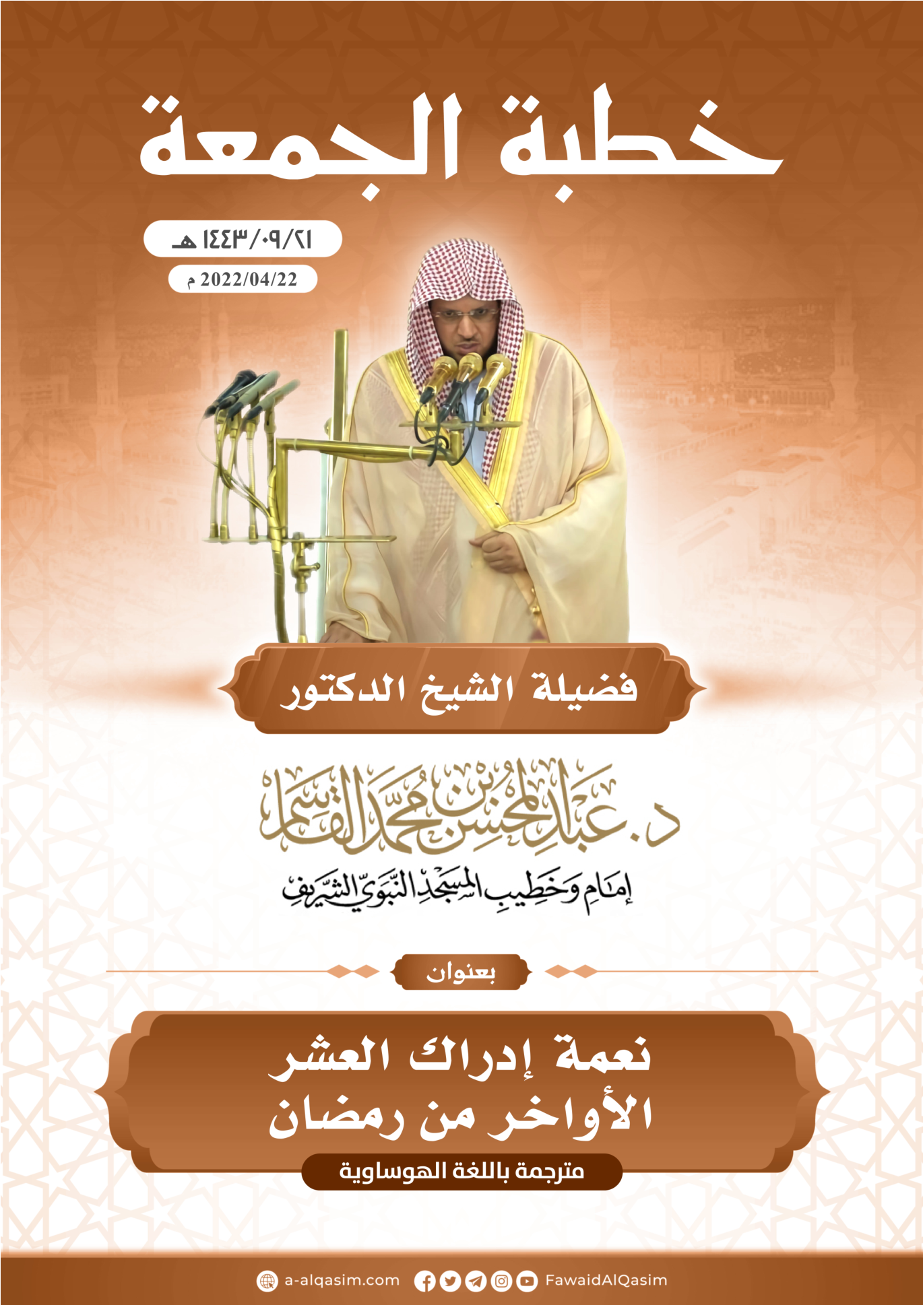

(?) An gabãtar da ita ranar Juma’a, Ashirin da ɗaya ga watan ramadan, shekara ta dubu ɗaya da dari huɗu da Arba'in da uku, bayan Hijira, a Masallacin Annabi.

