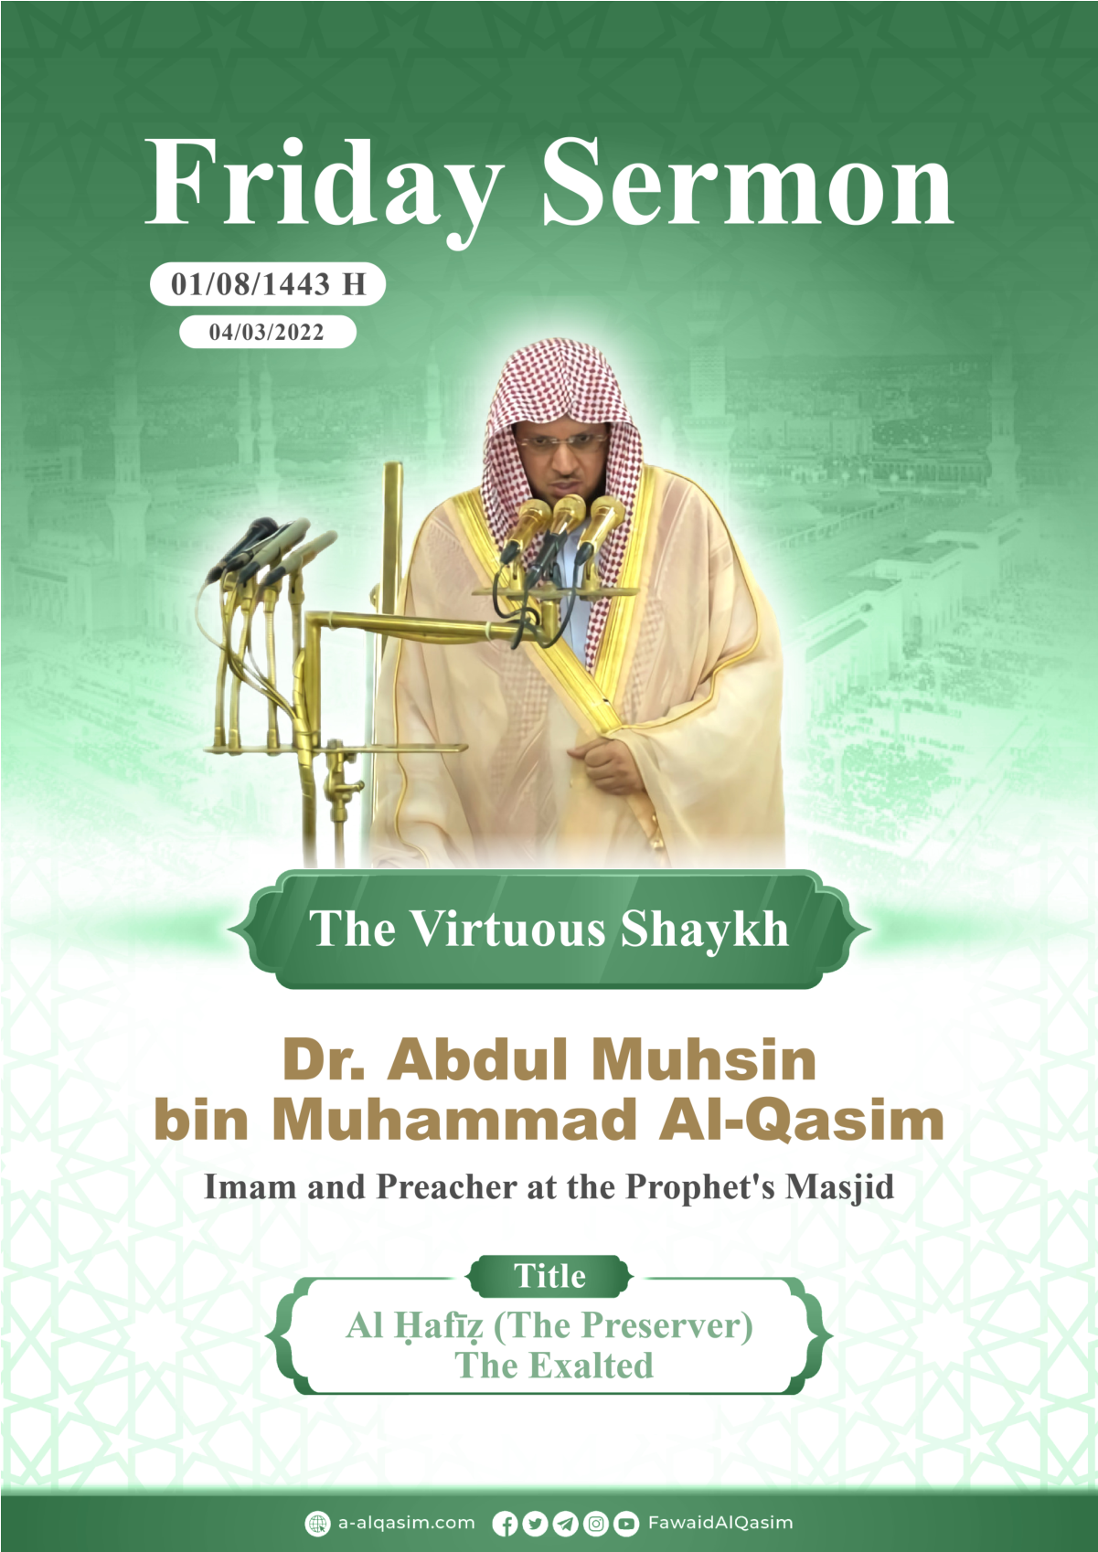
Al-Ḥafīẓ (The Preserver), May He Be Exalted
All praise is due to Allah. We praise him, seek his assistance, and seek his forgiveness. We seek refuge in Allah from the evil of ourselves, and from our bad deeds. Whomever Allah guides, then there is none who can misguide him, and whomever He misguides, then there is none who can guide him. I testify that there is no deity worthy of being worshipped except Allah, alone, without any partners, and I testify that Muḥammad, is His servant and messenger, may Allah send much peace and blessings upon him, and upon his family and companions.
To proceed: Fear Allah as he ought to be feared (by obeying his commandments and avoiding his prohibitions) and be aware that He is watching (even) in times of secrecy and privacy.
O Muslims!
Allah, The Most High, has the most beautiful names that comprise the most perfect and highest attributes. His names and attributes, The Most High, are indicative of each other, and people are differentiated in their worship and closeness to Allah according to their knowledge of His names and attributes. From amongst His names are those that if one were to enumerate them and become fully acquainted with them them, he would enter Paradise. Everything in the world: every movement or silence, is influenced by His names and attributes. He, may He be Exalted, said:
﴿اللَّهُ الَّذِي خَلَقَ سَبْعَ سَمَاوَاتٍ وَمِنَ الْأَرْضِ مِثْلَهُنَّ يَتَنَزَّلُ الْأَمْرُ بَيْنَهُنَّ لِتَعْلَمُوا أَنَّ اللَّهَ عَلَى كُلِّ شَيْءٍ قَدِيرٌ وَأَنَّ اللَّهَ قَدْ أَحَاطَ بِكُلِّ شَيْءٍ عِلْمًا﴾
“Allah is the One Who created seven heavens, and likewise for the earth. His Command descends between them, that you may know that Allah is Most Capable of everything, and that Allah certainly encompasses all things in (His) knowledge.” [65:12]
Two of His names, may He be Exalted, that He called Himself and is known by them among His creation are Al-Ḥafīẓ (i.e., The Preserver) and Al-Ḥāfiẓ (i.e., The Protector). He protects the creation He brought into existence with His power. Were it not for His protection, they would cease to exist and vanish. Likewise, were it not for His attention and care, the order of the creation would be dismantled, and some would be unjust to others.
For that reason, the heavens, the earth, and everything in them and between them are under His command. He, may He be Exalted, said:
﴿إِنَّ اللَّهَ يُمْسِكُ السَّمَاوَاتِ وَالْأَرْضَ أَنْ تَزُولَا
وَلَئِنْ زَالَتَا إِنْ أَمْسَكَهُمَا مِنْ أَحَدٍ مِنْ بَعْدِهِ﴾
“Indeed Allah grasps the heavens and the earth lest they should move away from their places, and if they were to move away from their places, there is none that could grasp them after Him.” [35:41]
He preserved the heavens and the earth and everything in them so they remain for the time they were destined to remain, they do not cease to exist or vanish, and preserving them is the easiest thing for Him.
﴿وَسِعَ كُرْسِيُّهُ السَّمَاوَاتِ وَالْأَرْضَ
وَلَا يَئُودُهُ حِفْظُهُمَا وَهُوَ الْعَلِيُّ الْعَظِيمُ﴾
“His footstool extends over the heavens and the earth, and He feels no fatigue in guarding and preserving them. And He is the Most High, the Most Great.” [2:255]
His preservation is inclusive of all His creation. Not a single thing is independent of His preservation—not even for a blink of an eye.
﴿إِنَّ رَبِّي عَلَى كُلِّ شَيْءٍ حَفِيظٌ﴾
“Surely, my Lord is a Protector over all things.” [11:57]
There is not a single thing in the heaven, above the earth, nor under it, except that it is preserved in a book (i.e., the preserved tablet, where all decrees are recorded). Ibn Kathīr, may Allah have mercy on him, said, “It means: We certainly know the bodies that are decomposed by the earth. We have knowledge of that, and these matters are not hidden to us: Where were the bodies scattered? Where did they go? Where did they end up?’”
Among His preservation of His servants is that he entrusted angels to be in front of them and behind them that follow them around. They protect them from harm and obstacles by Allah’s command.
﴿لَهُ مُعَقِّبَاتٌ مِنْ بَيْنِ يَدَيْهِ وَمِنْ خَلْفِهِ يَحْفَظُونَهُ مِنْ أَمْرِ اللَّهِ﴾
“For each person, there are angels in succession, in front of him and behind him that guard him by Allah’s command.” [13:11]
Mujāhid, may Allah have mercy on him, said, “There is no servant (of Allah) except that he has an entrusted angel who protects him during his sleep and while he is awake, from the jinn, people, and dangerous creatures. None of them approach him wanting (to harm) him except that he says, ‘Go back! Unless it is something that Allah has decreed for him, in which case it will afflict him.‘”
He also preserves all the deeds of His servants; nothing from their speech escapes Him. He entrusted an angel for every person to memorize his deeds and keep track of his actions of obedience and disobedience.
﴿إِنْ كُلُّ نَفْسٍ لَمَّا عَلَيْهَا حَافِظٌ﴾
“There is no person that doesn’t have a protector over him (i.e., angels in charge of protecting him).” [86:4]
They are preserved in the angel’s records as well.
﴿وَإِنَّ عَلَيْكُمْ لَحَافِظِينَ كِرَامًا كَاتِبِينَ يَعْلَمُونَ مَا تَفْعَلُونَ﴾
“Indeed, over you are honorable scribes, recording everything. They know all that you do.” [82:10-12]
He also entrusted an angel for His devoted servants among the Prophets, peace be upon them, and their followers. They have a been granted a special protection. He, The Exalted, protects them from things that harm their faith or shake their certainty of belief, such as doubts, trials, and desires. He also protects them from their enemies among the jinn and people: he grants them victory over them and deflects their evil plots away from them.
He who preserves Allah’s commandments by obeying them and His prohibitions by avoiding them, and preserves His boundaries and do not transgress them, Allah will be with him during all his circumstances wherever he goes, He protects him and supports him, protecting his religion from doubts and desires, and his worldly life. He will protect him in his family and protect his religion for him at the time of death, causing him to die upon faith. The Prophet, peace and blessings of Allah be upon him, said, “Be perseverant with Allah (by fulfilling his commandments, avoiding his prohibitions, and obeying him), and in return He will protect you from evil. Be perseverant with him, you will find him in front of you [i.e., He will actually be with you in a way that best fits His Glory and Majesty, assisting you, protecting you].” Reported by at-Tirmidhi.
The Prophets of Allah, the Exalted, delivered their Lord’s messages and established the religion that Allah is pleased with for His servants. On that path, they faced many difficulties and adversities, and their shelter during all of that was (none other than) Al-Ḥafīẓ, may He be Exalted. He protected them and prevented them from deviance in delivering His message. They were mistreated, so He protected them from the evil plots of their enemies.
Ibrāhīm was thrown in a massive fire, which didn’t leave anything thrown in it except that it burned it. So, he attached himself to Al-Ḥafīẓ, may He be Exalted, and said…
﴿حَسْبُنَا اللَّهُ وَنِعْمَ الْوَكِيلُ﴾
“Allah is Sufficient for us, and He is the Best Disposer of affairs.” [3:173]
Consequently, Allah saved him from the fire and it became cold and peaceful for him.
Ismā ̒ īl, peace be upon him, was laid down by his father (i.e., Ibrāhīm) to slaughter him just as his Lord commanded. When they both submitted to Allah’s command and believed in the vision, and when he (i.e., Ismā ̒ īl) said to his father…
﴿افْعَلْ مَا تُؤْمَرُ سَتَجِدُنِي إِنْ شَاءَ اللَّهُ مِنَ الصَّابِرِينَ﴾
“Do that which you are commanded, if Allah wills, you shall find me from among the patient. [37: 102]
…Al-Ḥafīẓ ransomed him with a great sacrificial animal.
Hūd, peace be upon him, invited his people (to the worship of Allah). When they rejected him and threatened to harm him, he sought shelter in His Lord, Al-Ḥafīẓ, and said…
﴿فَإِنْ تَوَلَّوْا فَقَدْ أَبْلَغْتُكُمْ مَا أُرْسِلْتُ بِهِ إِلَيْكُمْ وَيَسْتَخْلِفُ رَبِّي قَوْمًا غَيْرَكُمْ وَلَا تَضُرُّونَهُ شَيْئًا إِنَّ رَبِّي عَلَى كُلِّ شَيْءٍ حَفِيظٌ﴾
“So, if you turn away, then I have already conveyed the message with which I was sent to you. My Lord will make another people succeed you, and you will not harm Him in the least. Surely, my Lord is a Protector over all things.” [11:57]
Meaning, He will protect me from your evil, your plot, and from your harm.
Allah’s protection is complete compared with that of people. Yūsuf’s attributed his protection to themselves, and they said to their father…
﴿أَرْسِلْهُ مَعَنَا غَدًا يَرْتَعْ وَيَلْعَبْ وَإِنَّا لَهُ لَحَافِظُونَ﴾
“Send him with us tomorrow to enjoy himself and play, and certainly, we will take care of him.” [12:12]
However, they lost him. Then, when Yaʻqūb, peace be upon him, attributed the protection of Yūsuf and his brother (i.e., Benjamin) to Allah, and said…
﴿فَاللَّهُ خَيْرٌ حَافِظًا وَهُوَ أَرْحَمُ الرَّاحِمِينَ﴾
“Allah is the best Protector, and He is the Most Merciful of all those who show mercy.” [12:64]
… Allah protected them, returned them both to him, and they both had a good ending. In fact, Allah made Yūsuf someone who protected the rights of His servants. Yūsuf said about himself…
﴿إِنِّي حَفِيظٌ عَلِيمٌ﴾
“I’m one who will protect them and has knowledge.” [12:55]
Mūsā’s mother, peace be upon him, set him in the sea while he was still an infant, trusting in Allah’s protection. So, his Lord protected him, raised him under His Eye in his enemy’s home, and made him a prophet of great status, from Ulu al- ̒Azm among the messengers (i.e., those of strong will and firm resolve, They are Nūḥ, Ibrāhīm, Mūsá, ̒Īsā, and Muḥammad).
Yūnus, peace be upon him, was swallowed by a whale, and while in the darkness of its belly, the dark depths of the sea, and the darkness of the night, he called out to His Lord, Al-Ḥafīẓ…
﴿أَنْ لَا إِلَهَ إِلَّا أَنْتَ سُبْحَانَكَ إِنِّي كُنْتُ مِنَ الظَّالِمِينَ﴾
“… There is none worthy of worship except You, exalted be You far above all that they associate with You. Truly, I have been of the wrong-doers.” [21:87]
So, his Lord answered him and saved him from his distress. Like such, Allah saves the believers. Neither was he left alone on the shore.
﴿فَنَبَذْنَاهُ بِالْعَرَاءِ وَهُوَ سَقِيمٌ وَأَنْبَتْنَا عَلَيْهِ شَجَرَةً مِنْ يَقْطِينٍ﴾
“But We cast him forth on the open shore while he was sick, And We caused a gourd vine to sprout over him.” [37:145-146]
Sulaymān, peace be upon him, was given a great kingdom, and Allah made the jinn subservient to him, to obey his command and make amazing things for him. Allah was his protector from their mutiny and harm. He, The Exalted, said
﴿وَمِنَ الشَّيَاطِينِ مَنْ يَغُوصُونَ لَهُ وَيَعْمَلُونَ عَمَلًا دُونَ ذَلِكَ
وَكُنَّا لَهُمْ حَافِظِينَ﴾
“And from the devils of the jinn were some who dived for him, and did other work besides that; and it was We Who protected them.” [21:82]
Ibn Kathīr, may Allah have mercy on him, said, “It means: ‘Allah will guard him from any of the devils that wish to harm him. They were all in his grip, under his authority, and none of them dared to draw near, nor come close to him. Not only that, but he was also the arbiter amongst them. If he willed, he would release them, and if he willed, he would seize any of them he wished.’”
There was also, ̒Īsá, peace be upon him. The Jews strived to kill him and eradicate his message. So, Allah raised him up to Himself while he was still alive, protected him from the evil of their hands, and ransomed him with one of his enemies who looked like him.
﴿وَمَا قَتَلُوهُ وَمَا صَلَبُوهُ وَلَكِنْ شُبِّهَ لَهُمْ﴾
“…They neither killed nor crucified him—it was only made to appear so…” [4:157]
Our Prophet Muḥammad, peace and blessings of Allah be upon him; Allah finalized all the messages through him, and took it upon Himself to protect him. He said…
﴿وَاللَّهُ يَعْصِمُكَ مِنَ النَّاسِ﴾
“Allah will protect you from the people.” [5:67]
i.e., He will protect you from their evil plots, and preserve your message and that which you came with.
Jābir, may Allah be pleased with him, said, “We set out with Allah’s Messenger, peace and blessings of Allah be upon him, until we arrived in Dhāt Ar-Riqāʻ and we came across a tree with a well-shaded area. So, we left it for Allah’s Messenger, peace and blessings of Allah be upon him. Then, a man from amongst the polytheists came while the sword of Allah’s Messenger was hanging from the tree. He took the sword of Allah’s Prophet, peace and blessings of Allah be upon him, unsheathed it, [and pointed it at him], then said to Allah’s Messenger, peace and blessings of Allah be upon him, ‘Do you fear me?’ He replied, ‘No’. He said, ‘So who will protect you from me?’ He said, ‘Allah will protect me from you.’ Then, he sheathed the sword and hung it back on the tree.” Agreed upon [i.e., reported by al-Bukhāri and Muslim].
The followers of the Prophet, peace and blessings of Allah be upon him, also have their share of Allah’s protection, to the degree of their following of him. Ibn Al-Qayyim, said, “The followers of the Prophet have their share of Allah’s protection. Allah’s protection, defense, fortification, and support for them is according to their following of the Prophet. There are those who get plenty and there are those who only get a little.”
The Great Quran is the last of all books and the most complete among them. Allah took it upon Himself to preserve it. He said…
﴿إِنَّا نَحْنُ نَزَّلْنَا الذِّكْرَ وَإِنَّا لَهُ لَحَافِظُونَ﴾
“We are certainly the ones who sent down the Dhikr (i.e., the Quran) and surely, We will preserve it.” [15:9]
As a result, it is not afflicted by the hands of men subjecting it to change and alteration. No falsehood can be added to it, nor can any of its rulings, punishments, and obligations be deleted from it. Its words and meanings are preserved. Allah, The Exalted, said…
﴿وَإِنَّهُ لَكِتَابٌ عَزِيزٌ لَا يَأْتِيهِ الْبَاطِلُ مِنْ بَيْنِ يَدَيْهِ وَلَا مِنْ خَلْفِهِ﴾
“… It is indeed an Honorable and Fortified Book. Falsehood cannot come to it from before it nor behind it …” [41:41-42]
When Allah entrusted the people of the book (i.e., the Jews and Christians) to preserve their book, as He said…
﴿بِمَا اسْتُحْفِظُوا مِنْ كِتَابِ اللَّهِ﴾
“…they were entrusted with preserving Allah’s book…” [5:44]
…it was changed and altered.
The heavens are the passageway of the revelation to the earth. Allah has protected it and guarded it with angels and shooting stars, protecting His book from the devils’ eavesdropping.
﴿إِنَّا زَيَّنَّا السَّمَاءَ الدُّنْيَا بِزِينَةٍ الْكَوَاكِبِ وَحِفْظًا مِنْ كُلِّ شَيْطَانٍ مَارِدٍ﴾
“Indeed, We have decorated the near heaven with stars as an adornment and as a protection against every rebellious devil.” [37:6-7]
The servant is never independent of asking Allah for protection. The Prophet, peace and blessings of Allah be upon him, used to supplicate to his Lord in both ends of the day (i.e., morning and evening) with a prayer inclusive of all pillars of protection. He would say, “O Allah! Protect me from in front of me, behind me, my right side, my left side, above me, and I seek refuge in your greatness from being swallowed up from beneath me (i.e., being sucked up by a sinkhole).” Reported by Abū Dāwūd. Which means, protect me from the evil of jinn, people, dangerous creatures, and the evil of Iblīs (Satan), who said…
﴿ثُمَّ لَآتِيَنَّهُمْ مِنْ بَيْنِ أَيْدِيهِمْ وَمِنْ خَلْفِهِمْ وَعَنْ أَيْمَانِهِمْ وَعَنْ شَمَائِلِهِمْ﴾
“Then I will come to them from in front of them, from behind them, from their right, and from their left…” [7:17]
… And protect me from trials, being swallowed by the earth, punishment, and all that brings about destruction.
A servant is prone to the jinn’s and other’s harm during his sleep. Whoever recites Āyat al-Kursī as he goes to bed, a guardian from Allah will remain with him, and no devil will come near him until the morning. Reported by al-Bukhāri.
Similarly, a servant is never independent of Allah after his sleep, while he is awake. The Prophet, upon him be blessings and peace, said, “When one of you goes to bed, then let him say, ‘Exalted are You, O Allah, my Lord! By You I place my side, and by You I lift it up. If you take my soul, forgive me, and if you let it go i.e., return my soul to me, then protect it with that which You protect Your righteous servants.’” Agreed upon.
Whoever preserves Allah’s boundaries according to what He commanded, with sincere obedience to Him and striving for perfection in the best way possible, Allah will admit him into Paradise. He, The Most High, said
﴿هَذَا مَا تُوعَدُونَ لِكُلِّ أَوَّابٍ حَفِيظٍ﴾
“This is what you were promised, for those who frequently turn to Allah and persevere (by fulfilling His commandments, avoiding His prohibitions, and obeying Him).” [50:32]
To proceed, O Muslims!
Allah is great and of great status. Despite the vastness of the world, He protects it along with everything in it. Naturally, the soul is bound to love the one who protects and guards it, and Allah protects you in all places and during all times. Therefore, He is the most deserving of being loved and obeyed. Whoever is mindful of Allah’s protection over his actions, it will yield for him his mindfulness of Allah’s surveillance.
Whoever is certain that Allah, alone, is The Protector of everything and that His protection of things is better than that of the creation, he will trust him to protect his religion, family, children, wealth, and other than that. The best means one can take to protect his soul is Allah’s oneness and His obedience. Whenever Allah is entrusted with something He protects it.
I seek refuge in Allah from Satan, the outcast.
﴿وَرَبُّكَ عَلَى كُلِّ شَيْءٍ حَفِيظٌ﴾
“And your Lord is a Protector over everything.” [34:21]
May Allah bless me and all of you…
The Second KhuṬbah
All praise is due to Allah for His favors, and we give thanks to Him for His guidance and kindness. I testify that there is no deity worthy of being worshipped except Allah, alone, without any partners, whilst glorifying His affairs, and I testify that Muḥammad, is His servant and messenger, may Allah send much peace and blessings upon him, and upon his family and companions.
O Muslims!
Whoever knows that Allah is The Protector of everything and has power and control over them, won’t rely on just the means. He will carry them out while being certain that all protection is in Allah’s Hands and that the means do not necessarily lead to that which is expected. Therefore, one should be true in seeking shelter with Allah and turn to Him, alone, in requesting protection, defense, safety from harmful things, and salvation from that which leads to destruction.
In conclusion, know that Allah has commanded you to send peace and blessings upon His Prophet…
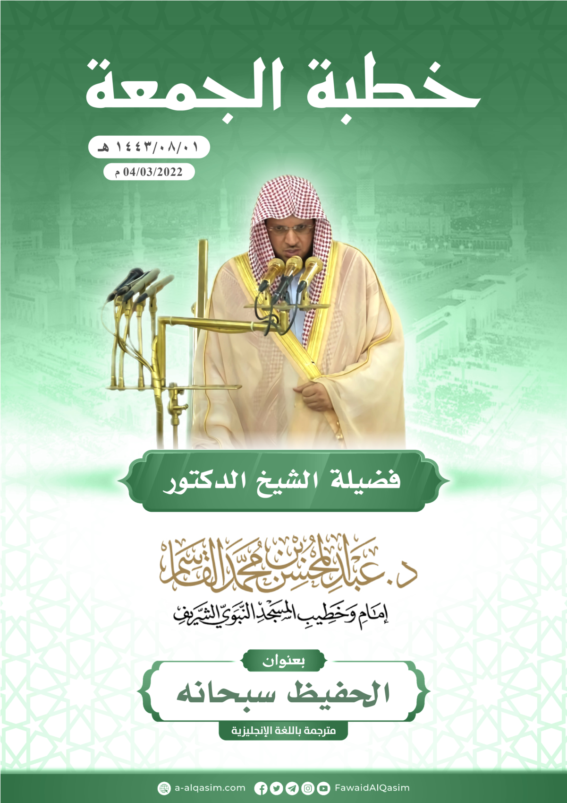

Delivered in The Prophet’s Masjid on 1/8/1443 Hijri which corresponds to 4/3/2022 Gregorian.

