You Have No Right
to Translate
Individuals' Names!

Prepared by: Abo Karim El-Marakshy

The name of the Prophet Muhammad May Allah's Peace and Blessings be Upon Him (PBUH) was mentioned in the ancient Hebrew Bible of the Eighth century, Solomon's Song of Songs (Shir ha-Shirim, 5:16).

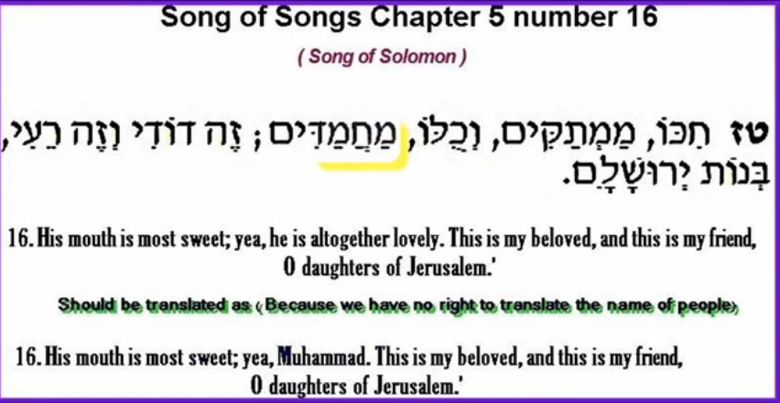

The transliteration In Hebrew language is: "Hikko Mamittakim we kullo Muhammadim Zehdoodeh wa Zehraee Bayna Jerusalem."

It was translated to English language as follows:
"His mouth is most sweet: yea, he is altogether lovely. This is my beloved, and this is my friend, O daughters of Jerusalem."- Old Testament (Tanakh) (Solomon 5:16)

However the English translation must be corrected to be as follows:
"His mouth is most sweet: yea, he is Muhammad. This is my beloved, and this is my friend, O daughters of Jerusalem."- Old Testament (Tanakh) (Solomon 5:16)

In the Hebrew language 'im' is added for plurality of respect. Similarly 'im' is added after the name of the Prophet Muhammad to make it Muhammadim.

i.e. In the English translation they translated the name of the Prophet Muhammad (PBUH) to be "altogether lovely"!!!

Notice carefully this Hebrew word מוחמד (Muhammad), it is made of four letters , if you read it with no vowels , the word can be read in the original form as Mahammad or Mahmad.

According to the Hebrew/English Dictionary: Yehuda, Ben: this word מוחמד is correctly pronounced as MUHAMMAD and not Mahamad.

If you watch this video, then you will hear a Hebrew Rabbi reading this word מוחמד as Muhammad.
http://www.youtube.com/watch?v=3YsA45CuvFk

If you copy this word מוחמד and paste in the Google translation web site, then you will find that the word מוחמד is translated to Muhammad.
http://translate.google.com

From Hebrew to English language.
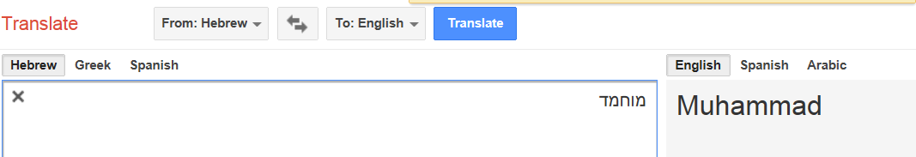

From Hebrew to Arabic language.
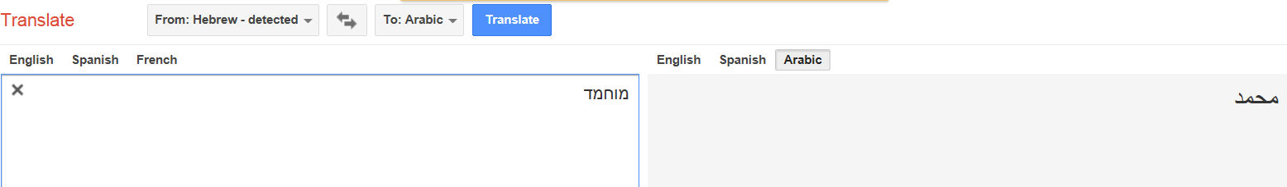

From Hebrew to Greek language.
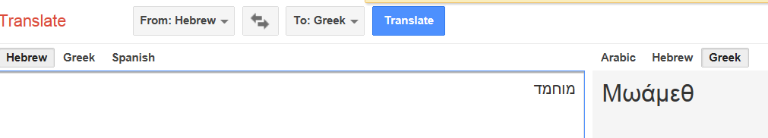

From Hebrew to Urdu language.
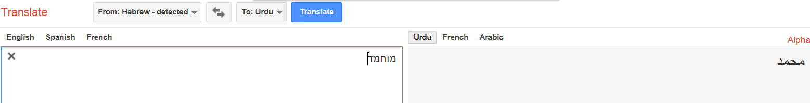
From Hebrew to German language.
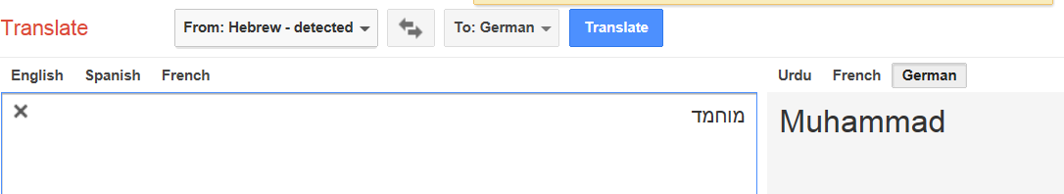

From Hebrew to Italian language.
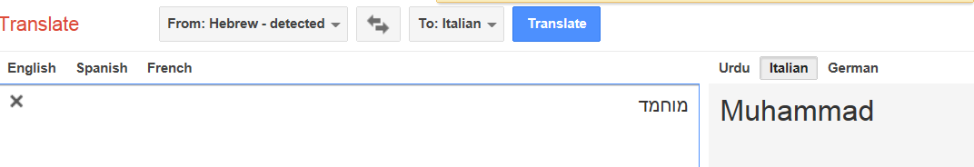
From Hebrew to Albanian language.
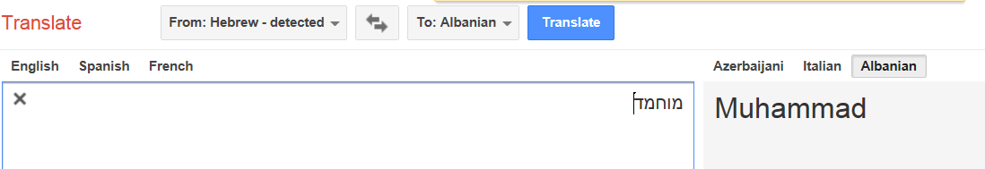

From Hebrew to Persian language.
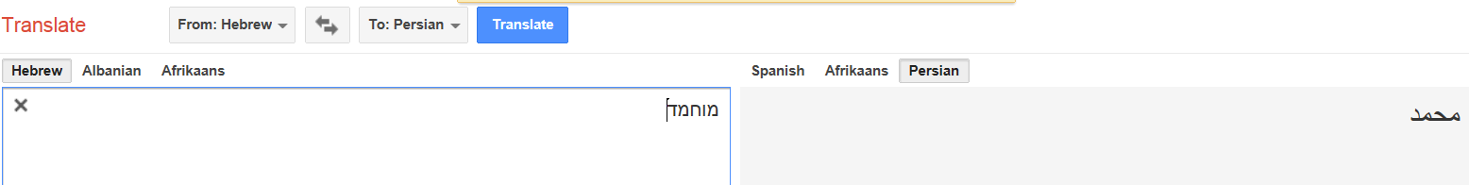

From Hebrew to Indonesian language.
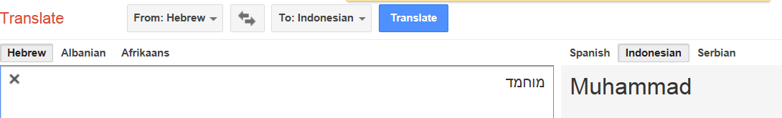

From Hebrew to Croatian language.
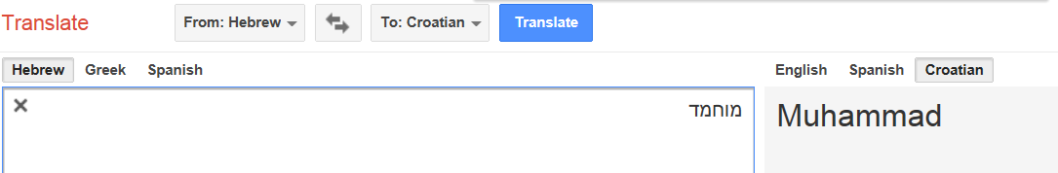

Conclusion:

This word מוחמד must be translated correctly to be Muhammad and not "altogether lovely".

The name of the Prophet Muhammad (PBUH) was written in the Torah and the Gospel.

Finally you can download the translation of the Noble Qur'an and recite "Surat Al-'A`rāf" verse number (157).

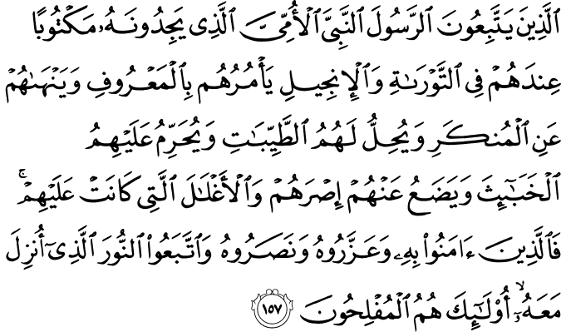

Those who follow the Messenger, the unlettered prophet, whom they find written in what they have of the Torah and the Gospel, who enjoins upon them what is right and forbids them what is wrong and makes lawful for them the good things and prohibits for them the evil and relieves them of their burden and the shackles which were upon them. So they who have believed in him, honored him, supported him and followed the light which was sent down with him - it is those who will be the successful. (Surat Al-'A`rāf 157)

www.islamic-invitation.com

