You Have No Right
to Translate
Individuals' Names!

Prepared by: Abo Karim El-Marakshy

Do you know that the name of the Prophet Muhammad May Allah's Peace and Blessings be Upon Him (PBUH) was mentioned in the Hebrew Bible, Solomon's Song of Songs (Shir ha-Shirim, 5:16)?
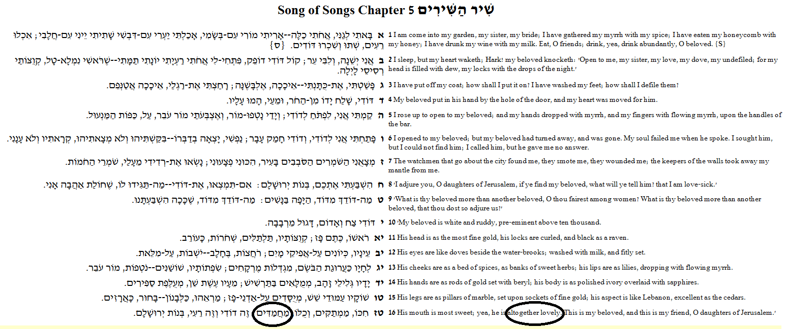
http://www.mechon-mamre.org/p/pt/pt3005.htm

 | 5:16 written with vowels | 5:16 written without vowels
In Hebrew language | חִכּוֹ, מַמְתַקִּים, וְכֻלּוֹ, מַחֲמַדִּים; זֶה דוֹדִי וְזֶה רֵעִי, בְּנוֹת יְרוּשָׁלִָם. | חכו ממתקים וכלו מחמדים זה דודי וזה רעי בנות ירושלם׃
Source | שיר השירים 5:16 Hebrew OT: Westminster Leningrad Codex | שיר השירים 5:16 Hebrew Bible

There are different English translations for this Hebrew word מַחֲמַדִּים

1- King James Version: it is translated as "altogether lovely".
2- The New American Standard Bible: it is translated as "and he is wholly desirable".

Jews will say this word in Hebrew מַחֲמַדִּים is discussing Solomon (PBUH), while Christians will say it is discussing Jesus (PBUH).

Is it a prophecy describing a man who was not yet alive at that time?

Here is verse 5:16 and how it is written in an ancient Hebrew before introducing the vowels in the Eighth century from the Hebrew Bible.
http://scripturetext.com
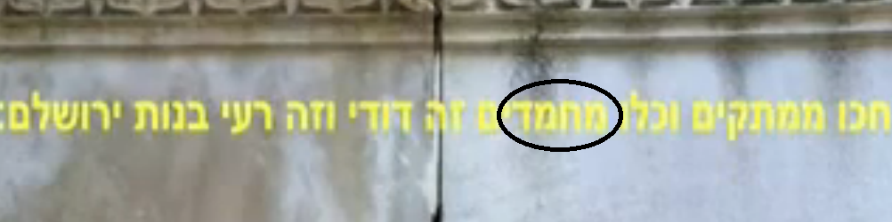
This Hebrew word is made of four letters and it is read from right to left.
 |  | 

If it is read as it is written in its original form with no vowels, then it can be read as:
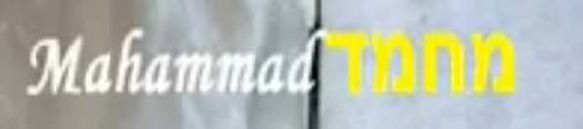 | 
Mahammad which is the name of the Muslims Prophet. | Mahmad with no "a" after the "h" which is a random Hebrew word.

According to the Hebrew/English Dictionary: Yehuda, Ben: this word is correctly pronounced as Mahammad and not Mahmad. | 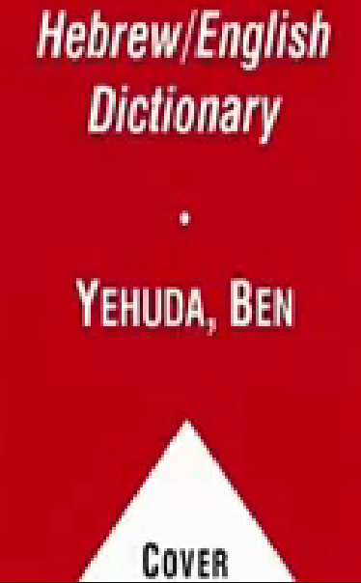

This Hebrew word with vowels מַחֲמַדִּים can be read in the original form as Ma.ha.mad.dim; notice that in the Hebrew language 'im' is added for plurality of respect.
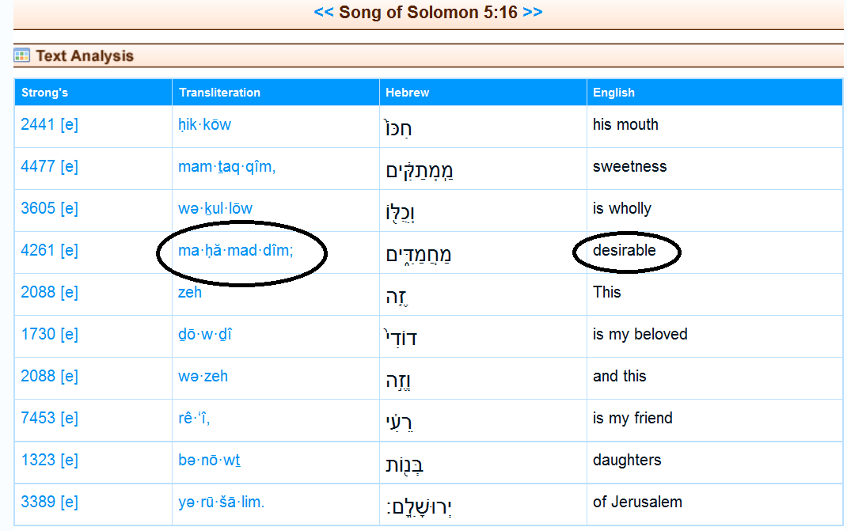
http://biblos.com/songs/5-16.htm

If you watch this video Song of Solomon 5:16 read in Hebrew: youtube.com/watch?v=3YsA45CuvFk , then you will hear a Hebrew Rabbi reading this word as Mahammad-im.
According to Strong's Concordance
Original Word: מַחְמַד
Part of Speech: Noun Masculine

According to NAS Exhaustive Concordance that the word origin of this Hebrew word מַחְמַד is from "chamad".
http://concordances.org/hebrew/4261.htm

According to Brown-Driver-Briggs Hebrew and English Lexicon
This word "chamad" is verb desire, take pleasure; Arabic is حَمِدَ
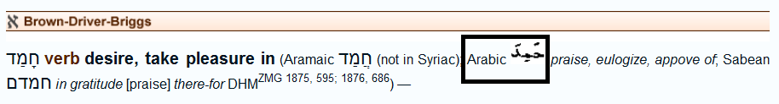
http://concordances.org/hebrew/2530.htm

In Arabic language the word حَمِدَ is verb praise, and it is the prime root of the Arabic word مُحَمَّدٌ which is read as Muhammad.

If you copy this Hebrew word מוחמד and paste in the Google translation web site http://translate.google.com , then you will find that the word מוחמד is translated to Muhammad.

From Hebrew to English language.  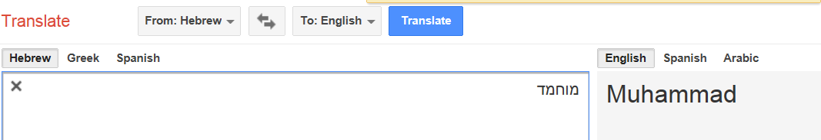 | From Hebrew to Arabic language.  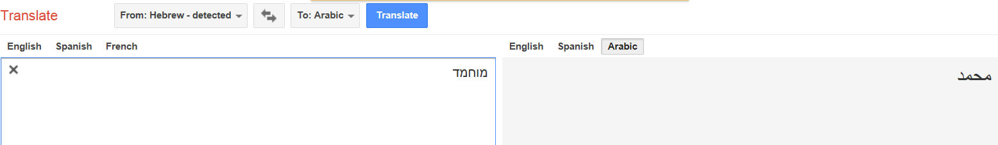
From Hebrew to French language.  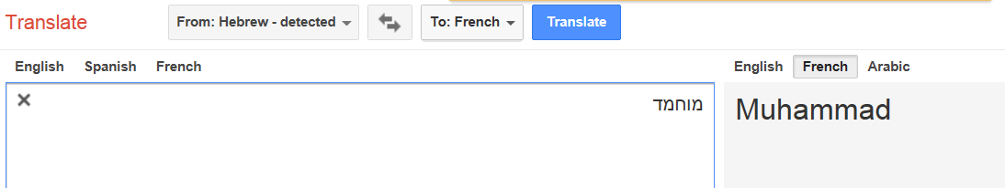 | From Hebrew to German language.  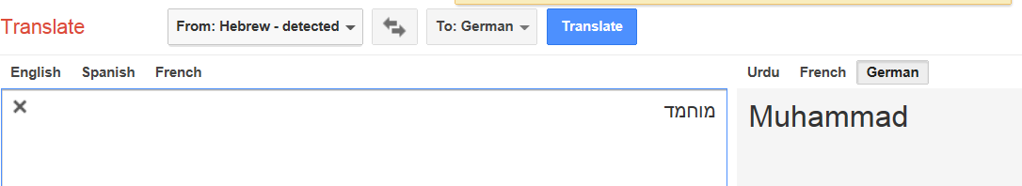

Conclusion:

The wrong translation Shir ha-Shirim, 5:16 | The correct translation Shir ha-Shirim, 5:16
"His mouth is most sweet: yea, he is altogether lovely. This is my beloved, and this is my friend, O daughters of Jerusalem." | "His mouth is most sweet: yea, he is Muhammad. This is my beloved, and this is my friend, O daughters of Jerusalem."-

It is stated in the Noble Qur'an "Surat Al-'A`rāf" verse number (157), that the name of the Prophet Muhammad (PBUH) was written in the Torah and the Gospel.

"Surat Al-'A`rāf" (157) of the Noble Qur'an in Arabic language | The translation for the meanings in English language
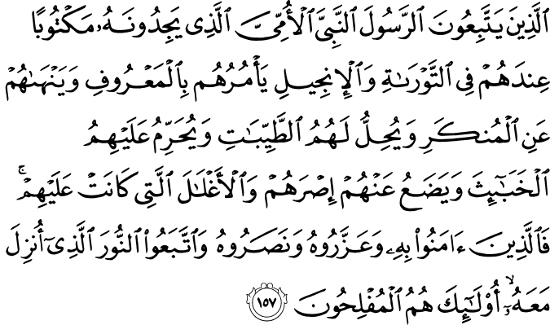 | Those who follow the Messenger, the unlettered prophet, whom they find written in what they have of the Torah and the Gospel, who enjoins upon them what is right and forbids them what is wrong and makes lawful for them the good things and prohibits for them the evil and relieves them of their burden and the shackles which were upon them. So they who have believed in him, honored him, supported him and followed the light which was sent down with him - it is those who will be the successful.

www.islamic-invitation.com

