ark<U cao|\jr[ L#l|k rHdjujMk= Lelgalu LrkYz |aldk'k cfUik;, LcfUik; SiGfjgj&[ arÍjhl)kilrk= cijSC<~kÓj t'k=f[. LfkeSulzj&[ sdl![ ark<UR :pUaluj ds!S\!f[ LisRy c{<[mlijsruldk'k. L#l|k LisRy LmjadX)[ rHdju asËlgk Lrk Yz|aldk'k LisRyumk)H cIJdlgUalu Tc[hl; t'f[. Tf[ dqjÉlH L#l|k ark<Ucao|\jr[ rHdjujMk= ihju LrkYz|aln[ Êa t'f[. Tc[hlajsRy DhJEulu KaykH ElyoD[éê eyuk'kî éTc[hlaj'[ SC<; ÊaSu)lX ijClh alu QgrkYz|ik; B*X)[ h>j&jMj#ê
t'lH TO a|\lu LrkYz|s\/Ëj ehgk; Lw[Bf ujhln[, Êauksm LaohUfsu eËj arÍjhl)juiG ixsg ijgxaldk'k. Shldgksm Salvr\jr[ Si!j ShldS\)[ rjSulzjfglu t#l YeilvdØlgk; fsRy YeS~lPr elfujH TO LrkYz|\jsRy alPkgU; gkvj&yjÉigk;, aËk=iG)[ Lf[ eAj/j&[ sdlmk\igkalujgk'k. KaGéyêsr Selshuk= a|lØlglu cI|l~l)X Lfjsr c;~r[Pj&[ ixsg S~lPilØlglujgk'k. c&gjfglu chEj en[}jf Ølgk; :elfujH fs'ulujgk'k cÖgj&jgk'f[.
rl; arÍjhlS)! YePlrs/M dlgUaln[ frj)[ igk' egJÊn*xjhk;, Yeulc*xjhk;, ~kÓjakMkdxjhk; TO LrkYz |a#lsf Sisy Qgk YefjijPjukaj#lsu' cfU;. ijCkÓ DkG:rjhk;, fjgkck'\jhk; ixsg zOgi\jH fs' Êasu/Ëj KnG\jufluj rak)[ dlnlrlik;.
cS|lpgl,,,à Lyjukd, Êa ijhSuyju Qgk gf[raldk'k. a|lf[al)X Lf[ dgzfal)kilR Si!j LfUPjd; enjs/Mjgk'k.
cS|lpgl,,, rJ TO LaohU cÙ\[ dgc[Fal)kilR Si!j YCaj&jMkS!l? LSfl rJ Lfjsr elql)j dxÉjgj)k dulSnl??? t(jH Lf[ dgc[Fal)kilR YCajS)! cau; LfjYdaj&jS#???
iGÑdmhlckdX aj'jfjx*k'f[ Selsh T|Shlds\ LrkYz|*X rjr)[ vkËk; f\jdxj)kduln[, cS|lpgl,,, rJ LfjH iÖjfrldlfjgj)kd, T|Shld; igk;Shldalu egShldS\)k= d{<jujmaldk'k, Tijsm ijf&iSr Lij sm ijxsimk)kilR clPj)kduk=o, ijf&lH alYf; Selgl, fsRy ijxsu rCj/j)k' dJm*xjH rj'k;, rlCdlgjdxjH rj'k; Lfjsr egjgÊjs&(jH alYfSa r+ksm LÓIlr\j sRy uFlGÒdohj rak)[ h>j)kduk=k, :ufjrlH Tijsm rj'k; Lrk>ijS)! Yeulc*xjhk;, ~kÓjakMkdxjhk; Êauih;~j)kd. LfjH L#l|kijSrlm[ cpl YelGÒj&[ sdl!jgj)kd. L#l|k eyuk'kî
éc|rik;, rac[dlgik;aoh; éL#l|kijsRyê c|lu; Sfmkd. Lf[érac[dlg;ê >d[fØlg#l\iG)[ ihju éYeulc ak=êdlgU; fs'uldk'k. f*xksm gÊjflikaluj d!kakSM !jigksa'k;, Li(Sh)[ fjgj&[ SelSd!j igksa'k; ijvl gj&ksdl!jgj)k'igSYf LiGé>d[fØlGê. LH~Dy- 45-46
Êa YeilvdØlgksm akD akYp.
dlhldlh*xjhluj iUfUc[f YeSpC*xjSh)[ rjSulzjfglu YeilvdØlG)[ f*xjH LG/jfalu K\gilpjfI rjG% |n\jsRy elfujH egJÊn*xksm rjh)l\ Yeil| alujgk'k SrgjSm!ji'f[. LfjhiG)[ roykSarj SrmkilR
1
clPj&f[ TO a|\lu LrkYz|; sdls!l'k alYfaluj gk'k. t#l YeilvdØlgksmuk; akDakYp fs'ulujgk'k Êa. ijCkÓ DkG:rjsRy :u\kdxk;, Yeilvd ivr*xk; Lfj'[ sfxjildk'k. LfjH domkfH dlh; Êaj& ro|[éLêsRy vgjYf; DkG:R rak)[ ig&[ fgk'k![. LS`|; 950 iG<)lh; fsRy YeS~lPr alGÏ\jH Êa uih;~j&k. aËk= Yeilvdgk; Tfj'eilpalujgk'j#.
éaocl)[ rl; Yzr[F; rHdj. LS`|\j'k SC<; fkmG&ul uj rl; pofØlsg Lu&k sdl!jgk'k. ay[uajsRy adrlu TOcl)[ rl; iUd[falu p{<[mlÔ*X rHdkduk;, LS`| \j'[ rl; egjCkÓlf[alijsRy ejR~h; rHdkduk; sv u[fk. t'jM[ rj*xksm Lmk\[ igkSÙlsqls) rj*X L |(gj)kduk;, vjh pofØlsg rj*X f=jdxukduk;, aËk vjhsg rj*X iPj)kduk; sv$kdulSnl?ê LH~Dy- 87
YeilvdØlgjH fs' domkfH Yeulc*X c|j&iglujgk'k Þp{@arîc[dglu YeilvdØlGß LiG c|j& c|r; cfU ijCIlcjdSxlm[ wJijf\jH edG\kilR Si!j L#l|k dHej)k'k![.
é:dulH p{@ arc[dglu sspi pofØlG Êaj&f[ Selsh rJ Êaj)kd. Ligksm écfU rjS<Pjdxksmê dlgU\jr[ rJ P{fj dlnj)gkf[. LiG)[ fl)Jfk rHds/mk'f[ éCjÊê LigjH SrgjH dlnk'pjic; edhjHrj'k= Qgk rlqjd Srg; alYfSa f*XéT|Shld\[ê flacj&jMk=ksi' Selsh LiG)[ Sfl'k;. Tsflgk Kp[S~lPraldk'k. t'lH Pj)l gjdxlu wr*x#lsf rCj/j)s/mkSal? ê L|[DlE[ - 35
YeilvdØlsg#l; fs' YeS~lPr alGÏ\jH Êauih;~j &k, ak|+p[ r~juk; LrkvgØlgk; Qgkelm[ Êaj&k, Licl r; cIÔ; rlmk;, iJmk; KSeÊjS)!ji'S/lX t#l; L#l|kijH LG/j&[ Êaj&[ sdl![ Lfjrk; f$lyluj. YeS~lPralGÏ; LYfsuxk/ak=f#, Lijsm Yeulcik;, ~kÓjakMkdxk; SrgjSm!jigkSÙlX YeilvdØlgksm wJijf\j H rj'k; elA; KXsdl![ p{@arc[dgluj cÖgj)kd.
Êa cfU ijCIlcjdxksm Lmulx;.
egadlgknjdsRy Lmjadxksm cI>li*X tÑj eyuk'jm \[ L#l|k eyÉ Qgk cI>lialdk'k Êa, Lfluf[ LiG f*X)[ SrgjSm!ji' t#l Yeulc*xjhk; Êa Lih;~j &fjsRy SegjH LiG)[ L#l|k a|\lu YefjEh; rHdk'fldk'k. :ufjrlH uFlGÒ cfUijCIlcj Lf[ fsRy wJijf\jH edG\kilR YCajS)!fldk'k. L#l|k eyuk'kî éL\g)lG)[ f*X Êaj&fjsRy SegjH écIGÏ \jHê K'falu c[Flr; YefjEhaluj rHds/mk'fln[. L>jilpUS\lmk;, calPlrlC;cSulmk; domj LiG Lijsm cIJdgj)s/mk'fkaln[. LiG LfjH rjfUilcjdxlujgj )k;. tYf r# flixik;, elG/jmik;ê EkGDlR - 75-76
rl; ÊajS)! cau;î
rl; ÊajS)!f[, Êaj&lH Eh; djMk' cau\ldk'k. Sdle; akSDr iSg! t#l Spl<*xk; i'fj'[ SC<; Êaj&jM[ YeSulwraj#. YeilvdØlgjH Tfjr[ rak)[ Qgkelm[ Kpl|gn*X dlnlR clPj)k'fln[. a)ujsh akC[gj)kdxksm KeYpi; c|j)lR dqjulsf i'S/lX Yeilvdrk; Lijmks\ LrkvgØlgjH vjhgk; domj fsRy ~r[Pk)xk; domjuk= fIlTEjSh)[ LHe; :CIlc;
2
h>j)kilR Si!j sv'S/lX fsRy ~r[Pk)xm); fs' Lealrj)kd alYfa# ds#yjukd Selhk; svu[fk, Lfjrl H ixsg ij<aik;, pkîDik; aoh; Yeilvd'[ fsRy S~l P; fs' rCj)kalylujgk'k. Tf[ ]qlrldlC\krj'k; d! fsRy gÊjfli[ ah)kH wj~lhjsr YeilvdsRy c;gÊn\jrk;, LYdajdsx CjÊj)kilrk; Si!j Lu)k duk!luj. YeilvdR Q'[ aOrlrkilp; rHdjulH afj, Lisg L#l|k Q'm(; rCj/j)kalujgk'k, t'lH Yeilv dR eyÉ aykemj r+ksm t#ligksmuk; dÑ[ fky/jS)! fldk'k. YeilvdR eyÉf[î Þigk; dlh*xjH Ligksm fhakydxjH :sg(jhk; L#l|kijsr alYf; :glPj)k'i gkuk!lSu)l; Lisg CjÊjS)!fj#, LiG Lyjij#l\ wr*xldk'k.ß YeilvdsRy Êaujsh Lfk#Ualu alf{d uln[ rak)jijsm dlnkilR dqjÉf[. ~kDlgj KÓgj)k s'lgk |pJcjH rak)j*srdlnlR clPj)k'k.ÞLrc[ ~[rkalhjd[éyêijH rj'[ rjSipr;î éD~yj'gjdjH rj'[ dg É[ sdl!jgj)k' Qgk c[YfJuksm Lgjdjhosm YeilvdRécê rm'[ Seldkduk!luj, YeilvdR : c[YfJSulm[ eyukd uk!lujî ÞrJ L#l|kijsr coÊj)kd, rJ Êaj)kdß L S/lX LiX eyÉkî Þts'~lPj& Yeulc; rjr)[ ~lPj &jMj#, rjr)fjsr/Ëj Lyjukdukaj#ß LiSxlm[ Lf[ Yeil vdrlsn'[ eyus/MS/lX LiX YeilvdsRy ilfjhjr mk\[sv'[ eyÉkî-YeilvdsRy Lmk\[ LiX elylikdlsg d!j#î- éfl(xlsn'[ trj)[ Lyjuj#lujgk'kß LS/lX YeilvdR eyukduk!lujî ÞÊa LfjsRy YeFa ZM\jhl dk'kß ê TfjH rj'k; rak)[ arÍjhldk'f[, ÊajS)!f[ fs' Sdleik;, iUcrik; dJq[s/mk\k' Licg\jhldk 'k. Lf#lsf Êa ssdijM[[ iSg! t#l d<[mfdxk; i'fj'[ SC<; Êaj&jM[ YeSulwraj#. fkmG'[ rl; SDpjS)!jigk;.
Êauih;~j)kilrk= dHer.
ijCkÓDkG:R Lmj)mj Êa ssdsdl=kilR Si!j cfU ijCIlcjdsx KnG\k'k![. raks)sÔ(jhk; ~kÓjak MkdSxl, Yeulc*Sxl igkSÙlX Lijsm r+X L#l|kij sRy YeJfj dl;Êj&[ sdl![ Êa Lih;~j&lH rl; fjØul uj dgkfjudlgU; rØuluj >ij)k'fluj rak)[ dlnlR clPjS&)l;. r+ksm wJijf\jH rj'[ fs' rak)fj'[ Qgkelm[ Kpl|gn*X rjg\lR clPj)k;. L#l|k eyuk'kî
ét'lH Qgk dlgU; rj*X siyk)kduk; éuFlGÒ\jHê Lf[ rj*X)[ zkndgalujgj)kduk; sv$l;. rj*sxlgk dlgU; T<[ms/mkduk; éuFlGÒ\jHê Lf[ rj*X)[ Spl<dgaluj gj)kduk; svu[sf'k; igl;. L#l|k Lyjuk'k, rj*X Lyjuk'j#.ê LH~Dy - 126
L#l|kij'[ Si!j Yeulc*xjH Êa Lih;~j&lH CYfk s)Xs)fjgjH L#l|k rs+ c|luj)kduk;, CYfk)xksm dkfYÔ*sx L#l|k Qgk elq[ Sihul)kduk; svu[Sf)l;. L#l|k eyuk'kî érj*X)[ i# SrMik; h>j)k' eÊ; LfiG)[ arîYeulcak!l)k;. rj*X)[ i# Spl<ik; SrgjMlH LigfjH cSÔl<j)kduk; sv$k;. rj*X Êaj)kduk;, coÊ[af elhj)kduk; sv$k' eÊ; Ligk sm dkfYÔ; rj*Xs)lgk KeYpiik; igk\kduj#. fJG&ul uk; L#l|k Ligksm YeiG\r*xksm t#l iCik; Lyjuk'irldk'k.ê :hk T;ylR- 120
3
écfU ijCIlcjdsx, rj*X Êaj)kduk;, ÊaujH ajdi[ dlnj)kduk;, YefjSglP c'Óglujgj)kduk; sv$kd. rj*X L#l|ksi coÊj&[ wJij)kd. rj*X ijwu; YelejS&)l;.ê :hk; T;ylR - 200
Êa ssdsdl=kduk;, egc[eg; Êa ssdsdl=kilR KeSp Cj)kduk; sv$l\iG akqkirk; r<[m\jhlsn'[ L#l|k coy\kH LcI[yjhosm YeDUlej)k'k. L#l|k eyuk'kî éijCIcj)kduk;, cHdG+*X YeiG\j)kduk;, cfU; ssdsdl=kilR LSrUlrU; KeSpCj)kduk;, Êa ssdsdl =kilR LSrUlrU; KeSpCj)kduk; sv$l\isglqjsdê LH LcI[G- 3 écfUijCIlcjdsx, rj*X c|rik;, rac[dlgik; aoh; éL#l|kijSrlm[ê c|lu; Sfmkd. fJG&uluk; Êaj)k' iSglsml/aldk'k L#l|kê LH~Dy- 15
éc|rik;, rac[dlgik; aoh; éL#l|kijsRyê c|lu; Sfmkd. Lf[érac[dlg;ê >d[fØlg#l\iG)[ ihju éYeul cak=ê dlgU; fs'uldk'kê LH~Dy - 45
YeilvdØlsg#l; fs' f*xksm cIcao|*Sxlm[ egc[e g; Êa ssdsdl=kilR KeSpCj&jgk'k, aocl r~jéLê fsRy cao|s\ Lfj'[Si!j Qgkelm[ KeSpCj&fluj rak)[ DkG:rjH dlnlik'fln[. aocl r~jéLê eyuk 'fluj L#l|k eyuk'kî éaocl fsRy wr*Sxlm[ eyÉkî rj*X L#l|kSilm[ c|lu; Sfmkduk;, Êaj)kduk; sv$kd. fJG&uluk; >oaj L#l|kijsRyfldk'k. LisRy plcØlgjH rj'[ LiR KS`Cj)k'iG)[ LiR Lf[ LidlCs/mk\j sdlmk)k'k. egUiclr; PG+rj<[A elhj )k'iG)rkdohalujgj)k;.ê LL[ylE[ - 128
Êa)k= YefjEh;.
Êassdsdl=k'iG)[ L#l|k a|\lu YefjEh; rHdk sa'[ ijCkÓDkG:rjH ilz[plr; rHdk'k![. L#l|k eyuk'kî é dkys&ls) >u;, eMjnj, Prr<[m;, wJir<[m;, ij>ir<[m; t'jiakSDr rj*sx rl; egJÊj)kd fs' sv$k;. éL\g; cÕG>*xjHê Êaj)k'iG)[ cSÔl <ilG\ Lyjuj)kdê LH~Dy - 155
Yeulc*xjhk;, ~kÓjakMkdxjhk; Êa Lih;~j)k'iG)[ L#l|k a|\lu YefjEh; Qgk)ksa'[ ilz[plr; rHdjuj gj)k'k. L#l|k eyuk'k éLiG)SYf f*xksm gÊjfl ij(H rj'[ LrkYz|*xk; dlgknUik; h>j)k'f[. Lig sYf cØlGÏ; Yelej&iGê LH~Dy - 157
éij<afdxk;, pkgjf*xk; SrgjmkSÙlqk;, ukÓg;z\k; Êa ssdsdl=kduk; svu[figlSgl Ligldk'k eknUilØlG. Ligldk'k cfU; elhj&iG. LiG fs'uldk'k éSpl< ~lPsuê coÊj&iG.ê LH~Dy - 177
éL#l|k Êaj)k'igksm dosmuldk'kê éLiG Êaj&f[ sdl ![ T'jfl BlriG)[ YefjEh; rHdjujgj)k'k. Lsf sÔ'lH LiG fs'uldk'k >lzUilØlGê LHakL[ajroR - 111 éL\g)lG)[ f*X Êaj&fjsRy SegjH écIGÏ\jHê K'falu c[Flr; YefjEhaluj rHds/mk'fln[. L>j ilpUS\lmk;, calPlrlC;cSulmk; domj LiG Lijsm cIjd gj)s/mk'fkaln[. LiG LfjH rjfUilcjdxlujgj)k;. tYf r# flixik;, elG/jmik;àê EkGDlR - 75-76
f*X Êaj&fjsRy SegjH LiG)[ g![ YeliCU; YefjE h; rHdksa'ln[ L#l|k eyuk'f[.
éL\g)lG)[ LiG Êaj&fjsRy Ehaluj Ligksm
4
YefjEh; g!kam*luj rHds/mk'fln[. LiG rØsdl![ fjØsu fmk)kduk; rl; LiG)[ rHdjujMk=fjH rj'[ svhiqj)kduk; sv$k;ê Dcc[ - 54
L~Jalhjd[ LH |lgjFj~[rk :cIjajH LC[|gjéyêijH rj'[ YeilvdRécê eyÉk, ÞCkÓj ijCIlc\jsRy >lzal dk'k, ãLH |;pkhj#l|[ä t'f[ fkhlc[ rjy)k'fldk'k, ãck~[|lr#l|[, LH|;pkhj#l|[ä :dlC>oajdX)jmujhk= fjsr rjy)k'fldk'k, rac[dlg; YedlCik;, plrPG+ *X sfxjik;, Êa sixj&ik;, DkG:R rjr)[ Lrkdo halSul, YefjdohalSul sfxjikaldk'k, t#ligk; Ye>lf \jH wJijfalg;>j)kduk; cIÔs\ cIu;fs' ijH)k duk; sv$k'k, vjhgfjsr Salvj/j)k'k, aËkvjhgfjsr rlC\jhl)kduk; sv$k'kß akc[hj;.
~kÓjakMkdxjH Êaj)kd.
~kÓjakMkdxjhk;, Yeulc*xjhk;, egJÊn*xjhk; Êa ssd sdl=kd. L*jsr sv$k'iG)[ L#l|k LxiË YefjEh; ilz[plr; rHdk'k.
édkys&ls) >u;, eMjnj, Prr<[m;, wJir<[m;, ij>i r<[m; t'jiakSDr rj*sx rl; egJÊj)kd fs' sv$k;. éL\g; cÕG>*xjHê Êaj)k'iG)[ cSÔl< ilG\ Lyjuj)kdê LH~Dy - 155
étYfsuYf YeilvdØlSglsml/; LSrd; sspiplcØlG ukÓ; svu[fjMk![à t'jM[ L#l|kijsRy alGÏ\jH f*X)[ SrgjM ulsfl'k sdl!k; LiG fxG'j#. LiG pOG~hU; dlnj)kdSul Qfk*jdomkdSul svu[fj#. L\ g; ÊalCJhsg L#l|k c[Sr|j)k'k.ê :hk T;ylR - 146
L#l|k tÔ[ dHej&kSil Lf[ tÔ[ fs'ulsn(jhk; arcl ilvl dGanl rm/jH igk\kdsu'fln[ Qgk akc[hjajsRy ~lPUf. Lfln[ L#l|kijsRy DhJhlu TY~l|J;, Tc[alTOHéLê t'J YeilvdØlgjH rj'[ rak)[ alf{d KXsdl=kilrk=f[. L#l|k eyuk'kî
ét'jM[ : ~lhR LS`|S\lsml/; Yeuf[rj)kilrk= Yelusa\juS/lX LS`|; eyÉkî tsRy dkÉkadsrà BlR rjs' Lyk)nsa'[ BlR cIe[r\jH dlnk'k. Lfksdl![ Srl)o rJ tÔln[ L>jYelus/mk'f[? LiR eyÉkî tsRy ejflsi, dHej)s/mk'sfSÔl Lf[ fl(X svu[f[ sdl=kd. L#l|k KS`Cj)k'eÊ; Êal CJhgksm doM\jH fl(X ts' ds!\k'fln[.ê cIlE[El\[ - 102
SaH ijigj&fjH rj'k; Êa)[ Tc[hl; rHdk' YelPlrU; rl; arÍjhl)j. :ufjrlH L#l|k dHej& Yedlg; Êa Lih;~j&[ sdl![ L#l|kijsRy af; wJijf\jH YeliG\jdal)lrk;, Lf[ wr*X)jmujH Yevgj/j)kilrk; rl; YCaj)kd. LfjsRy elfujH rak)[ SrgjSm!j igk' ~kÓjakMkdxjH Êauih;~j)kd, L#l|k Lfj'[ fOEJD[ rHdsM. :aJR.

domkfH Lyjukilrk;, eAj)kilrk; ~r[Ps/mkd.
SElNî 03- 3625500 x 1030

5

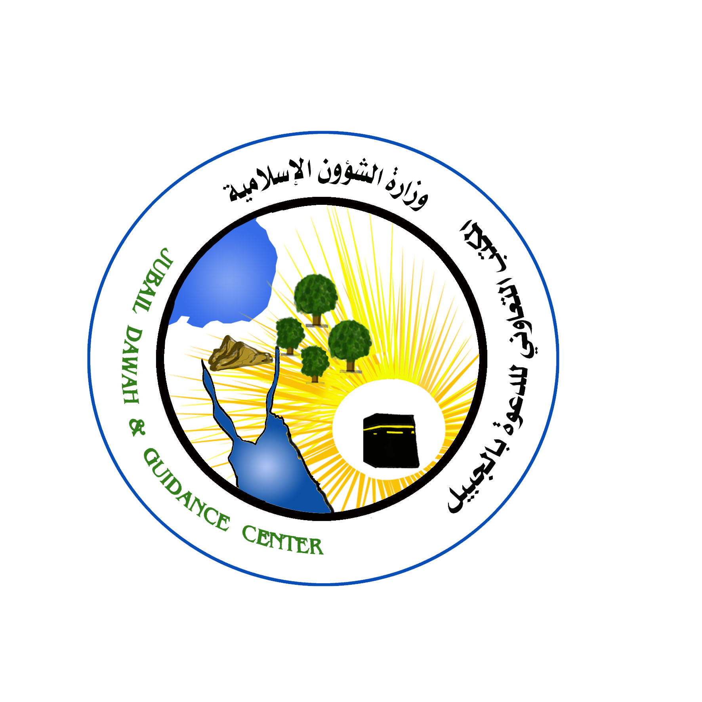

المكتب التعاوني للدعوة والإرشاد وتوعية الجالياتبالجبيل

قسم المسلمة

اعداد:
سيد سعفر صادق
الداعية بالمكتب

£a:
hnizmknbpsS apJap{Z

f$lyl)juf[î
c$jp[ c|[EG cIlpjD[
wkss~H pL[i scRyG

