ijCIlcjdX ixsg cSÔl<S\lsm cIJdgj)k' alcal n[ yaxlR. cIGz dilm*X fky)kduk;, rgd dilm *X sdlMjum)kduk;, ejClvk)sx ~r[Pj)kduk; sv$k' alc;. ijCkÓDkG:R LifJGnalu, :ujg; alcS\)lX K\aalu sshh\kH Dp[yk= alc;. L#l|k eyuk'kî ÞcfU ijCIlcjdsx, rj*X)[ akÙk =iG)[ SrlÙ[ rjG^r[Pal)s/Mjgk'f[Selsh rj*X )k; Lfk rjG^r[Pal)s/Mjgj)k'k. rj*X PG+ rj<[Auk=igluj\JglR Si!julnf[ß éLH~Dyî183ê
ycoHécê Lgkxjî ÞTc[hl; LÖk dlgU*xjH rjG+jf aln[…ß LfjH i{flrk<[Alrik; KXs/mk\jujMk![. é~kDlgj, akc[hj;ê
yaxlrjsh i{flrk<[Alr; rjG^r[Palsn'fjhk; Lf[ Tc[hlajsRy eÖc[f;>*xjshl'lsn'fjhk; akc[hj; cakplu; ]dl>jYelu)lgln[.
SYC<[Afî
i{fark<[Aj)k'f[ iG`j& YefjEh; h>j)k' a|\l u Qgk :glPrl dG+aln[. Dkp[cjulu |pJcjH fjgk pofGécê eyuk'kî Þ:p; cÔfjuksm QlSgl cHdG+ \jrk; e\kakfH tqkroy[ TgMjdxluj YefjEh; rHd s/mk;. L#l|k eyuk'kî SrlÙ[ Qqjsd, Lf[ trj)k =fln[. Blrln[ Lir[ YefjEh; rHdkdß éakc[hj;ê TO |pJcjH rj'[ fs' rak)[ SrlÙjsRy YeSfUd fuk;, SYC<[Afuk; arcjhl)lrlik'fln[. YeilvdR écê eyuk'kî ÞcIGz\jH y$lR ts'lgk dilmak![. SrlÙkdlG)[ alYfSa LÔUrlxjH : dilm\jhosm YeSiCj)lrldo. aËlG)k; Lfjhosm YeSiCraj#. Lijsm si&[ SrlÙ[dlG tijsm t'[ ijx;~g; K!l dk;. LS/lX Lisg#ligk; Lfjhosm dm'[ Seldk;. ejs' : dilm; Lm)s/mk;. Sisy :gk; fs' Lfj hosm YeSiCj)kduj#ß éak\EDkR Lssh|jê eknU* xksmuk; rØuksmuk; eo)lhaln[ yaxlR, Qgj)hk; iJ s!mk)lrlil\ dlh;, QlSgl ijCIlcjdxk; TO Lck h>licg; egaliPj KeSulzs/mk\kd.
SrlÙ[ rjuaal)jufjsh ffI;î
ark<U arÍjsr pkîcI>li*xjH rj'k; ijahJdgj)kd, >Ofjd ckDS>lz*Sxlm[ ijgd[fjuk!l)kd, CgJg\jH ejClvjsRy cÖlg\jr[ fmÍak!l)kd, elis/Migk sm YeC[r*xjH c|lrk>ofjuk; c|fleikak!ldkd, cGS%legj egShld vjÔuk!l)kd fkm*j Qgk ijCIl cjsu ijCkÓ wJijf\jr[ egjCJhr; rHdkilR Keuk d[falufln[ Yiflrk<[Alr;.
yaxlR i{f;, Yelu[C[vj\ i{f;, SrG&ul)ju iUf; fkm*ju rjG^r[Paluk; rjG%|jS)! iUf\jr[ rj$ \[éKS`C;ê LrjilgUaln[. rj$\[ t'[ eyukSÙlX LGÒayjul\ ilvd*X Kgkijmkdu#. ayj&[ arÍjH dgkfhldk'k. :ujCléyêujH rj'k; KÓgj)s/
1
mk' Qgk |pJcjH T*sr dlnl;. ÞYe>lf\jr[ akSÙ SrlsÙmk)nsa'[ fJgkalrj)l\ir[ SrlÙk!lujgj )kduj#ß éL|[ap[, T~[rk |j^lRê stVjd Yifal sn(jH Ye>lSflpu\jr[ SC<; SrlÙk akyjuk' c; zfjsul'kak!lujs#(jH edH cau\[ fs' KS` Cj&jgk'lhk; érj$\k!lulHê Lfk afjuldk'fln[. :ujCléyê eyuk'kf[ YCÓj)kdî ÞQgk pjic; éedhjHê r~jécê tsRyumk\[ dm'[ i'k Svlpj&k dqj)k ilR i#fkakS!l? BlR eyÉkî ÞQ'kaj#ß r~jécê eyÉkî Þt(jH BlR SrlÙkdlgrlikduln[ß éakc[hj;ê
SrlÙjsRy ck'\kdXî
1- DkG:R, pjd[y[ elglun;, plrPG+*X rjG% |j)kd, siyk)s/M dlgU*xjH rj'[ rlijsr rju YÔj)kd T~[rk L^lc[éyêijH rj'[ rjSipr;î Þr ~jécê wr*xjH si&[ ]Ëik; plrPG+; svu[fj gk' iUd[fjulujgk'k. yaxlrjsh QlSgl glYfjujhk; wj~[gJHéLê r~jécê)[ DkG:R QlfjS)X/j&jgk' S/lqln[ YeilvdR ]Ëik; domkfH plrPG+*X rjG%|j&jgk'f[. LS/lX Lmj&k iJCk' dlËjSr)l X PG+; rHdk'irlujgk'kß é~kDlgjê
2- :sg(jhk; fs' :SÊej)kdulsn(jH BlR SrlÙ[ dlgrlsn'[ K&\jH eyuk'f[ r#fln[. ~kDlgjuk; akc[hjak; K`gj& |pJcjH rak)[ Lf[ dlnl;.
3- L\lq; dqj)kdî YeilvdRécê eyuk'kîÞrj*X L\lq; dqj)kd, fJG&uluk; L\lq; dqj)k'fjH LrkYz|; K![ß éakc[hj;ê
4- L\lq; ejÔj/j)kd, SrlÙk fky)k'f[ sesM 'l)kdî r~jécê eyuk'kî ÞL\lq; ejÔj/j)kduk; P{fjujH SrlÙ[ fky)kduk; sv$k' dlhS\lx; tsRy cakplu; rØujH fs'ulujgj)k;ß éL|[ap[ê
5- TO\/q;, dlg), si=; t'ji sdl![ SrlÙ[ fky)kd, Lfs#(jH ]fk >Ên elrJualujgk 'lhk; afjulik'fln[. éL~o pliop[ê
6- SrlÙ[ fky)k' SixujH KS`Cj)k' t#l dlgU *xk; YelGÒj)kd. ÞSrlÙ[dlgsRy fkyijuksm cau \k= YelGÒr f=s/ml\fln[ß éT~rkalwê fky )k' SixujH flsq igk; Yedlg; YelGÒj)hk; ck'\ln[.
(ذَهَبَ الظَمَأُ وَابتَلت العُروق وَثبَتَ الأَجرُ إِن شَاءَ الله ) (رواه أبو داود).
Þpl|; fJG'k, L'rlxjdX TOyrnjÉk, TRClL[ L#l|[ L#l|kijsRy YefjEh; c[Fjgs/Mkß
7- ajc[il)[ sv$kdî. :ajyk~[rk y~JLî eyuk'kî Þr~j fjgkSarj SrlÙkdlgrlujgjs) fs' rjgiPj fin ajc[il)[ sv$k'f[ BlR d!jMk![ßéfjGajpj,ê
2
8- yaxlrjH fyliJ|[ rac[dgj)kd. |pJckdxjH rak)fjr[ sfxjikdX ds!\lrlik'fln[.
9- SrlÙ[ fky/j)kd. Þycohk#l|[ eyuk'kî ÞSrlÙk fky/j)k'ir[ : SrlÙkdlgsRy LYf fs' eknU; Srmlrldk;. t'lH Lulxksm YefjEh\jH ulsfl 'k; dkyi[ igjdukaj#ß éfjGajpj, T~[rkalwê
10- ãT|[fjdlE[ä Tgj)kdî YeilvdR Liclrs\ e\jH c[Fjgaluj T|[fjdlE[ Tgj)lyk!lujgks''[ |pJckdxjH dlnl;.
11- domkfH cf[dG+*X LPjdgj/j)kd. Þ:TCl éyê eyuk'kî ÞLiclrs\/\[ dm'[ i'lH fjgkSa rjécê Ky)ajx)kduk;, fsRy dkmk;~s\ KnG\k duk; :glPrlrk<[Alr*X)luj dAjr egjYCa; rm \kduk; sv$kalujgk'kß éak\EDkR Lssh|jê
KarJG SCDgj&[ Q'j&[ ijqk*k'fk;, ilu sdle[xj )k'fjhk; ao)jH si=; vJËk'fjhk; Lfjgkdij uk'fk;, :iCUaj#lsf >Ên\jsRy gkvjSrl)k' fk; SrlÙ[dlG)[ dyl|\ln[.
dxi[, ]<nj, egpo<n;, iq)[, Lc>U; t'ji iGwjS)!f[ t#l cau\k; rjG^r[Palsn(jhk; SrlÙkdlgR Tsf#l; KSeÊjS)!f[ YeSfUd; rjG ^r[Paln[. YeilvdsRy |pJc[ YCÓj)kdî ÞiUlw c;clgik; YeiG\rik; LijSid; dlnj)k'fk; QglX KSeÊj)k'js#(jH LulX >Ên elrJu *X iGwwj)nsa'[ L#l|kijr[ ulsflgk :iCU ikaj#ß é~lDlgjê
SrlÙrk<[Aj&lH Spl<ak!ldks'[ >us/mk' Sglzj, rac[dlg; Dc[yl)kilR LrkiprJualu ulYf)l gR érj*xjhlsg(jhk; SglzjulikdSul ulYfujhlikd Sul svu[flH aËk pjic*xjH rj'[ LYfuk; tÑ; éSrlsÙmkS)!fln[êß éLH~Dyî 184ê, fkm*juiG)[ SrlÙ[ Qqjil)l;. edg; SrlË[ iJMjulH afj.
ÞulYf)lgR SrlÙrk<[Aj)kd eknU\jH seMf#ß éak\EDkR Lssh|jê Trj SrlsÙmk\lH Lf[ afjulik'fln[.
:G\idlgjuk; Yeci gd[f)lgjuk; SrlsÙlqjil) n;. ej'Jm[ SrlËkiJMn;. TiG)[ SrlsÙmk)H LrkiprJua#. Ligksm SrlÙ[ |yl; fs'uln[.
4- zG>jnjuk; akhuoMk'ixk;î LiG)k; dkMjdX)k; Q'jS&l, Lf# LiG)[ alYfSal ~kÓjakMk!liksa' >uaks!(jH SrlsÙlqjil)l;. t'lH SglzjsuSel sh SrlËk iJSM!fk![. t'lH LiG)[ YeC[raj# dkMjdXs) YeC[rak=ksi(jH SrlsÙlqjil)l;. esÊ, SrlËk iJMkduk; Q/; QlSgl pjic\jrk; QlSgl Lzfj)[ >Ên; rHdkduk; Sin;. L#l|k eyÉkî ÞésBgk*js)l![ alYf;ê Lfjrk clPj)k'iG éedg;ê Qgk elis/Mi'k= >Ên; YeluC[vj\aluj rHSd!fln[ß éLH~Dyî 184ê
3
SrlsÙmk)lrlil\ i{ÓR, S>paliksa' YefJÊuj #l\ Sglzj TiG)[ SrlÙ[ Qqjil)l;. edg; QlSgl pjic\jrk; QlSgl Lzfj)k; L'lMjsh Lg cIlL[ >Ên; rHdn;. ak*j agj)kilR Seldk'ulsx gÊj)lSrl, wj|lpjr[ Si!jSul SrlÙ[ akyj)k'iR. Li'fjr[ Lrkilpak![.
T\g; dlgn*sxl'kaj#lsf SrlsÙlqjil)lrrk ilpaj#. arîeoG%; SrlsÙlqjil)julH Lirk dkËak![. LiR fO~ sv$kd rjG^r[Paln[. SrlËk iJMkduk; Sin;.
SrlÙ[ LclPkildk' dlgU*Xî
yaxlrjH arîeoG%; >ÊnSal elrJuSal Lfjrk fk#Ualu z[xoS)lc[ TÖd[<Srl gd[f; duËShl fkm*jui sv$H. t'lH z[xoS)lc#l\ TÖd[< rlsn(jH SrlÙk akyjukduj#. Qqjil)hln[ r#f[. ay'k sdl!ln[ >Ên; dqj&sf(jH dkq/aj#. ycoHécê eyuk'kî ÞSrlÙkdlgrlujgjS) ay'[ sdl ![ :sg(jhk; fj'kdSul dkmj)kdSul svu[flH LiR SrlÙ[ eoG\jul)sM, L#l|kiln[ Lisr fJËkduk; dkmj/j)kduk; svu[ff[ß é~kDlgj, akc[hj;, L~opliop[, fjGajpjê
ilujhosmSul ao)jhosmSul i#fk; Ld\[ dm)kd, t'lH cIÔ; T<[mYedlga#lsf i# TO&Sul sel mjSul Ld\[ dm'lH Qgk YeC[rikaj#. arîeoG%; VG`j)H. t'lH VG`ji'lH dkq/aj#.
cIÔ; YeiG\jsdl![ TYÕju; ekys/mH. c;Sulz Sal, vk;~rSal, c[eGCrSal, SrlMSal, cIu;S>lz Sal Tisuls) dlgnaldl;. sdlÙ[ si&jSMl, c; >lir rHdkilSrl CgJg\jH rj'k; gd[f; tmk)H. t'lH gd[f; egjSClPj)kilSrl es#mk)H akyji[ Tfjhosmsuls) igk' LHe; Svlg SrlÙjsr ~l Pj)kduj#. :G\i gd[fik; Yeci gd[fik;. Tfk !lik'f[ cogUlc[far\jr[ sflMk akÙlsn(jhk; Cgj SrlÙk akyjuk;. c;Sulz;. c[Dhrak!lulhk; Ts#(jhk; Cgj SrlÙk akyjuk;.
SrlÙ[ akyjuk'fjsRy rj~r[PrdXî
SrlÙ[ akyjuk' dlgU*sx c;~r[Pj&[ Lyjik=i rlujgj)n;. Lyjij#l\irlujgj)gkf[. QlG+Sulsm ulin;. ay'[ sdl!ligkf[. rjG~r[PjfrlujMldgk f[. cIÔ; T<[mYedlgalin;. Lyjij#lsfSul KS`C aj#lSfSul SaHeyÉ SrlÙk akyjuk' dlgU*xjH ]sf(jhksal'[ svu[flH SrlÙk akyjukduj#. Srl Ù[ clPkiluj fJgk'fln[.
ck'\[ SrlÙkdXî
]Ëik; SYC<[Aalu SrlÙ[ pliop[éLêukSmfln[. Qgk
4
pjic; SrlsÙmk)k; Lmk\ pjic; Qqjil)k;. é~kDlgj, akc[hj;ê
yaxlR alc\jr[ SC<; ]Ëik; SYC<[Aalu SrlÙ[ L#l|kijsRy alcalu ak|Gyalc\jsh SrlÙln[. éakc[hj;ê LfjH ]Ëik; YePlr; ak|Gy; QÙfk; e\k;. ak|Gy; e\jsRy SrlÙ[ dqjÉiG<s\ ele *X)[ YeluC[vj\aln[. e\jr[ akSÙl ejSÙl Qgk pj ic; éQÙSfl, efjsrlS'lê SrlsÙmk)k'f[ ixsg eknUak= dlgUaln[.
C%lhjsh :yk pjic\jsh SrlÙ[. akc[hj; rjSipr; svu[f |pJc[. ÞyaxlrjH SrlsÙmk\jM[ LfjsRy fk mG&uluj :yk pjic; C%lhjH rj'k; SvG\lH :uk<[dlhs\ akqkiR SrlÙjsr Selsh :ujß
pkH |jwwî Q'k akfH QRef[ isg. LfjH YePlr; QRef[. LyEl pjr;. 9 sh SrlÙ[ g!k iG<s\ ele*X selyk)s/mk;. t'lH |w[w[ sv$k'i G)[ TO SrlÙj#.
t#l alcik; ao'[ pjics\ SrlÙ[. LfjH ]Ëik; YePlr; 13, 14, 15 sixk\ pjic*X t' Segjhyju s/mk' L$lakH ~Jx[.
t#l fj(xk; iUlqik;. |pJc[ YCÓj)kd. ÞdG+*sxl s) L#l|kijsRy akÙjH caG/j)s/mk' pji c*xlnjf[. SrlÙkdlgrlujgjs) tsRy dG+*X caG/j)k'f[ BlR T<[ms/mk'kß
yw~jsh SrlÙ[, si=julq[v alYfaluj SrlsÙmk)k 'f[, c;Cu pjic; SrlsÙmk)k'f[, CL~lR efj rÖjr[ alYf; SrlsÙmk)k'f[ t'J SrlÙkdX siyk )s/Mfldk'k. dlgn; |pJckdxjH T*sruk= SrlÙjr[ ulsflgk Lmjc[Flrikaj#.
g![ segk'lX pjic; SrlsÙmk)k'f[ rj<jÓaln[. Lf[Selsh L$lak\C[gJDjH ~hjuyk)kilR dqjul \ |lwjalGs)lqjsd SrlsÙmk)k'f[ rj<jÓaln[.
sshh\kH Dp[Gî
ÞfJG&uluk; rl; Tfjsr éDkG:rjsrê rjGÑu\j sRy glYfjujH Lifgj/j&jgj)k'k. rjGnu\jsRy glYfj t'lH tÔlsn'[ rjr)yjulSal?, rjGn u\jsRy glYfj :ujg; alcS\)lX K\aaldk'k. ah)kdxk; :f[alik; Ligksm gÊjflijsRy t#l dlgUs\ c;~r[Pj&kak= K\gikaluj : glYfjujH Ty*j igk'kß éDp[Gî 1-5ê
YCÓj)kdî
ihju LCkÓjSulsmuln[ QglX Kngk'sf(jH Li R L\lq; dqj&[ SrlsÙmk)n;. ck~|j)[ SC<; dkxj&lhk; afjulik'fln[. :G\idlgjuk;, Yecig d[f)lgjuk; ck~|j)[ sflMkakÙ[ CkÓjulukhk; SrlÙ[ tmk)n;. ck~|j)[ SC<; dkxj&lhk; afjulik'fln[.
5

المكتب التعاوني للدعوة والإرشاد وتوعية الجاليات بالجبيل
قسم الجاليات المسلمة
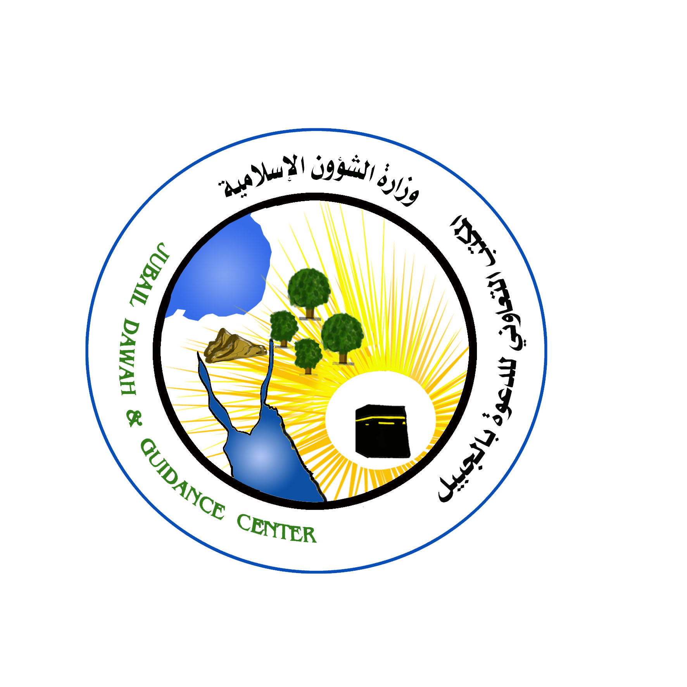

اعداد :
سيد سعفر صادق
الداعية بمكتب الدعوة وتوعية الجاليات بالجبيل

dafm³ amkw

f$lyl)juf[î
c$jp[ c|[EG cIlpjD[
wkss~H pL[i scRyG
مليالم رقم العام

