Common Mistakes in Hajj
{الأخطاء الشائعة في الحج}
{إنجليزي-English}

Prepared by Muhammad Al Shareef

Source:
http://www.jannah.org

Islamic Propagation Office in Rabwah, Riyad
المكتب التعاوني للدعوة وتوعية الجاليات بالربوة بمدينة الرياض
1430-2009


{الأخطاء الشائعة في الحج}
(إنجليزي)

أعده / محمد الشريف

Source:
http://www.jannah.org

Islamic Propagation Office in Rabwah, Riyadh
المكتب التعاوني للدعوة وتوعية الجاليات بالربوة بمدينة الرياض
1430-2009
A- In ‘Aqeedah (the Muslim’s Belief)
1. Many pilgrims when they travel to Madinah, they pray to the graves. They make du’aa’ to Rasul Allah (peace be upon him). This could not only ruin their Hajj, it could nullify their Islam.

2. Do not rub graves for barakah.

3. Do not make du’aa’ to anyone except Allah ta’aala.

4. When going to Madinah, your initial intention should be to visit Masjid An-Nabawee, the Prophet’s Masjid.
B- In Ihraam
1. Do not pass the Meeqaat without being in the state of Ihraam. If you are landing in Jeddah and going to Makkah to perform Umrah directly, you must be in a state of Ihraam before you land, as the plane shall enter the Meeqaat. Jeddah is inside the Meeqaat.
2. If you are landing in Jeddah, you need your Ihraam towels with you on the airplane in your carry-on bag.
3. Women may wear anything Islamically permissible for Ihraam.
4. Do not take pictures of yourself in Ihraam. You came to worship Allah and taking pictures for showing others later may contradict your sincerity of doing this for the sake of Allah.

5. Women in their menses must be in a state of Ihraam when they pass the Meeqaat. They should shower and do talbiyah like everyone else.

6. Do not uncover your right shoulder until you reach the Ka’bah and begin Tawaaf. This is the time that the Messenger uncovered his shoulder and it is an act of Hajj, so we must follow when the Prophet did it.
7. You may change your Ihraam towels if they get dirty.
8. You do not enter into Ihraam by just wearing the towels. You must make the intention to begin.
9. Do not shave your beard, whether before, during or after Ihraam.
10. You should wear sandals, but if you do not have sandals, you do not have to walk barefoot. Wear what you have until you find a place to get sandals.
11. When beginning your Ihraam for Hajj, do it from where you are: in your hotel, on the street, etc. You do not have to go to the Ka’bah to start your Ihraam for Hajj.
12. Do pay attention to what you are saying when you are making the Talbiyah: Labbayk Allahumma Labbayk…
13. When you hear that you are not allowed to wear stitches in Ihraam, know that what is meant is that you cannot wear pieces of cloth that are sewn together to wrap your body, such as a T-Shirt or underwear.
14. Both men and women may shower with unscented soap. Yes, for women and men, you may comb your hair, as the Prophet’s wives used to do when they were in Ihraam.
C - In Tawaaf

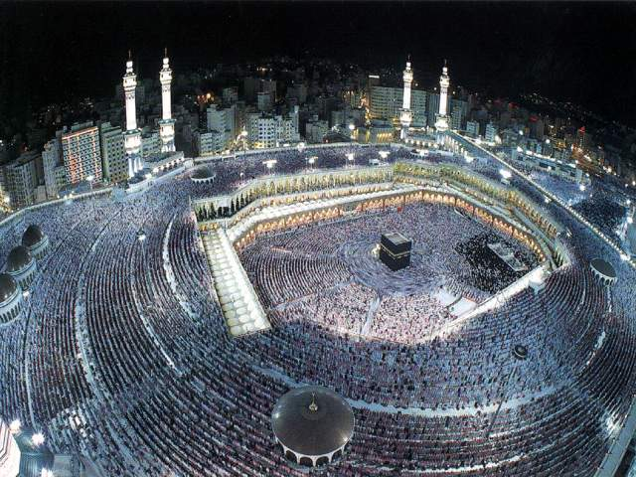
1. You do not have to say your intention out loud to begin Tawaaf. Saying intentions out loud is something the Prophet (peace be upon him) never did except after Ihraam when he said, “Labbayk Allahumma Umrah wa Hajj.”
2. You do not have to touch the black stone for your Tawaaf to be accepted. If it is crowded you may face your hand toward the stone and say Allahu Akbar.
3. Do not kiss the Yemeni corner. You may only touch it.
4. Do not worship the black stone. You are glorifying Allah by coming to this house and worshiping Him, following the Sunnah of Rasul Allah (peace be upon him).
5. Do not follow those du’aa’ books that make up du’aa’ for each time you go around the Ka’bah. Read Quran and make du’aa’ from your heart and glorify Allah.
6. Make du’aa’ by yourself, do not do it in a shouting group around the Ka’bah.
7. Do not wipe the walls of the Ka’bah during Tawaaf. Rasul Allah did not touch anything other than the black stone and the Yemeni corner.
8. Do not hurt anyone to kiss the black stone.
9. Do not face your hand to the Yemeni corner and say Allahu Akbar. This is only for the black stone.
10. Do not push or hurt anyone during Tawaaf.
11. The Ka’bah should be to your left. Do not do Tawaaf with your back to the Ka’bah.
12. Do not stand at the black stone line for a long time. Move on.
13. Do not lengthen your 2 rak’ahs of Tawaaf.
14. There is nothing in the Sunnah about: Du’aa’ Maqaam Ibraheem. After you pray the 2 rak’ahs of Tawaaf, move on.

D - In Sa’i (Going between As-Safa and Al-Marwah)
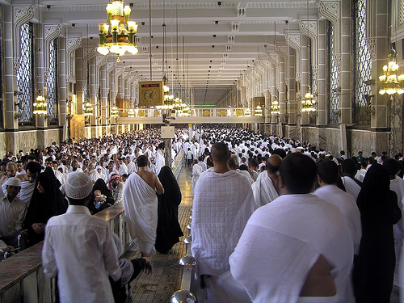
1. Although preferable, you do not have to have wudu’ during Sa’i.
2. You do not have to climb to the top of As-Safa or Al-Marwa.
3. You can take breaks in Sa’i to drink water or rest.
4. You can take a break after Tawaaf, before Sa’i.
5. You do not have to jog the whole way, from As-Safa to Al-Marwa. Only within the green lights, the valley of As-Safa and Al-Marwa.
6. Women do not have to run between the green lights.

7. There is no specific du’aa’ to say between As-Safa and Al-Marwa.
8. Do not miss the du’aa’ that Rasul Allah (peace be upon him) said when he stood on As-Safa. Then raise your hands and pray as he did (peace be upon him).
9. Do not say your intention out loud before making Sa’i.

E -When Shaving or Trimming:
1. Shave your complete head, do not leave parts unshaved.

2. If you shall trim, take from all sides of your head.
3. Do not take off your Ihraam until you have shaved or trimmed. You are still in Ihraam until you do so.
4. Do not shave your beard.

F - In Mina, ‘Arafah, and Muzdalifah:
1. Many people do not confirm if where they are located is inside or outside the borders of the holy sites. Confirm.
2. Do not reserve a place that is more than your need. Many people are looking for places to sit down and sleep.
3. Only in ‘Arafah and Muzdalifah do you shorten and combine prayers. In Mina only shorten your prayers, but pray them at the correct time.

4. Do not waste your Hajj time in vain chatting.
5. Spending the 8th day in Mina is the Sunnah of Rasul Allah. Many people skip this and go to ‘Arafah.
6. Do not push anyone when you are in a crowd.

7. You do not have to go to Mt. of Mercy in ‘Arafah. Many people hurt themselves and others to be there even though it is not a waajib (obligatory) thing to do.

8. Mt. Rahmah (mercy) is not a holy mountain. Do not wipe its sand and rocks for barakah.
9. You do not have to pray Dhuhr and Asr on ‘Arafah day in the Masjid of ‘Arafah (Masjid Namirah). You may pray in your tent with your group.
10. Do not leave ‘Arafah before Maghrib time.
11. Women should avoid getting into a crushing crowd, like in Masjid Namirah.
12. Do not face Mt. Rahmah on ‘Arafah day when you make du’aa’. You should face the qiblah.
13. You should not treat your time in ‘Arafah like any other day. You should realize the significance and pray to Allah in humility.
14. At Maghrib time in ‘Arafah, do not pray Maghrib and ‘Ishaa’ until you reach Muzdalifah, even you reach there at 11:00 at night. However, if you see half the night approaching, pray where you are on the road.

15. Make sure you are in Muzdalifah before you stop and rest. Many people think they are in Muzdalifah but they are not. Look for the border signs. If you have not seen one, chances are you are still not in Muzdalifah even if you see others sleeping on the road.
16. After praying Maghrib and ‘Ishaa’ in Muzdalifah, go to sleep immediately, this is what Rasul Allah (peace be upon him) did.

17. Through all of this, continue doing your Talbiyah.

G - In Stoning the Jamaraat:
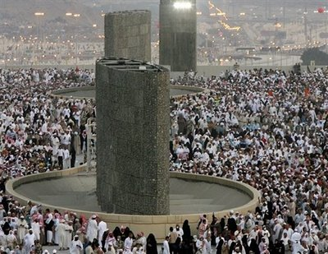
1- The Jamaraat are not devils, and Shaytaan is not tied up for the stoning of himself. Hajjis that hold this misconception end up cursing, swearing, throwing sandals, etc. It is a commandment from Allah to glorify Allah by saying ‘Allahu Akbar’ with each pebble.

2. You do not have to wash your stones.
3. Do not throw sandals or wood or big rocks. This is all against the Sunnah.
4. Do not hurt/shove when at the Jamaraat.
5. Say Allahu Akbar with each pebble. Do not say Bismillaah.
6. Throw the pebbles separately.
7. Make du’aa’ after the first and second Jamaraat.

8. Do not throw the Jamaraat before it is time.

9. Throw the Jamaraat from small to medium to large. Not the other way.
10. If someone is throwing on your behalf, you must be unable to throw yourself.
11. If someone is throwing on your behalf, you do not have to collect the stones yourself and hand the stones to that thrower.
12. Throw seven pebbles, not more or less.

H - In Tawaaf Al-Wadaa’ (Farewell Tawaaf):
1. You cannot do your final Jamaraat after Tawaaf Al Wadaa’, as some people attempt.
2. Do not walk in massive groups during Tawaaf. This hurts many people.
3. You MUST spend the night in Mina on the 10th night and 11th night. The two days of Hajj, the days of Mina, are the 11th and 12th, not the 10th and 11th.
4. After Tawaaf Al-Wadaa’ you must leave Makkah, or else another Tawaaf should be made.
5. After Tawaaf Al-Wadaa’ you may have lunch or wait at a bus, etc., as long as you are on your way out of Makkah.

I - In Madinah:
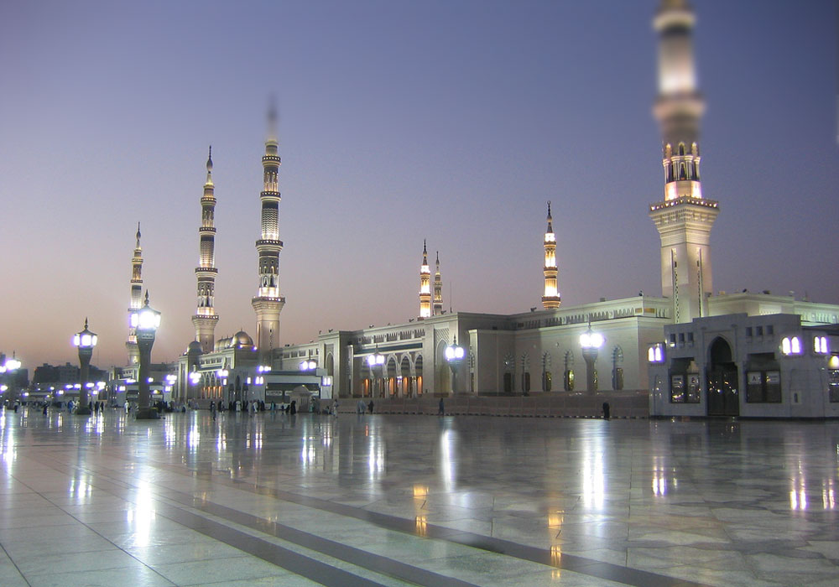
1. Visiting Madinah has nothing to do with your Hajj. It is something different and separate.

2. Do not wipe or kiss any walls for barakah. It is only rock and marble.

3. Do not raise your voice near the Prophet’s grave.
4. Do not do Tawaaf around the Prophet’s grave.
5. You do not need Ihraam to enter Madinah.
6. Do not make du’aa’ to the Prophet. Du’aa’ is to be made to Allah and Allah alone.
7. If you want to pray for the Prophet to intercede for you on the day of Judgment (Shafaa’ah), pray to Allah for that. “O Allah, allow Your Prophet to intercede for me.”

8. Do not raise your voice in du’aa’ near the grave. Face qiblah and leave the grave area when you want to make du’aa’.
Miscellaneous:
1. Do not add the term Haajj to your name after returning home.
2. Hadith such as: “whoever visits my grave, I shall intercede for them.” Hadith to this effect are lies against Rasul Allah (peace be upon him).

A Final Note:

The Muslims in these mistakes are three:
1. One group is sincerely ignorant of these things and they have little clue that what they are doing is haram or incorrect. For these people – in shaa’a Allah - there is nothing upon them.
2. A second group is ignorant, but they have the ability to learn and find out. All that stops them from doing so is their laxness in studying and asking. For these people, it is feared that they may be sinful for their laziness in learning.
3. A third group is aware of these mistakes. They perform it however to either follow their culture or to misguide people. This person is sinful and they shall assume the sin of those that they misguide.
“Our Lord, do not take us to account if we forget or make a mistake” (Al-Baqarah: 286)

