The Claim of the Numerical Miracle of the Quran
(English)
ادعاء الإعجاز الرقمي في القرآن الكريم
( إنجليزي )

Dr. Abu Ameenah Bilal Philips
د. أبوأمينة بلال فيليبس

http://www.Bilalphilips.com

Rashad Khalifa, an Egyptian biochemist educated in the United States claimed to have discovered an intricate mathematical pattern involving 19 and its multiples throughout the Quran and especially what he calls the Quranic initials which precede 29 chapters (Alf, Laam, Meem, etc.). However when critics began checking his numbers, they found numerous discrepancies and some outright fabrications in his data.
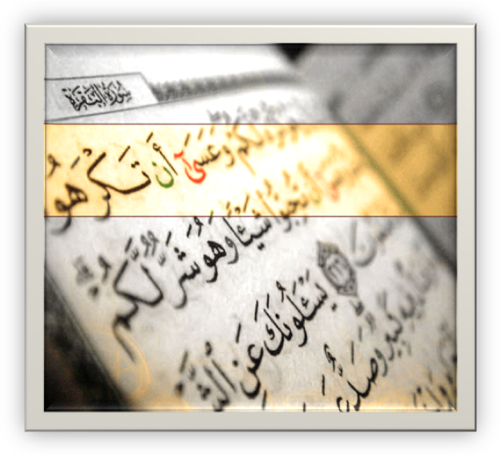
The most famous proponent of this idea was Rashad Khalifa, an Egyptian biochemist educated in the United States. According to Dr. Khalifa, there is a miraculous numerical code to the Qur’aan based on its “first” verse (Bismillahir-Rahmaanir-Raheem), which consists of 19 letters. This miraculous code is supposedly referred to in verse 30 of Chapter 74 (al-Muddath-thir) which states “Over it are 19.” Based on these two premises, Dr. Rashad claims to have discovered an intricate mathematical pattern involving 19 and its multiples throughout the Qur’aan and especially in what he calls the Qur’aanic initials which precede 29 chapters (Alif, Laam, Meem, etc.).
From this discovery, Dr. Khalifa concludes that the complexity of this mathematical code’s pattern in a literary work of the Qur’aan’s size is far beyond human capabilities, and that it alone constitutes the only real miracle of the Qur’aan which proves its divine origin.
He further concludes that 19 and its multiples represent the key to the correct interpretation of the Qur’aan and Islam, and the reason why 19 was chosen is that 19 means “God is One,” which is the message of the Qur’aan.
Many Muslims at first received Khalifa’s theories with uncritical enthusiasm. However, when more rigorous critics began checking his numbers, they found numerous discrepancies and some outright fabrications in his data. His claims were based on the number of times a given letter or word occurs in a given soorah or group of soorahs.
It was discovered that he would sometimes treat hamzahs like alifs and sometimes he wouldn’t, depending on the totals he needed in a given soorah to confirm his theory. Sometimes he counted letters that weren’t there, sometimes he failed to count existing letters, sometimes he counted two words as one, sometimes he added to the Qur’aanic text and sometimes he deleted from it, all for the purpose of making the letter and word counts conform to his theory.
On top of that, his letter counts changed over time, depending on whether he wanted to establish a pattern for a soorah by itself or as part of a group of soorahs. When confronted with inconsistencies in his data, he began claiming that certain verses had been inserted into the Qur’aan that did not belong there.
After this clear statement of disbelief he went on to claim knowledge of the exact date of the Day of Judgment and eventually claimed prophethood for himself. He attracted a group of followers in Tucson, Arizona, but his career was cut short when he was stabbed to death by an unknown assailant in 1990.

