Shiism and Islam (Part 1 of 2)
(English)
الشيعة و الإسلام ( 1 )
( إنجليزي )

http://www.islamreligion.com

One of the most perplexing scenarios to non-Muslims and new Muslims alike is the division they may see between Shiites and Sunni Muslims. Some tend to become confused when they see that each group claims to be following the true Islam.
To truly understand this subject to the fullest, one must delve into the early history of Islam and see under what circumstances this division actually began, a study far from possible for most people.
Another way, much more in the scope of the average person, is to analyze which group is true to the teachings of Islam, a simple comparison may be done between Sunni and Shiite beliefs and practices in relation to textual evidence, the Quran – the revealed word of God, and the Sunnah – or teachings of Prophet Muhammad, may the mercy and blessings of God be upon him.
Many times, people see this division to be a major one, while the fact remains that Shiites only make up a mere 8 percent of the Muslim population, reaching even this figure after taking hold of certain important political regions in history.
Not a division, one can confidently say that the Shiites are but one of the various splinter groups which left the pure teachings of traditional Islam.
Sunnis, on the other hand, are not a splinter group, but merely name themselves as such to differentiate themselves from the Shiites and other deviant sects.
The word “Sunni” itself comes from the term “Sunnah”, explained earlier to be the teachings of Prophet Muhammad, for they are strict in abiding by these teachings without any introductions, interpolations, or omissions.
The word Shiite (Shi’a in Arabic) means a “party”, “sect”, “supporters” or a “group of like minded individuals”. God says in the Quran addressing His Prophet, Muhammad:
“Verily, those who divide their religion and break up into sects (Shi’a), you have no concern in them in the least. Their affair is only with Allah, Who then will tell them what they used to do.” (Quran 6:159)
Although the specific groups called the Shiites is not what is directly intended in this verse, it is inclusive of them.
When one studies a bit of history, they will see that the term Shiite was first used amongst the Muslims in regards to a political issue over which the Muslims varied, 37 years after the death of the Prophet. Although the Shiites claim that their origin lies in that scenario, the actual term Shiite being used to denote this specific sect actually occurred much later in history.
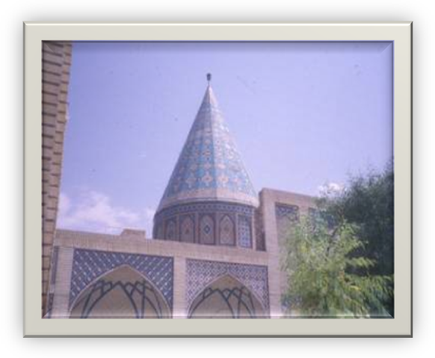
In either case, it is clear that the term was unheard of during the time of the Prophet, and thus we can say that the Shiites were a group which appeared after the death of the Prophet.
Over the long evolution of Shiite thought, they incorporated many foreign concepts into their faith. Starting as a political opinion which favored some views of Ali, the cousin of the Prophet, over some other companions, it became a sect purporting strange ideas foreign to Islam. This was due mainly to the fact that this ideology was mainly espoused by people in areas far from the centers of Islamic learning, namely Persia, those who were either new to Islam, had either converted to Islam nominally, and were living in areas where a large percentage of people remained upon their previous religions.
The Shrine of the Zoroastrian, Abu Lu’lu’ah, in Kashan, Iran, venerated by Shiites
Thus the Shiites became fertile soil to the introduction of foreign ideas, which they struggled to incorporate into some aspects and beliefs maintained by Islam, resulting in a sect composed of ideas stemming from Judaism, Zoroastrianism and Islam.
Not strange is it then that we see that one of the most important shrines in Shiism visited by many Shiites is that of Abu Lu’lu’ah, a Zoroastrian who died after the Caliphate of Umar, located in the city of Kashan in present day Iran. Muhammad Ali Mu’zi, an Iranian Shiite researcher in France, stated:
“The basic fundamentals of the Zoroastrian religion have entered into Shiaism even in some minute issues. …And this relationship marked the brotherhood between Shiaism and the ancient Magian Iran.”
We will now take a brief look at Shiism from just one aspect, that of beliefs. From these few examples, one will clearly see how different it truly is from the religion of Islam brought by Prophet Muhammad.
There are various articles of faith in Islam, and from them branch other beliefs which must be held by all who attribute themselves to Islam. They are as mentioned in the verse:
“…but piety is that one has firm belief in God, the Last Day, the angels, the scriptures and the Prophets…” (Quran 2:177)
This is also mentioned in a statement of the Prophet, may God praise him:
“Faith is that you believe in God, the angels, the scriptures, the Prophets, the Last Day...” (Saheeh Muslim)
This short discourse will merely touch on some of these various aspects of faith, and mention just some of the beliefs of the Shiites and how they differ from Islam.

Belief in God
The proper belief about God, or creed is the most important aspect of the religion of Islam. During the first 13 years of Muhammad’s Prophethood, he corrected people’s beliefs about God, warning them against calling to others besides God, whether angels, prophets, saints, martyrs, trees, stones, stars, or idols.
He clarified that only God alone, the One who created them was to be worshipped. Very few legislations and acts of worship were revealed for this period.
The majority of the Quran itself calls to this belief. God says in the Quran that calling to others besides Him is a sin worthy of eternal damnation in Hellfire:
“Verily, whosoever sets up partners in worship with Allah, then Allah has forbidden Paradise for him, and the Fire will be his abode.” (Quran 5:72)
This is an uncompromising belief in Islam, and is the basis from which one enters the fold of Islam. We find, however, that Shiites believe in the veneration of others besides God. Homage is to be paid to great saints and martyrs, such as Ali, Hussein, Fatimah, their Imams, and they are directly called out to in times of need.
They believe that they can answer their calls as well as intervene for them with God, a belief that according to Islam is clear disbelief. God says:
“Is not He (God) Who responds to the distressed one, when he calls Him, and Who removes the evil.” (Quran 27:62)
Another important tenet which Shiism clearly violates is the concept that God Alone administers the affairs of the universe, and it is He alone who knows the Unseen. Shiism attributes these powers to their leaders, called Imams, and places them in a position higher than the Prophets and angels. God says:
“Say: ‘None in the heavens and the earth knows the unseen except Allah, nor can they perceive when they shall be resurrected.” (Quran 27:65)
“And among His Signs is that He shows you the lightning, by way of fear and hope, and He sends down water (rain) from the sky, and therewith revives the earth after its death. Verily, in that are indeed signs for a people who understand.” (Quran 30:24)
The Shiites give many of these attributes to their Imams. Some of them even attribute lightning to be caused by them.
In authoritative Shiite texts, its states:
“The Imams have knowledge of whatever occurred in the past and whatever will happen in the future, and nothing is concealed from them.” (Al-Kulaini, Al-Kaafi, p.260)
“The Imams have knowledge of all the revealed books, regardless of the languages in which they were revealed” (Ibid, p.227)
“The Imams know when they will die, and they do not die except by their own choice” (Ibid, p.258)
“All of the earth belongs to the Imams.” (Ibid, p.407)
There are many aspects of faith in Shiism that oppose Islam and which render a person out of its fold. Due to this reason, Muslims do not consider Shiism to represent Islam, but rather believe it to contradict the very basics of Islamic teachings.

The Role of Zoroastrianism in the Development of Shiaism.
Bihaar Al-Anwar, Al-Majlisi. An example of such preposterous beliefs can be found in the following statements of one of their Imams, or leaders: “When Prophet Noah (Peace be upon him) was about to drown in the flooding waters, he invoked God Almighty by our (i.e. the names of the Imams) names. Hence God Almighty came to his rescue. When Prophet Abraham (Peace be upon him) was thrown into the scorching fire, he prayed to God through our names, and God Almighty ordered the fire to be cool and a means of safety for him [Abraham]. When prophet Moses (Peace be upon him) struck the Sea with his rod in quest of a path, he invoked God with respect to our names and God made the sea dry out. Finally when the Jews plotted to kill Jesus (Peace be upon him), he supplicated to God by mentioning our names and was rescued from death. God eventually raised him up.” (Wasa’il As-Sheea, 4/1143)
Bihaar al-Anwar, Al-Burhan, and others.

