Prophet Mosque, Dome of Rock Mosque, Al-Aqsa Mosque

(English)
نبذة عن المسجد النبوي وقبة الصخرة والمسجدالأقصى
(إنجليزي )

http://www.thekeytoislam.com

The Prophet's Mosque
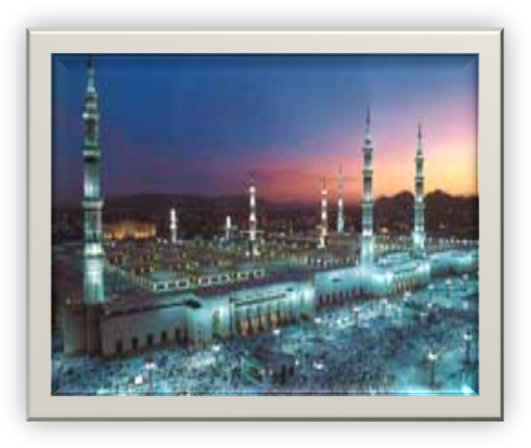
It is the first Mosque to be built in Islam. The Prophet was buried in his house, which was adjacent to the Mosque, as Prophets are to be buried where they die. It is praiseworthy to greet the Prophet when one passes by his grave.
The Prophet's Mosque in Madinah can accommodate over two million people at one time. Muslims perform prayer in the Prophet's Mosque in order to attain the great reward promised for the one who performs prayer in it.

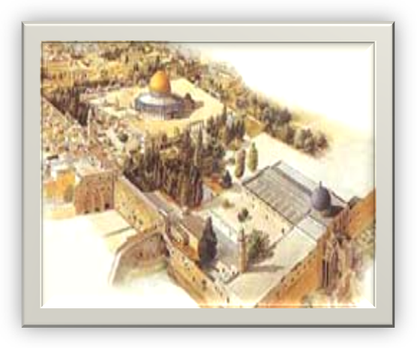
Mosque of the Dome of the Rock
Ibraheem took for himself a place of prayer and a place where he slaughtered sacrificial animals. Jacob stood by it, when he saw a pillar of light atop it. Moses encamped there, with his people during the period of Teeh (when they were lost). David built his prayer place there, and the Temple of Solomon was built there. The Prophet ascended to the Heavens from there during the Night Journey.

Al-Aqsa Mosque
It is the second Mosque placed on earth. Abu Dharr said:
'I said, 'O Messenger of Allah, what is the first Mosque placed on the earth?' He said: 'Masjid al-Haram'. I then asked: 'What is the second Mosque?' He said: 'Al-Aqsa Mosque'. I asked: 'What is the time period between the placements of these two Mosques?' He said: 'Forty years, and whenever you have to pray perform prayer for the entire earth has been made a place of prayer.' (Muslim)
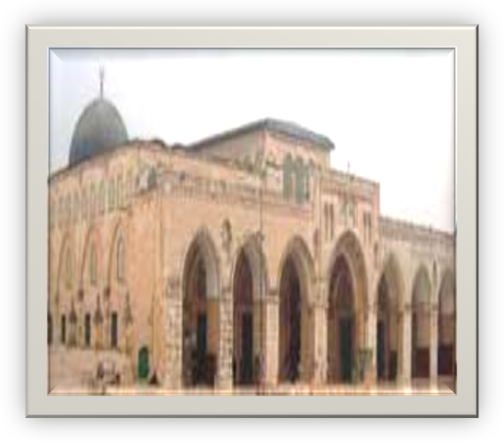
It was built by Prophet Solomon, son of David. Abdullah b. Amr b. al- Aas reported that Amr b. al-Aas said that the Messenger of Allah said:
'After Solomon, son of David, finished building Mosque al- Aqsa, he asked Allah to bestow him a Rule and Kingdom like no one had before, it not befitting anyone afterwards, and that no one would come to this Mosque seeking to pray in it, except that he would return from it sin-free.' The Prophet said: 'As for two (of the three requests) he was granted, and I hope that I will be granted the third.' (Ibn Khuzaimah)
It is the first of the two Qiblah (direction of prayer) the Prophet faced in his prayers and the Muslims prayed towards it before they were ordered to pray facing the Kabah. During the Night Journey, he stopped at Mosque al-Aqsa, and from there he ascended to the Heavens. He led the prophets in prayer during this night journey. It is the third Haram (sacred sanctuary), after Makkah and Madinah.

