cG% c[fkfjuk; ]drlu L#l|kijrsYf. LisRy plc rk; pofrkalu ak|+p[ r~jécêujH LrkYz|lCjckdX iG <j)sM. dkq/*xk;, ~kÓjakMkdxk; iGÓj)kSÙlX QlSgl ij CIlcj ijCIlcjrjdxk; ssdsdlS=! vjh dlgU*xln[ fl sq sdlmk)k'f[.
1- L#l|kijSh)[ rj<[dx(aluj eC[vlflej&[ am*kd. dlg n; egJÊn*xjhPjdik; K!ldk'f[ ele*X aohaln[ Lf[ uFlGÒ eC[vlfle; sdl!#lsf rJ*jSeldkduj#.
2- L#l|kijsRy ijPjujH c;f{e[fjumukd. c{<[mjdxjH rm)k' QlSgl c;>i ijdlc*xk; L#l|kijsRy KS`Cik; aCJL\k; Lrkcgj&lsn'ln[ QlSgl akL[ajrkdxk; ijCIcj S)!f[. Qgk dlgUik; fs' L#l|k ~kÓjakM[ alYfak=fluj K!l)k'j#, YefUÊ\jH fjØulsn'[ Sfl'k' Qgk dlgU \jH tYfSul rØum*jufluj rak)[ ej'Jm[ arcjhl)kil R clPj)lyk![. Kpl|gnaluj :T<léyêuksm SegjH K!l u Leilp\jH Qgkelm[ rØuks!'[ L#l|k fs' DkG: rjH eyuk'kî
ÞLf[ rj*X)[ Spl<dgalsn'[ rj*X dn)lS)!. L#, Lf[rj*X)[ zkndg; fs'uldk'kß éroGî11ê
Þérj*X arÍjhl)kdê rj*sxlgk dlgU; siyk)kduk; LSf dlgU\jH L#l|k Plglx; rØ rjC[vuj)kduk; svu[sf'[ igl;ß érjclL[î19ê
3- akc[hj; cakplu\jH dkq/*X K!ldksa'[ Yeilvd fjgkSarj ak'yjuj/[ rHdjujMk![. LfjH rj'[ gÊs/mkilrk = alGz; YeivdR fs' rjGS`Cj&jMkak![. r~jécê eyuk 'kî Þrj*X)[ g![ dlgU; BlR KSeÊj&jgj)k'k, Lf[ ak yksd ejmj)kdulsn(jH trj)[ SC<; rj*X Qgj)hk; i qjejq)kduj#. L#l|kijsRy Yzr[Fik;, tsRy vgUuk;ß r ~jfjgkSarj Lgkxk'kî Þrj*X tsRy vgUuk;, DkhElKGyl CjpJ*xksm vgUuk; Ln/#kdX sdl![ akyksd ejmj)kd. ek \rlvlg*sx rj*X dgkfjujgj)kd. t#l ekfkrjG+jfjd xk; ~jp[L\kdxln[, t#l ~jp[L\kdxk; iqj Sdmldk'kß éL~opliop[- LH~lrj cI|J|l)jujMk![ê alYfa# ijCkÓDk G:R fs' TfjSh)ln[ ijCIlcjdsx Ênj)k'f[. L#l |k eyuk'kîÞ
ÞTrj i#dlgU\jhk; rj*X)jmujH >j'j/k!ldkdulsn(jH rj*xf[ L#l|kijSh)k; ycohjSh)k; am)kd. rj*X L #l|kijhk; LÔUpjr\jhk; ijCIcj)k'ksi(jH éLfln[ Si !f[ê Lfln[ K\aik; domkfH r# egUliclrak=fk;ß érj clL[î 59ê
4- Qgk ijCIlcj dkq/*xjH rj'[ ijM[ rjH)kduk;, fsRy rlijsr coÊj)kduk; svS$!fk![. dkq/*X)[ Srf{fI; i|j)k'fjsr YeilvdRécê fl)Jf[ rHdjujMk![. L~o|k ssyyéyêijH rj'k; rjSipr;î YeilvdRécê eyuk'kî Þigk; rlxkdxjH dkq/*xk!lik;, LfjH Tgj)k'irlujgj)k; rj H)k'iSr)lX K\a;, LfjH rjH)k'irlujgj)k; rm )k'iSr)lX K\a;, LfjH rm)k'irlujgj)k; Lfjr[ Si!j egjYCaj)k'iSr)lX K\a;, :sg(jhk; Lfjr[ Sr f{fI; i|j)kdulsn(jH rl; Lisr rCj/j)k;, :Gs) (jhk; LfjH rj'[ gÊs/mkilR i# L>uik;, cS(fik; h>j)kdulsn(jH LiR LfjH L>u; Yele)sMß é~kDl gj, akc[hj;ê
1
5- SdMkSdXijuk;, dxikdxk; Yevgj/j)k'fjsr sflM[ Ql Sgl akc[hJ*xk; dgkfjujgjS)!fk![. dlgn; Lf[ cao| \jsRy alrcjdalu fdG&)[ dlgnalik;. Sfl)kdxk; S~l;~kdxk; eJg(jdxk; ijf)k'fjSr)lX domkfH rlC; vjhulxkdxksm il)kdX sdl!k!ldk'fluj rak)[ dlnl rlik;. alYfa# :Pkrjd aJ}judX CYfk)xksm dg*xjhl sn'k=fk; Lfjr[ :); doMkduk; sv$k'k. :ufjrlH QlSgl ilG\dxk; Yevgj/j)kSÙlX Lf[ cfUcr[PalSnl su'[ egjSClPj&[ Ky/[ igkS\!fk![. L#l|k eyuk'kî
ÞQgk LPG+dlgj i# ilG\uk; sdl![ rj*xksm Lmk\[ i 'lH rj*xfjsr/Ëj iUd[faluj LSrIl<j&yjun;ß é|kwkyl \[î 6ê cao|\jH LPjdik; Yevgj)k' ilG\dX Lmjc[ Flr g|jfalsn'fjr[ dlh; clÊjuln[.
6- Yeulc*xk;, dkq/*xkak!likSÙlX af\jH LzlPw[ Blrak= rjC[dx(glu en[}jfØlgjSh)[ am*kduk;, Li gjH rj'[ flR cIJdgjS)! rjhelm[ arÍjhl)kduk; sv $kd. L#l|k eyuk'kî
ÞcalPlrikalSul, éukÓê>JfjukalSul ~r[Ps/M i# ilG\ uk; LiG)[ i'kdjMjulH Ligf[ Yevgj/j)kduluj. Li gf[ ycohjsRyuk; Ligjsh dlgUijigak=igksmuk; fJgkal r\jr[ ijMjgk'ksi(jH Ligksm doM\jH Lf[ rjgJÊj&[ a rcjhl)kilR dqjik=iG LfjsRy ulFlGÒU; arÍjhl)j s)l=kalujgk'kß érjclL[î 83ê dkq/*X K!ldk' Lic g\jH QlSgl cao|ik; ssdsdlS=! rjhelm[ fJgkalrjS) !f[ af rjua*xln[, : fJgkalr; tmkS)!f[ afen[}j fgkaln[.
7- akc[hj; walL\jsruk;, Talajsruk; ejReËkduk;, Lrk cgj)kduk; sv$kd. éTc[hlajd >gnaj#l\ rlmkdxjH DkG :rk; fjgkck'\k; eoG%cogjdxksm alf{dukarkcgj&[ Ye S~lPr; rm\k' c;Z*xjH Svgkdê YeilvdRécê L*j sruln[ |ksspEéyêijr[ icIju\[ rHdk'f[. Þtrj)f[ éEjf[rê ejmjsemkdulsn(jH tÔln[ svS$!f[, fjgkSarj Lgkxkduk!luj rJ akc[hj; walL\jsruk;, Talajsruk; ej Ôkmgkd, akc[hJ*X)[ L*jsr walL\k; Tala\k; Ts# (jH BlsrÔ[ sv$n;? rJ agj)k'f[ isg t#l ij>lz* sxuk; simjun;ß éakc[hj;ê
8- Ejf[rujH rj'k;, LfjH Lds/mk'fjH rj'k; L#l|k ijSrlm[ gÊ Svlpj)kd. Qgk LFyjécI|l~jdxksm il)[ê H i'fjYedlgaln[ ãcO>lzUilR Ejf[rujhds/ml\irln[.ä
9- Ejf[ruksm cÕG>*xjH tmk\[vlmlsf ijSidik;, :f[ ac;uarik; elhj)kd. dlgn; Ejf[ruj#l\ rlxkdxjH f s' P{fjdoMH rlC\jSh)ln[ iqj rm\kd. Qgk LFyjHT Yedlg; dlnlrlik;î Þt#l dlgU*xjhk; cliPlr; dlnj )H rØuln[ igk\kd, egShld\jsRy dlgU\jH Qqj&[ß
10- Ejf[ruk!lik' cÕG>*xjH :glPrdxk;, cHdG+ *xk; LPjdgj/j)kd. YeilvdfjgkSarjécê eyuk'kî ÞEjf[r uksm cÕG>\jhk= :glPr t'jSh)k= |jw[y Selshul dk'kß éakc[hj;ê
11- akc[hJ*X f+jhk= c|lu c|dgn*X rjhrjG\kd uk;, TS*lMk ukÓ; sv$k' LijCIlcjdsx KËajYf*xk; c|lujdxkal)lfjgj)kduk; sv$kd. dlgn; TS*lMk ukÓ; sv$k' :xkdSxlm[ Ejf[r T#lfl)k'f[ isg ukÓ; sv$kilrluj L#l|k eyuk'kî
2
Þdkq/; T#lflikduk; af; akqkiR L#l|kijrk Si!jul dkduk; sv$k'f[ isg rj*X LiSglm[ ukÓ; sv$kdß éLRElHî 39ê
12- YelGÒr LPjdgj/j)kd, dlgn; egJÊn*xk; Ejf[r dxk; L#l|kijsRy LrkafjYedlg; rJ*jSeldk'f[ YelGÒ r sdl!ldk'k. Lf[Selsh egJÊn*X Ty*kSÙlX YelG Òr Lfjsr fmuk'k,. ~kÓjakMkdxk!likSÙlX svlS#! YelGÒrî ÞL#l|ksi tsRy TO Yeulc\jH rJ trj)[ YefjEh; rHSdnSa, LfjSr)lX K\aalufjsr rJ trj )[ edg; rHSdnSaß :sg(jhk; TO YelGÒr YeliG\j dal)julH L#l|k Lir[ YefjEh; rHdkduk; LfjSr )lX K\aaluf[ edg; rHdkduk; sv$k'fln[. YelGÒr )[ K\g; h>j)k' cau*xk; cÕG>*xk; ds!\j rl; Li KeSulzs/mk\kduk;, K\g; h>j)k'fjr[ fmÍaldk' dlgU*xjH rj'[ ijM[ rjH)kduk; sv$kd.
13- egJÊn*xjH Êa ssdsdl=kd. |pJcjH i'f[ Yedl g; Qgk cfUijCIlcj)[ akqkirk; rØuln[. Lisr Qgk c SÔl<; ~lPj&lH LiR Lfjr[ L#l|kijsr c[fkfj)k 'k, Lfir[ rØuln[. Lir[ Qgk egJÊn; SrgjMlH Li R LfjH Êaj)kduk; sv$k'k. Lfk; Lir[ rØuln[. Tf[ Qgk ijCIlcj)#lsf h>j)kduj#. L#l|k eyuk'kî
ÞÊalCJhG)[ fs'uldk'k f*xksm YefjEh; dn)kSrl )lsf rjySiËj sdlmk)s/mk'f[ß éckaGî10ê
|pJcjH TYedlg; dlnl;î ÞL#l|kijsr ds!\k'f[ isg Qgk ijCIlcjsu egJÊn*X QlSgl'luj ejmjdomkdulsn(j H, LirjH ejs' ele*sxl'k; fs' LiSC<j)kduj#ß éfjGapj, L|[ap[ê
14- af\jH LzlPw[Blr; Srmk'f[ L#l|kijsRy Lrka fjSulsm Ejf[rujH rj'[ gÊs/mkilrk= alGzaldk'k. L #l|k :Gs)(jhk; rØ KS`Cj)kdulsn(jH Lir[ af \jH LzlP eln[}jfU; rHdk'flsn'[ |pJcjH dlnl;. af\jH eln[}jfUak=ir[ CYfk)xksm dkfYÔ*xk;,cwwJd gn*xk; ds!\kilrk; Lfjsrfjsg wr*sx S~lPiH )gj)kilrk; L#l|kijsRy LrkYz|\lH clPj)k'fln[.
15- ijCIlcjdX)jmujH ClÔjuk;, calPlrik; Yevgj/j)k 'Sflsml/; c|lu; h>j)ksa'k= YefJÊ Kxil)kduk; sv$kd. dlgn; cfUijCIlcj g![ cSÔl<*X)jmujhln[. Q'[ L#l|kijsRy c|lu;, asËl'[ L#l|kijsRy alGz\j hk= gd[fclÊjfI;. L#l|keyuk'kî
Þeyukdî égd[fclÊjfI; ijwu; t'Jê g!k r# dlgU*xjH ]sf(jhk; Q'#lsf B*xksm dlgU\jH rj*X YefJÊj)k 'kS!l? t'lH rj*xksm dlgU\jH B*X YefJÊj)k'f[ rj*X)[ L#l|k fsRy e)Hrj'[ SrgjSMl, B*xksmssd S)l CjÊ ]Hej)k; t'ln[. LfjrlH rj*X YefJÊj&[ sdl=kd. B*xk; rj*Sxlsml/; YefJÊj)k'igln[.ßéfO~î 52ê ijCIlcjdxksm cS(f; L#l|kijsRy LrkafjSulsm cIGzik;, LijCIlcjdxksm cS(f; rgdikaln[. LiG ag ns\ >us/mk'fk;, LfjH rj'[ LiG)[ clPUaldk'jm S\lx; Qlmjsulxj)k'fk; Tf[sdl!ln[.
16- L#l|k Yed{fjujH vjhdlgU*X rjC[vuj&jgj)k'k, L fjr[ ulsflgk alËik; K!lujgj)kdujs#'[ ijCIlcjdX )yjul;. L#l|k eyuk'kî
3
ÞLS/lX eoG%jdgksm dlgU\jH K!lu rmemjYdaa#lsf t ÔlniG dl\jgj)k'f[? L#l|kijsRy rmemjYda\jr[ ul sflgk S>fzfjuk; rJ ds!\kduj#. L#l|kijsRy rmemj Yda\jr[ ulsflgk alËik; rJ ds!\kduj#ß éElfIjGî43ê
1- cfUik; LcfUik; LiclrrlXisg ]Ë[akMk;, :p;éLê ak fH T'[isg Lf[ fkmG'[ sdlS!ujgj)k'k.
ÞL#l|k KS`Cj&jgk'ksi(jH Ligksm Srsg LiR CjÊl rmemj cIJdgj)kalujgk'k. esÊ, rj*xjH vjhsg aËk vjh sgs)l![ egJÊjS)!fjrln[ Tf[ß éak|+p[î 4ê
LcfUs\ cfU; sdl![ fmukdsu'f[ L#l|k YeeÖ\j H rjC[vuj&jMk= a|\lu Qgk dlgUaln[, Lfjr[ ijCIlc; LrjilgUaln[, LfjsRy Qgk >lz; fs'uln[ L#l|kij Srlmk;, ycohjSrlmk; tfjg[ YeiG\j)k'isg siyk)kduk; LiG)[ cfU; sixjil)j sdlmk)kduk; sv$kdsu'f[. akRdqjÉ Qgkelm[ YeilvdØlgk; pofØlgk; cp[i{\gk; LYd aj)s/mkduk;, egJÊj)s/mkduk; svu[fjMk![, cdgj$, u|[ uléLê t'JYeilvdØlG iPj)s/Mk, aocl TOcl, ak|+p[ écê t'jiG LYdaj)s/Mk, ~jhlHéyê aGÓj)s/Mk, |;céyê iPj)s/Mk, LS`|\jsRy dgX LYdajdX vi&[ fk/kd uk; L;zSVp; igk\kduk; svu[fk, esÊ, LS`|; L#l |kijsRyumk\[ c$jp[ Ck|plL[ égd[f clÊjdxksm Srfl i[ê :n[. L#l|k eyuk'kî
ÞLhjE[-hl;-aJ;ß, B*X ijCIcj&jgj)k'k t'[ eyuk'f[ sdl![ alYf; f*X egJÊn\jr[ ijSPugdlsf ijSM)s/ mksa'[ ark<UG ijvlgj&jgj)kdulSnl. Ligksm akÙk!luj gk'isg rl; egJÊj&jMk![. LS/lX cfU; eyÉiG :sg '[ L#l|k Lyjukd fs' sv$k;. d=; eyuk'isguk; L iryjuk;ß éLRd~of[î1-3ê ijCIlcjdX Ligksm TOalrjr rkcgj&[ egJÊj)s/M[ sdl!jgj)k;, Qgk |pJcjH TYedlg; dlnlik'fln[ ÞdomkfH egJÊn*X)[ ijSPualdk'f[ YeilvdØlgldk'kß. L#l|k YeeÖ\jH alË; domlsf rjC[ vuj&jMk= asËl'ln[ flsq igk' :u\jH eyuk'f[î
Þ]sflgk wrfuk; f(xksm cIÔ; rjhelmkdxjH alË; igk \k'f[ isg L#l|k Ligksm c[Fjfj)[ alË; igk\kduj#, fJG&ß éyLp[î11ê
Þrj*X)[ Qgk ije\[ SrjMk. LfjsRy TgMj rj*X CYfk) X)[ igk\jsi&jMk!lujgk'k. t'jMk; rj*X eyukdul Snlï Tsf*sruln[ c;>ij&sf'[? ér~jsu,ê eyukdï Lf[ rj*xksm e)Hrj'[ fs' K!lufldk'kß é:hkT;yl Rî165ê arÍjH alË; igk\k'fjrrkcgj&[ L#l|k ~l|Ual ujMk= Lic[FSuuk; alËk'fln[, rØulsn(jH rØujSh )k; fjØulsn(jH fjØujSh)k;. L#l|k QMk; LrJfj sv $k'ir#.
2- L#l|k eyuk'kî Þ:éukÓêpjic*xjsh wulewu*X :xkdX)jmujH rl; alËj sdl!jgj)k'fln[. ijCIcj&isg L#l|k fjgj&yjukilrk;, rj*xjH rj'[ gd[f clÊjdsx K!l)j fJG)kilrk; domjulnf[. L#l|k LYdajdsx T<[ ms/mkduj#ß é:hkT;ylRî140ê TO :u\jhm*ju :Cu; L#l|k KS`Cj)k' goe\jH dlgU*X QlSgl'k; alyj ayj É[ sdl!jgj)k; t'fln[. stCIgU eoGnalu pjr\jr[ ed galuj pogjfeoGnalu pjic*X alËj sdl![ egJÊj)k' fjhosm gd[fclÊjfI; rHdk'Sflsml/; fs' ijCIlcjdsx dem ijCIlcjdxjH rj'[ SiGfjgj)kilrk; clPj)k'fln[.
4
3- akR dqjÉ cakplu; LfjYda; rm\kduk;, Lfjg[ h;Zj )kduk; svu[fS/lX L#l|k Lisg rCj/j)kduk!luj.
ÞTiG)[ akÙ[ tYfSul fhakydsx rl; rCj/j&jMk![ t' ic[fkf TiG)[ SrG iqjdlnj&jS#,? Ligksm ilc c[Fh *xjhosm TiG cÖgj&[ sdl!jgj)k'S#l. fJG&uluk; L fjH p{<[mlÔ*xk![. t'jMk; TiG SdMk arÍjhl)k'jS#?ß écwpî26ê L#l|k eyuk'kî
Þér~jsu,ê eyukdî rj*X >oajujhosm cÖgj&jM[ akÙk!luj gk'igksm egUiclr; t*srulujgk'k t'k Srl)kd. L igjH LPjdSegk; ~|ksspiglPdglujgk'kß éyo;î 42ê
4- L#l|k eyuk'kî Þrj*X L#l|ksi c|luj)k' eÊ; LiR rj*sx c|luj)k'fln[ß éak|+p[î7ê L#l|kijsRy dHerdX uFlijP; wJijf\jH edG\js)l![ L#l|k ijsr c|luj)k' ijCIlcjdX)[ L#l|k c|lu; rHdk sa'k= ilz[plr; rHdjujgj)k'k. L#l|k eyuk'kî Þfs' c|luj)k'flSgl Lisr fJG&uluk; L#l|k c|luj )k;. fJG&uluk; L#l|k Cd[frk; Yeflejuk; fs'uldk 'kß é|w[w[î 40ê
5- LijCIlcjdX tYf fs' LfjYda; YeiG\j&lhk;, tYf fs' Cd[fglulhk; Cgj Liclr; c|luik;, rØukak=f[ ijCIlcjdX)k; ak\DJ*X)k; alYfaldk'k.
ÞpofØlgluj rjSulzj)s/M r+ksm plcØlSglm[ r+ksm iv r; akSÙ K!lujMk![. fJG&uluk; LiG fs'ulujgj)k; c |lu; rHds/mk'isg'k;, fJG&uluk; r+ksm sscrU; fs'uln[ Swfl)xlujgj)kd t'k;ß écIlEEl\[î171-173ê
Þ>oajuksm LrÔglidlCsamk)k'f[ tsRy cp[i{\glu pl cØlglujgj)k; t'[ Kp[S~lPr\jrk SC<; rl; c~oyjH SgDs/mk\jujMk![. fJG&uluk; TfjH :glPrlrjgfglu :xkdX)[ Qgk cSÕCak![ß éLR~jul- 105-106ê Tal; L|[ ap[ fsRy akc[rpjH K`gj)k'kî faJak`lgjujH rj'k; rjSi pr;î ÞYeilvdfjgkSarjécê eyuk'fluj BlR SdMk,î ÞTO dlgU; gledhkdX t\k' t#l c[Fh\k; iUlej)k'fln[, L#l|k eMn*xjShSul, dkYza*xjShsul Qgk iJmk; fs' LfjsRy stCIgUS\lsm fs' TO af; t\j)lfjgj)kd uj#ß éL|[ap[ê
L#l|kijsRy plcrk; pofrkalu ak|+p[ r~jécêujhk;, dk mk;~lpjdxjhk;, Lisg rØujH ejReËjuigjhk; LrkYz|lCj ckdX iG<j)kalylisM. L#l|kijrln[ cG%c[fkfjuk;. :aJR.
TO ij<u\jH domkfhyjukilR iluj)kdî
1- L~o'cIG CH~juksm Lc[ylFkÍlL.
2- fkssiwjgjuksm T\j:EkH walL ~jal wlL EJ LC[yl\kÍlL.
3- il~jhjuksm LC[yl\kÍlLî
TO ij<u\jhk= dlcËkdXî
cIlhj|[ akrwwjpjsRy rx[y\kR Cy|j$î, al plfE[|hk; EjH Ejf[r iTC[fj~lKH KaoG.

domkfH Lyjukilrk;, eAj)kilrk; ~r[Ps/mkdî
wkss~H pL[il scRyG
SElNî 03- 3625500 Ex; 1030

5

المكتب التعاوني للدعوة والإرشاد وتوعية الجاليات بالجبيل
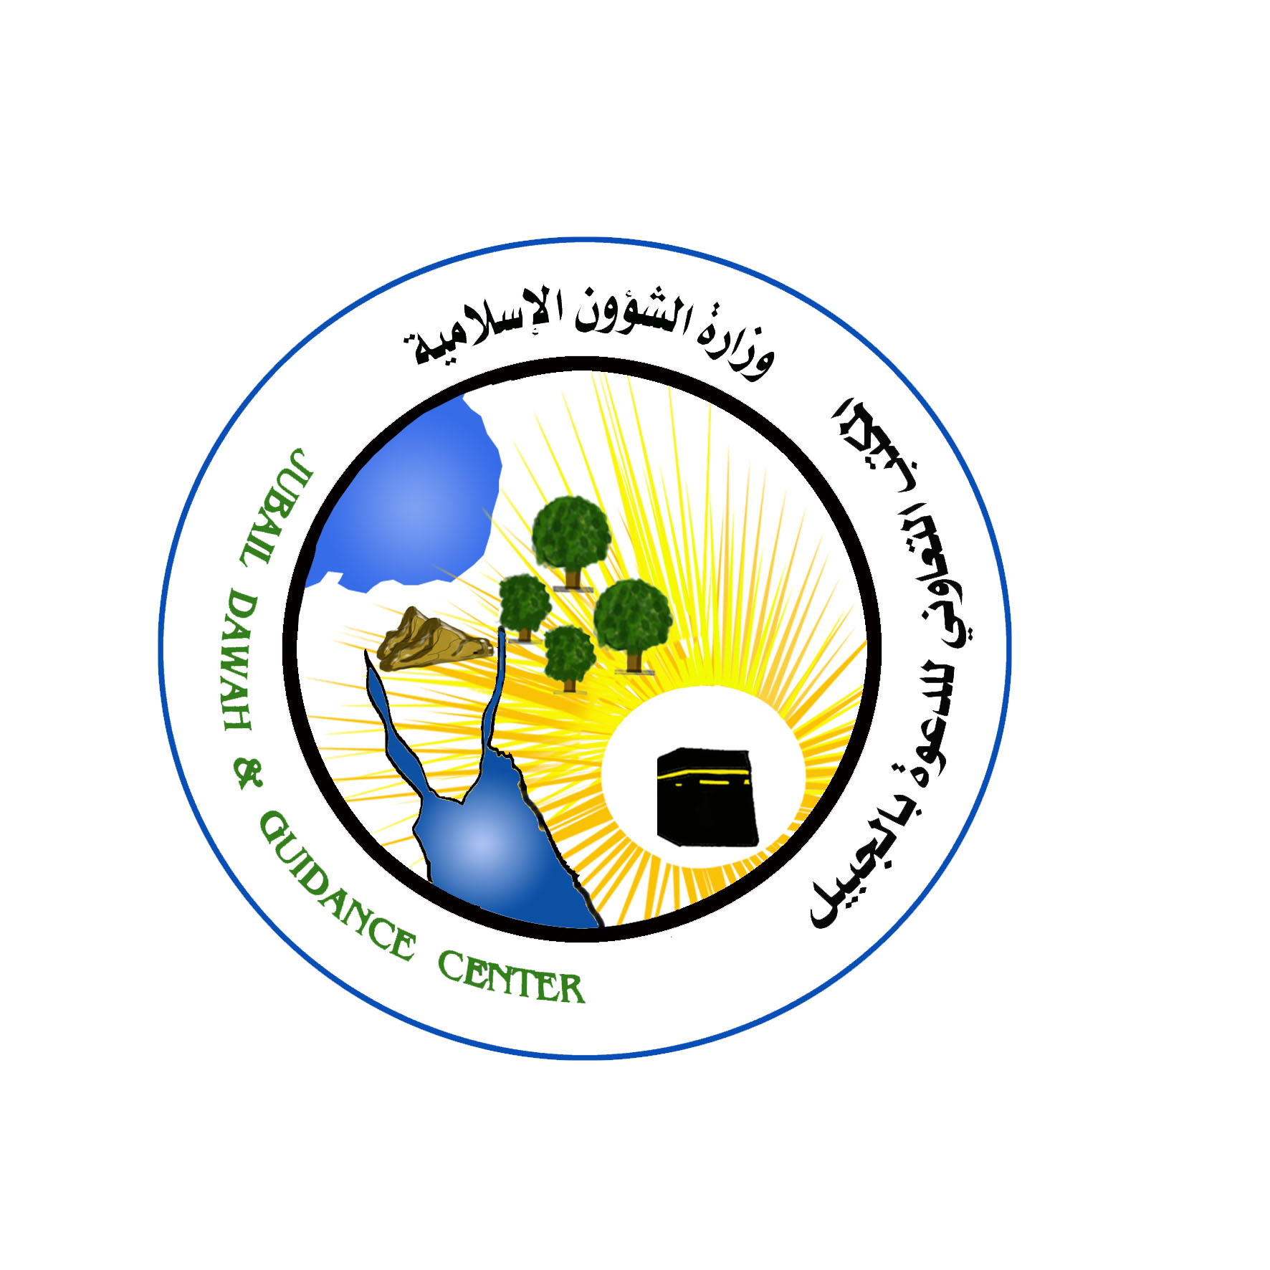
قسم الجاليات المسلمة

ترجمة: سيد سعفر صادق
الداعية بمكتب الدعوة وتوعية الجاليات بالجبيل

ijiG\r;î
c$jp[ c|[EG cIlpjD[
wkss~H pL[i scRyG
مليالم رقم العام

