Zakaah

by
Sheikh Abdul-Azeez ibn Baaz

Translated Reviewed and Edited by:
The Islamic Propagation Office at Rabwah
www.islamhouse.com
First Edition, 1428/2007
© 2006 All rights reserved. www.islamhouse.com
Permission is granted to all to take material from this publication, sub-ject to the following three conditions: 1) It may not be used for profit-able ventures; 2) Material must be source to the copyright owner; 3) Material must not be taken out of context.
If you have any corrections, comments, or questions about this publication, please feel free to contact us at:
en@islamhouse.com



1428 H
[ 1206 ]

A Publication of:
The Islamic Propagation Office in Rabwah
Tel. +4454900 - 4916065
Email: en@islamhouse.com
www.islamhouse.com
Content

Introduction 5
The Benefits of Zakaah 6
A Warning to those who do not offer Zakaah 7
Wealth upon which Zakaah is Due 10
Fruits and Grains 11
Grazing Animals 12
Gold and Silver 13
- Paper Currency 13
- Jewelry 14
Inventory (Stock) 16
Those Who have Right Over Zakaah 18
Selected Verdicts regarding Zakaah 20
Zakaah on Salaries 20
Zakaah on Loans 22
Interest-based Dealings with Banks
and its Zakaah 24
Giving Zakaah to Islamic Centers 26
Is Zakaah required of one who is in debt? 27

z

Introduction

All Praises are due to Allah alone, and may Allah praise him (Muhammad ) after whom there is no Prophet, and upon his family, companions, and keep them safe from all evil.
To proceed:
I wrote this treatise in order to sincerely advise and remind [the Muslims] about the obligation of Zakaah, a matter in which many Muslims have been too careless and lenient. Many do not offer their Zakaah in accordance to what has been legislated in the religion, despite its greatness and its being one of the five pillars of Islam without which it (Islam) cannot stand. The Prophet () said:
“Islam has been built (by Allah) upon five: The testimony (Shahaadah) that none has the right to be worshipped except Allah, and that Muhammad is the Messenger of Allah (Laa ilaaha ill-Allah, Muhammad-ur-Rasoolullaah); establishing Salaah, giving Zakaah, Fasting (Sawm) the month of Ramadan, and performing Hajj to the House [of Allah] (the Ka’bah).” (Bukhari and Muslim)
The fact that Zakaah is an obligation upon the Muslims is one of the most apparent indications of the beauty of Islam and the concern it has for its adherents. The benefits of Zakaah are indeed numerous, and [it has been made obligatory] due to the dire need of the poor amongst the Muslims.
From its benefits are the following:
1. It strengthens the bonds of love between the rich and the poor, for it is from human nature that a person shows affinity to those who treat them well.
2. It purifies and cleanses the soul and distances it from greed and avarice, as indicated in the Noble Qur`aan when Allah () says:
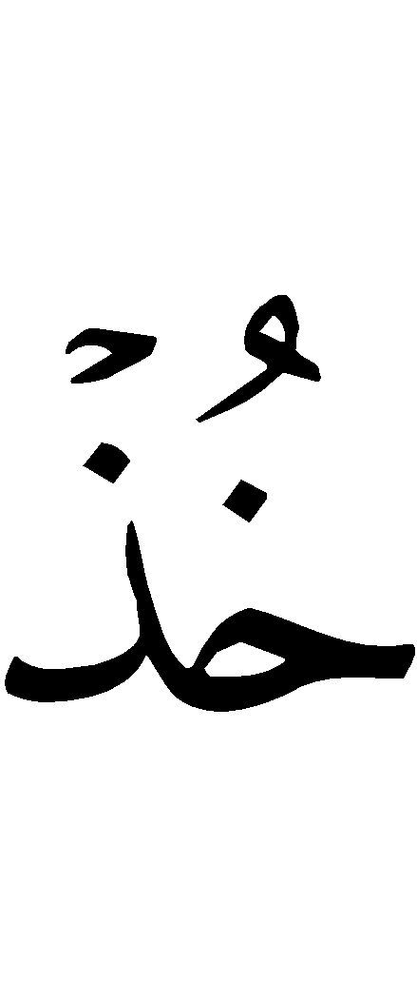
“Take Sadaqah (alms) from their wealth in order to purify them and sanctify them with it.” [Surah at-Tawbah (9):103]
3. It causes Muslims to grow accustomed to performing acts of generosity, hospitality and empathy towards those who are in need.
4. It brings increase and blessings to one’s wealth, and Allah replaces it (the wealth given as charity with something better), as Allah () said:
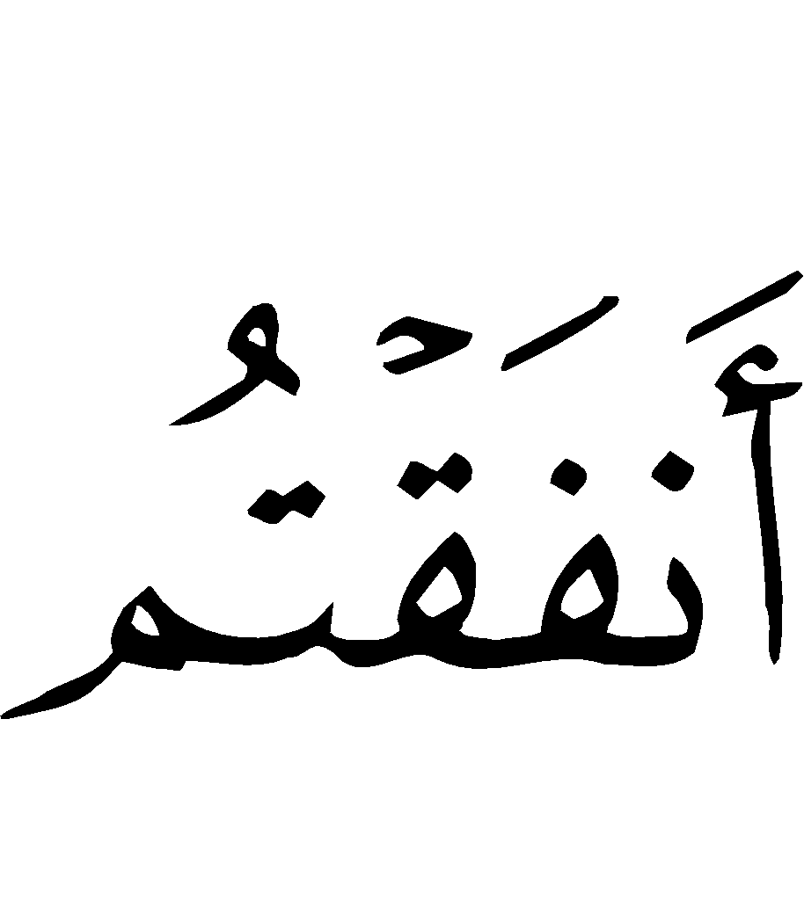
“And whatsoever you spend of anything (in Allah's Cause), He will replace it. And He is the Best of providers.” [Surah as-Saba´ (34):39]
In a Saheeh (authentic) hadeeth, the Prophet () narrated from Allah:
“O child of Adam! Spend in charity and We (Allah) will spend on you.”
There are numerous other benefits that may be found in the legislation of Zakaah.
A severe warning has been issued to those who do not offer Zakaah out of greed as well as those who fall short in doing so. Allah () said:
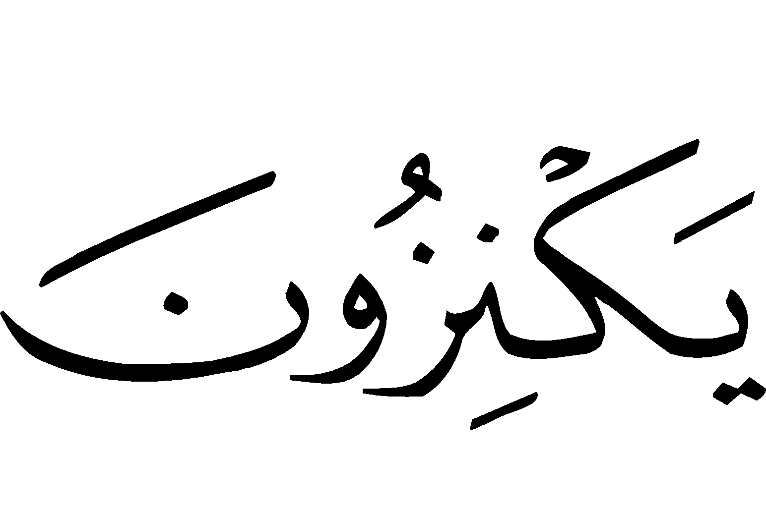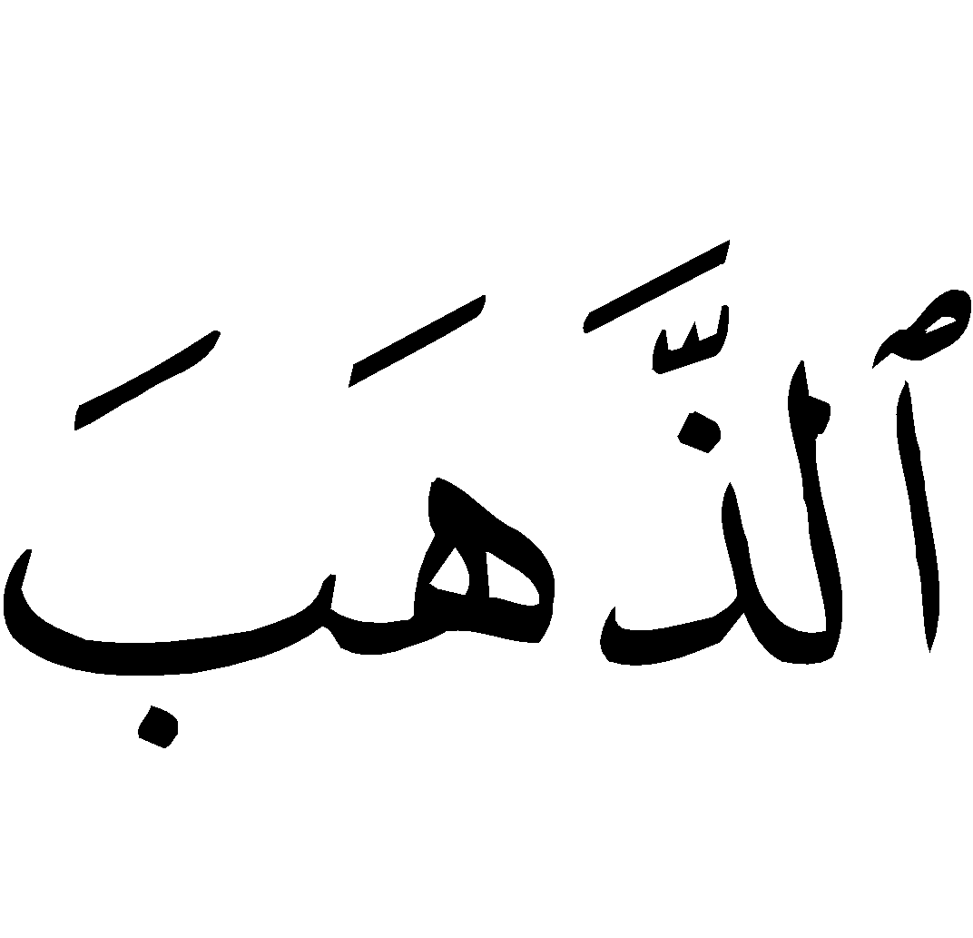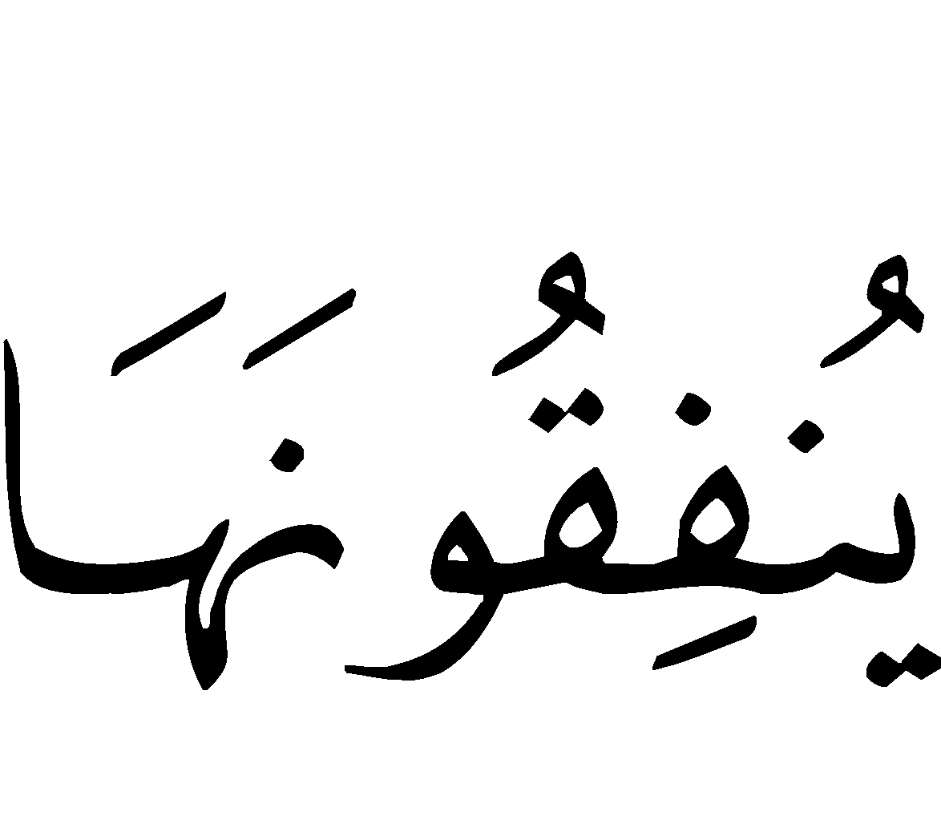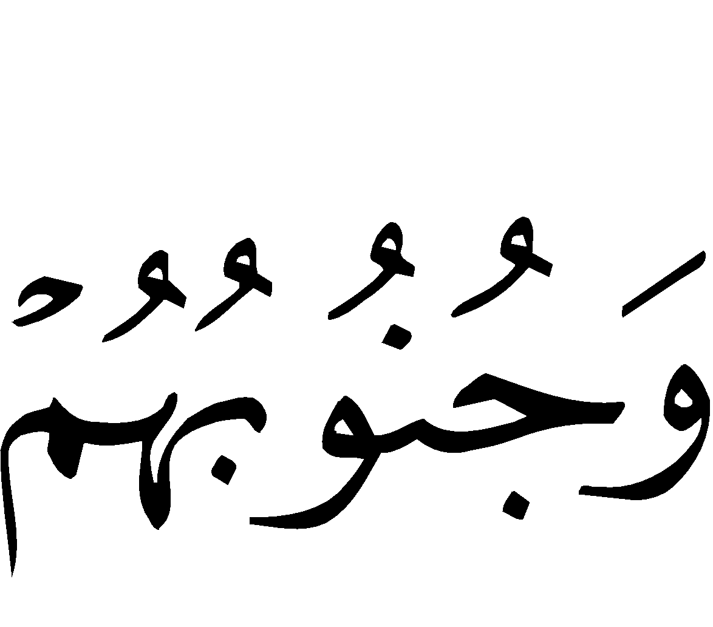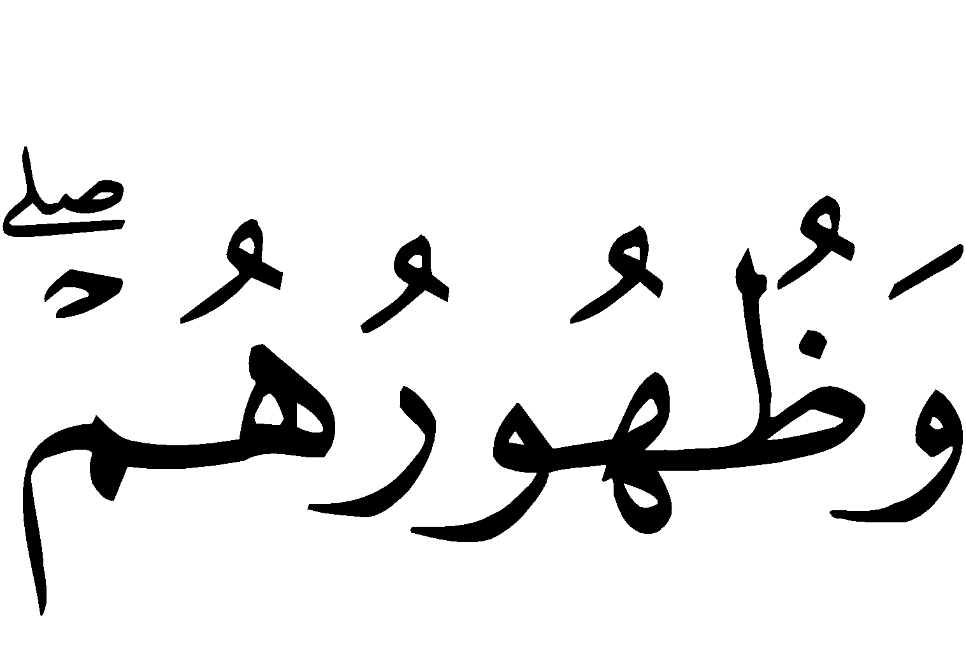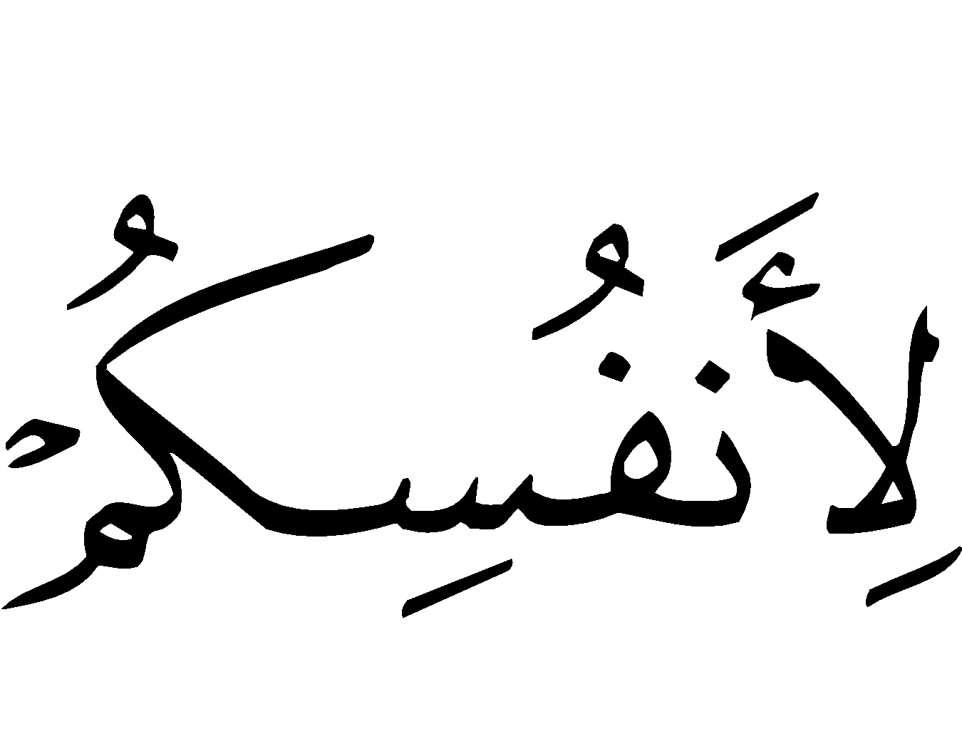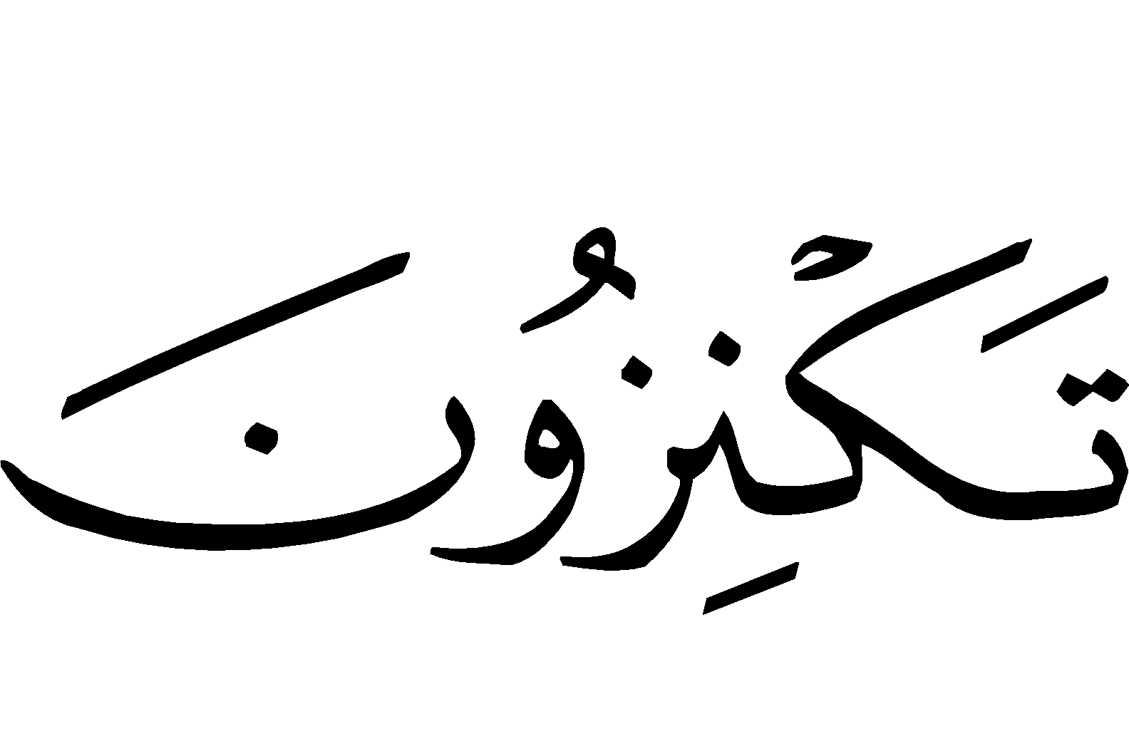
“And those who hoard up gold and silver [al-kanz: the money, the Zakaah of which has not been paid], and spend it not in the Way of Allah, - announce unto them a painful torment. On the Day when that (al-kanz: money, gold and silver, etc., the Zakaat of which has not been paid) will be heated in the Fire of Hell and with it will be branded their foreheads, their flanks, and their backs, (and it will be said unto them): ‘This is the treasure which you hoarded for yourselves. Now taste of what you used to hoard’.” [Surah at-Tawbah (9):34-35]
Any type of wealth from which Zakaah has not been offered is regarded as hoarded up treasure (al-kanz) for which one will be punished on the Day of Judgment. This has been indicated in the saheeh hadeeth in which the Prophet () said:
“No owner of gold or silver who does not offer its due right (Zakaah) except that in the Day of Judgement, plates of fire will be beaten out for him, and they will be heated in the Fire of Jahannam (Hell) and their flanks, foreheads, and their backs will be branded with them. Whenever they will cool, it will be done again to them, on a Day of which its length is fifty thousand years, until [Allah] judges between all [His] slaves. He will see his path, either to Jannah (Paradise), or to Jahannam.” (Muslim)
The Prophet () then further mentioned (in the hadeeth) that one who owns camel, cattle, and sheep and does not offer the Zakaah due upon it will be punished through them on the Day of Judgment.
It has also been authentically reported of the Messenger of Allah () that he said:
“Whomever Allah has provided with wealth and does not offer the Zakaah due upon it, on the Day of Judgement it will be made into a baldheaded poisonous male snake with two black spots over the eyes. The snake will encircle his neck and bite his cheeks and say, ‘I am your wealth, I am your hoarded treasure!’ The Prophet () then recited Allah’s saying:
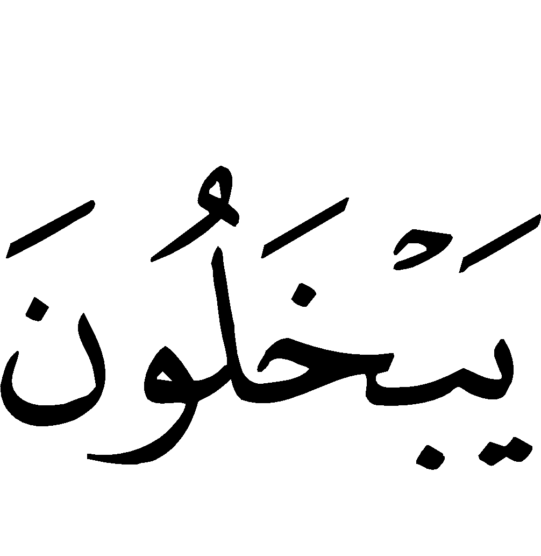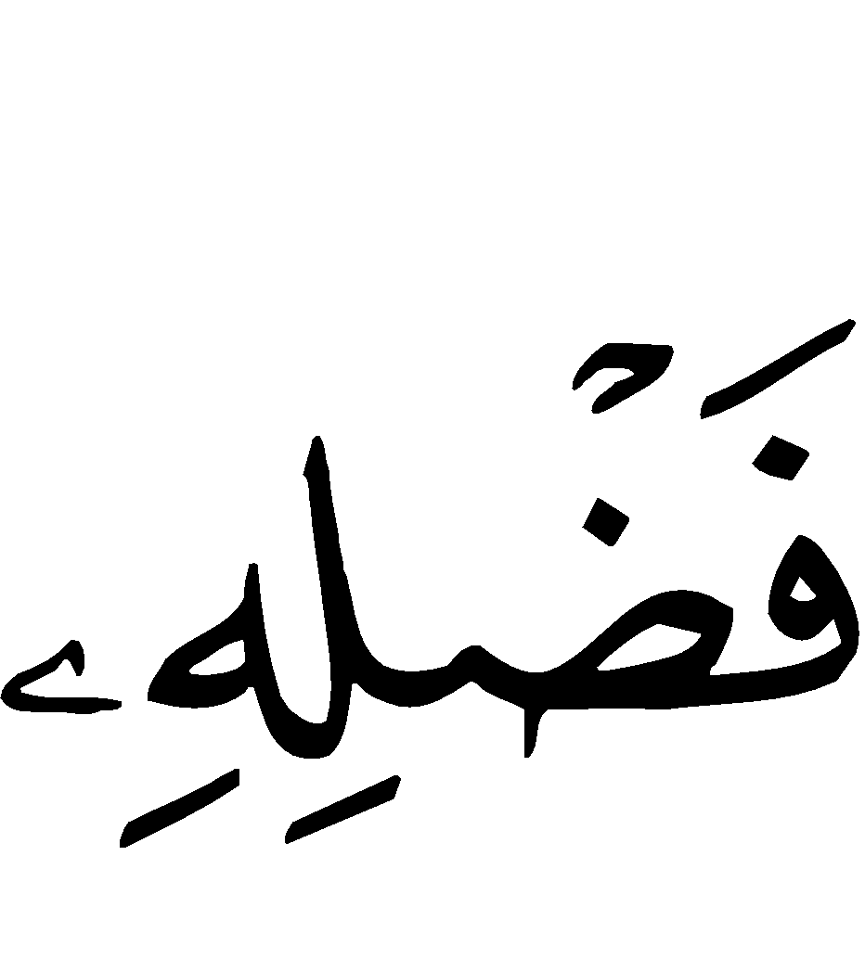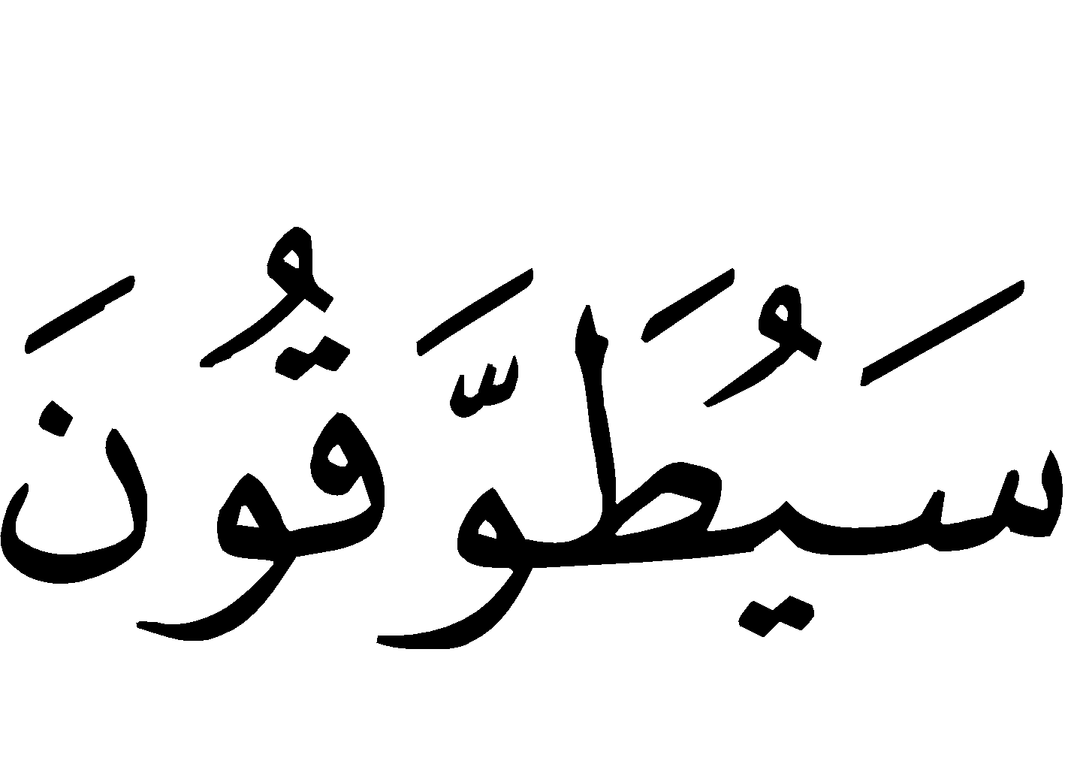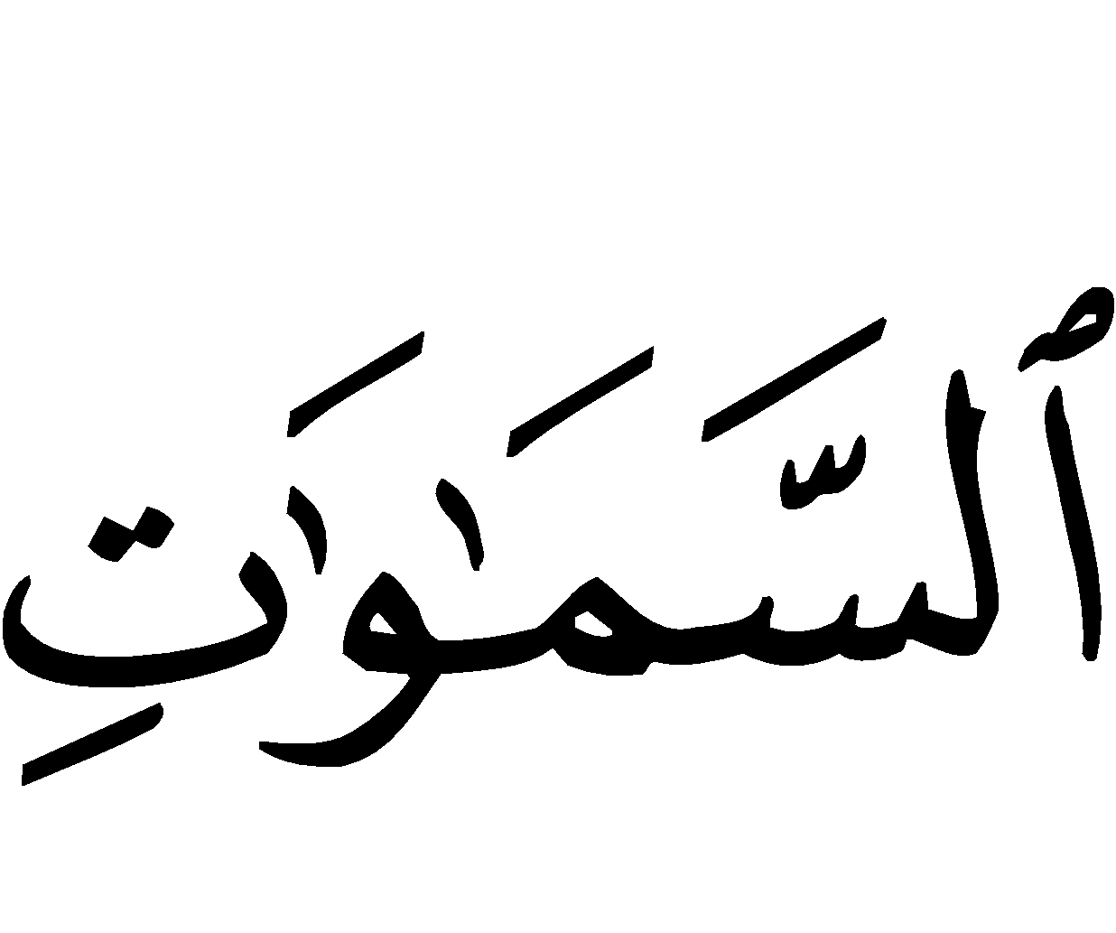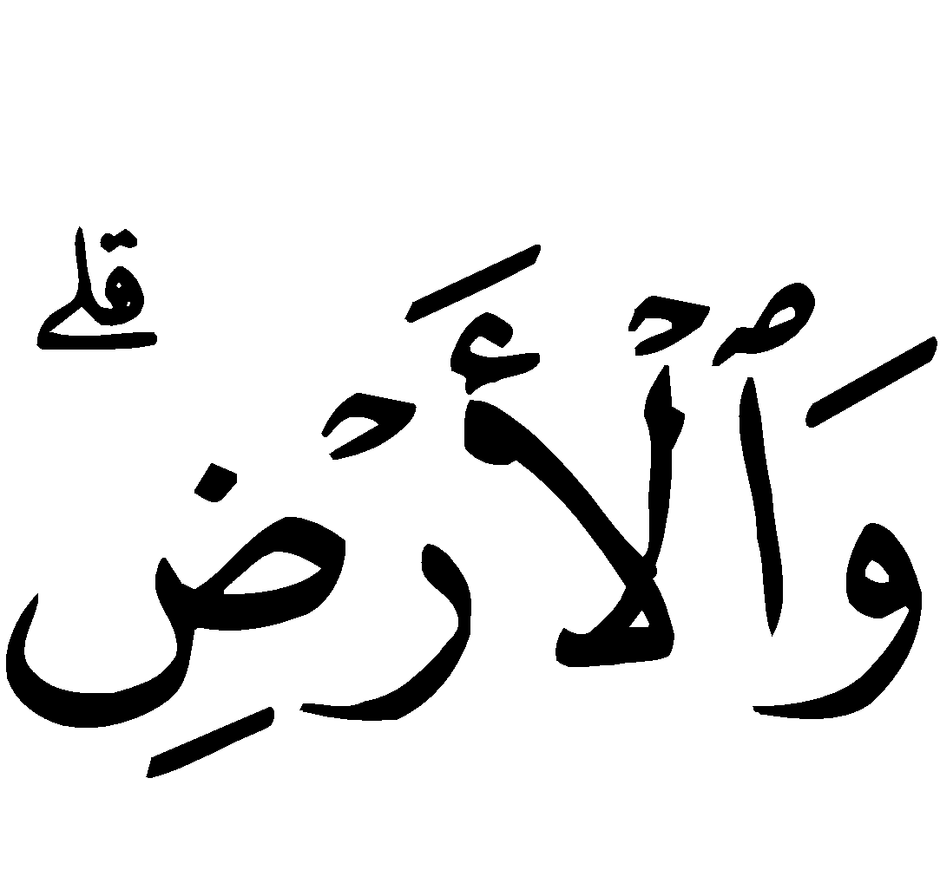
‘And let not those who covetously withhold of that which Allah has bestowed on them of His Bounty (Wealth) think that it is good for them (and so they do not pay the obligatory Zakaah). Nay, it will be worse for them; the things which they covetously withheld shall be tied to their necks like a collar on the Day of Resurrection.’ [Surah Aali ‘Imraan (3):180]”
Wealth upon which Zakaah is Due

Zakaah has been made obligatory upon four categories of wealth:
- Grains and fruits produced by the earth,
- Grazing or herding animals which feed freely from the earth,
- Gold and silver,
- And inventory (stock) with which one does business.
For each of these categories, there is a specified amount under which Zakaah is not obligatory (termed as ‘nisaab’).

Fruits and Grains

The nisaab for fruits and grains is 5 ‘wasaq’, and one wasaq is equal to 60 saa’ measured during the time of the Prophet (). This amount, measured according to the saa’ during the time of the Prophet (), such as dates, raisins, wheat, rice, barley, and their likes, is equal to 300 saa’ according to the saa’ during the time of the Prophet (). [One saa’] is equal to 4 handfuls made with the two palms cupped together of an average sized man.
The amount which is due upon fruits and grains [if it reaches the nisaab] is 10% if the date-palms or plants relied upon natural means for water, such as rain, rivers, flowing streams and their likes.
If they relied on unnatural means for water, such as using animals to water or machines which lift water or their likes, the amount which is due upon them is 5%, as has authentically been reported by the Messenger of Allah ().

Grazing Animals

The nisaab for camels, cattle and sheep which fed from natural grazing has been detailed in various authentic hadeeth of the Messenger of Allah (), and one who desires knowledge about this may ask the scholars about them. If it were not that we seek not to lengthen [this treatise] we would have mentioned them in order to gain the most benefit.

Gold and Silver

The nisaab for silver is 140 miskals. In the currency of Saudi Arabia, this is equal to 56 riyals. The nisaab for gold is 20 miskals, which is equivelaent to 11 3/7 (Saudi) pounds, equal to 92 grams.
The amount which is due upon them is 2.5 % of the total amount if it reached the nisaab and was in his continuous possession for a period of one [Hijri] year.
Profits must be calculated with the original stock, and it is not a condition that they be in a person’s possession for a period of one year, just as the newborns of herding animals are totaled along with the animals. If the original amount [of gold and silver] has reached the nisaab, it is not condition that the profits be in one’s possession for the period of one year (i.e. Zakaah must be paid on the whole amount).

Paper Currency
The paper currency and coined money which people use today come under the ruling of gold and silver, whether they be called Dirhams, Dinars, Dollars, or anything else. If its value reaches the nisaab of silver or gold and it is in a person’s possession for a period of one year, Zakaah becomes due upon it.

Jewelry
Gold and silver jewelry also comes under the [general] ruling of gold and silver. If its weight reaches the nisaab and it is in possession for a period of one year, Zakaah becomes obligatory upon it. This is the case even if the jewelry was actually worn by the owner or lent to others [and not just stored for later use or profit] according to the correct of the two opinions which the scholars hold. This is due to the general wording of the Prophet () when he said:
“No owner of gold or silver who does not offer its due right (Zakaah) except that in the Day of Judgement, plates of fire will be flattened for him…”
…as mentioned previously.
It has also been confirmed of the Prophet () that he saw two gold bangles on the hand of a woman and he said:
“Do you offer the zakaah for this?” She replied, “No.” He said, “Are you pleased that Allah encloses you with two bangles of fire on the Day of Judgement?” So she threw them and said, “They are for Allah and His Messenger.” (Abu Dawud and an-Nasaa`i with a Hasan chain of narration)
It has authentically been reported of Umm Salamah () that she wore some gold jewelry, and so she said, “O Messenger of Allah! Is this regarded as hoarded wealth (al-Kanz)? He () replied,
“Whatever had reached the amount liable for Zakaah, and then Zakaah is paid upon it, it is not regarded as hoarded wealth (al-kanz).”
There are also other hadeeth mentioned in this regard.

Inventory (Stock)

Inventory is the total amount of those commodities which are in one’s possession for the purpose of sale. One must total his inventory at the end of the year, and 2.5% must be paid from its value, whether its value was equal, greater than, or less than its price. Samurah narrated:
“The Messenger of Allah () would order us to give Zakaah for our commodities which we own in order to sell (to trade with).” (Abu Dawud)
Some examples of commodities which are included in this ruling are as follows:
- Land which one buys and sells,
- Buildings,
- Cars,
- Machines which lift water,
- All other commodities which one owns in order to sell.
As for the buildings which one owns and gives out on rent but does not sell, Zakaah is due upon its rent, if it is in his possession for a year [after having reached the nisaab]. As for its value, there is no Zakaah upon it, for it is not owned in order to sell.
Also, there is no Zakaah on one’s personal cars, or taxis, either (or rental cars), if they are not owned in order to sell, for the owner only purchased them for their use.
If the taxi owner (or rental car owner) saved an amount of money which reaches the nisaab, he must pay Zakaah upon it if a year passes and it is in his possession, with disregard as to why he saved it, such as daily expenditures, marriage, purchasing land, returning a loan, or anything else. This is due to the generality of the legislative proofs indicating the obligation of Zakaah in the likes of these cases.
Also, the correct stance from the statements of the scholars is that one is not excused from paying Zakaah if he is in debt, due to what we mentioned above.
Zakaah must also be paid for the wealth of orphans and the insane, according to the majority of the scholars, if the amount has reached the nisaab and it is in their possession for the period of one year. The guardians must pay it on their behalf after the completion of one year due to the generality of the evidences, such as the statement of the Prophet () in the hadeeth of Mu‘aadh when he sent him to [teach] the people of Yemen:
‹‹ إن الله افترض عليهم صدقة في أموالهم تؤخذ من أغنيائهم وترد في فقرائهم ››
“…that Allah has made Zakaah obligatory on their wealth, which should be taken from their rich and given to their poor.” (Abu Dawud)

Those Who have Right Over Zakaah

The Zakaah is a right of Allah, and one should not prefer those who do not have right to it over others. A person should not try to benefit in any way from it, nor should he use it to avoid some personal harm. He should not seek to protect his own wealth through it, nor should he seek to ward off any blame. Rather, what is obligatory is that a Muslim give Zakaah to those who have right over it and deserve it and not for any ulterior motive. He should do so joyfully and sincerely for Allah in order that he is not held responsible for it and receives abundant rewards.
Allah () clarified in His Noble Book the categories of people who have a right over the Zakaah. Allah () said:
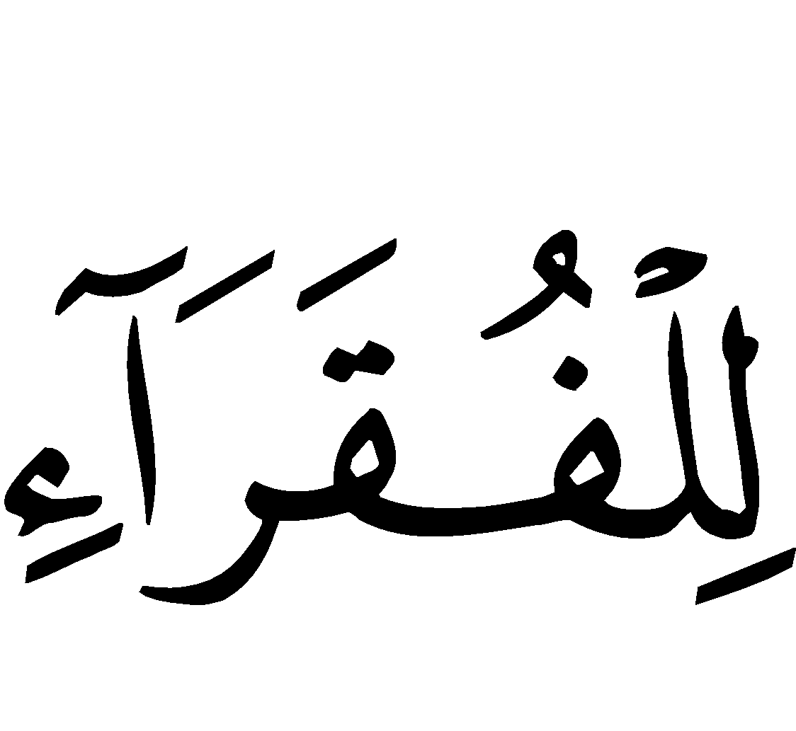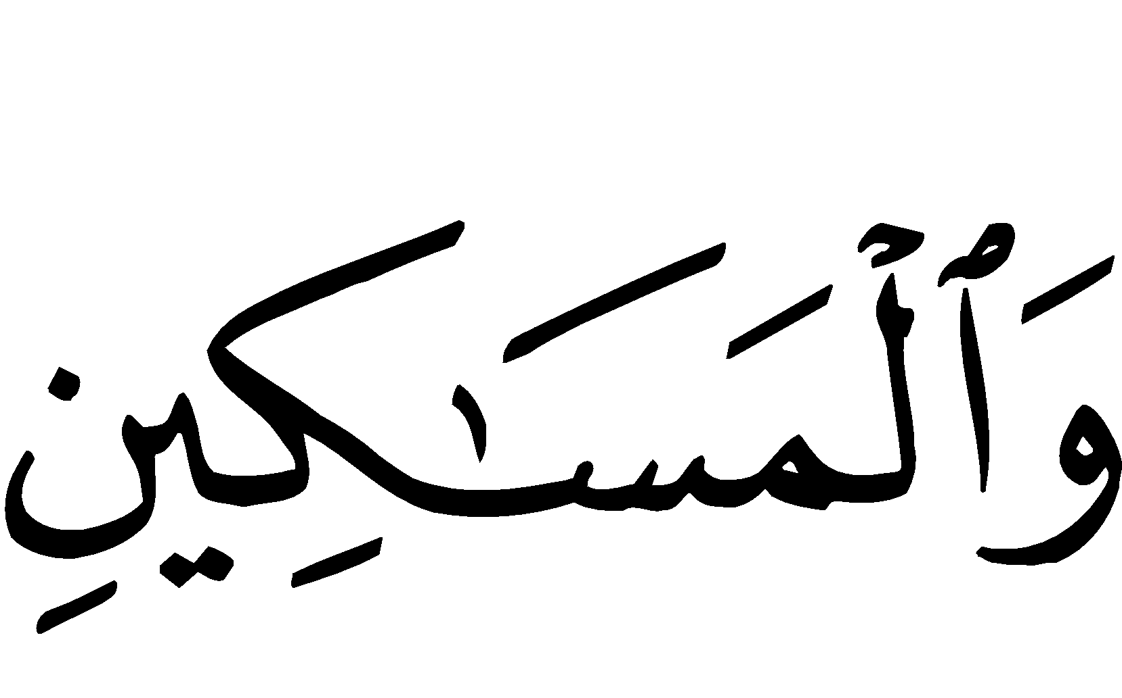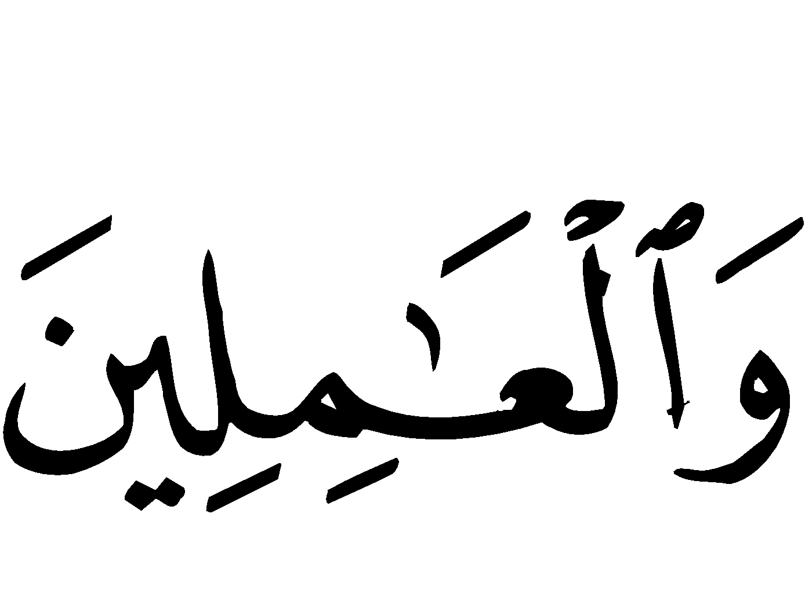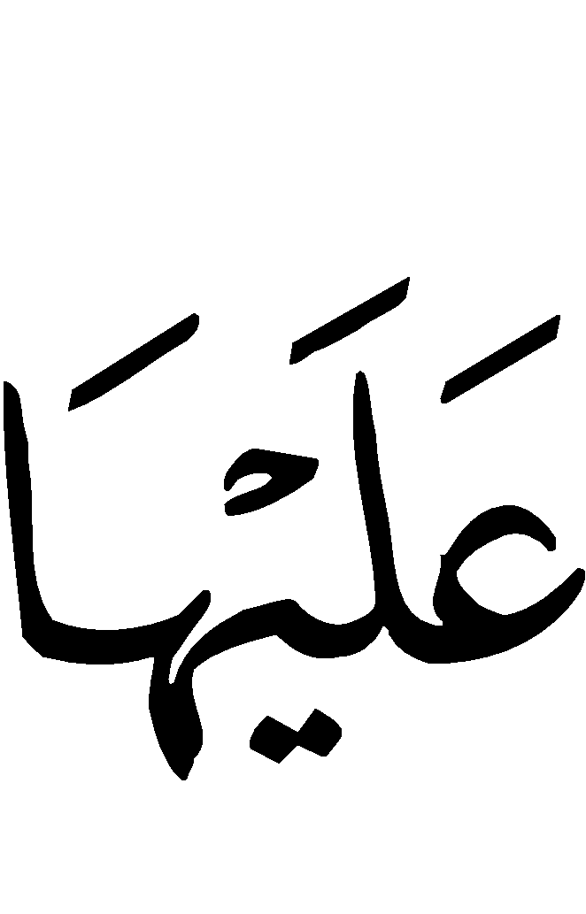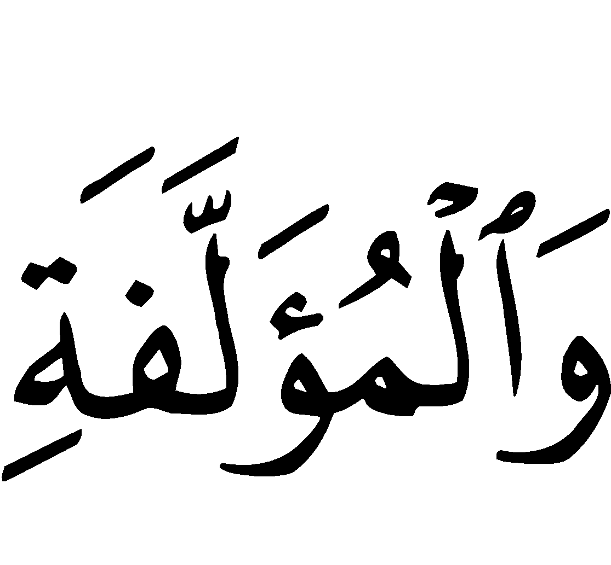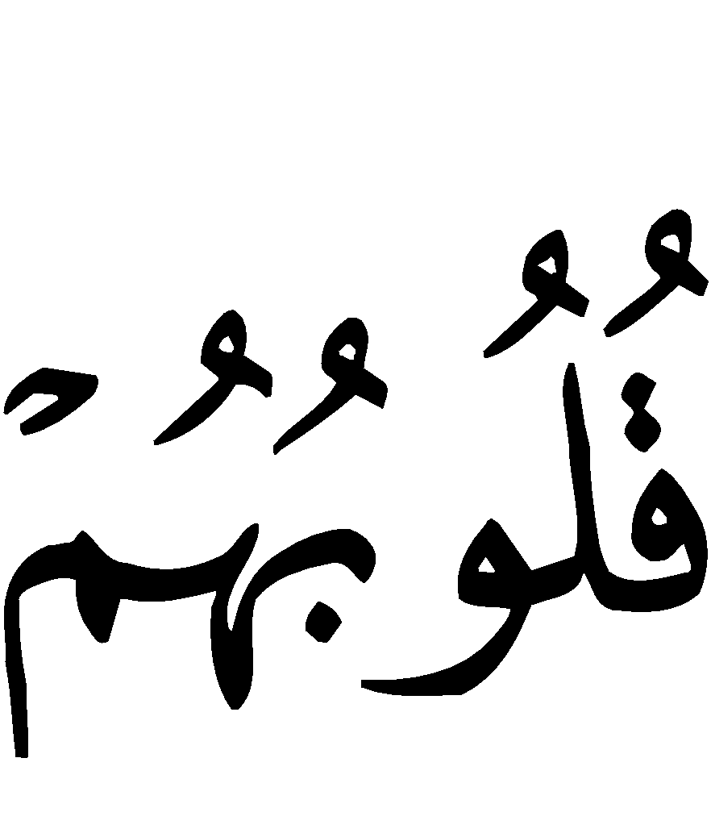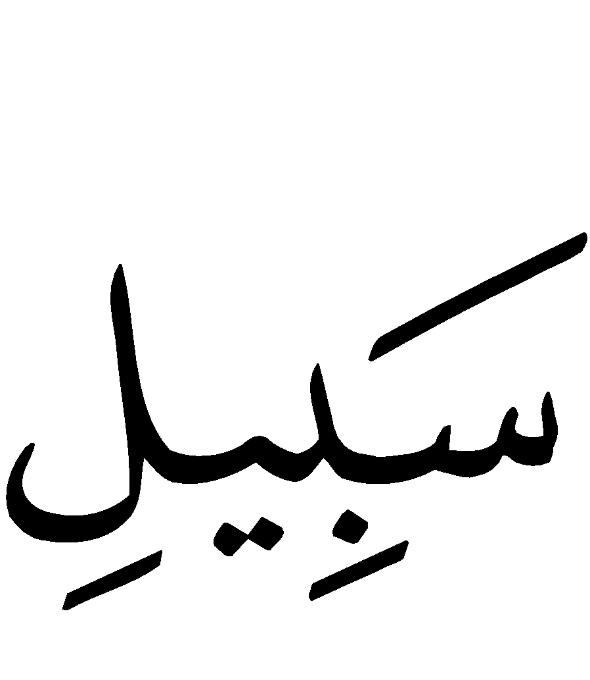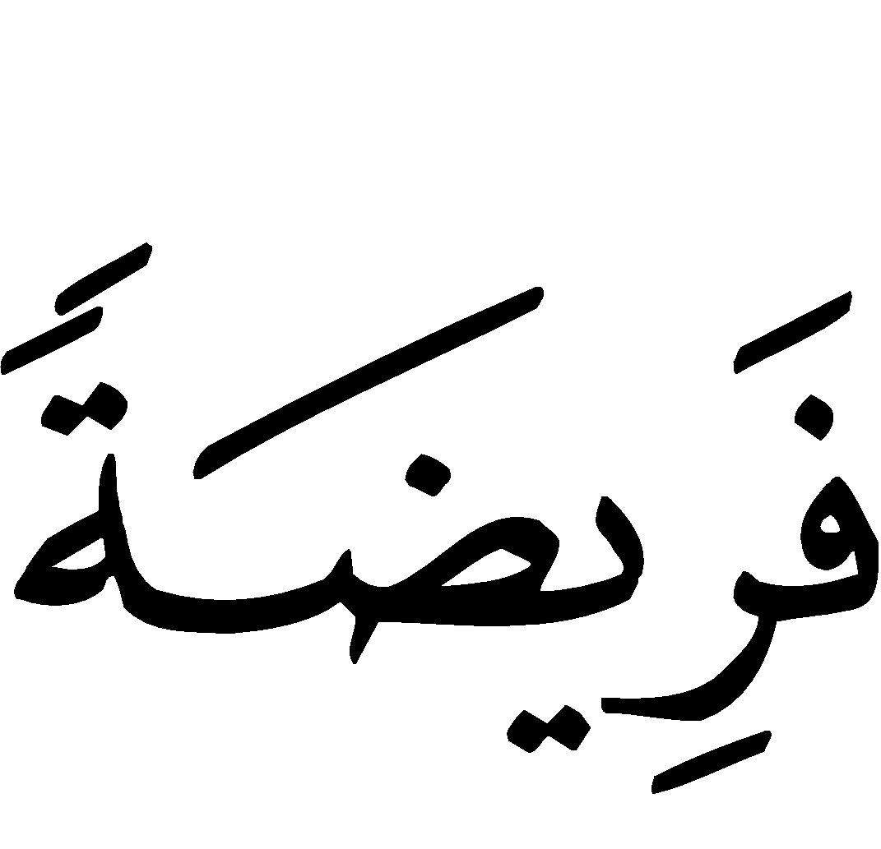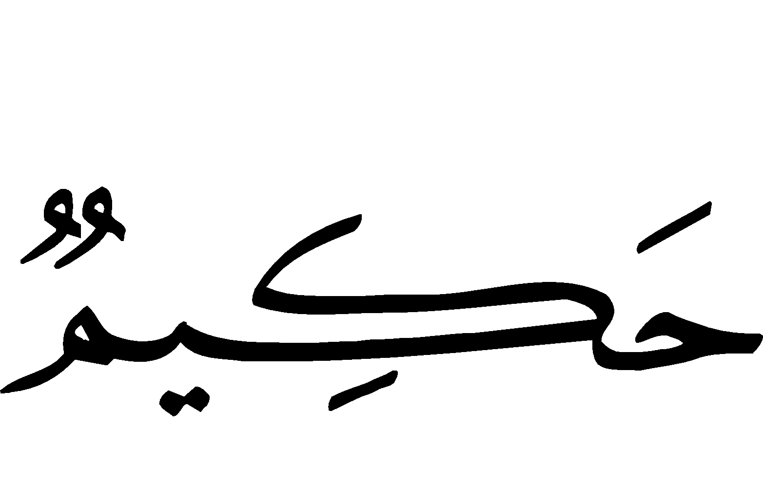
“The Sadaqaat (here it means Zakaah) are only for the Fuqaraa´ (needy), and the Masaakeen (the poor) and those employed to collect (the funds); and for to attract the hearts of those who have been inclined (towards Islam); and to free the captives; and for those in debt; and for Allah’s Cause (i.e. for Mujaahidoon - those fighting in the holy wars), and for the wayfarer (a traveler who is cut off from everything); a duty imposed by Allah. And Allah is All-Knower, All-Wise.” [Surah at-Tawbah (9):60]
Allah reminds His slaves by concluding this verse with these two Great Names of Allah, that He is All-Knowledgeable of the conditions of His slaves; He knows who exactly deserves Zakaah and who does not. He is All-Wise in His Legislation, Will and Measure; He does not do things except in a manner which is perfectly suitable, even if some of the secrets of His Wisdom may be unknown to some people. In this, His slaves find peace in His Legislation and also submit and surrender to His Wisdom.
We ask Allah that He grant us and the Muslims the Guidance to practice His religion properly, and Truthfulness in our relationship with Him, and that we race to that which pleases Him, and that He keeps us safe from those things which earn His Anger; indeed He is All-Hearing and Near.
And may Allah praise His slave and messenger, Muhammad, and upon his family and companions, and keep them safe from all evil.
Selected Verdicts regarding Zakaah

Zakaah on Salaries
Q. I am an employee who earns a good salary, all praise is for Allah, but I do not know how I should offer Zakaah for it. Should I offer it for every month, or should I select a certain month and offer Zakaah for whatever I have in my hands, whether I earned it from my work or otherwise? Also, if I spent all my money and then earned some more which reaches the nisaab, should I start calculating the year from the date I received the first amount which finished, or from the date I received the new amount?
A. Whenever you obtained a certain amount of money, you should start to calculate the year from that date you receive the new amount [if it reached the nisaab]. Whenever you obtain money, you should make a chart mentioning this. When a year passes on this new amount [which has reached the nisaab], you should offer its Zakaah. Zakaah should be offered for what you obtained in Muharram in Muharram [of the following year], what you obtained in Safar in Safar [of the following year], and what you obtained in Rabee’-ul-Aakhir in Rabee’-ul-Aakhir[of the following year], etc. But if you paid Zakaah for the last amount before hand along with the first, paying it before its time, it is fine and you are thanked. So if you have received a salary for Muharran, Safar, Rabee’-ul-Awwal, Rabee’-ul-Aakhir, etc., and you have recorded all of them, and then you pay the Zakaah for all of them beforehand along with Muharram, there is no harm in this. You will be paying the Zakaah for all of them when a year passes on the first amount. There is no harm if you do this, rather this is better and preferable. But what is obligatory upon you is that you pay the Zakaah when its time comes; whenever a year passes upon a certain amount [which has reached the nisaab], you must pay what is due upon it according to your records and time. And if you paid what was due upon some portion of that wealth before its actual time along with [the payment of Zakaah on the wealth] before it, then there is no harm in this as we mentioned. (Majmoo’-ul Fataawaa, Abdul-Azeez ibn Baaz, v.14, p,138)

Q. I am an employee who earns a salary, and every month I save a portion if it. There is no certain percentage which I save, so how should I pay the Zakaah due upon this wealth?
A. It is obligatory upon you to pay the Zakaah of every portion which you have saved if a year passes with it in your possession and it had reached the nisaab. If you paid the Zakaah for all the amounts beforehand at the time a year passes on the first amount, this is sufficient. In this case, the Zakaah on the later amounts would have been paid beforehand before a year passes upon it, and paying Zakaah before a year passes upon wealth is permissible, especially in cases where there is a need and a legislative advantage in doing so. (Majmoo’-ul Fataawaa, Abdul-Azeez ibn Baaz, v.14, p,143)

Zakaah on Loans
Q. By the Grace of Allah and His Guidance, I worked for twenty years, and I saved three sums of money. I lent a relative of mine an amount for a fixed time period, and time is passing and I have no hope of reimbursement. The second amount I lent to another relative in order to do some business, but years have passed without him doing anything with it. The third amount is in my possession.
What is the ruling regarding the Zakaah on the amount which was not reimbursed, the amount which was given for business purposes but was not used, and the amount from which I personally spend? Enlighten us, may Allah enlighten you.
A. You must pay Zakaah for the amount which you have in your possession as well as the amount which is with your relative for business but did not use it whenever a year passes upon it, except if your relative spent the amount you gave him [for business] for some personal need and is unable to return it. In this case there is no Zakaah upon it until he reimburses you and a year passes with it in your possession.
As for the amount which is with your first relative, the matter requires some further clarification.
- If he has wealth and is able to pay you back, you must pay Zakaah upon the amount whenever a year passes upon it. There is no harm in delaying the Zakaah until he reimburses you and paying for all the previous years, but it is safer and better that you pay it every year as a precaution against forgetfulness or death.
- If he is unable to reimburse you, or he is able but is constantly deferring payment or is refusing to pay, it is not obligatory upon you to pay the Zakaah according to the correct of the two stances of the scholars, until he reimburses you and a year passes with it in your possession. Zakaah is meant as a consolation (to the poor), and this consolation is not obligatory upon wealth which you do now know whether you will obtain. (Majmoo’-ul Fataawaa, Abdul-Azeez ibn Baaz, v.14, p,42)

Interest-based Dealings with Banks and its Zakaah
Q. Many people deal with banks, and it may be that they get into impermissible dealings like interest. Is Zakaah to be paid on this amount, and how is to be offered?
A. It is impermissible to deal in interest, whether with banks or anything else, and all the profits gained from interest are impermissible. They are not considered his wealth, and if he took possession of it knowing the ruling of Allah in its regard, it is obligatory that he disposes (of that wealth) by giving it to charitable purposes. If he has not taken possession of it, he is only allowed to take back his capital amount, as Allah () said:
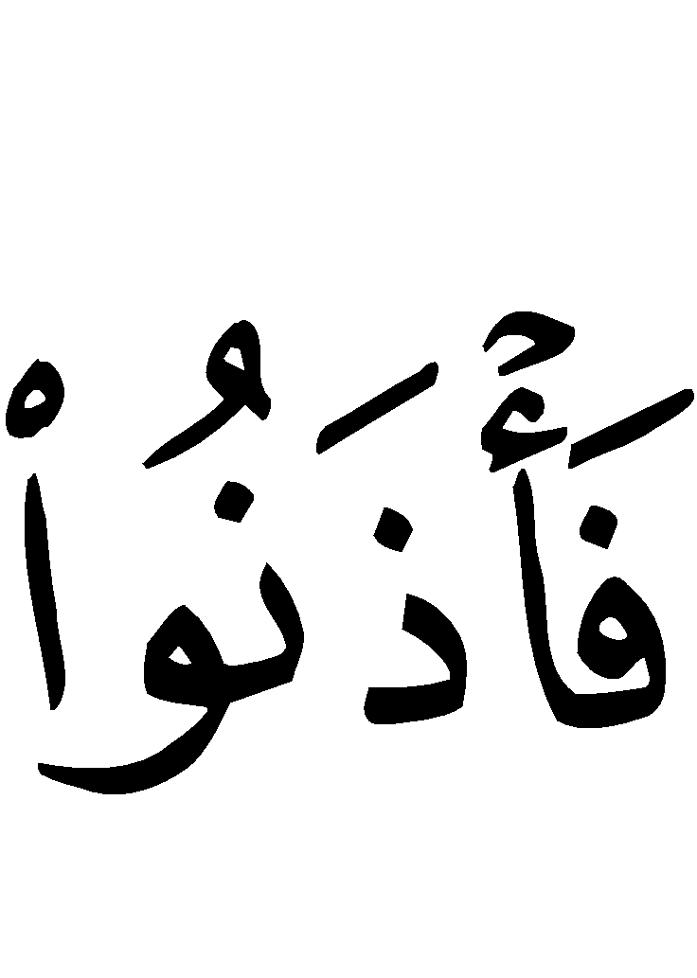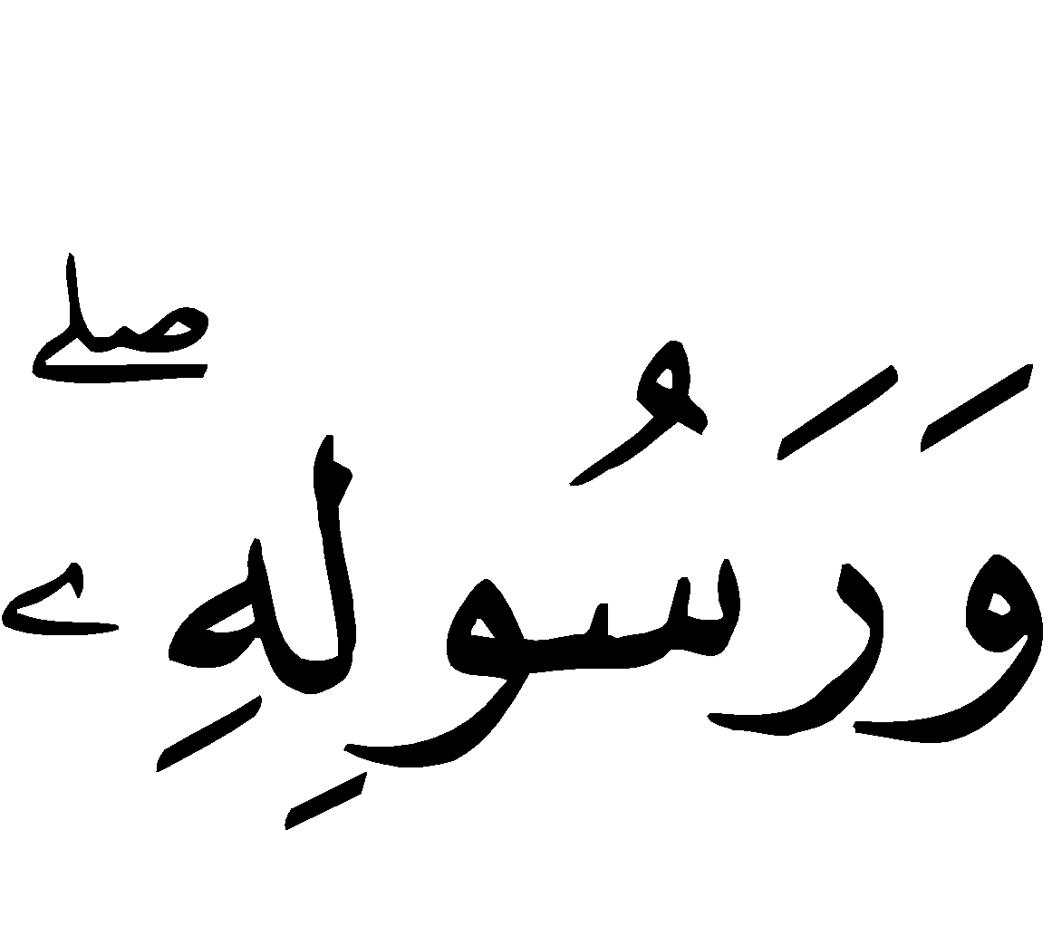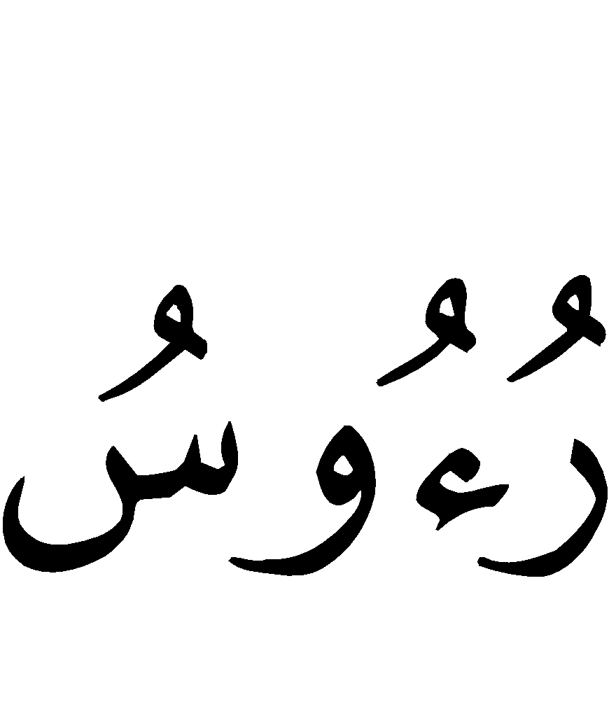
“O you who believe! Be afraid of Allah and give up what remains (due to you) from interest, if you are (really) believers. * And if you do not do it, then take a notice of war from Allah and His Messenger. But if you repent, you shall have your capital sums. Deal not unjustly (by asking more than your capital sums), and you shall not be dealt with unjustly (by receiving less than your capital sums).” [Surah al-Baqarah (2):278-279]
If he had taken the interest before knowing the ruling of Allah in its regard, he may keep it and it is not obligatory upon him to dispose of it, as Allah said:
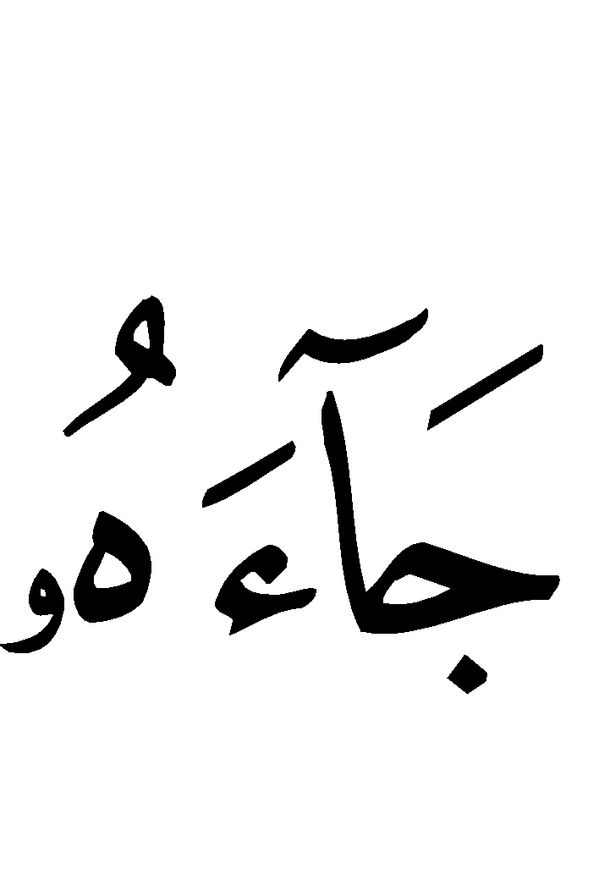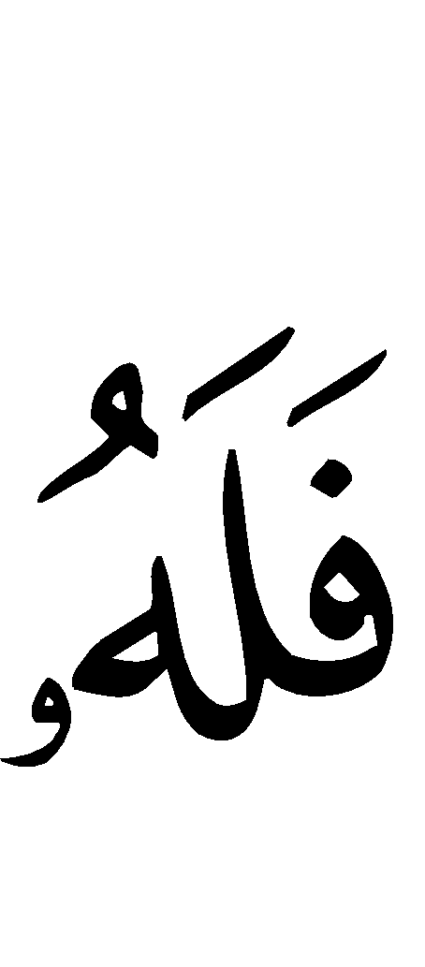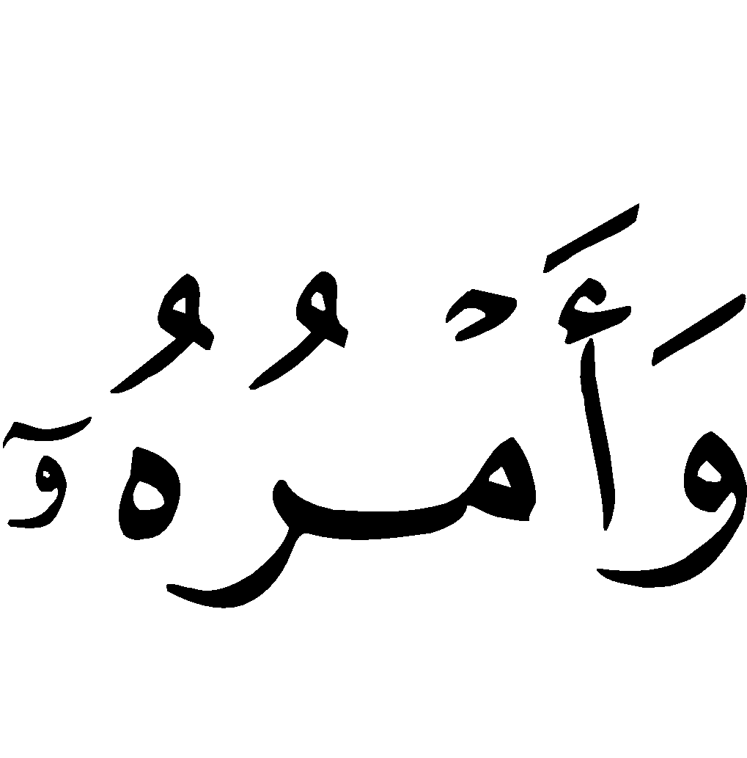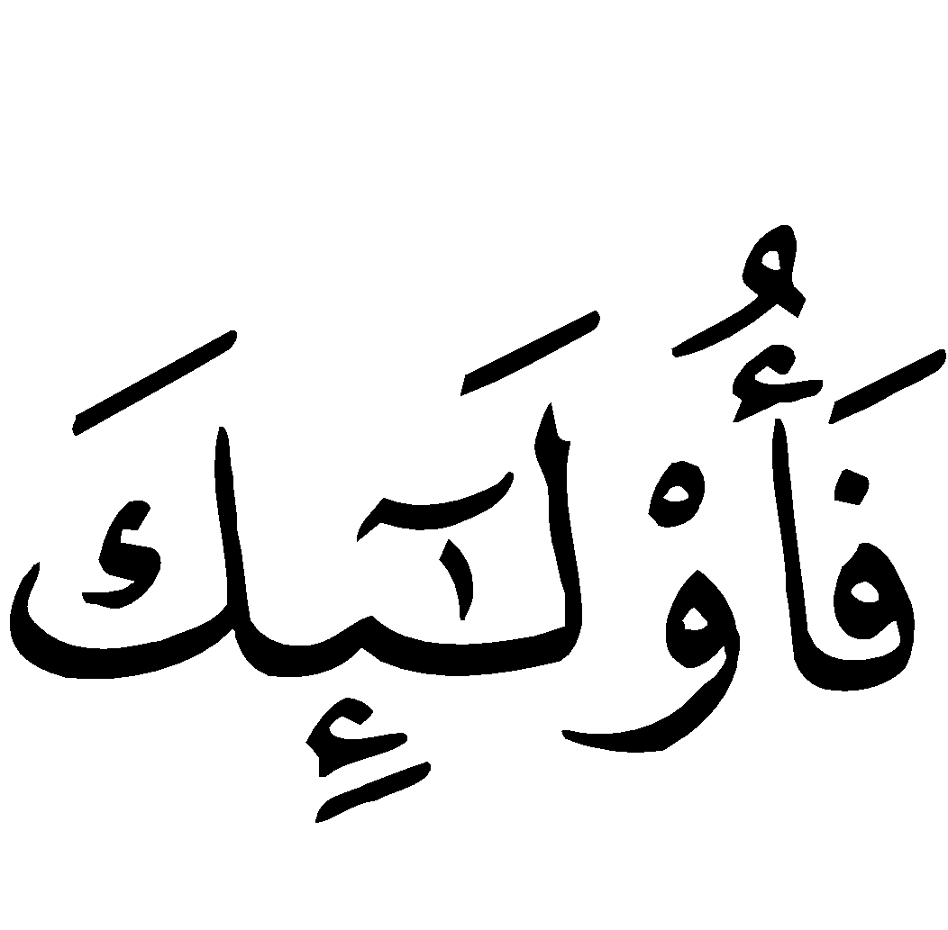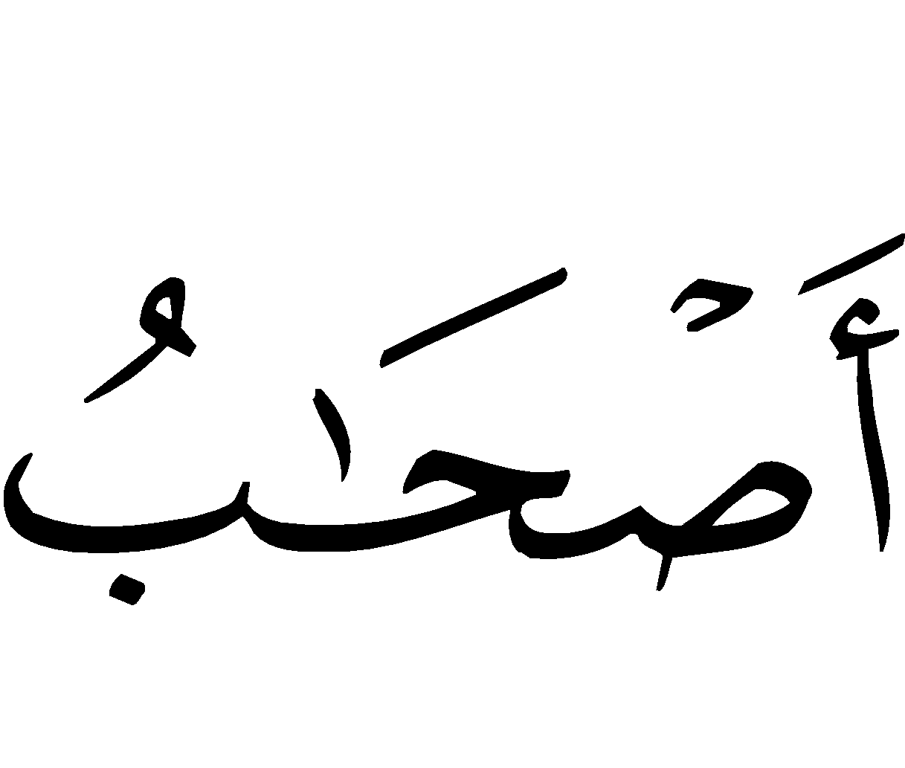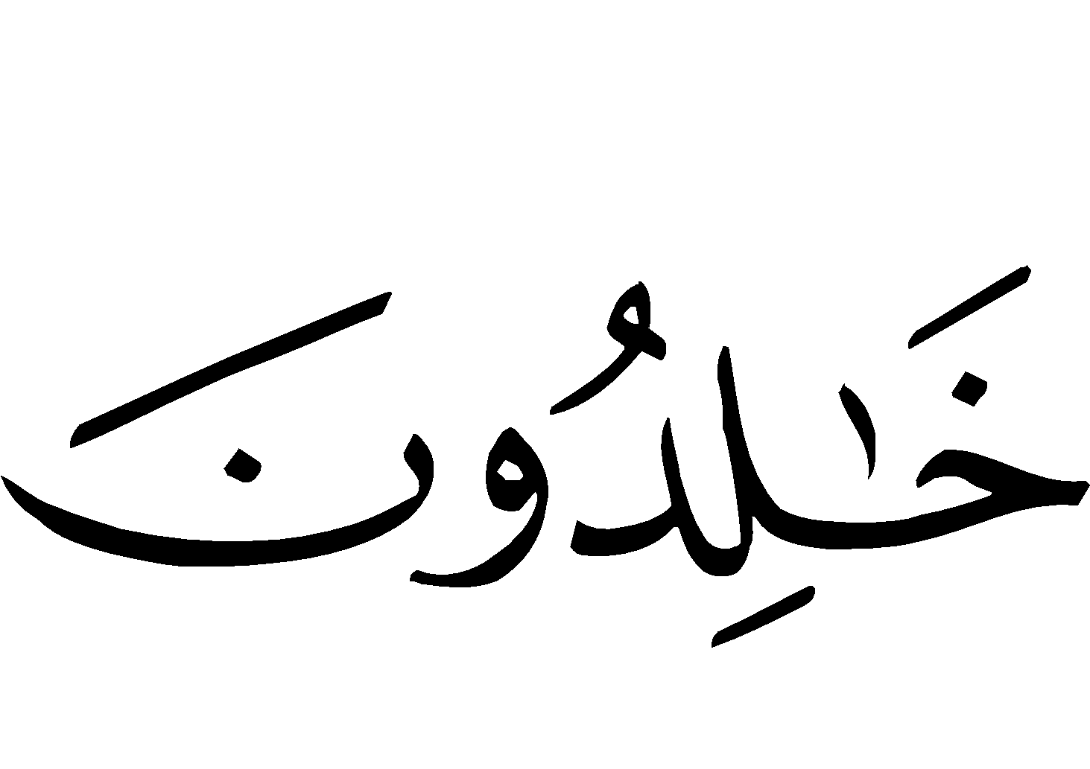
“Allah has permitted trading and forbidden interest. So whosoever receives an admonition from his Lord and stops eating interest shall not be punished for the past; his case is for Allah (to judge); but whoever returns [to dealing in interest)], such are the dwellers of the Fire - they will abide therein.” [Surah al-Baqarah (2):275]
The person must pay Zakaah on that portion which is not from the profits of interest, as he does for all his other wealth upon which Zakaah is due. But if he did not have knowledge of its impermissibility, Zakaah must also be paid upon the profits made from interest before, for it is like the rest of his wealth due to the verse mentioned above, All Guidance to Correctness is from Allah. (Majmoo’-ul Fataawaa, Abdul-Azeez ibn Baaz, v.14, p,153)

Giving Zakaah to Islamic Centers
Q. There is a charitable center for teaching Qur`aan to women which will soon be open, by the Will of Allah (), and this center, like other charitable projects, needs much money to meet its expenditures, like salaries for the teachers, office furniture, buses for the teachers and students, etc. Is it permissible, O respected sheikh, that Zakaah be spent on this center?
A. It is not permissible that Zakaah be spent on it except on those teachers who are needy and whose husbands do not spend on them, and those who have no well-to-do guardians which are able to spend upon them. Salaries should be only be given [from the Zakaah] to those of them who require money for their necessary expenditures. As for office furniture and buses, money other than Zakaah should be spent on them, like charitable donations, endowments, and general charity. And Allah knows best. (Abdullah ibn Jibreen, www.islamtoday.net)

Is Zakaah required of one who is in debt?

Q. If a person is in debt that is equal to all the wealth that he has in his possession, or more than that, is he required to pay zakaah on the money that he does have, if one year has passed since he acquired it?
A. Praise be to Allah. The one who has any “zakatable” wealth must pay zakaah on it, when one year has passed since he acquired it, even if he has debts, according to the more correct of the two scholarly opinions, because of the general meaning of the evidence that zakaah is obligatory upon everyone who has wealth on which zakaah is due, if one year has passed since he acquired it, even if he has debts. The Prophet () used to command his agents to take zakaah from those who owed zakaah, and he did not tell them to ask them whether they had any debts or not. If having debts meant that one did not have to pay zakaah, the Prophet (peace and blessings of Allah be upon him) would have told his agents to ask the people who were paying zakaah whether they had any debts or not. (Majmoo’-ul Fataawaa, Abdul-Azeez ibn Baaz, v14, p.51 )
“…But if you pay off the debt with cash in hand before one year has passed, there is no zakaah on what you have spent to pay off the debt; rather zakaah is due on whatever is left, if one year has passed and it reaches the minimum threshold (nisaab).”
Shaykh Ibn ‘Uthaymeen (may Allah have mercy on him) was asked about a person who has capital worth two hundred thousand riyals and owed a debt of two hundred thousand riyals, and was paying it off at a rate of ten thousand per year – does he have to pay zakaah?
He replied:
Yes, he has to pay zakaah on the wealth that is in his possession, because the texts which speak of the obligation of zakaah are general in meaning, and do not make any exceptions. No exception is made for one who is in debt. As the texts are general in meaning, we have to follow them.
Moreover, zakaah must be paid on wealth, because Allah says (interpretation of the meaning):


“Take Sadaqah (alms) from their wealth in order to purify them and sanctify them with it, and invoke Allah for them. Verily, your invocations are a source of security for them; and Allah is All-Hearer, All-Knower.” [Surah at-Tawbah (9):103]
And according to the hadeeth narrated by al-Bukhaari from Ibn ‘Abbaas (), when the Prophet () sent Mu‘aadh to Yemen he said:
“Tell them that Allah has enjoined zakaah from their wealth.”
So Allah and His Messenger have stated that zakaah has to do with the wealth itself, not with the person’s obligations towards others; debt has to do with personal obligations towards others. They are two separate issues, so zakaah must be paid from the wealth that is in your possession, and the debt is a personal responsibility.
Each person must fear his Lord and pay zakaah on the wealth that is in his possession, and seek the help of Allah to pay the debt that he owes, saying: O Allah, pay off the debt that I owe and make me independent of means.
Perhaps if he pays zakaah on the wealth that is in his possession, that may be a means of bringing blessing to this wealth and causing it to grow, so that he may discharge his duty of paying his debts. If he withholds zakaah, however, that may be a cause of his becoming poor, so that he always sees himself as being in need and not able to pay zakaah. Praise Allah if He makes you one of the givers and not one of the takers. (Majmoo’ ul-Fataawaaa, Shaykh Ibn ‘Uthaymeen, v.18, p.39)
And he said, in another Fatwa on the same issue (v.18, p.38):
If the debt is currently due and repayment is being demanded, and he wants to pay it off, in that case we say: Pay off the debt, then pay zakaah on what is left after that if it reaches the minimum threshold at which zakaah becomes due.
That is supported by what the scholars of the Hanbali madh’hab said about zakaat al-fitr. They said that being in debt does not mean that one should not pay it.
Similarly, it is reported that ‘Uthmaan () used to say during the month of Ramadaan:
“This is the month of your zakaah, but whoever is in debt, let him pay it off.”
This indicates that if a debt is currently due to be paid, and the debtor wants to pay it off, that should take precedence over zakaah. But if a debt is not yet due to be paid off, the zakaah must still be paid, beyond a doubt.
And it says in Fataawa al-Lajnah al-Daa’imah, v.9, p.189:
The correct scholarly view is that being in debt does not mean that zakaah should not be paid. The Prophet () used to send his agents to collect the zakaah, and he did not tell them to see if the people were in debt or not.
Islam Q&A (www.islam-qa.com)

Narrated by as-Suyuti in ‘Al-Jaami’ as-Sagheer’. Declared saheeh by Al-Albani.
Al-Bukhaari.
One saa’ is equal to about 3 kilograms of rice.
In a hadeeth narrated by al-Bukhaari: (cont'd…) “The amount due upon that which is watered by the sky by streams, or on its own roots is a tenth, and what is fed by (manual) watering a twentieth.”
If the salary of one month does not reach the nisaab, then the calculation starts when it does reach the nisaab. So if it takes three months to reach the nisaab, this is the date on which the calculation should start. The next amount (on which Zakaah should be paid) will be recorded the next time the amount reaches nisaab, which may be a few months later. So the person may not necessarily be paying Zakaah for every month he received a salary, but rather he is paying it on that amount which has been in his possession for a period of a year since the time it reached the nisaab.
The reason it is preferable is that it is extremely difficult to record all the money which comes into a person’s hands and leaves them, and this may lead a person to improperly offer his Zakaah. If a person pays the Zakaah for the remaining 11 months when a year passes on the first amount which reached the nisaab, then he will have surely paid what was due on all his wealth for that year. Although he was unsure whether the remaining 11 months actually will have remained in his possession for a total year, whatever extra he pays is regarded as charity.

